NAME: OKOLOCHA PRECIOUS DONALDJNR
MATRIC NO: 17/SMS03/025

Industrial Relations

Q1) Definition: The Industrial Relations or IR encompasses the relationship between the management and workmen and the role of a regulatory body to resolve any industrial dispute.
As the name implies, Industry Relations comprises of two words, Industry, and Relations. Where industry covers the production activity in which the group of workmen is engaged in, while the relations show the relationship between the management and the workers within the industry. IR plays a significant role in today’s working scenario where the harmonious relationship between the employers and employees is needed to have an uninterrupted production. The Industrial Relations mainly cover the following:
* Regulatory body to resolve industrial disputes.
* Collective Bargaining.
* The role of management, unions and government.
* Labor Legislation
* Worker’s Grievance Redressal system.
* Disciplinary policy and practice.
* Industrial Relations Training.

Importance of Industrial Relations
1. Increased Productivity: With amicable industrial relations both the workers and managers continue to work on their respective position and contribute towards the overall productivity of the firm. Thus, IR ensures the continuity of production.
2. Reduced Industrial Disputes: An effective IR helps in the reduction of industrial disputes as both the management and the workers maintain harmonious relations with each other and work in unison towards the accomplishment of production objective.
3. Increased Morale: The peaceful industrial relations boost the morale level of the employees as they feel that their interest coincides with that of the employer’s, and their efforts will result in the overall profitability of the firm.
4. Minimization of Wastage: A good IR ensures reduced wastage as the resources – Man, Machinery, Material are fully utilized and are effectively contributing towards the overall productivity of the firm.
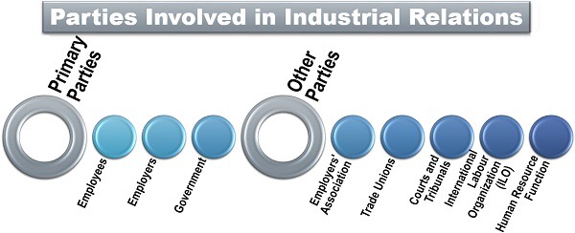
Primary Parties
Those persons or associations which are directly associated with or influenced by the functions of industrial relations are as follows:

Employees
The workers who provide their services to the organization are an essential resource and contributes to generating the desired output.
Following are some of the reasons for which employees find maintaining sound industrial relations to be useful for them:
* Sharing their views, suggestions and ideas with the management to improve the business operations;
* becoming a part of organizational decision-making and ensuring the betterment of the working conditions;
* speaking out their problems and grievances and seeking for the redressal of the same.

Employers
Employers are responsible for providing a favourable work environment for the employees. They have many rights and powers like laying off inefficient employees, taking strategic decisions such as mergers, acquisition or shutdown of the organization and adapting technological changes in the operations.
Following are the different ways in which managers can benefit from sound industrial relations in the organization:
* Motivating the employees to give their best and gaining their trust and commitment;
* improving the overall efficiency and ensuring effective communication among the employees and the management;

Government
Before the 19th century, the government didn’t use to intervene in the conflicts between the employer and the employee. However, later on, there was a change in the attitude of the government bodies, they started regulating the industrial relations through labour courts and tribunals, for the following reasons:
* Safeguarding the interest of both the parties;
* ensuring that both the employer and the employee, abide by the legal terms and conditions.

Other Parties
The parties (especially the internal or external bodies or associations) which impact the industrial relations within an organization are as follows:

Employers’ Association
It is an authoritative body, formed to protect the interest of the industrial owners. It performs the following functions to safeguard the rights of the employers:
* Representing the owners in collective bargaining with the employees or government and also in case of national issues;
* creating a proper mechanism to resolve industrial disputes;
* giving an insight into the employee relations in an organization and providing suggestions accordingly.

Trade Unions
When the workers unite together to form an association and elect a representative among themselves; for the protection of their rights and to raise their demands in front of the management; it is named as a trade union. Listed below are the objectives of such associations:
* Negotiating collectively with the administration for meeting the individual interest of an employee;
* upgrading the status of the employees in the organization;

Courts and Tribunals
The judiciary includes the ‘courts’ to resolve the legitimate conflicts and the ‘judicial review’ to administer the justice of the constitution. These courts and tribunals play an essential role in settlement of industrial disputes by eliminating the possibilities of the following:
* Judicial flaws;
* conflicting judgment;
* poor evaluation of penalty;
* confusing terms and conditions.

International Labor Organization (ILO)
On the international grounds, an association was formed under the name of International Labor Organization in the year 1919 to set up international norms and standards for dealing with industrial disputes and issues of the workers.
Simultaneously, an International Labor Code (ILC) was set up to establish the recommendations and conventions for minimum international labour standards.
The ILC aimed to look into matters like:
* Worker’s compensation, i.e., minimum wages;
* employee’s work duration and number of holidays;
* women employment;
* employee’s safety, security and health in the work environment;
* industrial relations;
* medical facilities and examination along with maternity protection.

Industrial Relations – Functions
i. Communication is to be established between workers and the management in order to bridge the traditional gulf between the two.
ii. To establish a rapport between managers and the managed.
iii. To ensure creative contribution of trade unions to avoid industrial conflicts, to safeguard the interests of workers on the one hand and the management on the other hand, to avoid unhealthy, unethical atmosphere in an industry.
iv. To lay down such considerations that may promote understanding, creativity and co-operativeness to raise industrial productivity, to ensure better workers’ participation.
The industrial scene is tormented by lack of central values, class struggle, competition and unhealthy compromisers. Even in the latter part of the century, the management considers trade unions as a nuisance or a hurdle. The trade unions on the other hand, considered the management and managers as exploiters. Workers are misled by their trade union leaders on the one hand and they allow themselves to be exploited by management.
The trade unions are organs of political organisations and they follow the ideologies of those organisations even at the cost of their own interest in the industry. As a result, the collective bargaining ends in either aggressive bargaining or futile waste of time. These and many other considerations led the I.L.O. to formulate certain principles for promoting healthy industrial relations.

Q2) The unemployment rate in Nigeria and other countries is defined as the number of unemployed people as percent of the labor force. The labor force includes the people who are either employed or unemployed, i.e. who don't have a job but are actively looking for one. The labor force does not include people who are not looking for work, children, and the retired.
The unemployment rate seldom declines below 4-5 percent even during boom times. There are always people who move between different sectors of the economy or between cities. When the economy goes into recession, then unemployment can reach much higher numbers, sometimes

Definition: Unemployment refers to the share of the labor force that is without work but available for and seeking employment.

Unemployment Rate in Nigeria increased to 23.10 percent in the third quarter of 2018 from 22.70 percent in the second quarter of 2018.
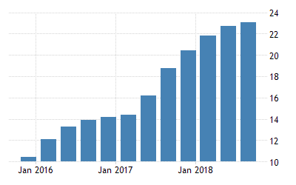

IN COMPARATION TO SOUTH AFRICA

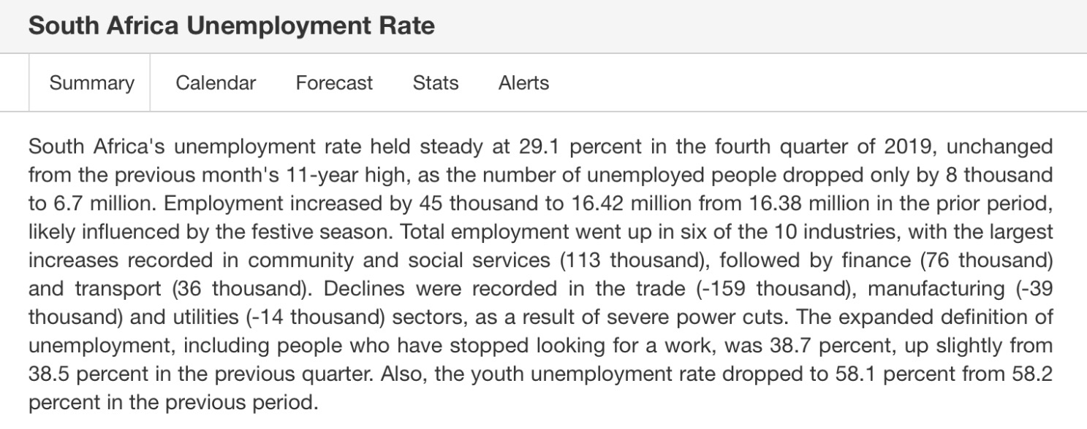

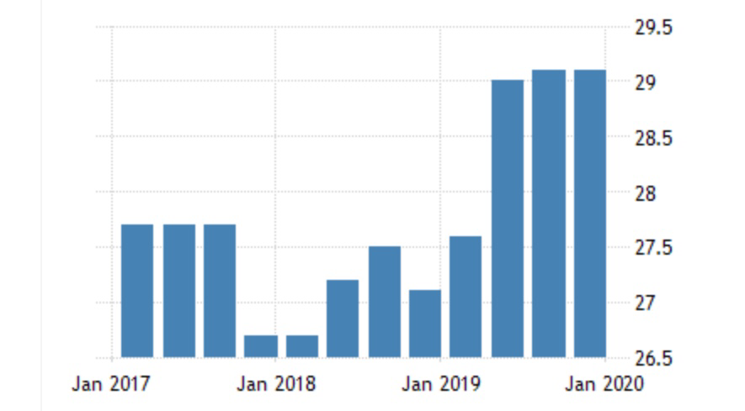

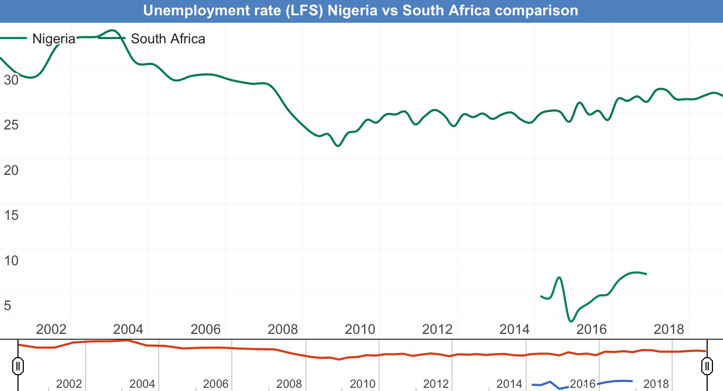
Nigeria in comparison to South Africa

