OVBUDE IRENOISE DEBORAH

16/MHS03/026

INTRODUCTION TO HISTOPATHOLOGY

MR EDEM E. EDEM

ASSIGNMENT
DISCUSS THE INVOLVEMENT OF T- AND B- LYMPHOCYTES IN THE PATHOGENESIS AND PROGRESSION OF OSTEOMYELITIS AND OSTEOARTHRITIS.

OSTEOMYELITIS

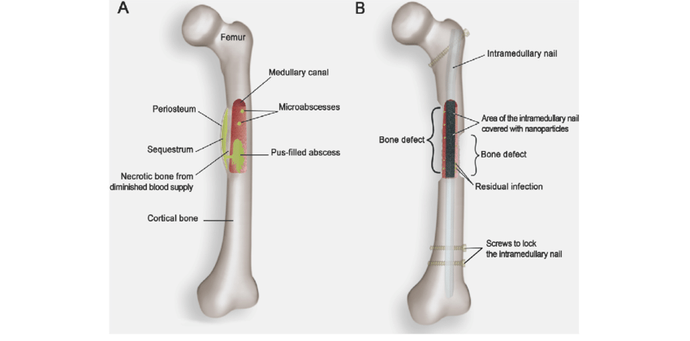
Fig.1. Chronic Osteomyelitis of the femoral shaft.

Osteomyelitis is inflammation of the bone caused by an infecting organism (Stephan, 2018). Osteomyelitis is sometimes a complication of surgery or injury, although infection can also reach bone tissue through the bloodstream. Both the bone and the bone marrow may be infected (William, 2018). Although bone is normally resistant to bacterial colonization, events such as trauma, surgery, the presence of foreign bodies, or the placement of prostheses may disrupt bony integrity and lead to the onset of bone infection. Osteomyelitis can also result from hematogenous spread after bacteraemia (Stephan, 2018).

PATHOGENESIS OF OSTEOMYELITIS

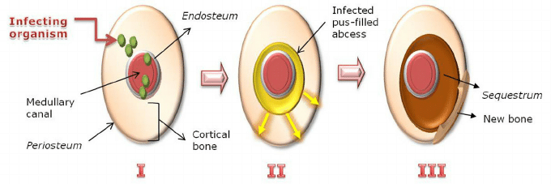

Fig.2. Pathogenesis of osteomyelitis. I - A large inoculum of bacteria reaches the medular channel; II - (Acute state) Pus resulting from inflammatory response spreads into vascular channels; III - (Chronic state) Vascular channels are compressed and obliterated by the inflammatory process, and the resulting ischaemia also contributes to bone necrosis.

Microorganisms may infect bone through one or more of three basic methods; haematogeneously (via the bloodstream) this is the most common (Luqmani et.al, 2013), from nearby areas of infection (as in cellulitis), penetrating trauma including iatrogenic causes such as joint replacements or internal fixation (Kumar, 2007).The area usually affected when the infection is contracted through the bloodstream is the metaphysis of the bone (Luqmani et.al, 2013). Once the bone is infected, leukocytes enter the infected area, and, in their attempt to engulf the infectious organisms, release enzymes that lyse the bone.

Pus spreads into the bone's blood vessels, impairing their flow, this forms the basis of a chronic infection(Kumar, 2007). Often, the body will try to create new bone around the area of necrosis. The resulting new bone is often called aninvolucrum. Histologically, these areas of necrotic bone are the basis for distinguishing between acute osteomyelitis and chronic osteomyelitis. Osteomyelitis is an infective process that encompasses all of the bone components, including the bone marrow. When it is chronic, it can lead to bone sclerosis and deformity (Ellington, 1999).Chronic osteomyelitis may be due to the presence of intracellular bacteria (inside bone cells). Also, once intracellular, the bacteria are able to escape and invade other bone cells. At this point, the bacteria may be resistant to some antibiotics (King et.al, 2006). These combined facts may explain the chronicity and difficult eradication of this disease, resulting in significant costs and disability, potentially leading to amputation. Intracellular existence of bacteria in osteomyelitis is likely an unrecognized contributing factor to its chronic form (Ellington, 1999).

PROGRESSION OF OSTEOMYELITIS
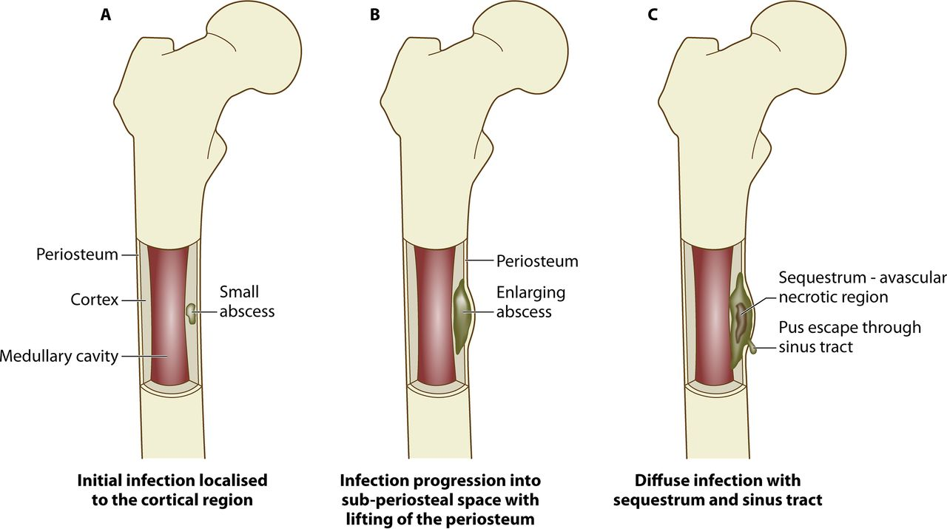
Fig.3. Progression of osteomyelitis. An abscess develops from a localized infection that constricts the blood flow to the area (A), resulting in an avascular region of necrotic bone tissue called the sequestrum (B), followed by development of new bone surrounding the sequestrum, termed the involucrum, which may also have a sinus tract through which purulence can escape (C)

There are many contributing factors that predispose a patient to developing osteomyelitis, including age, diabetes, peripheral vascular disease, intravenous (i.v.) drug use, surgical implants, and immunodeficiency due to disease or immunosuppressant drugs (Calhoun et.al, 2009). The causative organisms in osteomyelitis can originate from either hematogenous or contiguously spread sources, often referred to as endogenous or exogenous sources, respectively (Oryan et.al, 2014).It is estimated that half of osteomyelitis cases in adults are due to trauma (Lima et.al, 2014). Trauma can result in either open or closed fractures (presence or absence of exposed bone). Damaged connective tissues, including skin, muscle, and bone, expose proteins to which bacteria readily bind, such as collagen and fibronectin, increasing the chance of inoculation (Pasquet et.al, 015). In a clinical study carried out by Merritt, up to 1 in 5 patients who acquired open fractures were reported to have developed infections (Merritt et.al,1988).
People with soft tissue infections who develop underlying infection of the bone are most commonly over the age of 40 and have diabetes mellitus.

T- and B-Lymphocytes Involvement with the Pathogenesis and Progress of Osteomyelitis
The pathology of osteomyelitis is characterized by severe inflammation, impairment of vasculature, and localized bone loss and destruction. In an attempt to overcome the infective microorganisms, leukocytes produce inflammatory cytokines and enzymes that break down the infected and surrounding tissue (Vigorita et.al, 2007). Purulence consisting of dead leukocytes and host/bacterial cells can fill intercellular spaces around the infection and form an abscess. In chronic infection, abscesses can impair blood flow and strip the periosteum, creating an area of vascularized, necrotic bone called a sequestrum (Healy and Freedman et.al, 2006). Vascular impairment makes the foci of chronic infection impervious to the immune system and systemic antibiotics. The sequestrum is indicative of a chronic infection and compromises the bone's integrity. Often the formation of new bone an involucrum occurs, which forms from remaining intact fragments of the periosteum and functions to provide axial support to weight-bearing bones and prevent pathological fracture (Kumar et.al, 2012). Exudate or purulence from the infection may escape through an opening in the bone called a sinus tract (Fig. 3).
Activation and expansion of T and B lymphocytes is invariably associated with the immune response to virus infection, and the clearance of virus-infected cells. Activation of T and B cells, however, is also seen in bacterial infection, particularly in those caused by intracellular bacteria (Wong and Pamer, 2003) and as we showed recently in patients with implant-associated osteomyelitis, a prototype of a biofilm infection (Wagner et.al, 2006). Bacterial biofilms are increasingly recognised as the cause for persistent and destructive inflammatory processes ( Costerton et.al, 2003). Biofilms are defined as “microbial derived sessile communities characterised by cells that are irreversibly attached to a substratum or interface or to each other, embedded in a matrix of extracellular polymeric substances that they have produced, and exhibit an altered phenotype with respect to growth rate and gene transcription.” It is generally assumed that bacteria in biofilms escape the host defence (Donlan and Costerton, 2002). In vitro data suggest that bacteria in biofilms as not as susceptible to the phagocytic effector functions as their planktonic living counterparts (Jesaitis et.al,2002); there is, however, no doubt that biofilms are not entirely protected and that biofilm infection elicit an activation of the immune response with an infiltration into the infected site of leukocytes, predominantly of polymorphonuclear neutrophils (PMNs) and T and B lymphocytes (Wagner et.al, 2006).

OSTEOARTHRITIS
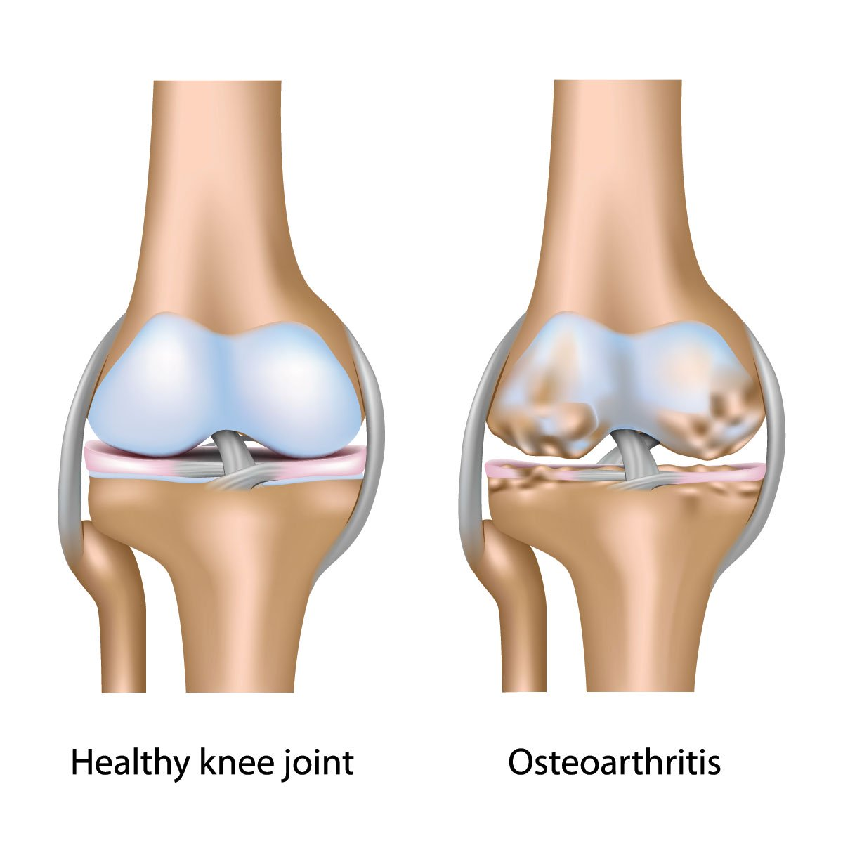
Fig. 4. Osteoarthritis of the Knee Joint
Osteoarthritis is a form of arthritis that features the breakdown and eventual loss of the cartilage of one or more joints. Cartilage is a protein substance that serves as a "cushion" between the bones of the joints (William et.al, 2020). It can be thought of as primarily a degenerative disorder with inflammatory components arising from the biochemical breakdown of articular (hyaline) cartilage in the synovial joints (Kotlarz et.al, 2009).

PATHOGENESIS OF OSTEOARTHRITIS
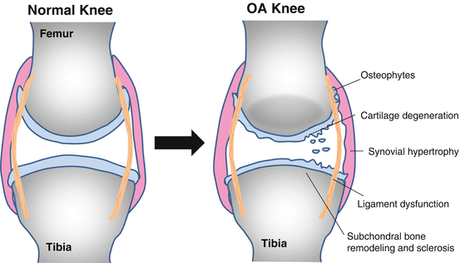
Fig.5. Pathogenesis of Osteoarthritis

In the past, osteoarthritis (OA) was considered to be simply a degenerative "wear and tear" process and therefore often misnamed as degenerative joint disease. However, the pathogenesis of OA is much more complex than just wear and tear and the term "osteoarthritis," where "-itis" is indicative of an inflammatory process, is indeed correct (Liu-Bryan and Terkeltaub, 2015). There are a variety of factors that play an important role in the pathogenesis of OA, including biomechanical factors, proinflammatory mediators, and proteases. By understanding the mechanisms driving joint tissue destruction in OA and identifying the key factors involved, new targets for therapy are emerging that will go beyond symptomatic relief to slowing or stopping the progression of OA (Huang et.al,2018).

PROGRESSION OF OSTEOARTHRITIS
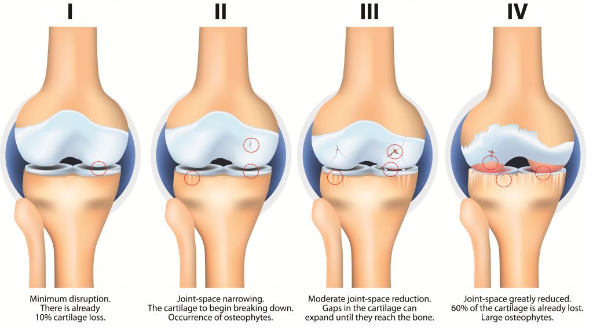
Fig.6. The Stages of Osteoarthritis as Demonstrated in the Knee Joint.

Once these lesions become significantly established and especially after a certain age, it will be difficult for the body to repair these lesions, osteoarthritis will then evolve to a worsening stage which means that there will be an increasingly greater loss of cartilage.
This loss of cartilage evolves in 3 clinical forms:
- a slow and progressive deterioration over several decades;
- or, conversely, a very rapid deterioration leading to loss of cartilage in 12 to 24 months (this is known as rapidly destructive osteoarthritis;
- or an intermediate form in which the evolution is punctuated by periods in which the osteoarthritis evolves very quickly and other periods, on the contrary, when the osteoarthritis does not evolve or evolves very little.
Osteoarthritis does not evolve uniformly, it is unpredictable. It can remain silent for a long time and not manifest itself even though the joint looks very damaged on the X-ray. But it can also worsen rapidly over several weeks or months at a stage when the X-rays are almost normal. It is this imbalance between pain and radiographic osteoarthritis which makes it difficult to understand and evaluate (Arthrolink, 2020).

T-Lymphocytes Involvement with the Pathogenesis and Progression of Osteoarthritis
Classically, inflammatory arthritis was defined in part based on cellular inflammation represented by increased numbers of leukocytes in the affected joint tissues and synovial fluid. Classic cellular inflammation is not prominent in osteoarthritis (OA), where the number of leukocytes in the joint fluid is normally low, and rarely exceeds 1000 to 2000 cells per milliliter (Sharma et.al, 2014). This is in contrast to forms of inflammatory arthritis, such as rheumatoid arthritis (RA), where the number of synovial fluid leukocytes will commonly exceed 2000 and will be accompanied by a more extensive synovial infiltrate of leukocytes with synovial fibroblast proliferation resulting in pannus formation Wood et.al, 2019). Synovial inflammation is also present in OA and in some individuals can be indistinguishable from RA. An important difference is that macrophages are the predominate leukocyte found in OA synovium, while in RA there are more T cells and B cells (Wood et.al, 2019). At the molecular level, OA is characterized by the presence of a host of proinflammatory mediators, including cytokines and chemokines, that are part of an innate immune response to joint injury (Liu-Bryan and Terkeltaub, 2015).
Proinflammatory factors appear to be driving the production of the proteolytic enzymes responsible for the degradation of the extracellular matrix that results in joint tissue destruction. Although destruction and loss of the articular cartilage is a central component of OA, all joint tissues are affected in some way, indicating that OA is a disease of the joint as an organ (Loeser et.al, 2012). Mechanical factors certainly play a key role in OA and there is some debate in the field as to the extent to which OA is mediated by abnormal joint mechanics. However, the balance of evidence suggests that rather than simply causing joint tissue damage by wear and tear, excessive or abnormal joint loading also stimulates joint tissue cells to produce proinflammatory factors and proteases that mediate joint tissue destruction (Sharma et.al, 2014).

The Role of B-Lympocytes in the Pathogenesis and Progression of Osteoarthritis
Ageing is a complex phenomenon. It affects cells and tissues, diminishes homeostasis and increases vulnerability. Many pathways have been shown to be involved in ageing and age-related diseases, including osteoarthritis (OA). In elders, infectious diseases are the primary cause of death, underpinning the role of the immune system. The acquired immune responses decline with age (increased susceptibility to infection, poor responses to vaccination, higher prevalence of cancers). In addition, there is intrinsic difficulty in dealing with common pathogens and a disproportionate inflammatory response. Paradoxically, this decline is accompanied by an increase in auto-reactivity (generation of autoantibodies) and chronic low-grade inflammation, which acts as predictor of mortality. Inflammatory response are so prevalent in driving tissue damage associated with age-related diseases that the term "Inflammageing" has been coined to explain the underlining inflammatory changes common to most age-associated diseases.
OA is a degenerative joint disease whose prevalence increases with age, and includes a group of pathologies involving structural degeneration of the joint resulting in pain and disability. Treatment is currently limited to the management of pain, exercise and lifestyle modification, and ultimately joint replacement surgery. There is evidence of OA in all individuals over the age of 60 but symptomatic OA, (disease that requires medical treatment), occurs in only 15%. The reasons why OA only becomes symptomatic in some people remain unexplained.
Recent magnetic resonance imaging studies have highlighted a very high frequency of pathology involving cartilage, bone and synovium (soft tissue lining of the joints), with relevance in structure-pain associations. Inflammation of the synovium (synovitis) is a well-recognised feature of OA, notably with an important role for interleukin-1beta (IL-1β). Many of the age-related defects of the immune system highlighted above are involved in the pathogenesis of OA. Furthermore, mechanical forces which produce cartilage damage breakdown products have been proposed as a source of immune stimulation, promoting persistent low-grade inflammation. Antigen-driven stimuli using collagen breakdown products as neo-antigens were suggested to lead to specific T/B-cell responses. Innate immune responses to calcium crystal deposition were shown to initiate IL-1β production.
The interactions between the musculoskeletal and the immune system are important sources of divergence between healthy people and patients with OA. We postulate that they can be used to better understand the pathology of OA by distinguishing ageing specific changes from those that are OA specific. We recently showed that the immune cell composition of the blood of OA patients is quite divergent from that of aged-matched controls notably with major changes in T-cells, loss of regulatory T-cells and alteration in the T to B-cell ratio. Synovitis has been proposed as niche for B-cell maturation and the production of auto-antibodies in OA. However, B-cell infiltration in OA is quite independent of T-cells and the presence of germinal centre like structures is rarely observed.

REFERENCE
Stephen .K. (2018). Ostheomyelitis: Medscape. 1994 2020.https://emedicine.medscape.com/article/1348767-overview.

William .C. (2018). Medical Defination of Osteomyelitis. MedicineNet. 19962020.https://www.medicinenet.com/hepatitis_pictures_slideshow/article.htm.

Luqmani, Raashid; Robb, James; Daniel, Porter; Benjamin, Joseph (2013). Orthopaedics, Trauma and Rheumatology (second ed.). Mosby. p. 96.ISBN 978-0723436805.

Kumar, Vinay; Abbas, Abul K.; Fausto, Nelson; & Mitchell, Richard N. (2007). Robbins Basic Pathology (8th ed.). Saunders Elsevier. pp. 810–11ISBN 978-1-4160-2973-1.

King MD, Randall W, Johnson D (2006-07-13)."Osteomyelitis". eMedicine. WebMD. Archivedfrom the original on 2007-11-09.
Ellington. "Microbial Pathogenesis" (1999).

Calhoun JH, Manring MM, Shirtliff M. 2009. Osteomyelitis of the long bones. Semin Plast Surg23:59–72. doi:10.1055/s-0029-1214158.

Oryan A, Alidadi S, Moshiri A, Maffulli N. 2014. Bone regenerative medicine: classic options, novel strategies, and future directions. J Orthop Surg Res 9:18. doi:10.1186/1749-799X-9-18.

Lima AL, Oliveira PR, Carvalho VC, Cimerman S, Savio E. 2014. Recommendations for the treatment of osteomyelitis. Braz J Infect Dis 18:526–534. doi:10.1016/j.bjid.2013.12.005.

Pasquet J, Chevalier Y, Couval E, Bouvier D, Bolzinger MA. 2015. Zinc oxide as a new antimicrobial preservative of topical products: interactions with common formulation ingredients. Int J Pharm 479:88–95. doi:10.1016/j.ijpharm.2014.12.031.
Merritt K. 1988. Factors increasing the risk of infection in patients with open fractures. J Trauma 28:823–827.doi:10.1097/00005373-198806000-00018.
Berendt AR, Peters EJ, Bakker K, Embil JM, Eneroth M, Hinchliffe RJ, Jeffcoate WJ, Lipsky BA, Senneville E, Teh J, Valk GD.2008. Diabetic foot osteomyelitis: a progress report on diagnosis and a systematic review of treatment. Diabetes Metab Res Rev 24(Suppl 1):S145–S161. doi:10.1002/dmrr.836.

Grayson ML,Gibbons GW, Balogh K, Levin E, Karchmer AW. 1995. Probing to bone in infected pedal ulcers. A clinical sign of underlying osteomyelitis in diabetic patients. JAMA 273:721–723.

Vigorita VJ, Ghelman B, Mintz D. 2007. Orthopaedic pathology, 2nd ed. Lippincott Williams & Wilkins, Philadelphia, PA.

Healy B, Freedman A. 2006. Infections. BMJ 332:838–841. doi:10.1136/bmj.332.7545.838

Kumar V, Abbas A, Fausto N, Mitchell R. 2012. Robbins basic pathology, 9th ed. Elsevier Health Sciences, Philadelphia, PA.

Dimitra Kotsougiani et al. (2010). Activation of T Lymphocytes in Response to Persistent Bacterial Infection: Induction of CD11b and of Toll-Like Receptors on T Cells. International Journal of Inflammation. Volume 2010. Article ID 526740. Pg. 2. https://doi.org/10.4061/2010/52674.

P. Wong and E. G. Pamer, “CD8 T cell responses to infectious pathogens,”Annual Review of Immunology, vol. 21, pp. 29–70, 2003.

C. Wagner, D. Heck, K. Lautenschläger et al., “T lymphocytes in implant-associated posttraumatic osteomyelitis: identification of cytotoxic T effector cells at the site of infection,” Shock, vol. 25, no. 3, pp. 241–246, 2006.

R. M. Donlan and J. W. Costerton, “Biofilms: survival mechanisms of clinically relevant microorganisms,” Clinical Microbiology Reviews, vol. 15, no. 2, pp. 167–193, 2002.

W. Costerton, R. Veeh, M. Shirtliff, M. Pasmore, C. Post, and G. Ehrlich, “The application of biofilm science to the study and control of chronic bacterial infections,” Journal of Clinical Investigation, vol. 112, no. 10, pp. 1466–1477, 2003.

J. Jesaitis, M. J. Franklin, D. Berglund et al., “Compromised host defense on Pseudomonas aerugionsa biofilms: characterisation of neutrophil and biofilm interactions,” Journal of Immunology, vol. 171, pp. 4329–4339, 2002.

D. Kabelitz, “Expression and function of Toll-like receptors on T lymphocytes,” Current Opinion in Immunology, vol. 19, pp. 39–45, 2007.
T. Imanishi, H. Hara, S. Suzuki, N. Suzuki, S. Akira, and T. Saito, “Cutting edge: TLR2 directly triggers Th1 effector functions,” Journal of Immunology, vol. 178, no. 11, pp. 6715–6719, 2007.

Nicola K. et.al.(2020). Staphylococcal Osteomyelitis: Disease Progression, Treatment Challenges, and Future Directions. American Society For Microbiology: Clinical Microbiology Reviews. ISSN: 1098-6618. DOI: 10.1128/CMR.00084-17.

William C. and Shiel Jr (2020). Osteoarthritis (OA or Degenerative Arthritis). MedicineNet.
2Kotlarz H, Gunnarsson CL, Fang H, Rizzo JA. Insurer and out-of-pocket costs of osteoarthritis in the US: evidence from national survey data. Arthritis Rheum. 2009 Dec. 60 (12):3546-53.

F Ponchel, AN Burska, EA Hensor R Raja, M Campbell, P Emery, PG Conaghan. Changes in peripheral blood immune cell composition in osteoarthritis. Osteoarthritis and Cartilage, in press, doi: 10.1016/j.joca.2015.06.018.

SAVIC S, L OUBOUSSAD, LJ. DICKIE, J GEILER, C WONG, GM. DOODY, SM.CHURCHMAN, F PONCHEL, P EMERY, GP. COOK, MH. BUCH, RM. TOOZE, MF. MCDERMOTT. TLR dependent XBP-1 activation induces an autocrine loop in rheumatoid arthritis synoviocytes. Journal of autoimmunity 2013, 50:59–66.

2020.How Does Ostroarthritis Evovle. Arthrolink.com. https://www.arthrolink.com/en/disease/knowing/evolution-osteoarthritis.

Liu-Bryan R, Terkeltaub, Nat Rev Rheumatol. (2015). Emerging regulators of the inflammatory process in osteoarthritis. PubMed. Jan;11(1):35-44. Epub 2014 Sep 30.

Huang Z, Ding C, Li T, Yu SP. (2018). Current status and future prospects for disease modification in osteoarthritis. Rheumatology (Oxford).;57(suppl_4):iv108.

Wood MJ, Leckenby A, Reynolds G, et al. Macrophage proliferation distinguishes 2 subgroups of knee osteoarthritis patients. JCI Insight 2019; 4.

Loeser RF, Goldring SR, Scanzello CR, Goldring MB. Osteoarthritis: a disease of the joint as an organ. Arthritis Rheum 2012; 64:1697.

Richard F. Loeser, (2020). Pathogenesis of Oateoarthritis. UpToDate. https://www.uptodate.com/contents/pathogenesis-of-osteoarthritis - subscribeMessage.

