NAME: FATAI-OSO AYODEJI
DEPT: PETROLEUM ENG
MATRIC NO: 15/ENG07/021
1.0 Steam Assisted Gravity Drainage (SAGD)
The SAGD process of heavy oil or bitumen production is an enhancement on the steam injection techniques originally developed to produce heavy oil from the Kern River Oil Field of California. The key to all steam flooding processes is to deliver heat to the producing formation to reduce the viscosity of the heavy oil and enable it to move toward the producing well. The cyclic steam stimulation (CSS) process developed for the California heavy oil fields was able to produce oil from some portions of the Alberta oil sands, such as the Cold Lake oil sands, but did not work as well to produce bitumen from heavier and deeper deposits in the Athabasca oil sands and Peace River oil sands, where the majority of Alberta's oil sands reserves lie. To produce these much larger reserves, the SAGD process was developed, primarily by Dr. Roger Butlerof Imperial Oil with the assistance of the Alberta Oil Sands Technology and Research Authority and industry partners. The SAGD process is estimated by the National Energy Board to be economic when oil prices are at least US$30 to $35 per barrel.

In the SAGD process, two parallel horizontal oil wells are drilled in the formation, one about 4 to 6 metres above the other. The upper well injects steam, and the lower one collects the heated crude oil or bitumen that flows down due to gravity, plus recovered water from the condensation of the injected steam. The basis of the SAGD process is that thermal communication is established with the reservoir so that the injected steam forms a "steam chamber". The heat from the steam reduces the viscosity of the heavy crude oil or bitumen which allows it to flow down into the lower wellbore. The steam and associated gas rise because of their low density compared to the heavy crude oil below, ensuring that steam is not produced at the lower production well, tend to rise in the steam chamber, filling the void space left by the oil. Associated gas forms, to a certain extent, an insulating heat blanket above (and around) the steam. Oil and water flow is by a countercurrent, gravity driven drainage into the lower well bore. The condensed water and crude oil or bitumen is recovered to the surface by pumps such as progressive cavity pumps that work well for moving high-viscosity fluids with suspended solids.

Sub-cool is the difference between the saturation temperature (boiling point) of water at the producer pressure and the actual temperature at the same place where the pressure is measured. The higher the liquid level above the producer the lower the temperature and higher is the sub-cool. However real life reservoirs are invariably heterogeneous therefore it becomes extremely difficult to achieve a uniform sub-cool along the entire horizontal length of a well. As a consequence many operators, when faced with uneven stunted steam chamber development, allow a small quantity of steam to enter into the producer to keep the bitumen in the entire wellbore hot hence keeping its viscosity low with the added benefit of transferring heat to colder parts of the reservoir along the wellbore. Another variation sometimes called Partial SAGD is used when operators deliberately circulate steam in the producer following a long shut-in period or as a startup procedure. Though a high value of sub-cool is desirable from a thermal efficiency standpoint as it generally includes reduction of steam injection rates but it also results in slightly reduced production due to a corresponding higher viscosity and lower mobility of bitumen caused by lower temperature. Another drawback of very high sub-cool is the possibility of steam pressure eventually not being enough to sustain steam chamber development above the injector, sometimes resulting in collapsed steam chambers where condensed steam floods the injector and precludes further development of the chamber.

Continuous operation of the injection and production wells at approximately reservoir pressure eliminates the instability problems that plague all high-pressure and cyclic steam processes and SAGD produces a smooth, even production that can be as high as 70% to 80% of oil in place in suitable reservoirs. The process is relatively insensitive to shale streaks and other vertical barriers to steam and fluid flow because, as the rock is heated, differential thermal expansion allows steam and fluids to gravity flow through to the production well. This allows recovery rates of 60% to 70% of oil in place, even in formations with many thin shale barriers. Thermally, SAGD is generally twice as efficient as the older cyclic steam stimulation (CSS) process, and it results in far fewer wells being damaged by the high pressures associated with CSS. Combined with the higher oil recovery rates achieved, this means that SAGD is much more economic than cyclic steam processes where the reservoir is reasonably thick.
This technology is now being exploited due to increased oil prices. While traditional drilling methods were prevalent up until the 1990s, high crude prices of the 21st Century are encouraging more unconventional methods (such as SAGD) to extract crude oil. The Canadian oil sands have many SAGD projects in progress, since this region is home of one of the largest deposits of bitumen in the world (Canada and Venezuela have the world's largest deposits).
The SAGD process allowed the Alberta Energy Resources Conservation Board (ERCB) to increase its proven oil reserves to 179 billion barrels, which raised Canada's oil reserves to the third highest in the world after Venezuela and Saudi Arabia and approximately quadrupled North American oil reserves. As of 2011, the oil sands reserves stand at around 169 billion barrels.
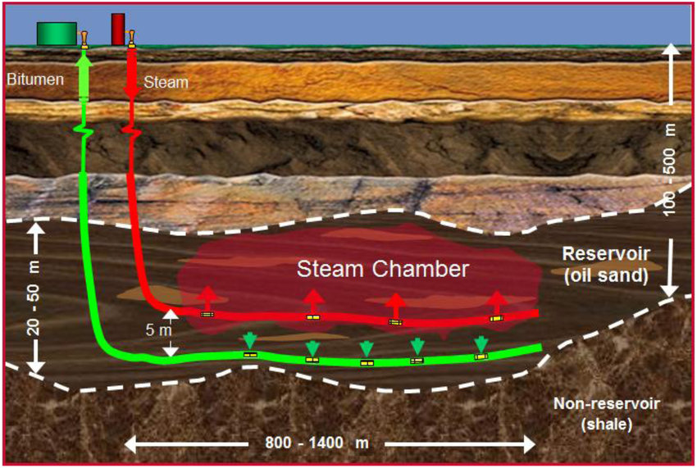
Figure 1.0: A typical steam assisted gravity drainage

Use of natural gas for steam generation
As in all thermal recovery processes, cost of steam generation is a major part of the cost of oil production. Historically, natural gas has been used as a fuel for Canadian oil sands projects, due to the presence of large stranded gas reserves in the oil sands area. However, with the building of natural gas pipelines to outside markets in Canada and the United States, the price of gas has become an important consideration. The fact that natural gas production in Canada has peaked and is now declining is also a problem. Other sources of generating heat are under consideration, notably gasification of the heavy fractions of the produced bitumen to produce syngas, using the nearby (and massive) deposits of coal, or even building nuclear reactors to produce the heat.

Use of water for steam generation
A source of large amounts of fresh and brackish water and large water re-cycling facilities are required in order to create the steam for the SAGD process. Water is a popular topic for debate in regards to water use and management. As of 2008, American petroleum production (not limited to SAGD) generates over 5 billion gallons of produced water every day. The concern of using large amounts of water has little to do with proportion of water used, rather the quality of the water. Traditionally close to 70 million cubic metres of the water volume that was used in the SAGD process was fresh, surface, water. There has been a significant reduction in fresh water use as of 2010, when approximately 18 million cubic metres were used. Though to offset the drastic reduction in fresh water use, industry has begun to significantly increase the volume of saline groundwater involved. This, as well as other, more general water saving techniques have allowed surface water usage by oil sands operations to decrease by more than threefold since production first began. Relying upon gravity drainage, SAGD also requires comparatively thick and homogeneous reservoirs, and so is not suitable for all heavy-oil production areas.

2.0 Cyclic Steam Stimulation (CSS)
The cyclic steam stimulation (CSS) method, also known as “huff-and-puff” or “steam soak,” consists of three stages:
- injection
- soaking
- production
In the initial stage, steam is injected into a well at a relatively high injection rate for approximately 1 month. At the end of the injection period, the well is shut in for a few days (approximately 5 days) to allow “steam soaking” to heat the oil in the area immediately around the wellbore. The well is then put on production until it reaches the economic flow rate and at this point, the entire cycle is repeated. The steam injection and soak may be repeated four to five times or until the response to stimulation diminishes to noneconomic level. In general, the process can be quite effective, especially in the first few cycles. Stimulating the well by the huff-and-puff process significantly improves oil rate by three means:
- Removing accumulated asphaltic and/or paraffinic deposits around the wellbore, resulting in an improvement of the permeability around the wellbore (i.e., favorable skin factor).
- Radically decreasing the oil viscosity, which in turn improves oil mobility and well productivity.
- Increasing the thermal expansion of the oil, which impacts the oil saturation and its relative permeability.
Many initial applications result in production increases considerably greater than those predicted by model studies. This is mainly due to well cleanup and permeability improvement around the wellbore. The improvement in the production rate associated with the decrease in oil viscosity and the removal of deposits can be approximated by applying the following simplified assumptions:
- Reservoir has been heated out to a radius “r_{hot}” to a uniform temperature.
- The heated oil viscosity out to radius “r_{hot}” is represented by (µ_{o})_{hot} as compared with original oil viscosity of (µ₀)_{cold}.
- Improved skin factor of S_{hot} as compared with original skin factor of S_{cold}.
This technology requires one well bore and the production consists of the injection to fracture and heat the formation prior to the production phases. First steam is injected above the formation fracture point for several weeks or months, mobilizing cold bitumen, the well is then shut in for several weeks or months to allow the steam to soak into the formation. Then the flow on the injection well is reversed producing oil through the same injection well bore. The injection and production phases together comprise one cycle. Steam is re-injected to begin a new cycle when oil production rates fall below a critical threshold due to the cooling of the reservoir. sCyclic Steam Stimulation (CSS) also has a number of CSS Follow-up or Enhancement Processes, including Pressure Up and Blow Down (PUBD), Mixed Well Steam Drive and Drainage (MWSDD), Vapor Extraction (Vapex), Liquid Addition to Steam for Enhanced Recovery of Bitumen (LASER) and HPCSS Assisted SAGD and Hybrid Process.
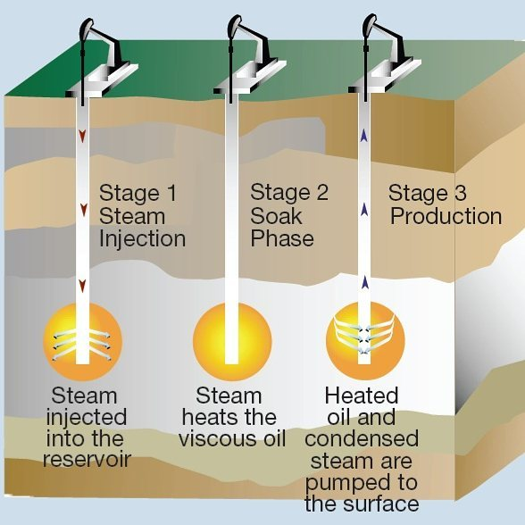
Figure 2.0: A typical cyclic steam injection process

3.0 Hot Water Flooding
Hot water-flooding is the most common thermal method of enhanced oil recovery used in the CIS. One reason for this is that the existing equipment for straight water-flooding can be used. Also, in practice, because the generators used for steam injection are not powerful enough, it is often only hot water that arrives at the well bottom: experiments on steam-flooding have demonstrated that the oil has actually been displaced by hot water. The choice of the water-flood parameters: the temperature of injected water, slug volume, injection rate, and starting time, is dictated by the specific geological and physical characteristics of the particular oilfield, after which a hydrodynamic estimate of the efficiency of hot water-flooding in comparison with other methods of enhanced oil recovery must be made. Hot water-flooding is particularly effective in the development of fields of high viscosity oils which contain large quantities of paraffins and resinous asphaltene substances, and which exhibit anomalous (non-Newtonian) properties as they flow through porous media.
The benefits of injecting water into the reservoir are:
- It supports the reservoir pressure, also known as voidage replacement.
- As oil is lighter than water hence it floats on top of the water. Also, the heat content of the water reduces the viscosity of heavy crude oil, making it not to stick on the edges of the reservoir and move quickly toward the producing well. Thus, water hel’[ps in displacing oil from its location in the reservoir and pushes it toward the producing well.
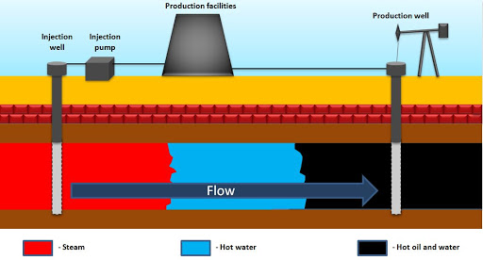
Figure 3.0: A typical Hot water flooding process

