Name: Raji Mubarak Akanji
Dept: Industrial Chemistry
Course: CHM 240.
Date:11/04/2020
ASSIGNMENT FOR CHM 240.
1.The price of crude has dropped to levels that we have not seen in a generation. The driver for this has been the disagreement between Russia and Saudi Arabia about decreasing production by 1.5 million barrels per day and instead increasing production by about 2 million barrels per day.
The global demand for oil until recently was about 100 million barrels per day. After nearly five years of oversupply, supply had finally come into close agreement with demand. COVID-19 is adding another, and by most accounts a more serious complication, and one that will last longer.
The impact of COVID-19 has been vastly underestimated by agencies such as the International Energy Agency. They had recently suggested that demand might drop by 90,000 barrels per day; that compares to a prediction in December 2019 that demand would go up by 900,000 barrels per day.
A recent estimate by IHS Markit suggests that we might be in for a bigger shock. They predict that gasoline consumption in the US will drop by 55% for March and April due to COVID-19. They also indicated that jet fuel demand would be halved over the same period. Lastly, they suggest that diesel demand would be down by 20%.
What does this mean? In 2019, the US consumed 20.5 million barrels of crude oil per day. How was that crude oil consumed? On average, 45% of each barrel goes towards making gasoline; 25% towards diesel; 9% towards jet fuel and kerosene. The remaining 21% goes to heating oil, residual fuel, feedstock for plastics manufacturing and other products including paints, resins, etc. If the IHS numbers are correct, then COVID-19 would result in US demand for crude oil dropping to 12.5 million barrels per day. That’s a drop of a whopping 8 million barrels per day of crude oil, or 8% of global crude production.
2. Yes, Nigerians should be awaiting a problem after covid-19 as a result of not diversifying the economy. The problems that will arise are,

AGGREGATE DEMAND WILL FALL, BUT GOVERNMENT EXPENDITURE WILL RISE
In Nigeria, efforts were already being made to bolster aggregate demand through increased government spending and tax cuts for businesses. The public budget increased from 8.83 trillion naira ($24.53 billion) in 2019 to 10.59 trillion naira ($29.42 billion) in 2020, representing 11 percent of the national GDP, while small businesses have been exempted from company income tax, and the tax rate for medium-sized businesses has been revised downwards from 30 to 20 percent. Unfortunately, the COVID-19 crisis is causing all components of aggregate demand, except for government purchases, to fall (Figure 1).
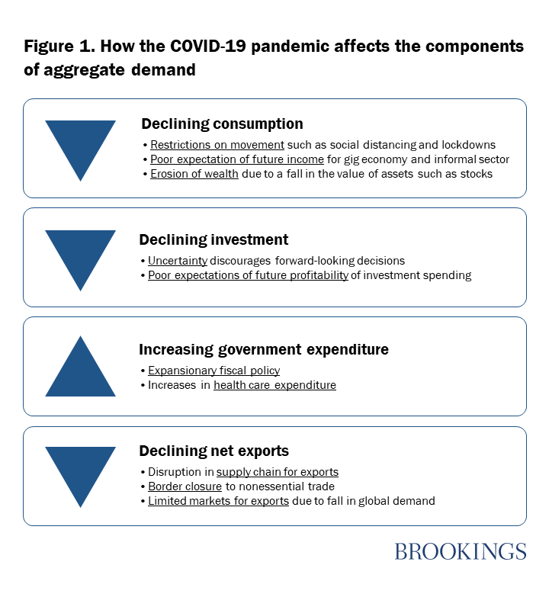
The fall in household consumption in Nigeria will stem from 1) partial (or full) restrictions on movement, thus causing consumers to spend primarily on essential goods and services; 2) low expectations of future income, particularly by workers in the gig economy that are engaged on a short-term/contract basis, as well as the working poor in the informal economy; and 3) the erosion of wealth and expected wealth as a result of the decline in assets such as stocks and home equity. The federal government has imposed a lockdown in Lagos and Ogun states as well as Abuja (which have the highest number of coronavirus cases combined). Subnational governments have quickly followed suit by imposing lockdowns in their states. Nigeria has a burgeoning gig economy as well as a large informal sector, which contributes 65 percent of its economic output. Movement restrictions have not only reduced the consumption of nonessential commodities in general, but have affected the income-generating capacity of these groups, thus reducing their consumption expenditure.
Investments by firms will be impeded largely due to the uncertainties that come with the pandemic-limited knowledge about the duration of the outbreak, the effectiveness of policy measures, and the reaction of economic agents to these measures—as well as negative investor sentiments, which are causing turbulence in capital markets around the world. Indeed, the crisis has led to a massive decline in stock prices, as the Nigerian Stock Exchange records its worst performance since the 2008 financial crisis, which has eroded the wealth of investors. Taking into consideration the uncertainty that is associated with the pandemic and the negative profit outlook on possible investment projects, firms are likely to hold off on long-term investment decisions.

3. Given the size and scope of the economic impact of the pandemic, there is the need to implement other recovery strategies to stimulate demand. Thus, we recommend the following fiscal and monetary policy measures: Although there is a cash transfer program in place, the federal government should improve efforts towards enhancing the efficiency and effectiveness of the distributive mechanisms to reach households that are worst-hit by the pandemic.
- The Federal Inland Revenue Service (FIRS) as well as State Inland Revenue Services (SIRS) should waive payments on personal and corporate income tax for the second quarter of 2020, considering that the shock has affected the income and profits of households and businesses.
- The CBN’s decision to increase the cash reserve ratio (CRR) from 22.5 percent to 27.5 percent in January 2020 should be revisited to provide liquidity for banks so that banks can, in turn, create credit to the private sector.
- FIRS and SIRS should delay tax collection for the worse-hit sectors including tourism, the airline industry, and hoteliers in order to enable them recover from the steep decline in demand.
- To provide additional liquidity in the forex market, the CBN should establish a swap facility with the U.S. Federal Reserve and/or the People’s Bank of China, as was done in 2018, to provide dollar and yen liquidity to financial institutions, investors, and exporters. This move would ease up forex shortage in the financial market and economy.
- While the naira has been adjusted as a result of the forex shortage, it is important that the CBN maintains exchange rate stability by deploying external reserves in order to avoid investors selling off naira-denominated assets.

