NAME: NWAGWUAGWU TOCHUKWU DAISY
MATRIC NUMBER: 17/ENG04/043
DEPARTMENT: ELECTRICAL ELECTRONICS ENGINEERING
COURSE CODE: EEE 326
COURSE TITLE: ELECTRICAL MACHINES
TUTORIAL ASSIGNMENT

QUESTION ONE
(a) The limitation of a single phase induction motor is that it is not self-starting.
(b) When the stator of a single phase motor is fed with a single phase power supply it produces an alternating flux in the stator winding. The alternating current flowing through the stator winding causes an induced current in the rotor bars according to faradays law of electromagnetic induction. This induced current in the rotor will also produce an alternating flux, however, even after the alternating flux are set up the motor fails to start. According to double field revolving theory, we can resolve any alternating quantity into two components. Each component has a magnitude equal to the half of the maximum magnitude of the alternating quantity, and both these components rotate in the opposite direction to each other. For example – a flux, φ can be resolved into two components
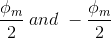
Each of these components rotates in the opposite direction i. e if one φ_{m}/2 is rotating in a clockwise direction then the other φ_{m} / 2 rotates in an anticlockwise direction.
When we apply a single phase AC supply to the stator winding of single phase induction motor, it produces its flux of magnitude, φ_{m}. According to the double field revolving theory, this alternating flux, φ_{m} is divided into two components of magnitude φ_{m}/2. Each of these components will rotate in the opposite direction, with the synchronous speed, N_{s}.
Let us call these two components of flux as forwarding component of flux, φ_{f} and the backward component of flux, φ_{b}. The resultant of these two components of flux at any instant of time gives the value of instantaneous stator flux at that particular instant.

(c) The constructional features:
- The Stator
- The Rotor
- The Stator windings
- Rotor windings / conductor
- The bearing – Bail or roller bearing
- The terminal box
- Fans

Stator of Single Phase Induction Motor
- The stator of the single-phase induction motor has laminated stamping to reduce eddy current losses on its periphery. The slots are provided on its stamping to carry stator or main winding. Stampings are made up of silicon steel to reduce the hysteresis losses. When we apply a single phase AC supply to the stator winding, the magnetic field gets produced, and the motor rotates at speed slightly less than the synchronous speed N_{s}. Synchronous speed N_{s} is given by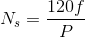
Where,
f = supply voltage frequency,
P = No. of poles of the motor.

The construction of the stator of the single-phase induction motor is similar to that of three phase induction motor except there are two dissimilarities in the winding part of the single phase induction motor.
- Firstly, the single-phase induction motors are mostly provided with concentric coils. We can easily adjust the number of turns per coil can with the help of concentric coils. The mmf distribution is almost sinusoidal.
- Except for shaded pole motor, the asynchronous motor has two stator windings namely the main winding and the auxiliary winding. These two windings are placed in space quadrature to each other.

Rotor of Single Phase Induction Motor
The construction of the rotor of the single-phase induction motor is similar to the squirrel cage three-phase induction motor. The rotor is cylindrical and has slots all over its periphery. The slots are not made parallel to each other but are a little bit skewed as the skewing prevents magnetic locking of stator and rotor teeth and makes the working of induction motor more smooth and quieter (i.e. less noisy).
The squirrel cage rotor consists of aluminum, brass or copper bars. These aluminum or copper bars are called rotor conductors and placed in the slots on the periphery of the rotor. The copper or aluminum rings permanently short the rotor conductors called the end rings.
To provide mechanical strength, these rotor conductors are braced to the end ring and hence form a complete closed circuit resembling a cage and hence got its name as squirrel cage induction motor. As end rings permanently short the bars, the rotor electrical resistance is very small and it is not possible to add external resistance as the bars get permanently shorted. The absence of slip ring and brushes make the construction of single phase induction motor very simple and robust.

Working Principle of Single Phase Induction Motor

Starting Principle
A single phase induction motor consists of a single phase winding on the stator and a cage winding on the rotor. When a 1 phase supply is connected to the stator winding, a pulsating magnetic field is produced. In the pulsating field, the rotor does not rotate due to inertia. Therefore a single phase induction motor is not self-starting and requires some particular starting means. Two theories have been suggested to find the performance of a single phase induction motor.
- Double revolving field theory.
- Cross-field theory.

Double revolving field theory
This theory for single phase states that a stationary pulsating magnetic field can be resolved into two RMF, each of equal magnitude but rotating in the opposite direction.
The induction machine responds to each magnetic field separately, and the net torque in the motor is equal to some of the torque due to each of the two magnetic fields.
The equation for an alternating magnetic field whose axis is fixed in space is given by:
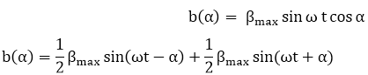
β_{max} is the maximum value of sinusoidally distributed air gap flux density. 'B' represents the equation of revolving field moving in the positive α direction, and 'A' represent equation of revolving field moving in a positive direction. The field moving in the positive α direction is called the forward rotating field and in negative α direction is called the backward rotating field.
It is therefore concluded that a stationary pulsating magnetic field can be resolved due to two rotating magnetic fields both of equal magnitude and moving at synchronous speed in the opposite direction at the same frequency as the stationary magnetic field.
The theory based on such a resolution of an alternating field into two counter-rotating fields is called the Double revolving field theory of single phase induction machine.
(d) 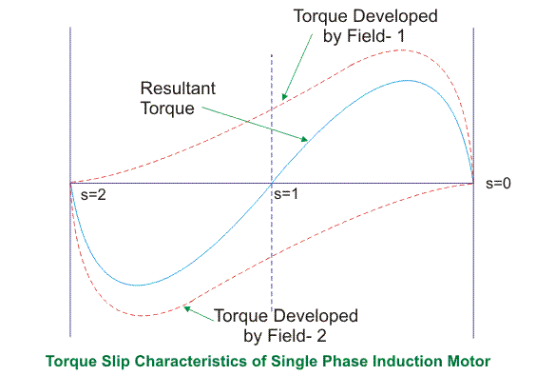
From the figure, we see that at a slip of unity, both forward and backward field develops equal torque but the direction of which are opposite to each other so the net torque produced is zero hence the motor fails to start. From here we can say that these motors are not self-starting unlike the case of three phase induction motor. There must be some means to provide the starting torque. If by some means, we can increase the forward speed of the machine due to which the forward slip decreases the forward torque will increase and the reverse torque will decrease as a result of which motor will start.
From here we can conclude that for starting of single phase induction motor, there should be a production of difference of torque between the forward and backward field. If the forward field torque is larger than the backward field than the motor rotates in forward or anti clockwise direction. If the torque due to backward field is larger compared to other, then the motor rotates in backward or clockwise direction. They are not self-starting because in induction machine a rotating magnetic field is required to produce torque. A rotating magnetic field can produced if we have balanced three phase supply and each phase is electrically spaced 120 to each other OR we have required minimum two phase but in single phase induction motor there is single phase supply to the stator of motor. A single phase supply cannot produce a rotating magnetic field but it produce a pulsating magnetic field which does not rotate. Due to this pulsating magnetic field torque cannot produce so motor is not self-start.
(e) Five types
- Resistance start motor or Split phase motor
- Capacitor start motor
- Permanent capacitor or Single value capacitor motor
- Capacitor start capacitor run motor
- Shaded pole motor

Split Phase Induction Motor
The Split Phase Motor is also known as a Resistance Start Motor. It has a single cage rotor, and its stator has two windings known as main winding and starting winding. Both the windings are displaced 90 degrees in space. The main winding has very low resistance and a high inductive reactance whereas the starting winding has high resistance and low inductive reactance.The Connection Diagram of the motor is shown below.
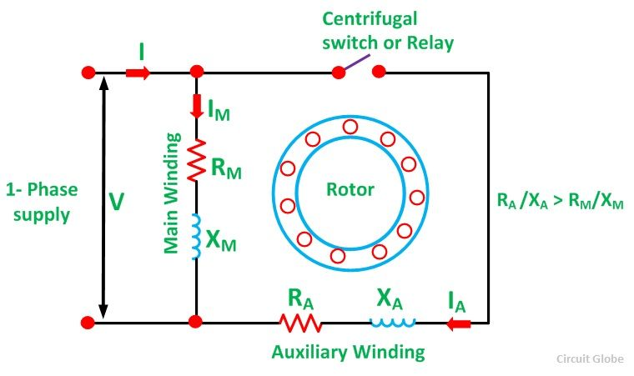A resistor is connected in series with the auxiliary winding. The current in the two windings is not equal as a result the rotating field is not uniform. Hence, the starting torque is small, of the order of 1.5 to 2 times of the started running torque. At the starting of the motor both the windings are connected in parallel.
As soon as the motor reaches the speed of about 70 to 80 % of the synchronous speed the starting winding is disconnected automatically from the supply mains. If the motors are rated about 100 Watt or more, a centrifugal switch is used to disconnect the starting winding and for the smaller rating motors relay is used for the disconnecting of the winding.
A relay is connected in series with the main winding. At the starting, the heavy current flows in the circuit, and the contact of the relay gets closed. Thus, the starting winding is in the circuit, and as the motor attains the predetermined speed, the current in the relay starts decreasing. Therefore, the relay opens and disconnects the auxiliary winding from the supply, making the motor runs on the main winding only.
The phasor diagram of the Split Phase Induction Motor is shown below.
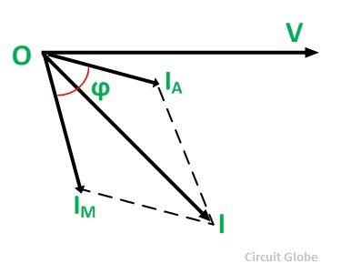The current in the main winding (I_{M}) lag behind the supply voltage V almost by the 90-degree angle. The current in the auxiliary winding I_{A} is approximately in phase with the line voltage. Thus, there exists the time difference between the currents of the two windings. The time phase difference ϕ is not 90 degrees, but of the order of 30 degrees. This phase difference is enough to produce a rotating magnetic field.

Capacitor Start Capacitor Run Motor
The Capacitor Start Capacitor Run Motor has a cage rotor, and its stator has two windings known as Main and Auxiliary Windings. The two windings are displaced 90 degrees in space. There are two capacitors in this method one is used at the time of the starting and is known as starting capacitor. The other one is used for continuous running of the motor and is known as RUN capacitor.
So this motor is named as Capacitor Start Capacitor Run Motor. This motor is also known as Two Value Capacitor Motor. Connection diagram of the Two valve Capacitor Motor is shown below
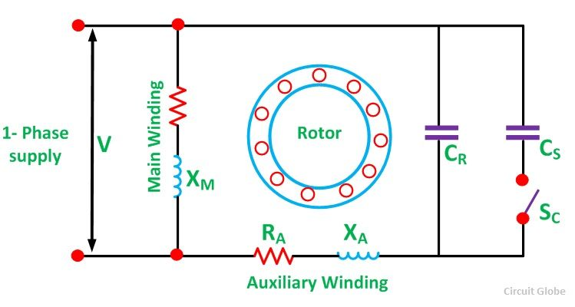There are two capacitors in this motor represented by C_{S} and C_{R}. At the starting, the two capacitors are connected in parallel. The Capacitor Cs is the Starting capacitor is short time rated. It is almost electrolytic. A large amount of current id required to obtain the starting torque. Therefore, the value of the capacitive reactance X should be low in the starting winding. Since, X_{A} = 1/2πfC_{A}, the value of the starting capacitor should be large.
The rated line current is smaller than the starting current at the normal operating condition of the motor. Hence, the value of the capacitive reactance should be large. Since, X_{R} = 1/2πfC_{R,} the value of the run capacitor should be small
As the motor reaches the synchronous speed, the starting capacitor Cs is disconnected from the circuit by a centrifugal switch Sc. The capacitor C_{R} is connected permanently in the circuit and thus it is known as RUN Capacitor. The run capacitor is long time rated and is made of oil filled paper.
The figure below shows the Phasor Diagram of the Capacitor Start Capacitor Run Motor.
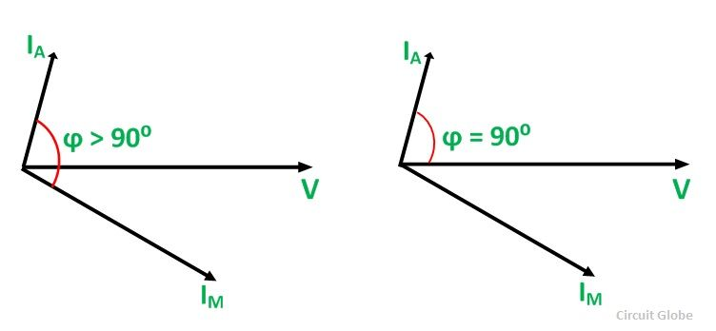
Fig(a) shows the phasor diagram when at the starting both the capacitor are in the circuit and ϕ > 90⁰. Fig (b) shows the phasor when the starting capacitor is disconnected, and ϕ becomes equal to 90⁰.

(f) 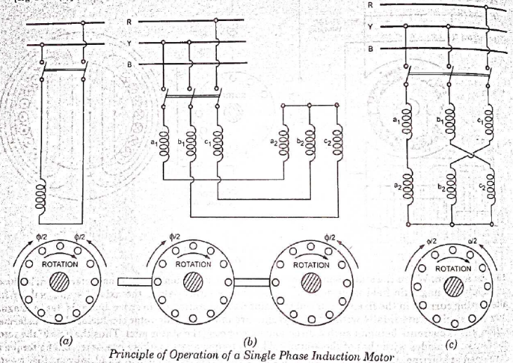
Under stationary rotor conditions (i.e, when speed N = 0 or slip s = 1), the two rotating fields slip pass the rotor at the same slip, s = 1 and inducing equal currents in the squirrel cage rotor. The two rotating fields are of the same strength and develop equal and opposite electro-magnetic torques resulting in net torque of zero value. Thus the starting torque is zero and the single phase induction motor is non- self-starting. Further, the two rotating fields induce a resultant EMF in the stator which balances the applied voltage assuming low leakage impedance of the stator winding.
QUESTION TWO
(a) This is a type of electric motor that operates on DC or AC power and uses an electromagnetic as its stator to create its magnetic field .
APPLICATIONS
- Grinders
- Hair dryers
- Drills
- Blowers
- Kitchen appliances
(b) Construction of a universal motor is very similar to the construction of a DC machine. It consists of a stator on which field poles are mounted. Field coils are wound on the field poles.
However, the whole magnetic path (stator field circuit and also armature) is laminated. Lamination is necessary to minimize the eddy currents which induce while operating on AC.
The rotary armature is of wound type having straight or skewed slots and commutator with brushes resting on it. The commutation on AC is poorer than that for DC. because of the current induced in the armature coils. For that reason brushes used are having high resistance.
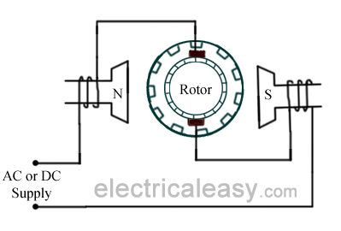
(c) ) there is no difference. A universal motor has its rotor and stator windings connected in series, and it can run on both AC and DC that is why it’s called universal, or sometimes a DC series motor. It is mostly used in home appliances, electric tools and so on. Because it has a high speed. The universal motor is very similar to a DC series motor in construction, but is modified slightly to allow the motor to operate properly on AC power.

QUESTION THREE
(a) 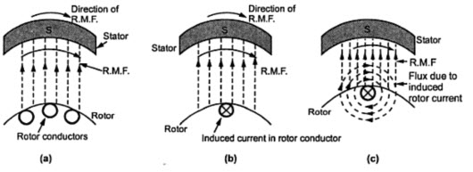
- When the motor is excited with three-phase supply,three-phase stator winding produce a rotating magnetic field with 120 displacements at constant magnitude which rotates at synchronous speed. This changing magnetic field cuts the rotor conductors and induces a current in them according to the principle of Faraday’s laws of electromagnetic induction. As these rotor conductors are shorted, the current starts to flow through these conductors.
- In the presence of magnetic field of stator, rotor conductors are placed, and therefore, according to the Lorenz force principle, a mechanical force acts on the rotor conductor. Thus, all the rotor conductors force, i.e., the sum of the mechanical forces produces torque in the rotor which tends to move it in the same direction of rotating magnetic field.
- This rotor conductor’s rotation can also be explained by Lenz’s law which tells that the induced currents in the rotor oppose the cause for its production, here this opposition is rotating magnetic field. This result the rotor starts rotating in the same direction of the stator rotating magnetic field. If the rotor speed more than stator speed,then no current will induce in the rotor because the reason for rotor rotation is the relative speed of the rotor and stator magnetic fields. This stator and the rotor fields difference is called as slip. This how 3-phase motor is called as asynchronous machine due to this relative speed difference between the stator and the rotors.
- As we discussed above, the relative speed between the stator field and the rotor conductors causes to rotate the rotor in a particular direction. Hence, for producing the rotation, the rotor speed Nr must always be less than the stator field speed Ns, and the difference between these two parameters depends on the load on the motor.
The difference of speed or the slip of the AC induction motor is given as
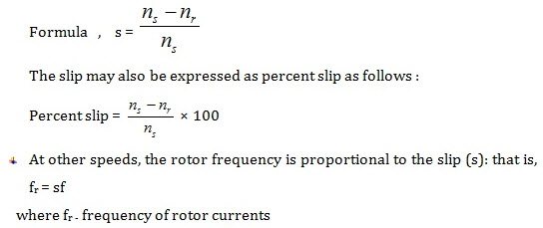
- When the stator is stationary, Nr=0; so the slip becomes 1 or 100%.
- When Nr is at synchronous speed, the slip becomes zero; so the motor never runs at synchronous speed.
- The slip in the 3 phase induction motor from no load to full load is about 0.1% to 3%; that’s why the induction motors are called as constant-speed motors.
(b) ADVANTAGES
- They have very simple and rugged (almost unbreakable) construction
- they are very reliable and having low cost
- they have high efficiency and good power factor
- minimum maintenance required
- 3 phase induction motor is self starting hence extra starting motor or any special starting arrangement is not required
- 3 phase induction motors will have self starting torque unlike synchronous motors, hence no starting methods are employed unlike synchronous motor. However, single-phase induction motors does not have self starting torque, and are made to rotate using some auxiliaries.
DISADVANTAGES
- At heavy load it draws high initial starting current
- Three phase induction motor speed difficult as compare to dc machine
- It operates lagging power factor which result to increase I²R losses

(c) Ro1= R1+R’2
Ro1= 0.06+0.06 = 0.12

Xo2 = X1+X’2
Xo2= 0.22+0.2= 0.42

Zo1= sqrt((Ro1^2)+(Xo1^2))
Zo1= 0.44
Slip corresponding to maximum gross power is= R’2/(R’2+Zo1)
S= 0.06/ (0.06+0.44)
S= 0.12 OR 12%
Voltage phase = Vline/sqrt (3)
Vphase = 400/sqrt (3)
Vphase = 230
Gross power output= 3(V1)^2/2(Ro1+Zo1)
Pgmax= 3(230)^2/2(0.12+0.44)
Pgmax= 141696.4= 141.7KW
(d) 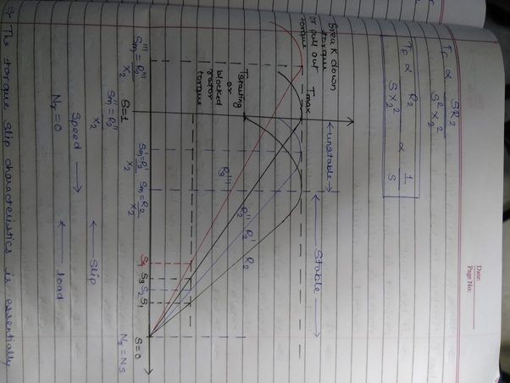
As the induction motor is located from no load to full load, its speed decreases hence slip increases. Due to the increased. load, motor has to produce more torque to satisfy load demand. The torque ultimately depends on slip as explained earlier. The behaviour of motor can be easily judged by sketching a curve obtained by plotting torque produced against slip of induction motor. The curve obtained by plotting torque against slip from s = 1 (at start) to s = 0 (at synchronous speed) is called torque-slip characteristics of the induction motor. It is very interesting to study the nature of torque-slip characteristics.
We have seen that for a constant supply voltage, E₂ is also constant. So we can write torque equations as,
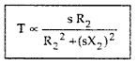Now to judge the nature of torque-slip characteristics let us divide the slip range (s = 0 to s = 1) into two parts and analyse them independently.
i) Low slip region :
In low slip region, ‘s’ is very very small. Due to this, the term (s X₂)² is so small as compared to R₂² that it can be neglected.
Hence in low slip region torque is directly proportional to slip. So as load increases, speed decreases, increasing the slip. This increases the torque which satisfies the load demand.
Hence the graph is straight line in nature.
At N = N_{s} , s = 0 hence T = 0. As no torque is generated at N = N_{s}, motor stops if it tries to achieve the synchronous speed. Torque increases linearly in this region, of low slip values.
ii) High slip region :
In this region, slip is high i.e. slip value is approaching to 1. Here it can be assumed that the term R₂² is very very small as compared to (s X₂)². Hence neglecting from the denominator, we get
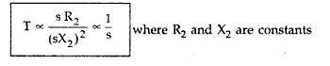
So in high slip region torque is inversely proportional to the slip. Hence its nature is like rectangular hyperbola.
Now when load increases, load demand increases but speed decreases. As speed decreases, slip increases. In high slip region as T α1/s, torque decreases as slip increases.
But torque must increases to satisfy the load demand. As torque decreases, due to extra loading effect, speed further decreases and slip further increases. Again torque decreases as T α1/s hence same load acts as an extra load due to reduction in torque produced. Hence speed further drops. Eventually motor comes to standstill condition. The motor can not continue to rotate at any point in this high slip region. Hence this region is called unstable region of operation.
So torque – slip characteristics has two parts,
1. Straight line called stable region of operation
2. Rectangular hyperbola called unstable region of operation.
Now the obvious question is upto which value of slip, torque – slip characteristics represents stable operation ?
In low slip region, as load increases, slip increases and torque also increases linearly. Every motor has its own limit to produce a torque. The maximum torque, the motor can produces as load increases is T_{m} which occurs at s = s_{m}. So linear behaviour continues till s = s_{m}.
If load is increased beyond this limit, motor slip acts dominantly pushing motor into high slip region. Due to unstable conditions, motor comes to standstill condition at such a load. Hence i.e. maximum torque which motor can produce is also called breakdown torque or pull out torque. So range s = 0 to s = s_{m} is called low slip region, known as stable region of operation. Motor always operates at a point in this region. And range s = s_{m} to s = 1 is called high slip region which is rectangular hyperbola, called unstable region of operation. Motor can not continue to rotate at any point in this region.
At s = 1, N = 0 i.e. start, motor produces a torque called starting torque denoted as T_{st}.
(e)
- The number of poles of the motor
Answer:
20rps = rps * 60 = rpm
20*60= 1200rpm
1200rpm= 120f/p

P= (120*60)/1200
Number of poles = 6 poles

- The percentage slip at full load
Answer:
15*60= 900rpm
Slip= (Ns-N)/Ns
Slip = (1200-900)/1200
Slip= 0.25
Slip = 25%

- The frequency of the rotor’s voltage

Answer:
F’=SF
F’= 0.25*60
F’=15Hz

- The rotor’s slip speed
Answer
Ns-N= slip speed
1200-900= 300
- The rotor’s frequency at a slip of 10 percent
Answer
F’ = SF
F’ = 0.1*60
F’= 6Hz
QUESTION FOUR
(a) i. by changing the applied voltage
ii. by injecting emf in rotor circuit
iii. by changing number of stator poles
iv. by changing applied frequency
v. by rotor rheostat control
(b) i. direct-on-line starting
ii. auto transformer starting
iii. star delta starting
iv. soft starter
(c) Autotransformer starting
Autotransformer reduced-voltage starting refers that the reduced voltage of grid power is attached to the motor stator windings until the speed approaches to a steady value and then the motor is connected to the power grid.
At starting, the switch is pulled to the “start” position, and the autotransformer is linked to the grid followed by connection to the stator windings of motor to achieve reduced-voltage starting. When the rotation speed approaches to the rated value, the switch will be pulled to “running” position, and the motor directly access to the grid under full pressure operation through cutting off autotransformer.
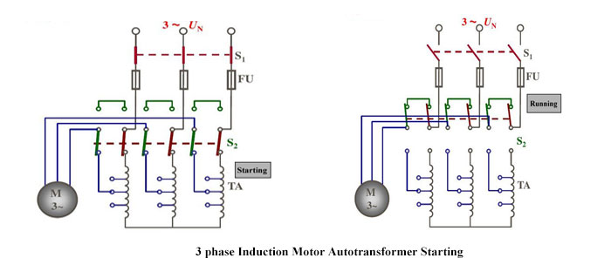
Autotransformer reduced-voltage starting is introduced into the star connection for the large capacity motor or normal operation with certain load starting. According to the load, transformer tapping is chosen according to receive required starting voltage and starting torque. At this moment, the starting torque is still weakened, but not reduced by one-third (compared with the star-triangle reduced-voltage starting). However, the autotransformer is large-sized and light weight with high price and inconvenience maintenance, which is not allowed to move frequently.
Direct On-Line Starter (DOL): The Direct On-Line (DOL) starter is the simplest and the most inexpensive of all starting methods and is usually used for squirrel cage induction motors. It directly connects the contacts of the motor to the full supply voltage. The starting current is very large, normally 6 to 8 times the rated current. The starting torque is likely to be 0.75 to 2 times the full load torque. In order to avoid excessive voltage drops in the supply line due to high starting currents, the DOL starter is used only for motors with a rating of less than 5KW. There are safety mechanisms inside the DOL starter which provides protection to the motor as well as the operator of the motor. The power and control circuits of induction motor with DOL starter are shown in figure1.
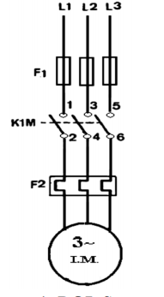
QUESTION FIVE
(a) i. To ensure it is in working order.
ii. To determine or confirm operational parameters.
iii. To monitor degredation and predict end-of-life.
iv. You could test it to see if it performs in accordance with its specifications.
v. You could test it to failure to see how much performance margin it has.
(b) DIFFERENCES
- in a blocked rotor test the rotor is blocked so that it cannot move, a voltage is applied to the motor, and the resulting voltage, current and power are measured while in a short circuit test the test is performed at a rated frequency and with balanced polyphase voltages applied to the stator terminal
- in a short circuit test as the motor is no load the power factor is very low whch is less than 0.5 while the block rotor test is conducted at low voltage because if the applied voltage was normal voltage then the current flowing through the stator windings were high enough to overheat the windings and damage them
SIMILARITIES
- the shaft of the motor is locked so that it cannot move and the rotor winding is short circuited.
- In the slip ring motor, the rotor winding is short circuited through the slip rings
(c) DIFFERENCES
- The purpose of the open circuit test is to determine the no-load current and losses of the transformer because of which their no-load parameter are determined. While the no load test determines the copper loss occur on the full load. The copper loss is used for finding the efficiency of the transformer.

A open circuit test is conducted when the secondary of the transformer is kept in open condition without connecting any load with it. Thus there will not be any current in the secondary coil. While A no load test is conducted shorting the secondary terminals. Thus there will be huge current flow in the secondary coil when voltage is applied in the primary
SIMILARITIES
- Open circuit test or no load test on a transformer is performed to determine 'no load loss (core loss)' and 'no load current
- The open circuit and no load test are performed for determining the parameter of the transformer like their efficiency, voltage regulation, circuit constant
(d) . earth continuity and resistance test
. power supply test
. running Amps test
. insulation resistance test
InsulationResistanceTest
Insulation resistance failure of an electric motor is one of the first signs that the motor is about to fail. For a three phase motor, insulation resistance is usually measured between each motor winding or phase and between each motor phase and motor frame (earth) using an insulation tester or megger. Set the voltage setting of the insulation resistance tester to 500V. Check from phase to phase (U to V, V to W, W to U). Check from phase to motor frame (earth) (U to E, V to E , W to E ). Minimum test value of motor insulation resistance is 1 Meg Ohm (1 MΩ).
(e) Applied Voltage per phase, V= 400V, No load line current=3A
No load phase current=3/√3= √3A, Input on no load= 645W
Stator copper loss=45W, windage and friction loss=183W
Total stator core loss= 645-45-183=417W
No load p.f, cosᶲ=$\frac{p_{1}}{3VI_{0}}=\frac{417}{3×400×√3}$=0.2
No load line current on energy= $I_{lo}×cos∅=3×0.2=0.6A$
Magnetizing component of no load line current,
$$I_{lm}=\sqrt{{(I_{lo})}^{2}-{(I_{le})}^{2}}=\sqrt{3^{2}-{0.6}^{2}}=2.94A$$
Energy component or no load phase current,
$$I_{e=}I_{0}cos∅=1.732×0.2=0.3464A$$
No load resistance,
$$R_{0}=\frac{V}{I_{e}}=\frac{400}{0.3464}=1.155Ω$$
No load phase current,
$$I_{m}=\frac{2.94}{√3}=1.7A$$
No load reactance,
$$X_{0}=\frac{V}{I_{m}}=\frac{400}{1.7}=236 Ω$$
Short Circuit Voltage=200V, short circuit stator line current=12.0A
Short Circuit stator phase current=6.928A, Input on short circuit= 1660W
Equivalent resistance per phase as referred to the primary,
$$R_{0}=\frac{P_{s}}{{{3I}_{s}}^{2}}=\frac{1660}{3×{(6.928)}^{2}}=11.53 Ω$$
Equivalent reactance per phase as referred to the primary,
$$Z_{0}=\frac{V_{s}}{I_{s}}=\frac{200}{6.928}=28.87Ω/phase$$
$$X_{0}=\sqrt{{Z_{0}}^{2}-{R_{0}}^{2}}=\sqrt{{(28.87)}^{2}-{(11.53)}^{2}}=26.5Ω$$
Power factor on short circuit,
$$cos∅_{s}=\frac{P_{S}}{{3VI}_{s}}=\frac{1660}{3×200×6.928}=0.4$$
Short Circuit current with normal voltage applied of 400 V across the stator,
$$I_{sc}=\frac{I_{s}×V}{V_{s}}=\frac{12×400}{200}=24A$$

QUESTION 7
(a) A synchronous generator has two main parts:
- The rotor
- The stator
- Rotor has north and south poles protruded on it, in the case of salient poles, on which Laminations are used to reduce Eddy losses. The north and south poles of the rotor are wrapped with windings, the number of poles will always be even and dependent on the speed of the generator.
- A separate DC supply is provided to the rotor with the help of slip rings and brushes and the current is passed to windings on the rotor. The rotor is attached to the shaft which makes the rotor rotate. As winding carrying current is under permanent magnet poles of rotor it will itself creates its own magnetic field
- Stator is the stationary part . it is the section made of steel plates combined together with windings on it at 120 degree intervals to balance it out.
- Now as the rotor rotates its magnetic field will cut the windings of the Stator and this in turn will cause an AC voltage to be induced in the Stator windings and an AC current is drawn.
A synchronous generator operates on the amount of poles wound within its stator. The more poles in the stator equates to a smaller rev/min. For example a 2 pole generator would run at maximum of 3000r/min whereas a 4 pole generator would only run at 1500r/min. This is done with the equation F=NsP to find the speed at which the motor runs at. The rotation of the shaft is synchronized with the frequency of the supply current, which means the rotation period is exactly equal to the number of AC cycles.
I would also use Faradays law to help explain the principle of operation with calculations. Faradays law means that the amount of voltage created is equal to the change in magnetic flux divided by the change in time. The bigger the change you have in the magnetic field, the greater amount of voltage.
Fleming's right hand rule (for generators) shows the direction of induced current when a conductor moves in a magnetic field. No current is induced if the motion of the conductor is in line with the field, going either direction, and the same can be said if it runs parallel to current.
The right hand is held with the thumb, first finger and second finger mutually perpendicular to each other (at right angles), as shown in the diagram.
- The Thumb represents the direction of Motion of the conductor.
- The First finger represents the direction of the Field. (north to south)
The Second finger represents the direction of the induced or generated Current (the direction of the induced current will be the direction of conventional current, from positive to negative.
(b) S/MVA rating=10MVA,$V_{line}=11KV$, p.f=0.8, $X_{s}=15Ω$, f=50Hz, number of poles=2
Induced emf is given as;
$$I_{a(line)}=\frac{V_{t(lines)}}{√3}$$
So;
$$\left|E_{f(phase)}\right|=\sqrt{\left(V_{t\left(phase\right)}Cosφ^{2}\right)+(I_{a}X_{a}+Sinφ^{2})}=12,741KW$$

$$\left(Cosφ+δ\right)=\frac{V_{t\left(phase\right)}Cosφ}{E_{f(phase)}}=\frac{(6351)(0.8)}{12,741}=0.399$$
$$φ+δ=\cos^{-1}\left(0.399\right)={66.5}^{0}$$
Recall;
$$Cosφ=0.8$$
$$φ=\cos^{-1}{(0.8)}$$
$$φ=36.90$$
Hence,
$$δ=66.5-36.9={29.6}^{0}$$

ii.) Maximum power,
$$P_{max}=\frac{3\left|V_{t}\right|\left|E_{f}\right|}{X_{s}}=\frac{3(12,741)(6351)}{15}=16,138,618.22W$$
iii.) Maximum torque,
$$T_{max}=\frac{P_{max}}{2πf}=\frac{16,138,618.22}{2×3.142×50}=51,507.4Nm$$

(c) Parallel operation of generators is by far the most common form of operation. Generators may be operated in parallel on a small scale, e.g. two or three generators operating in parallel to provide power to a remote community, or large scale, e.g. the north american power grid
Benefits of parallel operation include
- Redundancy: failure of one unit does not affect the integrity of the power supply, generators may be taken out of service for preventative maintenance
- Scaling: many units can combine to provide a power demand, rather than requiring fewer very large generators
- Resource management: generators can be located and operated to best meet the generating conditions, instead of having to be located and operated to meet the requirements of a local load. An example of this may be a nuclear power plant, which may take many weeks to bring up to full operating conditions. Using a nuclear generating station at full power to meet a "base load" with smaller more rapid response generators is one way to supply fluctuating load requirements.
- Efficiency: Generators operating at full load are more efficient than those operating at low loads. It is more efficient to meet a changing load by adding or removing smaller generators than having a single large generator operating inefficiently.
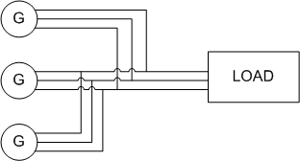FIG. 1. EXAMPLE CIRCUIT OF THREE GENERATORS OPERATING IN PARALLEL TO SUPPLY A LOAD

Voltage and Frequency Variation

V-Q Relationship
When considering synchronous generators operating alone it becomes clear that the terminal voltage of the machine is dependent on the reactive power being supplied to the load. When supplying more reactive power, the termial voltage falls. In general, the effect of changes to terminal voltage with reactive load can be plotted as shown. Increasing the inductive load on the generator reduces the terminal voltage, adding capacitance increases the terminal voltage. Reductions to the terminal voltage can be compensated by increasing the no load voltage EE
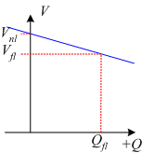
FIG. 2. GENERATOR VOLTAGE VARIATION WITH REACTIVE POWER

f-P Relationship
The output power of a generator is largely independent of the actual generator control. The ouput power closely matches in the input power from the prime mover. The speed of rotation of the generator is also set by the prime mover, with the frequency of the open circuit induced voltage directly determined by rotational speed:
f=p120nsf=p120ns
In order to understand the frequency-power relationship, it is important to try to understand the mechanical system that drives the generator. At no-load, the mechanical system is rotating at the no-load speed, nnlnnl and results in the generation of voltages at no load frequency nflnfl.
When the generator is loaded, power is drawn from the mechanical system and the generator applies a torque which opposes the direction of motion of the mechanical system. As a result, the generator tends to slow down the mechanical system. (In the same way that when you are driving on a flat road and then start to go up a hill, the car slows down).
In a synchronous generator, changing mechanical speed is undesirable, as it results in a change in the frequency of the induced voltages. For this reason, a "governor" is applied to the mechanical system to make the change in speed predictable with power changes. The mechanical governor sets the no-load speed and controls the reduction in speed so that the speed-power relationship is linear. This relationship is shown in Fig. 3. It is important to stress that this is not a function of the generator, but of how the mechanical system is controlled.
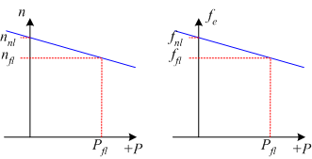
FIG. 3. GENERATOR FREQUENCY VARIATION WITH POWER OUTPUT
If the frequency of the generated voltages is too low, the frequency can be increased by increasing the no-load speed of the mechanical governor (equivalent to a cruise control in a car increasing the gas fed to the engine when the car goes up hill).
Mathematically, the changes in frequency with load are described using two quantities, the Speed Droop SDSD and the slope of the power-frequency plot, SpSp .
Speed Droop, SDSD is defined as
SD=nnl−nflnfl×100%=fnl−fflffl×100%SD=nnl−nflnfl×100%=fnl−fflffl×100%
Typical values for speed droop are in the range 2% - 4%
The power from the generator can be found using
P=Sp(fnl−fsys)P=Sp(fnl−fsys)
where
Sp=ΔPΔf=Pflfnl−fnlSp=ΔPΔf=Pflfnl−fnl
The slope SpSp is often quoted in kW/Hz or MW/Hz.
In the above equations, subscripts nl,flnl,fl refer to no-load and full-load operation respectively and syssys refers to the operating system frequency.

Infinite Bus
The infinite bus is a useful concept that summarizes how most people already view the power grid. It can be applied when the power grid is sufficiently large that the action of any one user or generator will not affect the operation of the power grid.
In an infinite bus:
- System frequency is constant, independent of power flow
- System voltage is constant, independent of reactive power consumed or supplied
An infinite bus assumed in many small electrical applications. As an example, we take for granted that the voltage supply to a residential outlet will be 120V and 60Hz: the voltage and frequency are not changed when you turn the TV on.
Frequency-power and voltage-reactive power plots for an infinite bus are shown in Fig. 4.
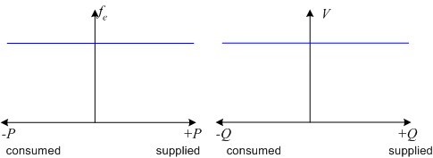
FIG. 4. F-P AND V-Q PLOTS FOR AN INFINITE BUS

