OCHENI CHUBIYOJO GRACE
PETROLEUM ENGINEERING
15/ENG07/031
PTE 512 ASSIGNMENT
Briefly discuss the following thermal enhanced oil recovery methods, (diagrams inclusive)
1. Steam assisted gravity drainage (SAGD)
2. Cyclic steam stimulation (CSS)
3. Hot water flooding.

Steam Assisted Gravity Drainage (SAGD)
Steam-Assisted Gravity Drainage (SAGD) is an enhanced oil recovery technology for producing heavy crude oil and bitumen involving an advanced form of steam stimulation [1]. SAGD is an outstanding example of a steam injection process devised for a specific type of heavy oil reservoir utilizing horizontal wells [2]. It is a method that is widely used to extract bitumen from underground oil sands deposits. This method involves forcing steam into sub-surface oil sands deposits to heat the bitumen locked in the sand, allowing it to flow well enough to be extracted. This technology is particularly relevant in Canada because it is the primary method of in situ extraction used in the oil sands. In Alberta alone, 80% (or 135 billion barrels) of the oil sands are located in these underground deposits and would be difficult to access without techniques like SAGD.
In recent history, SAGD operations have become more common as technology continues to advance. In 2000, there were 5 SAGD projects underway in Alberta, but by 2013 those numbers had jumped to 16. In 2012, the total in situ production of bitumen was 990 000 barrels a day, which is about 52% of the total crude bitumen production. By 2022 predictions put the in situ production at 2.2 million barrels a day. In total, there is an estimated 1 trillion barrels of oil that are potentially recoverable [3].
Steam Assisted Gravity Drainage (SAGD) Technique
Several variations of the basic process have been developed, and are being tested. The original SAGD process, as developed by Butler, McNab, and Lo in 1979, utilizes two parallel horizontal wells in a vertical plane. The upper section of this configuration is known as a steam injection well whereas the bottom section is known as the production well (Fig1 below). In these horizontal wells, there are two parallel horizontal pipes with one situated about 4-6 meters above the other. At a nearby plant, water is turned into steam and travels to the location where the drilling is taking place. If the oil/bitumen mobility is initially very low, steam is circulated in both wells for conduction heating of the oil around the wells. The steam is then passed through the upper well and into the reservoir that contains the oil sand. Steam then exits the upper well, expanding out into the formation in all directions. The heat from the steam is transferred to the bitumen. The warming of this bitumen results in a reduction of its viscosity, allowing it to flow more easily. Since the viscosity was decreased so dramatically, it is able to flow downward under the force of gravity into the production well. This draining of the bitumen is known as gravity drainage. As a result, steam rises forming a steam chamber with oil flowing at the sides of the chamber and condensate flowing inside the chamber. From the production well, the fluid bitumen is pumped to the surface. The steps of steam injection and bitumen production happen simultaneously and continuously. The resulting bitumen and condensed steam emulsion is piped to the plant where it is separated and treated. The water from this process is recycled for generating more steam. This is an idealized situation. Other flow regimes may occur depending on the oil and formation properties. After the extraction, water is injected into the deposit to maintain stability. 25-75% of the bitumen in the deposit can be extracted through SAGD operations [1], [3].
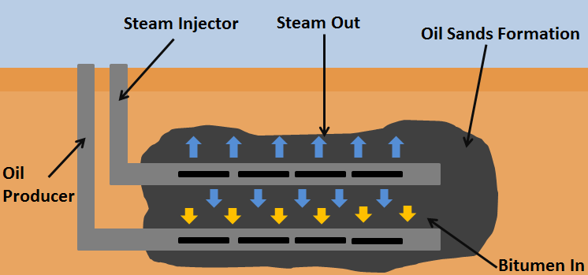
Fig 1: A SAGD Setup to Extract Bitumen from an Oil Sand Deposit

CYCLIC STEAM STIMULATION (CSS)
Conventionally, the cyclic steam stimulation uses a single well for both injection and production. Steam is injected into a production well for a period. The cyclic steam stimulation heats the oil and improves the mobilization of oil in the vicinity of the well. The heated oil is produced by a number of driving forces, including the reservoir pressure depletion, gravity, formation compaction, etc. Then the well is shut in and allowed to soak by steam for some period before it returns to production. The initial oil rate is high because of high initial oil saturation, high increased reservoir pressure, and lowered oil viscosity. As the oil saturation becomes lower, the reservoir pressure becomes lower and the oil viscosity becomes higher due to heat losses to the surrounding rock and fluids, oil rate declines. At some point, another cycle of steam injection is initiated. Such cycle may be repeated several times or many times. The terms of steam soak and steam huff-and-puff (huff-n-puff, huff ‘n’puff) are also used to describe CSS.
Cyclic steam stimulation is often the preferred method for production in heavy oil reservoirs that can contain high-pressure steam without fracturing the overburden, tar sand deposits, and in some cases, to improve injectivity prior to steam flooding or in situ combustion operations. The minimum depth for applying cyclic steam stimulation is on the order of 1,000 ft, depending upon the type and structure of the overlying formations. Cyclic steam stimulation works best when there are thick pay zones (>10 m) with high porosity sands (>30%). Shale layers that reduce vertical permeability are not a problem for vertical wells that penetrate thick pay zones. However, good horizontal permeability (>1 d) is important for production. Thus, this process is predominantly a vertical well process, with each well alternately injecting steam and producing heavy oil and steam condensate. In practice, steam is injected into the formation at greater than fracturing pressure. Recently, cyclic steam stimulation has been applied to wells with multilateral horizontal legs [4]. The diagrams below describes the cyclic steam stimulation process.
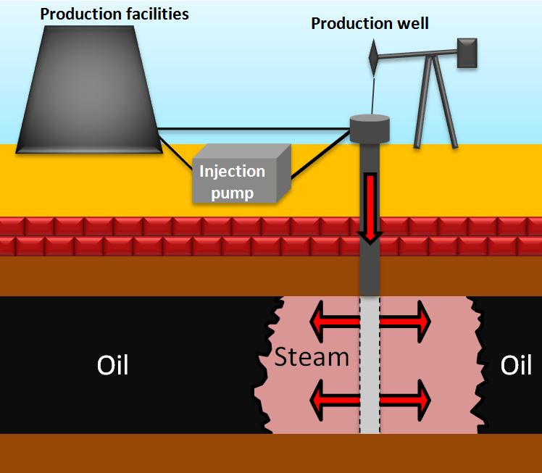
Fig 2: A Schematic Diagram of Cyclic steam stimulation- Steam injection. . (Source: G. Zerkalov)
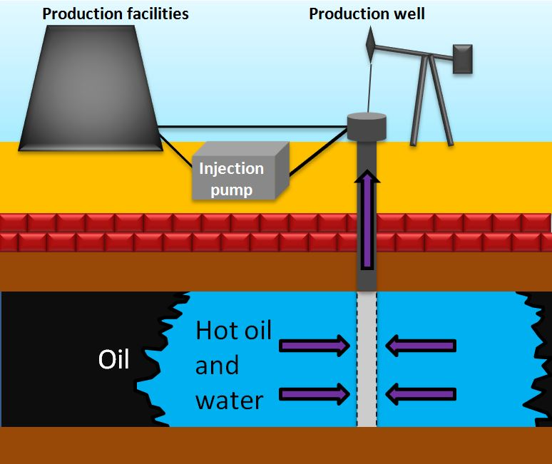
Fig 3: A Schematic Diagram of Cyclic steam stimulation- Production. (Source: G. Zerkalov)

HOT WATER FLOODING
Hot water-flooding is the most common thermal method of enhanced oil recovery used in the CIS. One reason for this is that the existing equipment for straight water-flooding can be used [5].
Hot water flooding, also known as hot water injection is considered as one of the techniques of increasing crude oil production from a producing well by injecting hot water into the reservoir, under Enhanced Oil Recovery Technique (EOR) and thermal recovery. The hot water is injected through an injection well which is drilled parallel to the primary producing well. The heat from the hot water acts as a way of reducing the viscosity of crude oil, making it to flow toward the producing well with ease. Hot water flooding is generally used to extract crude oil which has an API degree of less than 20. Use of water to increase oil production is known as "secondary recovery" and typically follows "primary production," which uses the reservoir’s natural energy (fluid and rock expansion, solution-gas drive, gravity drainage, and aquifer influx) to produce oil. It is less effective than steam injection process, due to the fact that hot water has a lower heat content as compared to steam.
Over time the pressure in an oil reservoir slowly and steadily decreases and as a result the production rate decreases. This is one of the techniques used by E&P organizations to enhance the production of heavy to medium category crude oil from a reservoir. To use this technique, an injection well is drilled parallel to the primary producing well through which hot water is injected forcefully into the reservoir in the direction of the producing well.
The benefits of injecting water into the reservoir are:
- It supports the reservoir pressure, also known as voidage replacement.
- As oil is lighter than water hence it floats on top of the water. Also, the heat content of the water reduces the viscosity of heavy crude oil, making it not to stick on the edges of the reservoir and move quickly toward the producing well. Thus, water helps in displacing oil from its location in the reservoir and pushes it toward the producing well.
With this technique, oil recovery factor can be increased and well production rate can be maintained for a longer period [6].
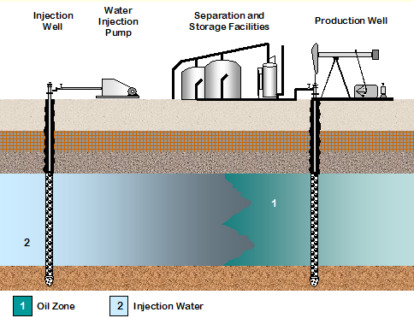

Fig 4: A Schematic Diagram of Hot Water Flooding

REFERENCES
[1] “Steam-Assisted Gravity Drainage (SAGD).” [Online]. Available: https://www.fluor.com/about-fluor/corporate-information/technologies/steam-assisted-gravity-drainage. [Accessed: 24-Apr-2020].
[2] “Steam assisted gravity drainage.” [Online]. Available: https://petrowiki.org/Steam_assisted_gravity_drainage. [Accessed: 24-Apr-2020].
[3] “Steam assisted gravity drainage.” [Online]. Available: https://energyeducation.ca/encyclopedia/Steam_assisted_gravity_drainage. [Accessed: 24-Apr-2020].
[4] “Cyclic Steam Stimulation.” [Online]. Available: https://www.sciencedirect.com/topics/engineering/cyclic-steam-stimulation. [Accessed: 24-Apr-2020].
[5] “Hot Water Flooding.” [Online]. Available: https://link.springer.com/content/pdf/bfm%3A978-94-017-2205-6%2F3%2F1.pdf. [Accessed: 24-Apr-2020].
[6] “Hot Water Flooding.” [Online]. Available: https://www.petropedia.com/definition/6773/hot-water-flooding. [Accessed: 24-Apr-2020].

