EKWE BERTILLA CHINWENDU
17/mhs01/110
1.)

Introduction
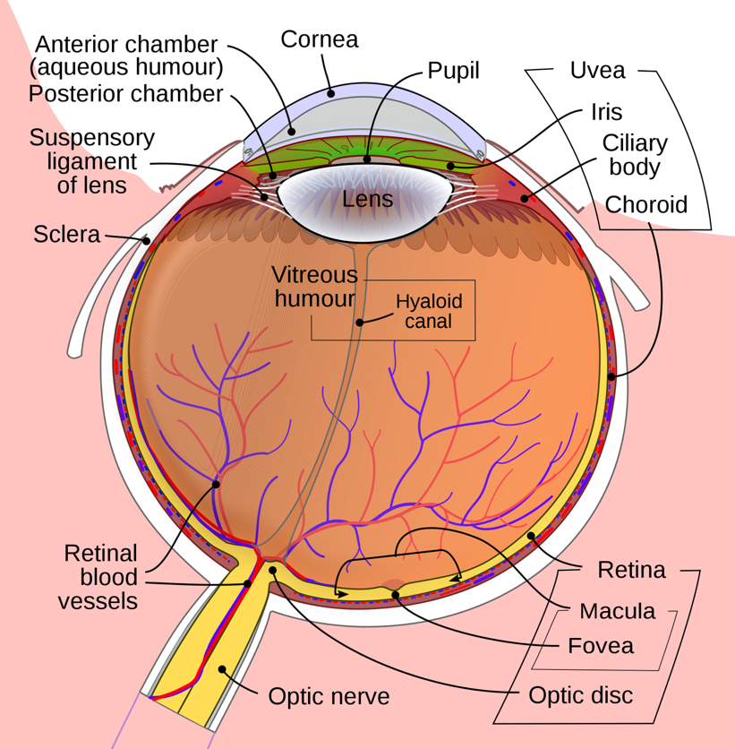
DIAGRAM OF THE EYE

A histological understanding of the layers of the eye is essential for appreciating disease pathophysiology and also understanding certain therapeutic approaches. Broadly, from an anatomical perspective, the eye can be viewed as a series of overlapping layers of tissue.
External structures of the eye include the eyelashes, lids, muscles, accessory glands, and conjunctiva.
The internal structures of the eye consist of three layers of tissue arranged concentrically:
The sclera and cornea make up the exterior layers.

The uvea is the vascular layer in the middle, subdivided into the iris, ciliary body, and choroid.

The retina constitutes the innermost layer and is made up of nervous tissue.

All of these layers can further subdivide and undergo histological classification.

Structure
"External Structures of the Eye":
1. Conjunctiva
The conjunctiva lines the inner part of the eyelids.

The tarsal plate lies beneath the conjunctiva and contains meibomian glands, which secrete an oily substance to decrease the evaporation of the tear film.

2. Tear film: The tear film consists of aqueous, mucus, and oily secretions.
3. Accessory glands: Apocrine glands of Moll, meibomian glands, lacrimal glands.
4. Muscles: Orbicularis oculi, levator palpebrae superioris, superior tarsal muscle.
5. Eyelid: The eyelid, likewise known as the cover of the eye, a mobile layer made up of skin and also muscular tissue and also covers the eyeball.
"Internal Structures of the Eye": The innermost structures of the eye are organized in the three layers as follows
(A)- "Outermost Layer: Sclera and Cornea":
1. "The sclera (white of the eye)" [2]:
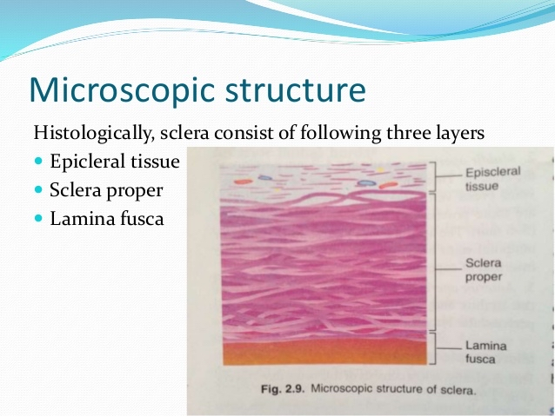
The sclera is dense connective tissue made of mainly type 1 collagen fibers, oriented in different directions. The lack of parallel orientation of collagen fibers gives the sclera its white appearance, as opposed to the transparent nature of the cornea. However, the collagen of the sclera and cornea are continuous.
The four layers of the sclera from external to internal are episclera, stroma, lamina fusca, endothelium.

The episclera is the external surface of the sclera. It is connected to the Tenon capsule by thin collagen fibers. At the corneoscleral junction, also known as the limbus, the Tenon capsule contacts stroma of the conjunctiva.

2. "Cornea (transparent front layer of the eye)":
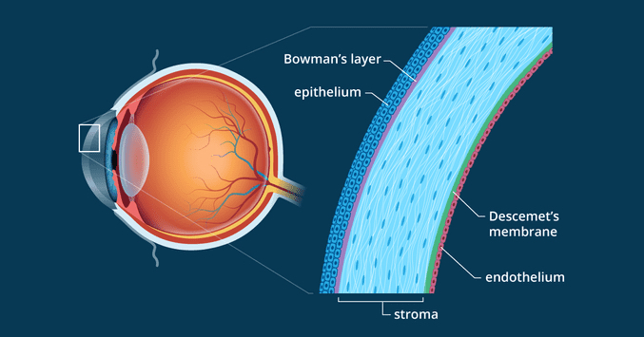
LAYERS OF THE CORNEA
Consists of type I collagen fibers oriented in a uniform parallel direction to maintain transparency

Consists of five layers: epithelium (non-keratinized, stratified squamous epithelium), Bowman layer, stroma (also called substantia propria), Descemet’s membrane, corneal endothelium.

Corneal epithelium: fast growing, regenerating multicellular layer which interacts directly with the tear film.

Bowman layer: This is a layer of subepithelial basement membrane protecting the underlying stroma. It is composed of type 1 collagen, laminin, and several other heparan sulfate proteoglycans.

Stroma: The largest layer of the cornea, the stroma has collagen fibers arranged in a regular pattern. Keratocytes maintain the integrity of this layer. The function of this layer is to maintain transparency, which occurs by the regular arrangement, and lattice structure of the fibrils, whereby scatter from individual fibrils gets canceled by destructive interference, and the spacing of less than 200 nm allows for transparency.

Descemet’s membrane: an acellular layer made of type IV collagen that serves as a modified basement membrane of the corneal endothelium

Corneal endothelium[6]: a one cell thick layer made of either simple squamous or cuboidal cells. Cells in this region do not regenerate and have pumps that maintain fluid balance and prevent swelling of the stroma[7]. When corneal endothelial cells are lost, neighboring cells stretch to attempt to compensate these losses.

(B)- "Middle Layer: Uvea (Iris, Ciliary Body, Choroid)":
1. "Iris":

Consists of (1) stromal layer with pigmented, fibrovascular tissue and (2) pigmented epithelial cells beneath the stroma

The sphincter pupillae and dilator pupillae muscles connect to the stroma

The pigmented layer of cells blocks rays of light and ensures that light must move through the pupil to reach the retina

The angle formed by the iris and cornea contains connective tissue with endothelial channels called the trabecular meshwork, which drains aqueous humor in the anterior chamber into the venous canal of Schlemm[8]. From here, fluid drains into episcleral veins.

2. "Ciliary Body": The tissue that divides the posterior chamber and vitreous body
Consists of the ciliary muscle and the ciliary epithelium

The ciliary muscle, via the lens zonules, controls the structure of the lens, which is vital for accommodation. Zonules are connective tissue fibers that connect the ciliary muscle and lens.

The ciliary epithelium produces aqueous humor which fills the anterior compartment of the eye.

3. "Choroid":
Consists of a dense network of blood vessels supplying nourishment to structures of the eye, housed in loose connective tissue.

The choriocapillary layer is located in the innermost part of the choroid and supplies the retina

The Bruch membrane is an extracellular matrix layer situated between the retina and choroid and has significance in age-related macular degeneration, where an accumulation of lipid deposits prevent diffusion of nutrients to the retina.

(C)- "Innermost layer: Lens, Vitreous, Retina":
1. Lens: separates the aqueous and vitreous chambers[9]

Consists of an outer capsule, a middle layer called cortex, and an inner layer called the nucleus.

The capsule is the basement membrane of the lens epithelium which lies below

New lens cells differentiate from the lens epithelium and are incorporated peripherally, pushing older lens cells towards the middle.

2. Vitreous: a jelly-like space made of type II collagen separating the retina and the lens
3. Retina: nervous tissue of the eye where photons of light convert to neurochemical energy via action potentials
Moreover, the retina itself is divided into various layers as follows [10][11][12][13][14]:
Retinal pigment epithelium: made of cuboidal cells containing melanin which absorbs light. These cells also establish a blood-retina barrier through tight junctions.
"Rod and cone cells": the layer of cells with photoreceptors and glial cells. Rods are located peripherally and are more sensitive to light and motion than cones. Cones have higher visual acuity and specificity for color vision.

"Outer limiting membrane": a layer of Muller cells and rod/cone junctions which serves to separate the photosensitive regions of the retina from the areas that transmit the electrical signals.

"Outer nuclear layer": This layer consists of nuclei of rod and cone cells.

"Outer plexiform layer": This layer contains synaptic processes of rod and cone cells.

"Inner nuclear layer': This layer contains the cell body of glial, amacrine, bipolar, and horizontal cells

"Inner plexiform layer": This layer relays information from cells of the inner nuclear layer. Thus, this layer has axons of amacrine, bipolar, and glial cells and dendrites of retinal ganglion cells.

"Ganglion cell layer": This layer contains nuclei of retinal ganglion cells.

"Nerve fiber layer": This layer contains axons of retinal ganglion cells and the astroglia which support them. Collectively, these axons constitute the optic nerve.

"Internal limiting membrane": A thin layer of Muller glial cells and basement membrane which demarcates the vitreous anteriorly from the retina posteriorly.[15]

Function
The layers of the eye perform distinct functions which coalesce to create a unified, perceptual experience. The essential role of the external eye structures is to protect the delicate tissue of the internal eye. The eyelid prevents foreign bodies from entering the inner eye and helps refresh and distribute the tear film by blinking. Eyelashes are finely sensitive to touch and warn the eye of possible debris and particles that may cause injury.
Internal parts of the eye have primarily structural and visual functions. The cornea serves a protective role and is responsible for two-thirds of the refractive properties of the eye. The remaining one-third of refraction is performed by the lens, which is functionally adjustable through the action of the zonular fibers and ciliary muscles. At the end of the visual process, as rays of light bend through the cornea and lens, photon energy is converted to neurochemical action potentials by cells of the retina, which then send these impulses to the brain, via the optic nerve.
The uvea of the eye is a crucial mediator of nutrition and gas exchange, as blood vessels course through the ciliary body and iris, while the choriocapillaris in the posterior eye help support the retina. This abundant blood supply is implicated in uveitis, as inflammatory mediators enter the eye through this vascular network.
2.)
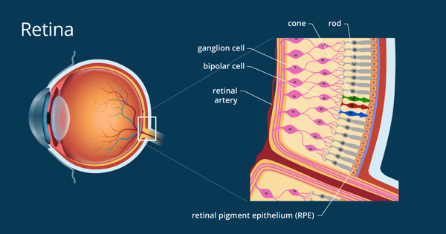
The neural retina consists of several layers of neurons interconnected by synapses, and is supported by an outer layer of pigmented epithelial cells. The primary light-sensing cells in the retina are the photoreceptor cells, which are of two types: rods and cones. Rods function mainly in dim light and provide black-and-white vision. Cones function in well-lit conditions and are responsible for the perception of colour, as well as high-acuity vision used for tasks such as reading. A third type of light-sensing cell, the photosensitive ganglion cell, is important for entrainment of circadian rhythms and reflexive responses such as the pupillary light reflex.
Light striking the retina initiates a cascade of chemical and electrical events that ultimately trigger nerve impulses that are sent to various visual centres of the brain through the fibres of the optic nerve. Neural signals from the rods and cones undergo processing by other neurons, whose output takes the form of action potentials in retinal ganglion cells whose axonsform the optic nerve.[1] Several important features of visual perception can be traced to the retinal encoding and processing of light.
In vertebrate embryonic development, the retina and the optic nerve originate as outgrowths of the developing brain, specifically the embryonic diencephalon; thus, the retina is considered part of the central nervous system(CNS) and is actually brain tissue.[2][3] It is the only part of the CNS that can be visualized non-invasively.

The retina is a thin layer of tissue that lines the back of the eye on the inside. It is located near the optic nerve. The purpose of the retina is to receive light that the lens has focused, convert the light into neural signals, and send these signals on to the brain for visual recognition.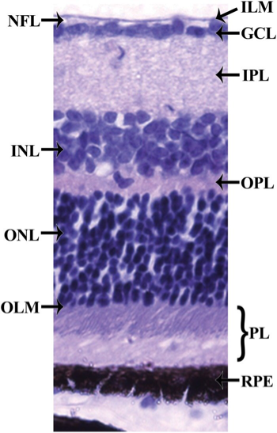

Histology of the retina. The retina can be divided into 10 layers including (1) the inner limiting membrane (ILM); (2) the nerve fiber layer (NFL); (3) the ganglion cell layer (GCL); (4) the inner plexiform layer (IPL); (5) the inner nuclear layer (INL); (6) the outer plexiform layer (OPL); (7) the outer nuclear layer (ONL); (8) the outer limiting membrane (OLM); (9) the photoreceptor layer (PL), and (10) the retinal pigmented epithelium (RPE) monolayer.

3.)

transmission through the eyes
When it comes to transmission through the eyes, the American Optometric Association(AOA) indicates the coronavirus might enter your body through the conjunctiva and then spread throughout your body through blood vessels within the conjunctiva.
The conjunctiva is the clear, thin membrane that covers part of the front of the eye as well as the inner part of the eyelids.
Some evidence suggests conjunctivitis, which most of us know as pink eye, could be a symptom of COVID-19. However, this is said to be rare, with pink eye developing in an estimated 1% to 3% of people with coronavirus.
SEE RELATED: Coronavirus linked to pink

