AWURUM IKECHUKWU CHARLES
15/ENG06/015
MEE 586 assignment
- What is an integrated CAD/ CAM?
The integration of CAD functions with CAM applications gives us the acronym CAD/CAM. CAD/CAM is concerned with engineering functions in both design and manufacturing; it denotes an integration of design and manufacturing activities by means of computer systems. Since the way a product is manufactured depends upon the specific design that is supplied, the combining of CAD with CAM in CAD/CAM, creates a direct link between product design and product manufacture that can be exploited in the production system. Conventional practices, practiced for many years in industry, saw design and manufacturing as essentially separate functions: engineering drawings were created by the design department, and these were later used by manufacturing engineers to develop the process plan. This two-step procedure was time-consuming and duplicated the efforts of design and manufacturing personnel. The application of CAD/CAM removed this problem. In an ideal CAD/CAM system, it is possible to take the design specification of the product as it resides in the CAD database, and convert it automatically into a process plan for making the product. As such, therefore, CAD/CAM operates as a system that facilitates concurrent engineering practices.
- Draw a product cycle to describe the scope of CAD/CAM in the operation of manufacturing firm
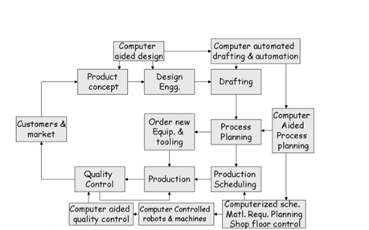

- Explain seven (7) characteristics of a good CAD software
  - Increase in the productivity of the designer: The CAD software helps designer in visualizing the final product that is to be made, it subassemblies and the constituent parts. The product can also be given animation and see how the actual product will work, thus helping the designer to immediately make the modifications if required. CAD software helps designer in synthesizing, analyzing, and documenting the design. All these factors help in drastically improving the productivity of the designer that translates into fast designing, lower designing cost and shorter project completion times.
  - Improve the quality of the design: With the CAD software the designing professionals are offered large number of tools that help in carrying out thorough engineering analysis of the proposed design. The tools also help designers to consider large number of investigations. Since the CAD systems offer greater accuracy, the errors are reduced drastically in the designed product leading to better design. Eventually, better design helps carrying out manufacturing faster and reducing the wastages that could have occurred because of the faulty design.
  - Better communications: The next important part after designing is making the drawings. With CAD software better and standardized drawings can be made easily. The CAD software helps in better documentation of the design, fewer drawing errors, and greater legibility.
  - Creating documentation of the designing: Creating the documentation of designing is one of the most important parts of designing and this can be made very conveniently by the CAD software. The documentation of designing includes geometries and dimensions of the product, its subassemblies and its components, material specifications for the components, bill of materials for the components etc.
  - Creating the database for manufacturing: When the creating the data for the documentation of the designing most of the data for manufacturing is also created like products and component drawings, material required for the components, their dimensions, shape etc.
  - Better communications: The next important part after designing is making the drawings. With CAD software better and standardized drawings can be made easily. The CAD software helps in better documentation of the design, fewer drawing errors, and greater legibility.
  - Readability: A good CAD software should be able to provide the capability within the software to help the user as and when required.

- Explain three (3) divisions of software components
System software: This class of software manages and controls the internal operations of a computer system. It is a group of programs, which is responsible for using computer resources efficiently and effectively. For example, an operating system is a system software, which controls the hardware, manages memory and multitasking functions, and acts as an interface between application programs and the computer.
- Application software: They are designed to allow the user of the system complete a specific task or set of tasks. They include programs such as web browsers, office software etc.
- Utility software: This is a software such as anti-virus software, firewalls etc. which help to maintain and protect the computer system but does not directly interfere with the hard ware.
- System services: They are built in data query languages on mainframes or QuickTime media layers of Macintosh

