NAME: OYEBOADE R. Kiitan
MATRIC NO: 17/ENG08/004
DEPARTMENT: Biomedical Engineering
COURSE CODE: BME322
COURSE TITLE: System BioEngineering I

ASSIGNMENT
METABOLISM
Metabolism is the process of extracting useful energy from chemical bonds. Metabolic pathway is the sequence of enzymatic reactions that take place in order to transfer chemical energy from one form to another. ATP is a common carrier of energy in cells. ATP is produce by the addition of inorganic phosphate group (HPO42-) to Adenosine Diphosphate (ADP) or by the addition of two (2) inorganic phosphate group to Adenosine Monophosphate (AMP) and Phosphorylation is formed by adding inorganic phosphate group with molecule.

GLYCOLYSIS
Glycolysis can be translated to "splitting sugars", is the metabolic pathway that converts glucose C₆H₁₂O₆, into pyruvate, CH₃COCOO⁻, and a hydrogen ion, H⁺. The free energy released in this process is used to form the high-energy molecules ATP and NADH. This is the process of breaking down glucose.
Characteristics of Glycolysis
- It can take place with or without oxygen.
- Glycolysis produces two molecules of pyruvate, two molecules of ATP, two molecules of NADH, and two molecules of water.
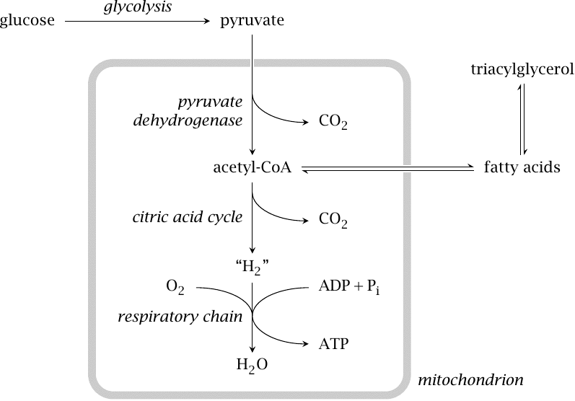
- It takes place in the cytoplasm.
Position of Glycolysis in glucose degradation
Glycolysis is only the first stage of glucose degradation. Under aerobic conditions, most of the pyruvate formed in glycolysis undergoes complete oxidative degradation to CO₂ and H₂O.
Pyruvate destined for complete degradation is transported to the mitochondria, where it is decarboxylase to acetyl-CoA by pyruvate dehydrogenase. Acetyl-CoA is completely degraded in the citric acid cycle (or tricarboxylic acid cycle; TCA cycle for short). The “H₂” that is produced here is not gaseous but bound to co-substrates, as NADH + H⁺ and FADH₂, respectively. It is subsequently oxidized in the respiratory chain; it is in this final stage of glucose breakdown that most of the ATP is actually produced.
If glucose is available in excess of immediate needs and glycogen is already stocked up to capacity, it will still be broken down by glycolysis and pyruvate dehydrogenase to acetyl-CoA. However, acetyl-CoA will then not be oxidized, but it will instead be used for fatty acid synthesis; the fatty acids are converted to triacylglycerol. Fatty acid synthesis occurs in the cytosol of cells in the liver and fat tissue.

STAGES OF GLYCOLYSIS
There are 10 enzymes involved in breaking down sugar. The 10 steps of glycolysis are organized by the order in which specific enzymes act upon the system.
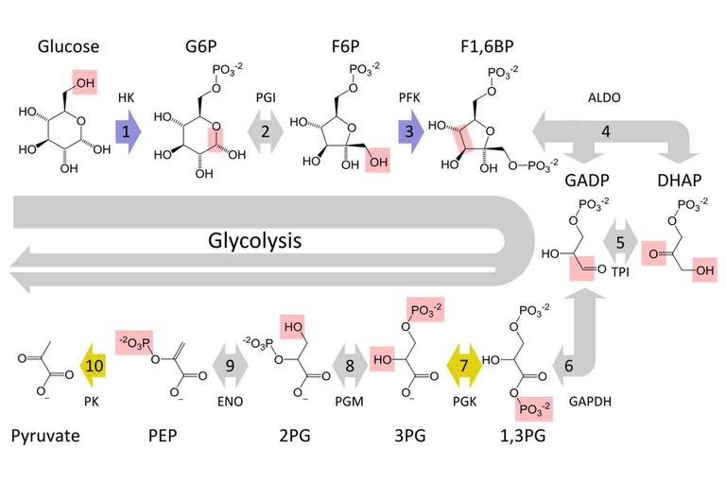
Stages of glycolysis
- STAGE 1: The enzyme hexokinase phosphorylates or adds a phosphate group to glucose in a cell's cytoplasm. In the process, a phosphate group from ATP is transferred to glucose producing glucose 6-phosphate or G6P. One molecule of ATP is consumed during this phase.
- STAGE 2: The enzyme phosphoglucomutase isomerizes G6P into its isomer fructose 6-phosphate or F6P. Isomers have the same molecular formula as each other but different atomic arrangements.
- STAGE 3: The kinase phosphofructokinase uses another ATP molecule to transfer a phosphate group to F6P in order to form fructose 1,6-bisphosphate or FBP. Two ATP molecules are use so far.
- STAGE 4: The enzyme aldolase splits fructose 1,6-bisphosphate into a ketone and an aldehyde molecule. These sugars, dihydroxyacetone phosphate (DHAP) and glyceraldehyde 3-phosphate (GAP), are isomers of each other.
- STAGE 5: The enzyme triose-phosphate isomerase rapidly converts DHAP into GAP (these isomers can inter-convert). GAP is the substrate needed for the next step of glycolysis.
- STAGE 6: The enzyme glyceraldehyde 3-phosphate dehydrogenase (GAPDH) serves two functions in this reaction. First, it dehydrogenates GAP by transferring one of its hydrogen (H⁺) molecules to the oxidizing agent nicotinamide adenine dinucleotide (NAD⁺) to form NADH + H⁺. Next, GAPDH adds a phosphate from the cytosol to the oxidized GAP to form 1,3-bisphosphoglycerate (BPG). Both molecules of GAP produced in the previous step undergo this process of dehydrogenation and phosphorylation.
- STAGE 7: The enzyme phosphoglycerokinase transfers a phosphate from BPG to a molecule of ADP to form ATP. This happens to each molecule of BPG. This reaction yields two 3-phosphoglycerate (3 PGA) molecules and two ATP molecules.
- STAGE 8: The enzyme phosphoglyceromutase relocates the P of the two 3 PGA molecules from the third to the second carbon to form two 2-phosphoglycerate (2 PGA) molecules.
- STAGE 9: The enzyme enolase removes a molecule of water from 2-phosphoglycerate to form phosphoenolpyruvate (PEP). This happens for each molecule of two (2) PGA from Step 8.
- STAGE 10: The enzyme pyruvate kinase transfers a P from PEP to ADP to form pyruvate and ATP. This happens for each molecule of PEP. This reaction yields two molecules of pyruvate and two ATP molecules.
Most of the pyruvate produced in step 10 undergoes oxidative degradation in the mitochondria. The 11th reaction, catalysed by lactate dehydrogenase, mostly occurs under anaerobic conditions, or in those cells that have no mitochondria and therefore lack the ability to oxidatively degrade pyruvate altogether. The latter applies to red blood cells and thrombocytes. Lymphocytes, which do have mitochondria, apparently rely largely on anaerobic glycolysis as well.
Most, but not all reactions in glycolysis are reversible because it contains several irreversible reactions, the pathway as a whole is also irreversible. However, alternate routes exist that bypass the irreversible reactions and allow glucose to be synthesized from pyruvate.

