Eke Paul
15/ENG06/022
MEE 586 Assignment

- What is an integrated CAD/CAM?
An integrated CAD/CAM system is a system that provides one model supporting both design and manufacturing functions instead of having various formats, numerous data translations/conversions and different CAD and CAM models.
- Draw a product cycle to describe the scope of CAD/CAM in the operation of manufacturing firm.
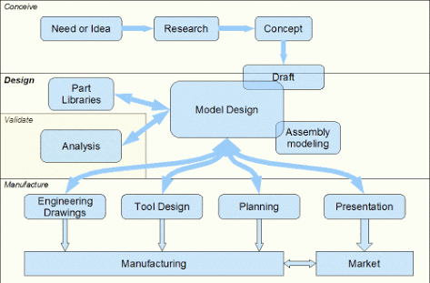
- Explain 7 characteristics of a good CAD software.
- Readability: a good cad software provides the capability within the software to help the user as and when required.
- Maintainability: a good CAD software should be easily maintainable. It should not be to complex or difficult to maintain.
- Efficiency: an efficient CAD software is on which requires less CPU/GPU power to give better results.
- Flexibility: a good CAD software must be able to incorporate the design modification without much difficulty.
- Portability: A Cad software should have the ability to be easily transferred from one system to another.
- Simplicity: a good CAD software should be simple and easy to use and understand.
- Recoverability: a good CAD software must be able to give warnings before getting crashed and must also be able to be recovered easily.
- Explain 3 divisions of software components.
- System Software (the code that boots the computer and controls the devices, resources and applications). Everyday folks know this as Windows, Mac, Linux, Unix, etc. This is typically read from disk and loaded into RAM, although it could also be manifested as PROM, in which case it is read from non-volatile memory.
- Network Software - This would include the OSI network stack that would be loaded AFTER the System Software. This constitutes industry standard network protocols such as TCP/IP that enables communication of the System Software to other computers over a network.
- Application Software. This is software that can be written for a platform such as Windows, or in today’s world, a web-based application that uses the Network and System software noted above.

