AMADI ACHINIKE S.
15/MHS01/021
PTE 512;FUNDAMENTALS OF ENHANCED OIL RECOVERY

Question; Briefly discuss the following thermal enhanced oil recovery methods with appropriate diagrams inclusive;
- Steam Assisted Gravity Drainage(SAGD)
- Cyclic Steam Stimulation(CSS)
- Hot water flood.

1. Steam Assisted Gravity Drainage (SAGD)
The Steam-Assisted Gravity Drainage (SAGD) process was developed by Butler when he was working for Imperial Oil for in situ bitumen recovery (Butler, 1985). In a typical SAGD process, two horizontal wells, which are parallel to each other with approximately 5 meters apart, are employed, with one used as steam injection well and the other one used as production well, as shown in figure 1.
To make a SAGD process successful, a steam circulation process for both the injection and production wells, in a period of about three months, is required to establish the communication between injection and production wells. After the establishment of effective inter-well communication, steam is then continuously injected into the reservoir though injection well to form a steam chamber. As illustrated in Figure 1, the heated bitumen and condensate will flow along the edge of the steam chamber downward into the liquid pool, which will effectively prevent direct production of injected steam.
However, for successful applications of SAGD processes, there are requirements such as presence of effective cap-rock, high vertical permeability, good reservoir geological properties, pay zone thickness and others. It is especially challenging to apply SAGD method to thin heavy oil reservoirs due to the small reservoir pay zone thickness (e.g., less than 6 meters) which makes effective vertical separation of the injection and production well very difficult. Moreover, with a small reservoir thickness, the steam chamber will quickly reach the top the pay zone and incur excess heat loss to over-burden. Therefore, up to date, for heavy oil and bitumen reservoirs with pay zone less than 10 meters, SAGD methods are not considered to be economic.

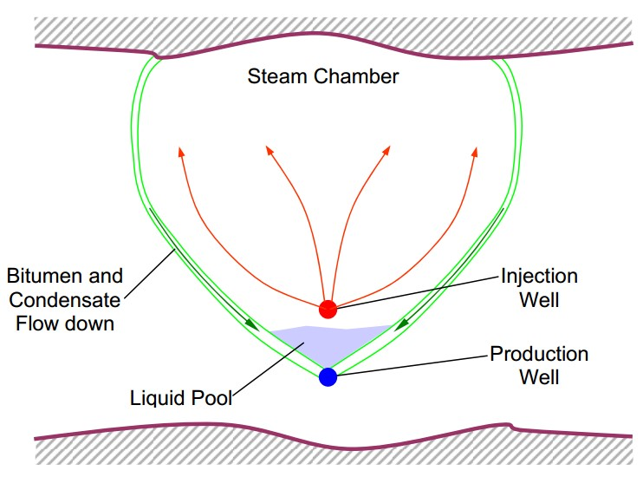
Figure 1: Illustration of the steam chamber cross-section in SAGD process

2. Cyclic Steam Stimulation
Cyclic Steam Stimulation (CSS) was initially investigated by Shell for its heavy oil reservoirs in Venezuela. CSS is three-stage process, as illustrated in Figure 2. In the first stage, high-pressure steam is injected into the pay zone to deliver the thermal energy so as to mobilize the oil and build up reservoir pressure. The steam injection period could last for up to a month. In the second stage, also called soak stage, the well is shut in to allow distribution of injected heat to the reservoir. After the soak stage, the well is put on production. The initial production rates are typically very high for short period of time and then decline gradually over several months. After depletion of reservoir pressure and further production is no longer economic, the cycle is repeated.
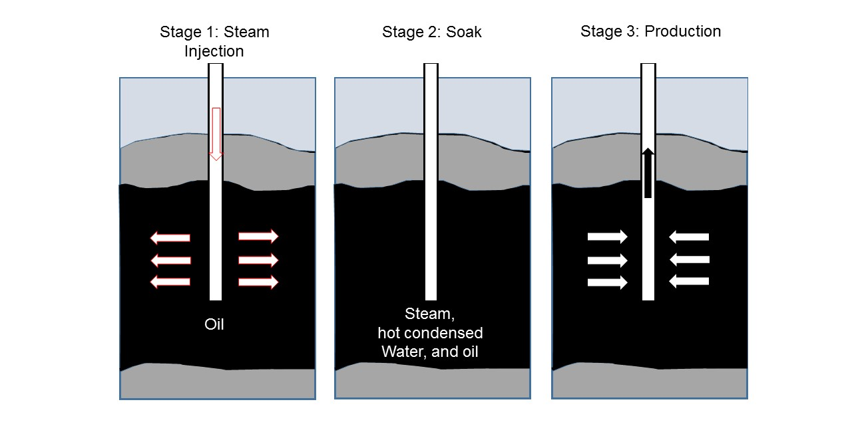
Figure 2: Illustration of Cyclic Steam Stimulation (CSS) process
3. Hot Water Flooding
In a hot water flooding case, hot water is injected into the oil zone as displacing agent. Compared with steam flooding, water flooding has advantages under special circumstances. For deep reservoirs with enough oil mobility, hot water flooding can provide the required high pressure at lower energy requirements due to low heat loss. In figure 3, there is hot water zone in which mixture of heated oil and hot water is pushed ahead towards production wells. In practice, there is a tendency for injected steam to segregate to the upper zone of the oil layer. So the heat loss for thin heavy oil reservoirs typically very significant.

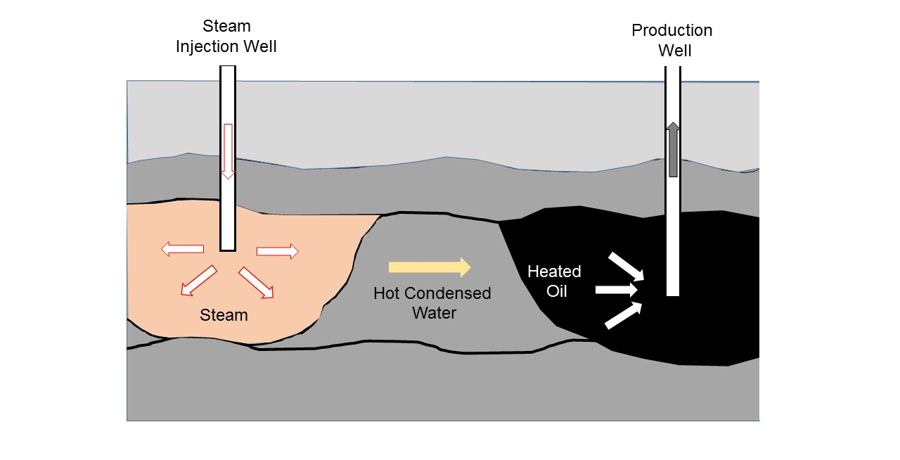
Figure 3: Illustrative mechanism of steam flooding process.

However, there are also disadvantages for a hot water flooding process. A major problem is the severe viscous fingering of the injected hot water due to high mobility of the water and low mobility of the in-place oil, which can result in poor volumetric sweep efficiency and early water breakthrough.

