Name: Oladimeji Oluwaseun Oreoluwa
Department: Anatomy
Matric no: 17/MHS01/253
Course Code: ANA 308

Questions
1. From our understanding of teratology, Can we say Corona virus is a teratogen and if No/ Yes, Justify your answer.
2. What are the impact of ageing and environment in the outbreak of this novel Covid 19.
3. Summarize the importance of Oogenesis and spermatogenesis.
4. Describe what you understand by personal hygiene and disaster; hence state their correlation if there any.

Answers
1 No. The research data on this is limited. For COVID-19 there is no data that states otherwise so no.

What is known about COVID-19 in pregnancy? Currently, there is limited information from published scientific reports about the susceptibility of pregnant women to COVID-19 and the severity of infection. Available data are reassuring but are limited to small case series. In general, pregnant women experience immunologic and physiologic changes that make them more susceptible to viral respiratory infections, including potentially COVID-19. It is reasonable to predict that pregnant women might be at greater risk for severe illness, morbidity, or mortality compared with the general population, as is observed with other related coronavirus infections [including severe acute respiratory syndrome coronavirus (SARS-CoV) and Middle East respiratory syndrome coronavirus (MERS-CoV)], and other viral respiratory infections, such as influenza, during pregnancy. Data from MERS-CoV and SARS-CoV, although limited, suggest that infection in pregnancy may be associated with severe infection and adverse neonatal outcomes, including increased risk of miscarriage, fetal growth restriction, and preterm birth. But again, data specific to COVID-19 are not yet available.
Does COVID-19 cause miscarriage or congenital anomalies? At this time, very limited data regarding risks associated with infection in the first and second trimesters exist. There are mixed data regarding the risk of congenital malformations in the setting of maternal fever in general. Currently, there are inadequate data on COVID-19 and the risk of miscarriage or congenital anomalies. Data from the SARS epidemic are reassuring, suggesting no increased risk of fetal loss or congenital anomalies associated with infection early in pregnancy.
Frequently asked Questions
Can having COVID-19 make it harder for me to get pregnant?
Studies have not been done to see if having COVID-19 could make it harder to get pregnant.
Does having COVID-19 during pregnancy increase the chance for miscarriage?
Miscarriage can occur in any pregnancy. Studies have not been done to see if having COVID-19 during pregnancy could increase the chance of miscarriage.
Does having COVID-19 in the first trimester increase the chance of birth defects?
In every pregnancy, a woman starts out with a 3-5% chance of having a baby with a birth defect. This is called her background risk. There are no published studies on COVID-19 in pregnancy and birth defects.
A high fever in the first trimester can increase the chance of certain birth defects.
Does having COVID-19 in the second or third trimester cause other pregnancy complications?
There is limited information about COVID-19 and pregnancy. Experience with other respiratory illnesses such as flu and SARS (severe acute respiratory syndrome) suggests that pregnant women may be at higher risk of complications if they have a respiratory illness, so prompt management of symptoms is important. Having severe symptoms or complications from any illness might require pregnant women to deliver their babies sooner than expected. Preterm delivery (before 37 weeks) can be associated with long-term health problems for babies.
Reports of women hospitalized with symptoms of COVID-19 during the second and third trimesters of pregnancy have included preterm deliveries, but it is not clear if these were due to the mother’s infection or other reasons. In limited reports of infants born to women with COVID-19 illness around the time of delivery, most newborns have not had evidence of infection. However, in one report 3 newborns developed symptoms of COVID-19 and tested positive for the virus soon after delivery. Although this report suggests the possibility that the virus could pass from a mother to a baby during pregnancy, researchers need more information in order to confirm this, and to better understand all the possible effects of COVID-19 in pregnancy.
Does having COVID-19 in pregnancy cause long-term problems in behavior or learning for the baby?
There is not enough information to know about any long-term effects of COVID-19 in pregnancy.

2
Ageing
Elderly people are more vulnerable to coronavirus therefore they have a much higher fatality rate.
There are both physical and social reasons. Older people don't have as strong an immune system so they are more vulnerable to infectious disease. They’re also more likely to have conditions such as heart disease, lung disease, diabetes or kidney disease, which weaken their body’s ability to fight infectious disease.
In many countries, they are more likely to be in institutionalized settings like a nursing or retirement home, or living with family in a more crowded situation where there's a greater risk of infection.
The elderly might also have isolation or mobility challenges. So because they're isolated, they can't get information about what to do, or they're not able to get food they need if stores are out of stock and things become more difficult. In many societies, seniors are more likely to live in poverty, which makes it more difficult for them to get the things they need and to take care of themselves. Poverty presents a whole range of challenges pertaining to health.
Why is the mortality rate higher for older people?
There's a direct correlation between mortality and age. So if you're 60 to 69, the mortality rate is at 3.6%. At 70 to 79, it’s 8%. And if you're 80 or above, it’s 15%. In some of the data I’ve seen, it’s even higher, at 18%. The elderly are more likely to get acute respiratory distress syndrome, the acute lung injury that is causing many of the deaths. But it seems the virus is also more likely to affect the heart than any similar viruses, so they're actually seeing people dying from heart attacks who have COVID-19. A dialysis centre in Wuhan had a number of patients die from coronavirus without any pneumonia, so it just stresses the body in general. It doesn’t have to be the pneumonia that kills them.
A side-effect of the impact of coronavirus on the health system is we'll see the elderly will be more likely to die of other causes.
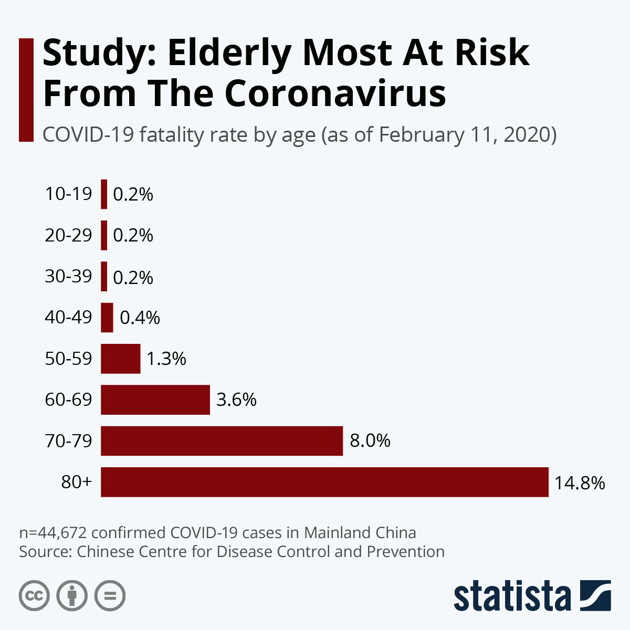

Environment
The spread of the novel covid-19 virus is thought to be dependent on temperature and humidity. It may spread faster in environments with cold weather than those with hot weather . It is transmitted when individuals come in contact with droplets containing the virus. It is believed that in cold climates this droplets can stay in the air for a few hours.
One study indicated countries particularly affected by the virus - those where it was spreading undetected via community transmission - by 10 March had lower average temperatures than those with fewer cases.
Another paper looked at 100 Chinese cities with more than 40 cases of Covid-19 and suggested the higher the temperature and humidity, the lower the rate of transmission.

In populated environments it spreads rapidly since there is close contact between infected and non-infected people

3. Importance of Spermatogenesis
- During spermatogenesis, one spermatogonium produces four sperms,
- Sperms have half the number of chromosomes. After fertilization, the diploid chromosome number is restored in the zygote. It maintains the chromosome number of the species,
- During meiosis I crossing over takes place which brings about variation,
- Spermatogenesis occurs in various organisms. Thus it supports the evidence of the basic relationship of the organisms.
- Spermatogenesis leads to the formation of sperms which undergo fertilization to form a zygote which develops into an embryo.

Importance of oogenesis
(i) One oogonium produces one ovum and three polar bodies.
(ii) Polar bodies have small amount of cytoplasm. It helps to retain sufficient amount of cytoplasm in the ovum which is essential for the development of early embryo. Formation of polar bodies maintains half number of chromosomes in the ovum.
(iii) During meiosis first crossing over takes place which brings about variation.
- Oogenesis occurs in various organisms. Therefore, it supports the evidence of basic relationship of the organisms.
- Oogenesis leads to the production of ova which undergo fertilization to form a zygote which develops into an embryo.

4 .Personal hygiene: Personal hygiene is how you care for your body. This practice includes bathing, washing your hands, brushing your teeth, and more.
In relation to diseases
The covid-19 virus for example spreads when an individual inhales the droplets of the virus, or when they touch a surface that has droplets and then touch their mouth nose or eyes. Proper personal hygiene entails that after coming in contact with multiple surfaces or people, a person washes their hands properly with soap and water to prevent an infection.
Disaster: a sudden accident or a natural catastrophe that causes great damage or loss of life.

