NAME:YUSUF RAKIYA ADEOLA
MATRIC NUMBER: 18/SMS04/063
COURSE CODE:CMS 204(SPECIALIZED REPORTING)

SOCIAL MEDIA AND PROLIFERATION OF FAKE NEWS, DODGY HEALTH ADVICES AND FAKE CURES’ OF COVID 19
As the world wrestles with the unprecedented implications of the COVID-19 coronavirus pandemic, "we are facing a human crisis unlike any we have experienced" and our "social fabric and cohesion is under stress." Before I delve into the angle which I will be focusing on, I would like to briefly explain in simple terms what this disease is all about in order to have a better understanding. Coronavirus disease 2019 (COVID-19) is defined as illness caused by a novel coronavirus now called severe acute respiratory syndrome coronavirus 2 (SARS-CoV-2; formerly called 2019-nCoV), which was first identified amid an outbreak of respiratory illness cases in Wuhan City, Hubei Province, China. It was initially reported to the WHO on December 31, 2019. On January 30, 2020, the WHO declared the COVID-19 outbreak a global health emergency. On March 11, 2020, the WHO declared COVID-19 a global pandemic.
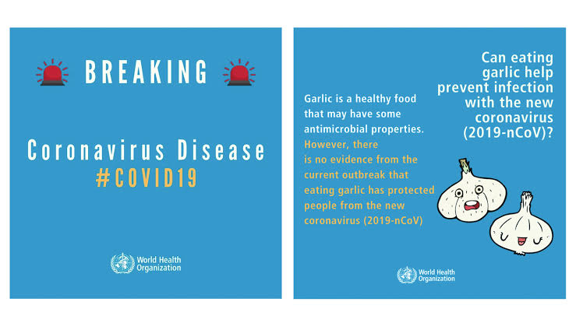
Fake news and other types of false information can take on different faces. They can also have major impacts, because information shapes our world view; we make important decisions based on information. We form an idea about people or a situation by obtaining information. So if the information we saw on the Web is invented, false, exaggerated or distorted, we won’t make good decisions. As expected, there are tendencies of rapid increase in fake news because this is a trending issue at the moment. Traditional media consists of mostly nameless and faceless people deciding what does and does not get printed and broadcasted. In this new era of internet and variety of social media, creation, and consumption of news and information in our society is changing. The rapid transformation of traditional print media into online portals has become a new trend. On one hand,
the online social media has democratized the means of news production, dissemination, but on the other hand, it has become a breeding ground for false and fake news.
False information in Nigeria is excluding medical advice, proffering fake cure thereby causing panic to the people. Sadly how some people do not even believe this disease exists. The global COVID-19 pandemic is happening at a time when sorting facts from fiction is increasingly difficult. In Nigeria, for instance, a loads of misinformation is being passed to the masses thereby causing fear and exploiting vulnerabilities.
Health misinformation is nothing new to Nigeria. During the Ebola epidemic in 2014, false news circulated around the country. This included advice that bathing in and drinking saltwater could stop you from getting the disease. This false information led to two deaths. Ebola itself killed eight people in Nigeria. However, it was later discovered that doing that changes nothing or makes you immune to the disease. Personally, I remember bathing with this salty water in order not to contact the disease not knowing I was just being fooled. This health misinformation has re-emerged during this COVID-19 outbreak. According to Lagos health officials, three people have been hospitalized after overdosing on chloroquine. This followed rumors, publicly endorsed by US President Donald Trump, that the drug could treat the virus. Unknowingly to people that a lot of people reacts to this particular drug called chloroquine. Nigerians not particularly because they are uniquely gullible that they believe in these fake news but because there is less communication between the government and its citizens and are however subjecting themselves to “miracle healing”. The already over-burdened Nigerian Centre for Disease Control (NCDC) does not just have to combat COVID-19 but also fake news in order to prevent more cases being identified.
Another Instance of fake news is when a blogger, Kemi Olunloyo, tweeted that President Muhammadu Buhari is sick with a persistent cough and that a makeshift ICU had been set up to treat him. Within hours, the tweet had been liked 3,300 times and retweeted more than 2,000 times. Social media activists, influencers posts these fake news content sometimes with the intention of gaining popularity. On 23 March, for example, an audio clip emerged on WhatsApp of an alleged World Health Organization (WHO) official predicting that at least 45 million Nigerians would die in the pandemic. The audio provoked so much fear as a result of the wide coverage it had. As at March 26,2020 wrong information swirled that Nigeria had 472 cases of corona virus with Edo state having the highest infected persons(167). The son of Atiku Abubakar, the PDP’s 2019 presidential candidate, had contracted the virus was followed by fake photos and videos of the son dancing in clubs, ignoring government isolation advice.
Personally, I have also been misled by these fake news at one point or the other by listening fake cures, unverified messages on various social media platforms. Due to my further verification I have been able to shun and turn deaf ears to these misinformation as they could lead to serious damages.
Moving further, we will be looking at the dodgy health advices and fake cures of COVID 19.
. Till date, there is no cure for corona virus, do not be deceived. Some other so called “experts” have proceeded cure such as constant sex or sitting in the sun or that African blood is immune to corona virus which is wrong. Do not be deceived! Some Africans are already infected with this disease. Some of the false claims floating around will be discussed briefly. Drinking water will ‘flush out’ the virus, some messages are going around telling you that drinking water will flush the virus from your throat into the stomach where gastric acids can destroy it. While drinking plenty of water and staying hydrated is always important, the idea that you can remove a virus this way is unscientific. The virus can find its way into the cells of the respiratory system, as well as transmitting through the nostrils or eyes. Also, a false claim states that if you can hold your breath for ten seconds you do not have the virus but the claim states that if you can hold your breath for ten seconds without coughing, you’re safe. Moreover, I came across a false claim earlier this morning stating that Drinking hot water and avoiding ice or cold drinks will help which is wrong. Working on the same flawed logic of the myth above, some advice recommends constantly drinking hot drinks and avoiding ice or cold drinks. But drinking hot drinks will not change your body temperature. You cannot kill the virus once it’s in the body – your immune system just needs to fight it off. Finally, Claims that the new Coronavirus ‘hates the sun’ and that therefore sunbathing can prevent you catching it are is not true. Given the global spread of the virus so far in both hot and cold climates, there is no evidence for this. It is not confirmed yet if COVID-19 is a seasonal flu. Myths like these can be really harmful, because they can fuel anxiety and panic, and mean that people do less of what we know actually works (such as hand washing, social distancing and avoiding touching your face). Most importantly, people should not share information that has not been verified to be true. Some fake cures, however, has been shown on various social media platforms which is fueling more confusion on the side of people. The Iran news agency reported that more than 210 people died from drinking toxic alcohol after claims circulated online that it could treat or ward off COVID-19. Another remedy that "kills the coronavirus", according to misleading social media posts, is drinking silver particles in liquid, known as colloidal silver. However, all these claims are wrong in the sense that once this virus is already in the system, you just need a strong immune system to fight it off. I keep seeing daily posts saying people should try drinking or inhaling garlic, lemon, onions that have been boiled. People, however, pay more attention these rather than following the simple laid down preventive measures to avoid being infected with this disease. People are just looking out for “miraculous cures” rather than employing the preventive measures employed by the World Health Organization(WHO). It is advisable to pay less attention to information published or disseminated by unverified sources.
Amidst all these, we need to turn deaf ears to unverified information and do the needful. There’s nothing like miraculous cures for COVID 19. People need to stay aware of the latest information on the COVID-19 outbreak, available on the WHO website and through public health authorities.Take care of your health and protect others. Regularly wash your hands with soap and water or alcohol based sanitizer in order to kill the virus. Most times we might have contacted this virus through handshakes and when you do this, it prevents the virus from going into your eyes, mouth, or nose. Another important thing we need to take note of is “social distancing”, Maintain at least 1 meter (3 feet) distance between yourself and anyone especially one who is coughing or sneezing because when someone coughs or sneezes they spray small liquid droplets from their nose or mouth which may contain virus. If you are too close, you can breathe in the droplets, including the COVID-19 virus if the person coughing has the disease. Avoid touching eyes, nose and mouth
Because the Hands touch many surfaces and can pick up viruses. Once contaminated, hands can transfer the virus to your eyes, nose or mouth. From there, the virus can enter your body and can make you sick. Also learn to practice respiratory hygiene; Make sure you, and the people around you, follow good respiratory hygiene. This means covering your mouth and nose with your bent elbow or tissue when you cough or sneeze. Then dispose the used tissue immediately because droplets spread virus. By following good respiratory hygiene you protect the people around you from viruses such as cold, flu and COVID-19. Most importantly, If you have fever, cough and difficulty breathing, seek medical care early. Stay home if you feel unwell. If you have a fever, cough and difficulty breathing, seek medical attention and call in advance. Follow the directions of health authorities in order to avoid spread the virus to other people.
Even though the battle of fake news is likely to last as long as the virus we need to turn deaf ears to them because “ignorance kills”. If you have not verified your fact as a social media influencer or public figure do well not to pass the information on to people. As it is now, everywhere is heated, people tend to believe whatever comes their way. All in all, practice the precautionary measures emphasized by WHO, and the national, local public health authority in your community. It is just a phase too we will pass through this as long as the nation as a whole gets the cooperation of the people to subsidize the spread of this virus and hereby treat those who are already infected.

References : npr.org
news.stanford.edu
nytimes.com
slideshare.net
wexnermedical.osu.edu
guardian.ng

