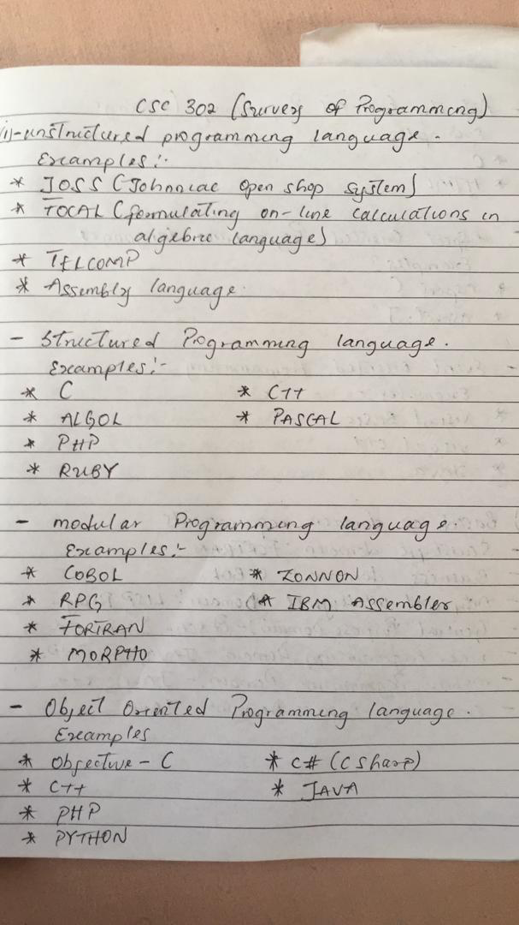

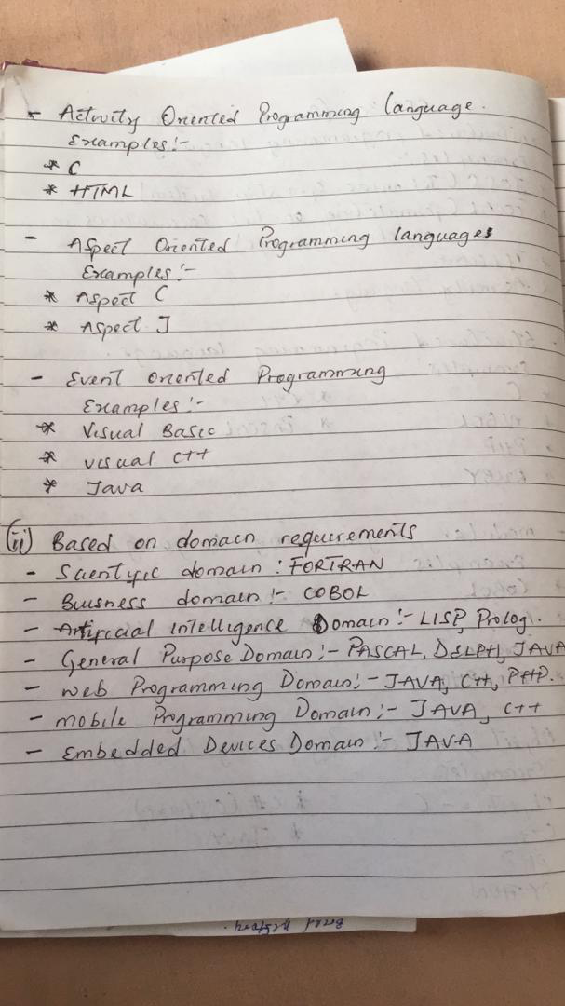

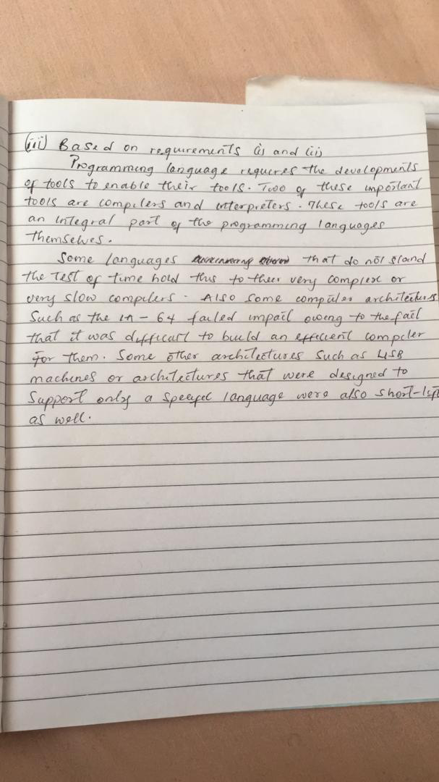

Number 2
Chronological Order of Popular Programming Languages

Below you’ll find a chronological order of some popular and/or important programming languages.

1840 – Analytical Engine Code
The Analytical Engine was a theoretical (i.e., never built) mechanical general-purpose computer, created by British mathematician Charles Babbage. Ada Lovelace came across the idea, and created some code for the Analytical Engine. That’s why she’s considered the first programmer ever.

1943 – ENIAC Coding System
The ENIAC is regarded as the first electronic general-purpose computer. Both the computer and its coding were created by John von Neumann, John Mauchly, and J. Presper Eckert.

1949 – Brief Code (Later Short Code)
Initially proposed by John Mauchly, it was one of the first attempts of an assembly language.

1954 – Fortran
One of the most popular high-level programming languages. It was created by John W. Backus at IBM as an easier alternative to programming in assembly.

1958 – LISP
Created by John McCarthy, one of the pioneers of AI as well.

1959 – COBOL
The name stands for COmmon Business-Oriented Language, as the language was aimed mainly at banks, financial institutions and companies.

1964 – BASIC
Beginner’s All-purpose Symbolic Instruction Code, a family of general-purpose, high-level programming languages whose design philosophy emphasizes ease of use.

1970 – Pascal
Pascal is an influential imperative and procedural programming language, designed in 1968–1969 and published in 1970 by Niklaus Wirth as a small and efficient language intended to encourage good programming practices using structured programming and data structuring.

1972 – Smalltalk
The language that started to inflate the popularity of object-oriented programming.

1972 – C
Created by Dennis Ritchie and Ken Thompson at the AT&T Bell Labs. It’s simplicity and efficiency made it one of the most popular languages around the world.

1972 – SQL
Created at IBM, it became the standard for dealing with databases.

1983 – C++
Originally named “C With Classes”, it brought object-orientation to C (which is technically a subset of C++).

1987 – Perl
Perl is a family of high-level, general-purpose, interpreted, dynamic programming languages.

1991 – Python
A high-level language that emphasizes code readability, and its syntax allows programmers to express concepts in fewer lines of code than would be possible in languages such as C.

1995 – Java
Java is the most popular object-oriented programming language around, and it was created to have as few implementation dependencies as possible. It’s widely used in commercial and business applications.

Number 3

An object-oriented program usually contains different types of objects, each corresponding to a particular kind of complex data to manage, or perhaps to a real-world object or concept such as a bank account, a hockey player, or a bulldozer.

Modular programming (also called "top-down design" and "stepwise refinement") is a software design technique that emphasizes separating the functionality of a program into independent, interchangeable modules, such that each contains everything necessary to execute only one aspect of the desired functionality.

