INVOLVEMENT OF T- AND B- LYMPHOCYTES IN THE PATHOGENESIS AND PROGRESSION OF OSTEOMYELITIS AND OSTEOARTHRITIS
OGUNDIPE TOLUWALASE CHERISH
16/MHS01/168

INTRODUCTION
Osteomyelitis
Osteomyelitis is an infection of bone (NORD, 2017) Symptoms may include pain in a specific bone with overlying redness, fever, and weakness (NORD, 2017). The long bones of the arms and legs are most commonly involved in children, while the feet, spine, and hips are most commonly involved in adults (GARD, 2016).
The cause is usually a bacterial infection, but rarely can be a fungal infection (NORD, 2017; GARD, 2016) It may occur by spread from the blood or from surrounding tissue (Schmitt, 2017). Risks for developing osteomyelitis include diabetes, intravenous drug use, prior removal of the spleen, and trauma to the area (NORD, 2017). Diagnosis is typically suspected based on symptoms (GARD, 2016). This is then supported by blood tests, medical imaging, or bone biopsy (GARD, 2016).
Osteoarthritis
Osteoarthritis is a type of joint disease that results from breakdown of joint cartilage and underlying bone (Arden et al.,2015). The most common symptoms are joint pain and stiffness (NIAMS, 2015). Usually the symptoms progress slowly over years (NIAMS, 2015). Initially they may only occur after exercise, but can become constant over time (NIAMS, 2015). Other symptoms may include joint swelling, decreased range of motion, and, when the back is affected, weakness or numbness of the arms and legs (NIAMS, 2015). The most commonly involved joints are the two near the ends of the fingers and the joint at the base of the thumbs; the knee and hip joints; and the joints of the neck and lower back (NIAMS, 2015). Joints on one side of the body are often more affected than those on the other (NIAMS, 2015). The symptoms can interfere with work and normal daily activities (NIAMS, 2015). Unlike some other types of arthritis, only the joints, not internal organs, are affected (NIAMS, 2015).
Function of T and B lymphocyte
The T and B lymphocytes (T and B Cells) are involved in the acquired or antigen-specific immune response given that they are the only cells in the organism able to recognize and respond specifically to each antigenic epitope. The B Cells have the ability to transform into plasmocytes and are responsible for producing antibodies (Abs). Thus, humoral immunity depends on the B Cells while cell immunity depends on the T Cells. In the present chapter, the processes of ontogeny are summarized for each type of lymphocyte together with their main characteristics, the different subpopulations described to date, the signaling mechanisms employed for their activation, and their main functions based on the immunological profile that they present.
Involvement of T- and B- lymphocytes in the pathogenesis and progression osteoarthritis
Involvement T cells in OA
Mononuclear cell infiltrates in synovial tissues have been reported in OA (Smith et al., 1997 ; Lindblad and Hedfors, 1987 ; Sakkas et al., 1988 ; kennedy et al., 1988; Haraoui et al., 1991) and have been shown to contain primarily CD3+ T cells (Ishii et al.,2002). Both CD4+ and CD8+ cells were found in OA synovium at similar levels as in RA synovium. The Th1 subset of T cells were found to be about 5 times more than Th2 cells (Ishii et al.,2002) and higher levels of Th1 cytokines, IL-2 and IFNγ, were detected in most of OA patients (Sakkas et al., 1988). T-cells in lymphocytic aggregates in OA synovium were shown to bear early (CD69), intermediate (CD25 and CD38) and late (CD45RO) activation markers. These observations suggest the presence of an active cell-mediated immune response in majority of OA patients. Analysis of α/β T cell receptor diversity revealed the presence of oligoclonal populations of T cells in OA patients (Nakamura et al., 1999 ; Zwillich et al., 1994 ; Scanzello et al., 1999) . This suggested that those cells were undergoing clonal expansion in response to specific antigens within the synovium. Although there are no conclusive data on the antigens, which drive the immune response in OA, several candidate antigens have been proposed. T cells derived from peripheral blood and synovial fluid of OA patients showed a strong response to autologous chondrocyte and fibroblast membrane preparations (Alsalameh et al., 1990). In another study OA chondrocytes were shown to stimulate autologous T cell response in vitro (Sakata et al., 2003). Cellular immunity to type III collagen and proteoglycan was detected after partial meniscectomy in rabbits (Champion and Poole, 1982). Higher cellular immunity was observed in OA patients compared to normal subjects when their peripheral blood lymphocytes were stimulated with human cartilage link protein and G1 globular domain of proteoglycan ( Guerassimov et al., 1999). More specifically, peptides representing amino acid regions 16–31 and 263–280 located in G1 domain of proteoglycan were more frequently recognized by PBMCs isolated from OA patients compared to healthy controls (De Jong et al., 2010). These studies suggest a role for cartilage components as autoantigens responsible for oligoclonal T cell response observed in OA patients. The role of CD4+ T cells in OA was highlighted by a recent study in anterior cruciate ligament-transection (ACLT)-induced OA mice where these cells were found to be involved in increased production of MIP-1γ followed by increased infiltration of macrophages in synovium and increased expression of MMP-9 [101]. In another study, when chondrocytes from OA patients were co-culture with autologous T cells, they produced higher amounts of RANTES and MMP-1, MMP-3 and MMP-13 (Nakamura et al., 1999).

Involvement of B cells and in OA
Cellular infiltrates in the inflamed OA synovium have been reported to contain activated B cells along with other cell types (Revell et al., 1988). A clonal analysis of B cells in OA synovium revealed their oligoclonal nature suggesting an antigen driven activation instead of non-antigenic activation (Shiokawa et al., 2001). Moreover, several studies found antibodies against cartilage components highlighting the activation of humoral adaptive immune response in OA. When cartilage cell surface proteins were used as substrate in an ELISA and sera from OA patients were applied, an elevated antibody titer was detected compared to controls (Mollenhauer et ali., 1988). Similarly, autoantibodies were found in OA patients against cartilage derived proteins osteopontin (Sakata et al., 2001), cartilage intermediate layer protein (CILP) (Tsuruha et al., 2001), YKL-39, (Tsuruha et al., 2001), fibulin-4 (Xiang et al., 2004) and collagen ( Charrière et al., 1988). Anti-CCP antibodies were detected in 7 out of 136 OA patients (Du et al.,2005), while another group also detected them in OA patients but at significantly lower levels compared to RA patients (Caspi et al., 2006). Antibodies against native G1 domain of aggrecan core protein were found in synovial fluid of OA patients (Karopoulos et al.,1996). Using proteomic approach, Xiang et al identified triosephosphate isomerase (TPI) as an important antigen with autoantibodies present specifically in OA but not in RA [127]. further highlighted by studies showing their deposition (Jasin, 1985 ; Cooke, 1987) and cytotoxic effects on cartilage (Takagi and Jasin, 1992), which may be one of the mechanisms playing important role in cartilage degeneration in OA
PATHOGENESIS OF OSTEOMYELITIS
Basic methods how infection gets into the bones;
Via the bloodstream (haematogeneously) – the most common method (Luqmani et al., 2013), From nearby areas of infection (as in cellulitis), or penetrating trauma, including iatrogenic causes such as joint replacements or internal fixation of fractures or secondary periapical periodontitis in teeth (Kumar et al., 2007).
The area usually affected when the infection is contracted through the bloodstream is the metaphysis of the bone (Luqmani et al., 2013). Once the bone is infected, leukocytes enter the infected area, and, in their attempt to engulf the infectious organisms, release enzymes that lyse the bone. Pus spreads into the bone's blood vessels, impairing their flow, and areas of devitalized infected bone, known as sequestra, form the basis of a chronic infection (Kumar et al., 2007). Often, the body will try to create new bone around the area of necrosis. The resulting new bone is often called an involucrum (Kumar et al., 2007). On histologic examination, these areas of necrotic bone are the basis for distinguishing between acute osteomyelitis and chronic osteomyelitis. Osteomyelitis is an infective process that encompasses all of the bone (osseous) components, including the bone marrow. When it is chronic, it can lead to bone sclerosis and deformity.
Chronic osteomyelitis may be due to the presence of intracellular bacteria (inside bone cells) (Ellington, 1999). Also, once intracellular, the bacteria are able to escape and invade other bone cells (Ellington, 2003). At this point, the bacteria may be resistant to some antibiotics Ellington, 2006). These combined facts may explain the chronicity and difficult eradication of this disease, resulting in significant costs and disability, potentially leading to amputation. Intracellular existence of bacteria in osteomyelitis is likely an unrecognized contributing factor to its chronic form.
In infants, the infection can spread to a joint and cause arthritis. In children, large subperiosteal abscesses can form because the periosteum is loosely attached to the surface of the bone (Kumar et al., 2007).
Because of the particulars of their blood supply, the tibia, femur, humerus, vertebra, the maxilla, and the mandibular bodies are especially susceptible to osteomyelitis (King et al.,2006). Abscesses of any bone, however, may be precipitated by trauma to the affected area. Many infections are caused by Staphylococcus aureus, a member of the normal flora found on the skin and mucous membranes. In patients with sickle cell disease, the most common causative agent is Salmonella, with a relative incidence more than twice that of S. aureus (Burnet et al., 1998).
Involvement of T- and B- lymphocytes in the pathogenesis and progression osteomyelitis
After further research, articles relating to the involvement of T- and B- lymphocytes in the pathogenesis of osteomyelitis haven’t been made available or been found, but with the knowledge of the disease and mechanism of action of T and B lymphocyte, when the inflammatory process begins;
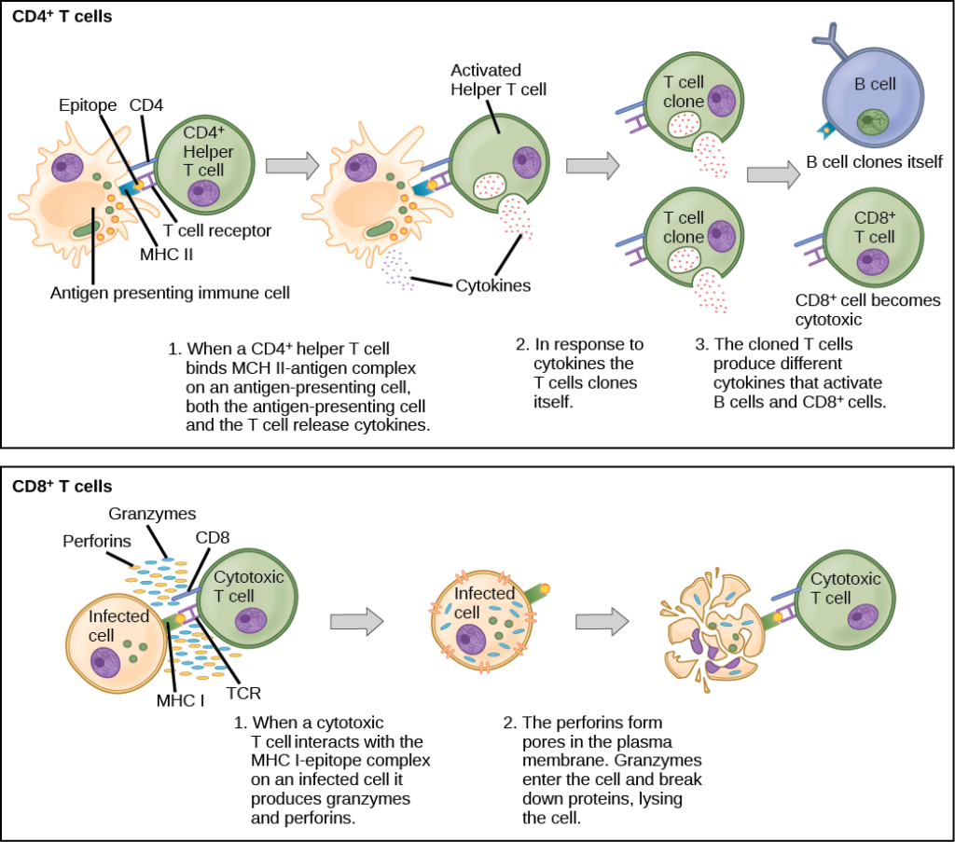
Figure 1. CD4+ T cells engage MHC II molecules on antigen-presenting cells (APCs) and become activated. Clones of the activated helper T cell, in turn, activate B cells and CD8+ T cells, which become cytotoxic T cells. Cytotoxic T cells kill infected cells (www.lumen.com).
B Lymphocytes
When stimulated by the TH2 pathway, naïve B cells differentiate into antibody-secreting plasma cells. A plasma cell is an immune cell that secrets antibodies; these cells arise from B cells that were stimulated by antigens.

REFERENCES
"Osteoarthritis". National Institute of Arthritis and Musculoskeletal and Skin Diseases. 2015.
"Osteomyelitis". Genetic and Rare Diseases Information Center (GARD). 2016. Archived from the original on 9 February 2017. Retrieved 20 July 2017.
"Osteomyelitis". NORD (National Organization for Rare Disorders). 2005.
Alsalameh S, Mollenhauer J, Hain N, (1990). Cellular immune response toward human articular chondrocytes: T cell reactivities against chondrocyte and fibroblast membranes in destructive joint diseases. Arthritis Rheum. 33:1477–1486.
Arden N, Blanco F, Cooper C, Guermazi A, Hayashi D, Hunter D, Javaid MK, Rannou F, Roemer FW, Reginster JY (2015). Atlas of Osteoarthritis. Springer. p. 21.
Berenbaum F (2013). "Osteoarthritis as an inflammatory disease (osteoarthritis is not osteoarthrosis!)". Osteoarthritis and Cartilage. 21 (1): 16–21.
Burnett, M.W.; J.W. Bass; B.A. Cook (1998). "Etiology of osteomyelitis complicating sickle cell disease". Pediatrics. 101 (2): 296–97.
Caspi D, Anouk M, Golan I (2006). Synovial fluid levels of anti-cyclic citrullinated peptide antibodies and IgA rheumatoid factor in rheumatoid arthritis, psoriatic arthritis, and osteoarthritis. Arthritis Rheum. 55:53–56.
Champion BR, Poole AR (1982). Immunity to homologous type III collagen after partial meniscectomy and sham surgery in rabbits. Arthritis Rheum. ;25:274–287.
Charrière G, Hartmann DJ, Vignon E (1988). Antibodies to types I, II, IX, and XI collagen in the serum of patients with rheumatic diseases. Arthritis Rheum. 31:325–332.
Conaghan P (2014). "Osteoarthritis – Care and management in adults" (PDF). Archived from the original on 22 December 2015or red.
Cooke TD (1987). Significance of immune complex deposits in osteoarthritic cartilage. J Rheumatol. 114:77–7
De Jong H, Berlo SE, Hombrink P (2010). Cartilage proteoglycan aggrecan epitopes induce proinflammatory autoreactive T-cell responses in rheumatoid arthritis and osteoarthritis. Ann Rheum Dis. ;69:255–262.
Du H, Masuko-Hongo K, Nakamura H, (2005). The prevalence of autoantibodies against cartilage intermediate layer protein, YKL-39, osteopontin, and cyclic citrullinated peptide in patients with early-stage knee osteoarthritis: evidence of a variety of autoimmune processes. Rheumatol Int. 26:35–41.
Ellington. "Microbial Pathogenesis" (1999).
Ellington. Journal of Orthopedic Research (2006)
Glyn-Jones S, Palmer AJ, Agricola R, Price AJ, Vincent TL, Weinans H, Carr AJ (2015). "Osteoarthritis". Lancet. 386 (9991): 376–87.
Guerassimov A, Zhang Y, Cartman A, (1999). Immune responses to cartilage link protein and the G1 domain of proteoglycan aggrecan in patients with osteoarthritis. Arthritis Rheum. ;42:527–533.
Haraoui B, Pelletier JP, Cloutier JM, (1991). Synovial membrane histology and immunopathology in rheumatoid arthritis and osteoarthritis: in vivo effects of antirheumatic drugs. Arthritis Rheum. 34:153–163.
Ishii H, Tanaka H, Katoh K, (2002). Characterization of infiltrating T cells and Th1/Th2-type cytokines in the synovium of patients with osteoarthritis. Osteoarthritis Cartilage. 10:277–281.
Jasin HE (1987). Autoantibody specificities of immune complexes sequestered in articular cartilage of patients with rheumatoid arthritis and osteoarthritis. Arthritis Rheum. 28:241–248.
Karopoulos C, Rowley MJ, Ilic MZ, Handley CJ (1996). Presence of antibodies to native G1 domain of aggrecan core protein in synovial fluids from patients with various joint diseases. Arthritis Rheum. 39:1990–1997.
Kennedy TD, Plater-Zyberk C, Partridge TA, (1988). Morphometric comparison of synovium from patients with osteoarthritis and rheumatoid arthritis. J Clin Pathol. 41:847–852.
King MD, Randall W, Johnson D (2006). "Osteomyelitis". eMedicine. WebMD. Archived from the original on 2007-11-09.
Kumar, Vinay; Abbas, Abul K.; Fausto, Nelson; & Mitchell, Richard N. (2007). Robbins Basic Pathology (8th ed.). Saunders Elsevier. pp. 810–11
Lindblad S, Hedfors E (1987). Arthroscopic and immunohistologic characterization of knee joint synovitis in osteoarthritis. Arthritis Rheum. 30:1081–1088.
Luqmani, Raashid; Robb, James; Daniel, Porter; Benjamin, Joseph (2013). Orthopaedics, Trauma and Rheumatology (second ed.). Mosby. p. 96.
Mollenhauer J, von den Mark K, Burmester G, et al. Serum antibodies against chondrocyte cell surface proteins in osteoarthritis and rheumatoid arthritis. J Rheumatol. 1988;15:1811–1817. [PubMed] [Google Scholar]
Nakamura H, Tanaka M, Masuko-Hongo K (2006). Enhanced production of MMP-1, MMP-3, MMP-13 and RANTES by interaction of chondrocytes with autologous T cells. Rheumatol Int. ;26:984–90.
Nakamura H, Yoshino S, Kato T, (1999). T-cell mediated inflammatory pathway in osteoarthritis. Osteoarthritis Cartilage. ;7:401–402.
Niebauer GW, Wolf B, Yarmush M, Richardson DW (1988). Evaluation of immune complexes and collagen type-specific antibodies in sera and synovial fluids of horses with secondary osteoarthritis. Am J Vet Res. 49:1223–1227.
Revell PA, Mayston V, Lalor P, Mapp P (1988). The synovial membrane in osteoarthritis: a histological study including the characterisation of the cellular infiltrate present in inflammatory osteoarthritis using monoclonal antibodies. Ann Rheum Dis. 47:300–307.
Sakata M, Masuko-Hongo K, Nakamura H, (2003). Osteoarthritic articular chondrocytes stimulate autologous T cell responses in vitro. Clin Exp Rheumatol. 2003;21:704–710.
Sakata M, Tsuruha JI, Masuko-Hongo K (2001). Autoantibodies to osteopontin in patients with osteoarthritis and rheumatoid arthritis. J Rheumatol. 28:1492–1495.
Sakkas LI, Scanzello C, Johanson N (1988). T cells and T-cell cytokine transcripts in the synovial membrane in patients with osteoarthritis. Clin Diagn Lab Immunol. 5:430–437.
Scanzello CR, Sakkas LI, Johanson NA, Platsoucas CD (1999). Oligoclonal populations of T-cells infiltrate the synovial membrane (SM) of patients with osteoarthritis (OA) Arthritis Rheum. 42(Suppl 59):S257.
Schmitt, SK (2017). "Osteomyelitis". Infectious Disease Clinics of North America. 31 (2): 325–38.
Shiokawa S, Matsumoto N, Nishimura J. Clonal analysis of B cells in the osteoarthritis synovium. Ann Rheum Dis. 2001;60:802–805. [PMC free article] [PubMed] [Google Scholar]
Smith MD, Triantafillou S, Parker A (1997). Synovial membrane inflammation and cytokine production in patients with early osteoarthritis. J Rheumatol. ;24:365–371.
Takagi T, Jasin HE (1992). Interactions between anticollagen antibodies and chondrocytes. Arthritis Rheum. 35:224–230.
Tsuruha J, Masuko-Hongo K, Kato T (2001). Implication of cartilage intermediate layer protein in cartilage destruction in subsets of patients with osteoarthritis and rheumatoid arthritis. Arthritis Rheum. 44:838–845.
Tsuruha J, Masuko-Hongo K, Kato T (2002). Autoimmunity against YKL-39, a human cartilage derived protein, in patients with osteoarthritis. J Rheumatol. 29:1459–1466.
Vingård E, Englund M, Järvholm B, Svensson O, Stenström K, Brolund A, Hall C, Kedebring T, Kirkeskov L, Nordin M (2016). Occupational Exposures and Osteoarthritis: A systematic review and assessment of medical, social and ethical aspects. SBU Assessments (Report). Graphic design by Anna Edling. Stockholm: Swedish Agency for Health Technology Assessment and Assessment of Social Services (SBU). p. 1. 253
Xiang Y, Sekine T, Nakamura H (2004). Proteomic surveillance of autoimmunity in osteoarthritis: identification of triosephosphate isomerase as an autoantigen in patients with osteoarthritis. Arthritis Rheum. 50:1511–1521.
Zwillich SH, Fang Q, Kieber-Emmons T, (1994). Vα gene usage in rheumatoid compared with osteoarthritic synovial tissue T cells. DNA Cell Biol.13:923–931.

