NAME: Amrophe Christabel Efe
COURSE: Chemistry 102
COLLEGE: Medicine and Health Science
DEPARTMENT: Nursing
MATRIC. NO.: 19/MHS02/023
(1). IUPAC names of organic compounds:
* HCOOH- Methanoic acid.
* HOOCCH2CH2CH2COOH- Pentan-1,5-dioc acid.
* CH3CH2CHCOOH- Butanoic acid.
* HO2C-CO2H- Ethanedioc acid.
*CH3(CH2)4COOH- Hexanoic acid.
* CH3CH=CHCH2CH2COOH- Hex-4-eneoic acid.
(2). Physical properties of carboxylic acids under the following headings:
~ Physical state: Carboxylic acids up to C10 are liquids at room temperature while others are solids at room temperature. Although acetic acid which is an anhydrous carboxylic acid freezes at room temperature.
~ Boiling point: The boiling point of carboxylic acid increases with corresponding increasing relative molecular mass. Aromatic carboxylic acids are usually crystalline in nature and have a higher melting point than their aliphatic counterparts.
~ Solubility: All carboxylic acids are soluble in organic solvents, low molecular mass of carboxylic acids with up to four carbon atoms in their molecules are soluble in water due to their to form hydrogen bonds with water molecules. The solubility however decreases as the relative molecular mass increases. This is because the structure becomes more covalent.
(3). Two industrial preparation of carboxylic acids:
a. Preparation from nitriles and amides: Nitriles undergo hydrolysis to form amides. The amides further undergo reaction in the presence of a catalyst which then to form carboxylic acids. The catalyst for this reaction is H+ or OH¯. Furthermore, application of mild reaction in the amide stage, it undergoes hydrolysis in the presence of catalyst H+ or OH¯ to form carboxylic acids.
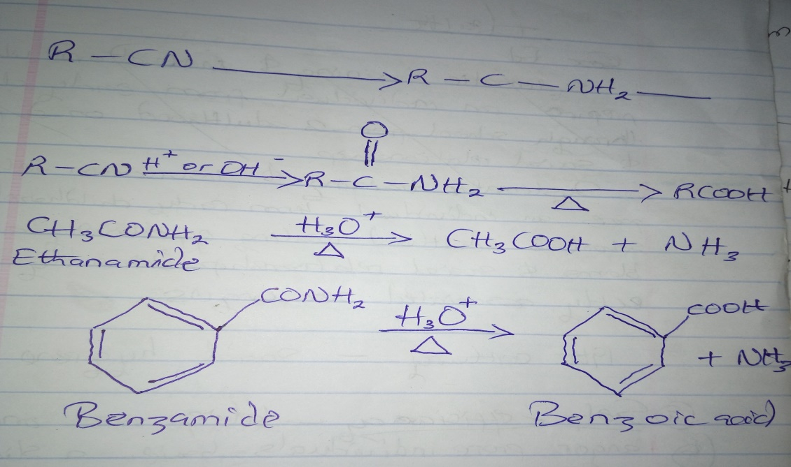
b. Preparation from esters: Acidic hydrolysis of esters leads to the formation of carboxylic acids. However, hydrolysis of the base produces carboxylates followed by acidification which leads to the formation of corresponding carboxylic acids. Furthermore, the hydrolysis of esters is carried out with mineral acids or alkali in order to produce a carboxylic acid.
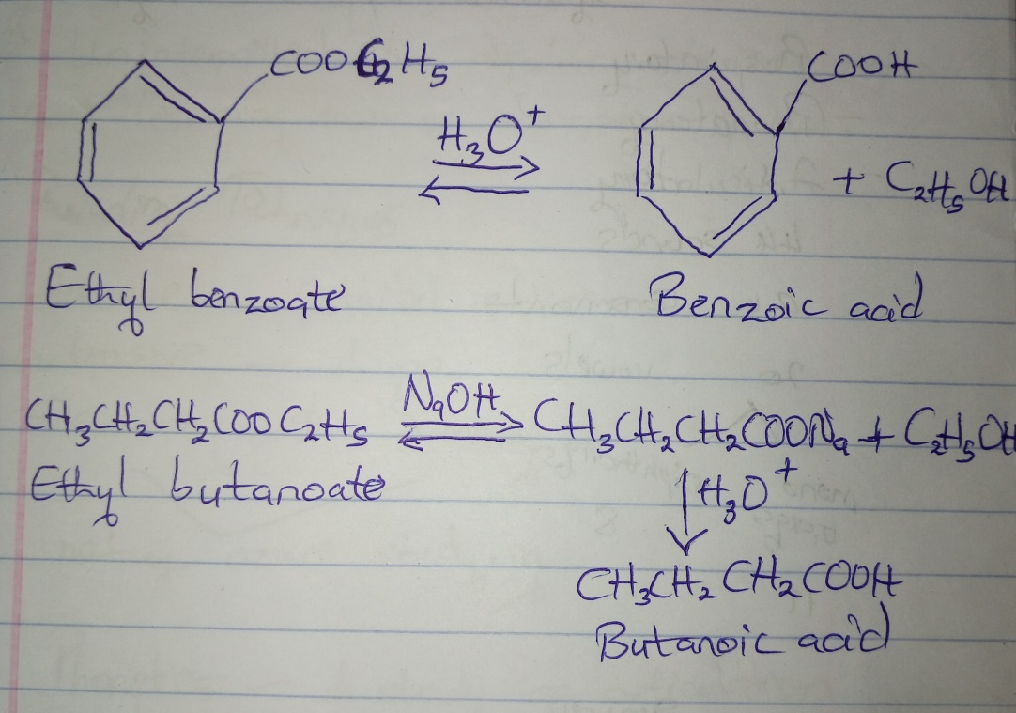
(4). Synthetic preparation of carboxylic acid with equation:
i. Hydrolysis of nitriles (cyanides) or esters.
H+
RCN + 2H2O −−−→ RCOOH + NH4+
H2O/H+ reflux
RCOOR’ −−−−−−−−−→ CH3CH2COOH + CH3OH
ii. Oxidation of primary alcohols and aldehydes: It can be used to prepare carboxylic acids using the usual oxidizing agents (i.e K2Cr2O7 or KMnO4) in acidic solution.
RCH2OH −−−−−−−−−−−−−−−−−−−−→ RCHO −−−−−→ RCOOH
iii. Carbonation of Grignard reagents: Aliphatic carboxylic acids are obtained by bubbling carbon(iv)oxide into the Grignard reagent and then hydrolyzing with dilute acid.
(C2H3)2O H2O/Dil. Acid
RMgBr + CO2 −−−−−−→ RCOOMgBr −−−−−−−−−−−−−−−−−−−−
(5). The reduction, decarboxylation and esterification of carboxylic acids with chemical equation only:
* Decarboxylation:
CH3CH2CH2COONa + NaOH −−−−→CH3CH2CH3+ −−−−−→ Na2CO3
Kolbe synthesis
Electrolysis/aq. CH3OH
2CH3CH2COONa + 2H2O −−−−→ CH3(CH2)2CH3 + CO2 (Anode) + 2NaOH + H2 (cathode).
* Esterification:
CH3CH2CH2COOCH2CH3 + H2O ←−
→CH3CH2CH2COOCH2CH2CH3 + H2O
* Reduction:
4RCOOH + 3LiAlH4 −−−−−−−−−−−−−−−→ (RCH2O)4AlLi + 2LiAlO2 + 4H2
4RCH2OH + Al(OH) + LiOH
LiAlH4
CH3CH2CH2COOH −−−−−→ CH3CH2CH2CH2OH.

