AGHA-IBIAM UCHENNA
15/ENG06/004
MECHANICAL ENGINEERING
MEE 586
ASSIGNMENT 1
1) What is an integrated CAD/CAM system?
An integrated CAD/CAM system provides one model supporting both design and manufacturing functions instead of having various file formats, numerous data translations/conversions, and different CAD and CAM models. To the CAM system, the CAD model becomes the sole geometry in play. Integrated CAD/CAM-systems are employed to achieve computer-aided integration in all production functions, from design and planning up to manufacturing and the assurance of quality standard.

2) Draw a product cycle to describe the scope of CAD/CAM in a manufacturing firm.
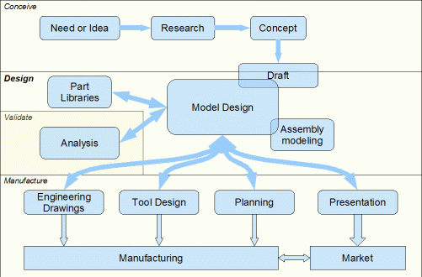

3) Explain seven characteristics of good CAM software.

A) Efficiency: - An Efficient software is that which can use fewer resources such as CPU in terms of time and usage to give a better output.

B) Simplicity: - A software must be simple to use and easy to understand and must be user friendly.

C) Flexibility: - The software must be able to incorporate the design modification without much of difficulty.

D) Readability: - This provides the capability within the software to help the user as and when required.

E) Portability: - The software must have the capacity to get transferred from one system to other.

F) Reliability: - To avoid causality the software must be able to avoid unwanted operation.

G) Recover ability: - A Good software must be able to give warnings before getting crashed and must be able to recover.

4) Explain 3 divisions of software components.

System Software
System software is a type of computer program that is designed to run a computer's hardware and application programs. If we think of the computer system as a layered model, the system software is the interface between the hardware and user applications. They may include the operating system, file management utilities and disk operating system. The operating system manages the computer hardware resources in addition to application and data.

Applications software
An application is any program, or group of programs, that is designed for the end user. They are often called end – user programs because they enable users to complete tasks such as creating documents, spreadsheets, databases and publications. Application software is specific to the task it is designed for and can be simple as a calculator application or as complex as a word processing application.

Web Application
A web application is a software application that runs on a remote server. In most cases, Web browsers are used to access web applications, over a network, such as the Internet. A web application utilizes web browser and web technology to perform tasks over the internet.

