OMOJOLA Temiloluwa Oluwatomisin
17/ENG04/058
Electrical/Electronics Engineering

SOLUTION
Q1.
- It is not self-starting.
- According to double field revolving theory, we can resolve any alternating quantity into two components. Each component has a magnitude equal to the half of the maximum magnitude of the alternating quantity, and both these components rotate in the opposite direction to each other. For example – a flux, φ can be resolved into two components
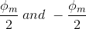
Each of these components rotates in the opposite direction i. e if one φ_{m}/2 is rotating in a clockwise direction then the other φ_{m} / 2 rotates in an anticlockwise direction. When we apply a single phase AC supply to the stator winding of single phase induction motor, it produces its flux of magnitude, φ_{m}. According to the double field revolving theory, this alternating flux, φ_{m} is divided into two components of magnitude φ_{m}/2. Each of these components will rotate in the opposite direction, with the synchronous speed, N_{s}. Let us call these two components of flux as forwarding component of flux, φ_{f} and the backward component of flux, φ_{b}. The resultant of these two components of flux at any instant of time gives the value of instantaneous stator flux at that particular instant. Now at starting condition, both the forward and backward components of flux are exactly opposite to each other. Also, both of these components of flux are equal in magnitude. So, they cancel each other and hence the net torque experienced by the rotor at the starting condition is zero. So, the single phase induction motors are not self-starting motors.
- The constructional features:
The single phase induction motor has two main parts; stator and rotor.
Stator:
As its name indicates stator is a stationary part of induction motor. A single phase AC supply is given to the stator of single phase induction motor.
The stator of the single-phase induction motor has laminated stamping to reduce eddy current losses on its periphery. The slots are provided on its stamping to carry stator or main winding. Stampings are made up of silicon steel to reduce the hysteresis losses. When we apply a single phase AC supply to the stator winding, the magnetic field gets produced, and the motor rotates at speed slightly less than the synchronous speed N_{s}. Synchronous speed N_{s} is given by 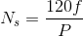
Where,
f = supply voltage frequency,
P = No. of poles of the motor.
The construction of the stator of the single-phase induction motor is similar to that of three phase induction motor except there are two dissimilarities in the winding part of the single phase induction motor.
- Firstly, the single-phase induction motors are mostly provided with concentric coils. We can easily adjust the number of turns per coil can with the help of concentric coils. The mmf distribution is almost sinusoidal.
- Except for shaded pole motor, the asynchronous motor has two stator windings namely the main winding and the auxiliary winding. These two windings are placed in space quadrature to each other.

Rotor:
The rotor is a rotating part of an induction motor. The rotor connects the mechanical load through the shaft. The rotor in the single-phase induction motor is of squirrel cage rotor type.
The construction of the rotor of the single-phase induction motor is similar to the squirrel cage three-phase induction motor. The rotor is cylindrical and has slots all over its periphery. The slots are not made parallel to each other but are a little bit skewed as the skewing prevents magnetic locking of stator and rotor teeth and makes the working of induction motor more smooth and quieter (i.e. less noisy).
The squirrel cage rotor consists of aluminum, brass or copper bars. These aluminum or copper bars are called rotor conductors and placed in the slots on the periphery of the rotor. The copper or aluminum rings permanently short the rotor conductors called the end rings.
To provide mechanical strength, these rotor conductors are braced to the end ring and hence form a complete closed circuit resembling a cage and hence got its name as squirrel cage induction motor. As end rings permanently short the bars, the rotor electrical resistance is very small and it is not possible to add external resistance as the bars get permanently shorted. The absence of slip ring and brushes make the construction of single phase induction motor very simple and robust.
Working principle:
We know that for the working principle of any electrical motor whether its AC or DC motor, we require two fluxes as the interaction of these two fluxes produced the required torque.
When we apply a single phase AC supply to the stator winding of single phase induction motor, the alternating current starts flowing through the stator or main winding. This alternating current produces an alternating flux called main flux. This main flux also links with the rotor conductors and hence cut the rotor conductors.
According to the Faraday’s law of electromagnetic induction, emf gets induced in the rotor. As the rotor circuit is closed one so, the current starts flowing in the rotor. This current is called the rotor current. This rotor current produces its flux called rotor flux. Since this flux is produced due to the induction principle so, the motor working on this principle got its name as an induction motor.

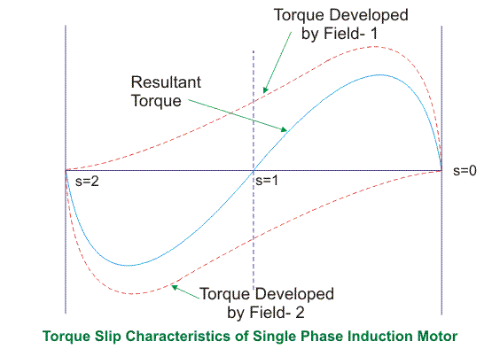
From the figure, we see that at a slip of unity, both forward and backward field develops equal torque but the direction of which are opposite to each other so the net torque produced is zero hence the motor fails to start. From here we can say that these motors are not self-starting unlike the case of three phase induction motor. There must be some means to provide the starting torque. If by some means, we can increase the forward speed of the machine due to which the forward slip decreases the forward torque will increase and the reverse torque will decrease as a result of which motor will start.
From here we can conclude that for starting of single phase induction motor, there should be a production of difference of torque between the forward and backward field. If the forward field torque is larger than the backward field than the motor rotates in forward or anti clockwise direction. If the torque due to backward field is larger compared to other, then the motor rotates in backward or clockwise direction. They are not self-starting because in induction machine a rotating magnetic field is required to produce torque. A rotating magnetic field can produced if we have balanced three phase supply and each phase is electrically spaced 120 to each other OR we have required minimum two phase but in single phase induction motor there is single phase supply to the stator of motor. A single phase supply cannot produce a rotating magnetic field but it produce a pulsating magnetic field which does not rotate. Due to this pulsating magnetic field torque cannot produce so motor is not self-start.
- ---- Split phase induction motor.
Capacitor start induction motor
Capacitor start capacitor-run induction motor
Permanent split capacitor motor
Shaded pole induction motor
Explaining two of these:
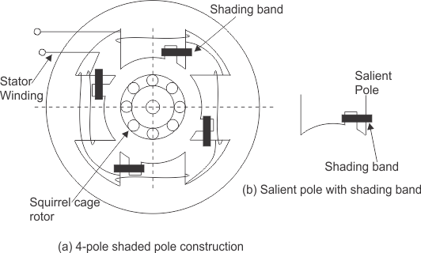
The stator of the shaded pole single phase induction motor has salient or projected poles. These poles are shaded by copper band or ring which is inductive in nature. The poles are divided into two unequal halves. The smaller portion carries the copper band and is called as shaded portion of the pole.
ACTION: When a single phase supply is given to the stator of shaded pole induction motor an alternating flux is produced. This change of flux induces emf in the shaded coil. Since this shaded portion is short circuited, the current is produced in it in such a direction to oppose the main flux. The flux in shaded pole lags behind the flux in the unshaded pole. The phase difference between these two fluxes produces resultant rotating flux.
We know that the stator winding current is alternating in nature and so is the flux produced by the stator current. In order to clearly understand the working of shaded pole induction motor consider three regions-
    - When the flux changes its value from zero to nearly maximum positive value.
    - When the flux remains almost constant at its maximum value.
    - When the flux decreases from maximum positive value to zero.
When the flux changes its value from zero to nearly maximum positive value – In this region the rate of rise of flux and hence current is very high. According to Faraday’s law whenever there is change in flux emf gets induced. Since the copper band is short circuit the current starts flowing in the copper band due to this induced emf. This current in copper band produces its own flux. Now according to Lenz’s law the direction of this current in copper band is such that it opposes its own cause i.e. rise in current. So the shaded ring flux opposes the main flux, which leads to the crowding of flux in non-shaded part of stator and the flux weaken in shaded part. This non uniform distribution of flux causes magnetic axis to shift in the middle of the non-shaded part.

When the flux remains almost constant at its maximum value- In this region the rate of rise of current and hence fluxes remains almost constant. Hence there is very little induced emf in the shaded portion. The flux produced by this induced emf has no effect on the main flux and hence distribution of flux remains uniform and the magnetic axis lies at the center of the pole.

When the flux decreases from maximum positive value to zero – In this region the rate of decrease in the flux and hence current is very high. According to Faraday’s law whenever there is change in flux emf gets induced. Since the copper band is short circuit the current starts flowing in the copper band due to this induced emf. This current in copper band produces its own flux. Now according to Lenz’s law the direction of the current in copper band is such that it opposes its own cause i.e. decrease in current. So the shaded ring flux aids the main flux, which leads to the crowding of flux in shaded part of stator and the flux weaken in non-shaded part. This non uniform distribution of flux causes magnetic axis to shift in the middle of the shaded part of the pole.
This shifting of magnetic axis continues for negative cycle also and leads to the production of rotating magnetic field. The direction of this field is from non-shaded part of the pole to the shaded part of the pole.

Split Phase Induction Motor
In addition to the main winding or running winding, the stator of single phase induction motor carries another winding called auxiliary winding or starting winding. A centrifugal switch is connected in series with auxiliary winding. The purpose of this switch is to disconnect the auxiliary winding from the main circuit when the motor attains a speed up to 75 to 80% of the synchronous speed. We know that the running winding is inductive in nature. Our aim is to create the phase difference between the two winding and this is possible if the starting winding carries high resistance. Let us say
I_{run} is the current flowing through the main or running winding,
I_{start} is the current flowing in starting winding,
V_{T} is the supply voltage
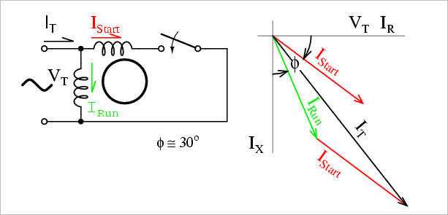
We know that for highly resistive winding the current is almost in phase with the voltage and for highly inductive winding the current lag behind the voltage by large angle. The starting winding is highly resistive so, the current flowing in the starting winding lags behind the applied voltage by very small angle and the running winding is highly inductive in nature so, the current flowing in running winding lags behind applied voltage by large angle. The resultant of these two current is I_{T}. The resultant of these two current produce rotating magnetic field which rotates in one direction. In split phase induction motor the starting and main current gets split from each other by some angle so this motor got its name as split phase induction motor.

Applications of Split Phase Induction Motor
Split phase induction motors have low starting current and moderate starting torque. So these motors are used in fans, blowers, centrifugal pumps, washing machine, grinder, lathes, air conditioning fans, etc. These motors are available in the size ranging from 1/20 to 1/2 KW.

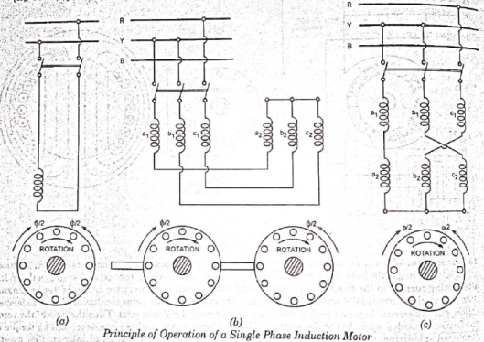
Under stationary rotor conditions (i.e, when speed N = 0 or slip s = 1), the two rotating fields slip pass the rotor at the same slip, s = 1 and inducing equal currents in the squirrel cage rotor. The two rotating fields are of the same strength and develop equal and opposite electro-magnetic torques resulting in net torque of zero value. Thus the starting torque is zero and the single phase induction motor is non- self-starting. Further, the two rotating fields induce a resultant EMF in the stator which balances the applied voltage assuming low leakage impedance of the stator winding.

Q2.

- A universal motor is a type of electric motor that either operates on AC or DC power and it uses an electromagnet as its stator to create its magnetic field.
Applications include:
-blenders
-vacuum cleaners
-drills
-hair dryer
-wind trimmer

- 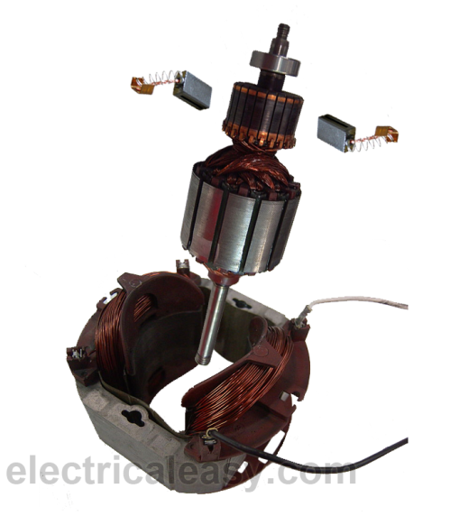
Construction of a universal motor is very similar to the construction of a DC machine. It consists of a stator on which field poles are mounted. Field coils are wound on the field poles.
However, the whole magnetic path (stator field circuit and also armature) is laminated. Lamination is necessary to minimize the eddy currents which induce while operating on AC.
The rotary armature is of wound type having straight or skewed slots and commutator with brushes resting on it. The commutation on AC is poorer than that for DC; because of the current induced in the armature coils. For that reason, brushes used are having high resistance.

- There is no difference. A universal motor has its rotor and stator windings connected in series and it can run on both AC and DC that is why it’s called universal, or sometimes a DC series motor. It is mostly used in home appliances, electric tools and so on. Because it has a high speed.

Q3.

- When the motor is excited with three-phase supply, three-phase stator winding produce a rotating magnetic field with 120 displacements at constant magnitude which rotates at synchronous speed. This changing magnetic field cuts the rotor conductors and induces a current in them according to the principle of Faraday’s laws of electromagnetic induction. As these rotor conductors are shorted, the current starts to flow through these conductors.

In the presence of magnetic field of stator, rotor conductors are placed, and therefore, according to the Lorenz force principle, a mechanical force acts on the rotor conductor. Thus, all the rotor conductors force, i.e., the sum of the mechanical forces produces torque in the rotor which tends to move it in the same direction of rotating magnetic field.

This rotor conductor’s rotation can also be explained by Lenz’s law which tells that the induced currents in the rotor oppose the cause for its production, here this opposition is rotating magnetic field. This result the rotor starts rotating in the same direction of the stator rotating magnetic field. If the rotor speed more than stator speed, then no current will induce in the rotor because the reason for rotor rotation is the relative speed of the rotor and stator magnetic fields. This stator and the rotor field difference is called as slip. This how 3-phase motor is called as asynchronous machine due to this relative speed difference between the stator and the rotors.
As we discussed above, the relative speed between the stator field and the rotor conductors causes to rotate the rotor in a particular direction. Hence, for producing the rotation, the rotor speed Nr must always be less than the stator field speed Ns, and the difference between these two parameters depends on the load on the motor.
The difference of speed or the slip of the AC induction motor is given as
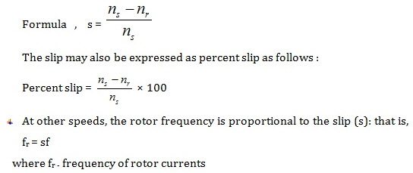
- Advantages include;
-they have low cost and require minimum maintenance
-they have simple and rugged construction
-they have power factor of 0.89
-they have high efficiency (90%)
-they have good speed regulation
-they are self-starting
-they have reduced power loss
Disadvantages include;
-its speed reduces with increase in load.

- The equivalent motor resistance referred to stator =
R₀₁= $R_{1}+\frac{R_{2}}{X_{2}}$ = 0.06+0.06 = 0.12Ω.
The equivalent motor reactance referred to stator,
X₀₁ = $X_{1}+\frac{X_{2}}{k^{2}}$ = 0.2+0.22 = 0.42Ω
Motor impedance
Z₀₁ = $\sqrt{\left(R_{01}^{2}\right)+\left(X_{01}^{2}\right)}$ = $\sqrt{{(0.12)}^{2}+{(0.42)}^{2}}$ = 0.437Ω.
s =
$$\frac{\frac{R_{2}}{K^{2}}}{\frac{R_{2}}{K^{2}}+Z_{01}}$$=
$$\frac{0.06}{0.06+0.437}$$= 0.12
Maximum gross power output
=
$$\frac{3V^{2}}{2(R_{01}+Z_{01}}$$=
$$\frac{3×\left(\frac{400}{\sqrt{3}}\right)\underset{←}{2}}{2(0.12+0.437)}$$
= 143,626W or 143.63KW

- The torque slip curve for an induction motor gives us the information about the variation of torque with the slip. The slip is defined as the ratio of difference of synchronous speed and actual rotor speed to the synchronous speed of the machine. The variation of slip can be obtained with the variation of speed that is when speed varies the slip will also vary and the torque corresponding to that speed will also vary.
The curve can be described in three modes of operation
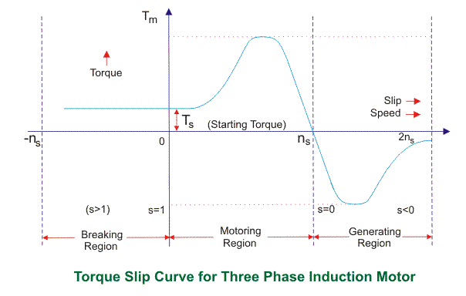
Motoring Mode
In this mode of operation, supply is given to the stator sides and the motor always rotates below the synchronous speed. The induction motor torque varies from zero to full load torque as the slip varies. The slip varies from zero to one. It is zero at no load and one at standstill. From the curve it is seen that the torque is directly proportional to the slip.
That is, more is the slip; more will be the torque produced and vice-versa. The linear relationship simplifies the calculation of motor parameter to great extent.
Generating Mode
In this mode of operation induction motor runs above the synchronous speed and it should be driven by a prime mover. The stator winding is connected to a three phase supply in which it supplies electrical energy. Actually, in this case, the torque and slip both are negative so the motor receives mechanical energy and delivers electrical energy. Induction motor is not much used as generator because it requires reactive power for its operation.
That is, reactive power should be supplied from outside and if it runs below the synchronous speed by any means, it consumes electrical energy rather than giving it at the output. So, as far as possible, induction generators are generally avoided.
Braking Mode
In the Braking mode, the two leads or the polarity of the supply voltage is changed so that the motor starts to rotate in the reverse direction and as a result the motor stops. This method of braking is known as plugging. This method is used when it is required to stop the motor within a very short period of time. The kinetic energy stored in the revolving load is dissipated as heat. Also, motor is still receiving power from the stator which is also dissipated as heat. So as a result of which motor develops enormous heat energy. For this stator is disconnected from the supply before motor enters the braking mode.
If load which the motor drives accelerates the motor in the same direction as the motor is rotating, the speed of the motor may increase more than synchronous speed. In this case, it acts as an induction generator which supplies electrical energy to the mains which tends to slow down the motor to its synchronous speed, in this case the motor stops. This type of breaking principle is called dynamic or regenerative breaking.

- 20 Rps = rpm = 20 x 60 = 1200rpm
15rps = rpm = 15 x 60 = 900 rpm
Ns =
$$\frac{120f}{p}$$
$$\frac{120 ×60}{1200}=6poles$$
$$\% slip= \left\lfloor \frac{Ns-Nr}{Ns}\right\rfloor ×100$$
=
$$\left\lfloor \frac{1200-900}{1200}\right\rfloor ×100=25\%$$
F’= sf
F’= 0.25 x 60 = 15Hz
Ns-Nr = 1200 -900 = 300
F’= SF
  - X 60 = 6Hz

Q4.
- Control from stator side
Control from rotor side
Speed control by frequency variation
Speed control by pole changing
Speed control by varying supply voltage
Speed control by varying rotor resistance
Speed control by injected EMF
Speed control by cascade connection

- Soft starter
Direct On Line starter
Reduced voltage starter

- Direct-on-line starting
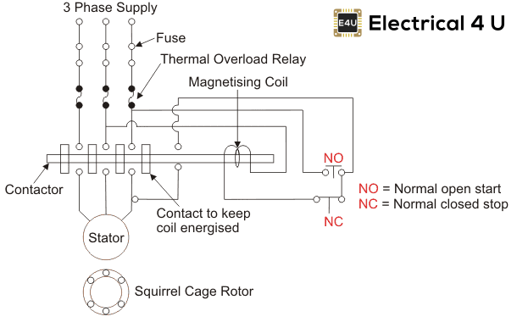
this kind of starting mode is the most basic and simplest in the motor starting. The method is characterized by less investment, simple equipment and small quantity. Although the starting time is short, the torque is smaller at starting and the current is large, which is suitable for starting small capacity motors.

Soft starter
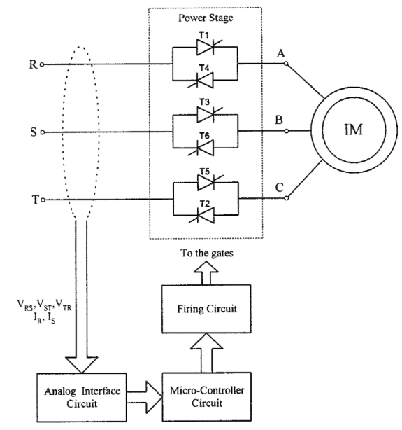
Soft starter is a new type control device whose main advantages include soft starting, light load and energy saving, and quickness. One of the most important features is that the electronic circuit is conducted in the silicon controlled rectifier of motor under the tandem connection of power supply. Using the soft starter to connect the power supply with the motor and different methods to control the conduction angle in silicon controlled rectifier can make the input voltage of motor increase gradually from zero and transfer all the voltage to motor from the beginning to the end, which is called soft starting. When starting in this way, the torque of motor will gradually increase with enhancive speed. In fact, the soft starter is a voltage regulator that only changes the voltage without altering the frequency at starting.

Q5.
- There are many reasons to test an induction motor.
-The simplest would be to find out if it works.
-You could test it to see if it performs in accordance with its specifications.
-You could test it to determine the machine parameters necessary for modeling and vector controlling the machine.
-You could test it for reliability and lifetime.
-You could test it to failure to see how much performance margin it has.
- Similarities include;
-the shaft of the motor is locked so that it cannot move and the rotor winding is short circuited.
-In the slip ring motor, the rotor winding is short circuited through the slip rings.
Differences include;
-in a blocked rotor test the rotor is blocked so that it cannot move, a voltage is applied to the motor, and the resulting voltage, current and power are measured while in a short circuit test the test is performed at a rated frequency and with balanced polyphase voltages applied to the stator terminal.
-in a short circuit test as the motor is no load the power factor is very low which is less than 0.5 while the block rotor test is conducted at low voltage because if the applied voltage was normal voltage then the current flowing through the stator windings were high enough to overheat the windings and damage them.

- Similarities include;
-Open circuit test or no load test on a transformer is performed to determine 'no load loss (core loss)' and 'no load current
-The open circuit and no load test are performed for determining the parameter of the transformer like their efficiency, voltage regulation, circuit constant.
Differences include;
-The purpose of the open circuit test is to determine the no-load current and losses of the transformer because of which their no-load parameter are determined. While the no load test determines the copper loss occur on the full load. The copper loss is used for finding the efficiency of the transformer.

-An open circuit test is conducted when the secondary of the transformer is kept in open condition without connecting any load with it. Thus there will not be any current in the secondary coil. While a no load test is conducted shorting the secondary terminals. Thus there will be huge current flow in the secondary coil when voltage is applied in the primary.

- –momentary over-load test
--no load test
--locked rotor reduced voltage test
--insulation resistance test
Locked rotor reduced voltage test: In this test, the rotor of the induction motor is blocked with mechanically methods such as brake drum pulley. And apply AC voltage to stator winding from zero voltage to full load voltage. In this condition, the induction motor will get short-circuited conditions. In this short circuit condition, the value of motor applied voltage, current, input power is measured; and in case of squirrel cage induction motor, torque measured. This test can be performed on both the squirrel cage and slip ring induction motor.

- 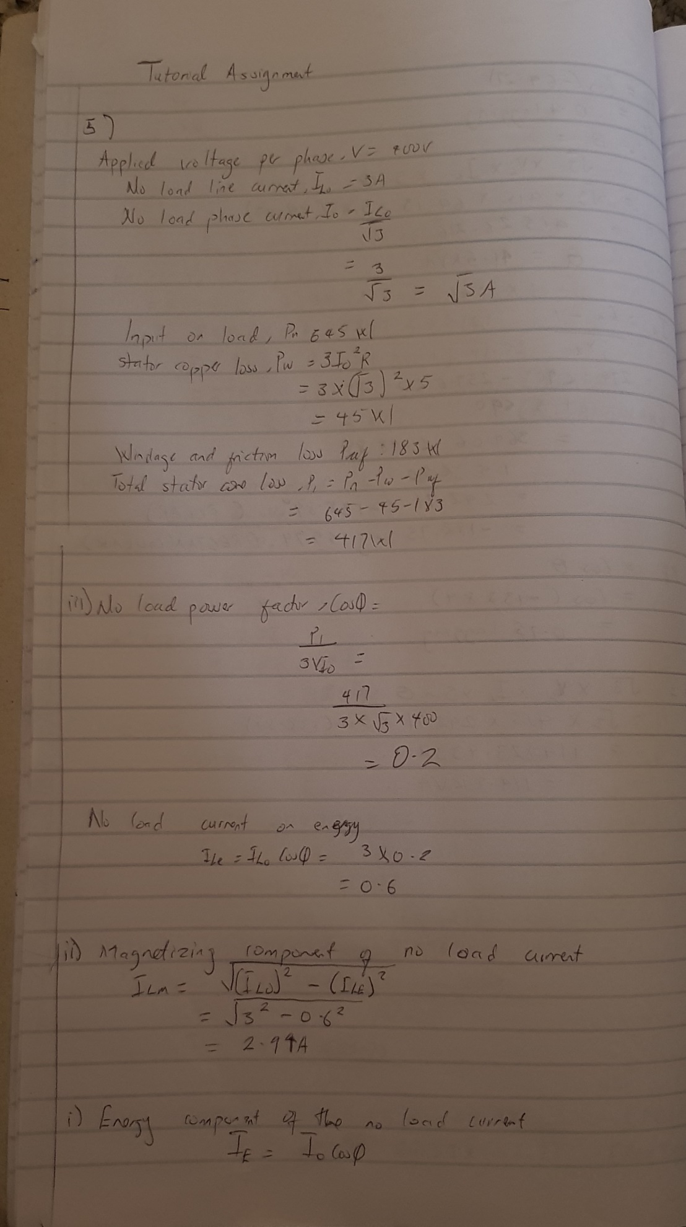
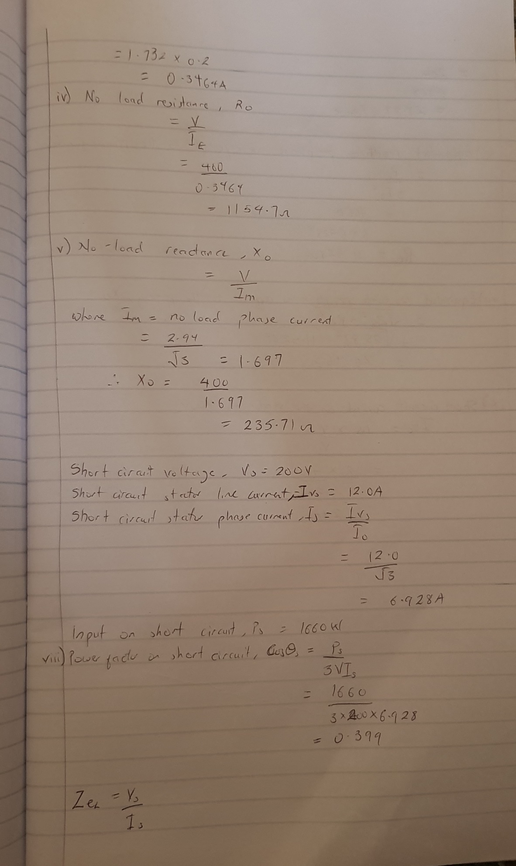
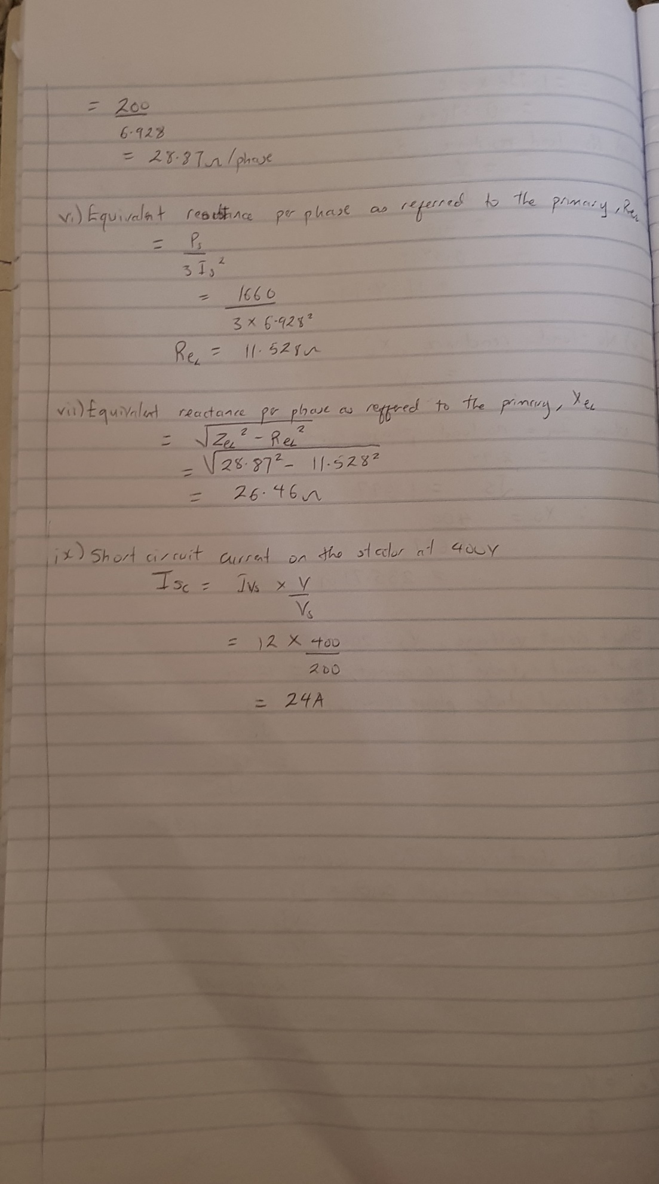

Q6.
- The principle of operation of synchronous generator is electromagnetic induction. If there exists a relative motion between the flux and conductors, then an emf is induced in the conductors. To understand the synchronous generator working principle, let us consider two opposite magnetic poles in between them a rectangular coil or turn is placed as shown in the below figure.
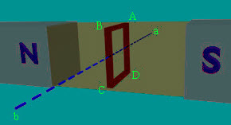
If the rectangular turn rotates in clockwise direction against axis a-b as shown in the below figure, then after completing 90 degrees rotation the conductor sides AB and CD comes in front of the S-pole and N-pole respectively. Thus, now we can say that the conductor tangential motion is perpendicular to magnetic flux lines from north to south pole.
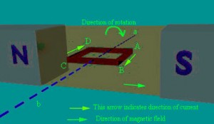
So, here rate of flux cutting by the conductor is maximum and induces current in the conductor, the direction of the induced current can be determined using Fleming’s right hand rule. Thus, we can say that current will pass from A to B and from C to D. If the conductor is rotated in a clockwise direction for another 90 degrees, then it will come to a vertical position as shown in the below figure.
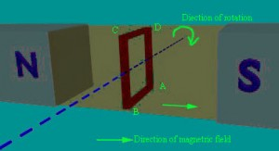
Now, the position of conductor and magnetic flux lines are parallel to each other and thus, no flux is cutting and no current will be induced in the conductor. Then, while the conductor rotates from clockwise for another 90 degrees, then rectangular turn comes to a horizontal position as shown in the below figure. Such that, the conductors AB and CD are under the N-pole and S-pole respectively. By applying Fleming’s right hand rule, current induces in conductor AB from point B to A and current induces in a conductor CD from point D to C.
So, the direction of current can be indicated as A – D – C – B and direction of current for the previous horizontal position of rectangular turn is A – B – C – D. If the turn is again rotated towards vertical position, then the induced current again reduces to zero. Thus, for one complete revolution of rectangular turn the current in the conductor reaches to maximum & reduces to zero and then in the opposite direction it reaches to maximum & again reaches to zero. Hence, one complete revolution of rectangular turn produces one full sine wave of current induced in the conductor which can be termed as the generation of alternating current by rotating a turn inside a magnetic field.
Now, if we consider a practical synchronous generator, then field magnets rotate between the stationary armature conductors. The synchronous generator rotor and shaft or turbine blades are mechanically coupled to each other and rotate at synchronous speed. Thus, the magnetic flux cutting produces an induced emf which causes the current flow in armature conductors. Thus, for each winding the current flows in one direction for the first half cycle and current flows in the other direction for the second half cycle with a time lag of 120 degrees (as they displaced by 120 degrees). Hence, the output power of synchronous generator can be shown as below figure.
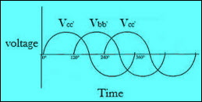

- 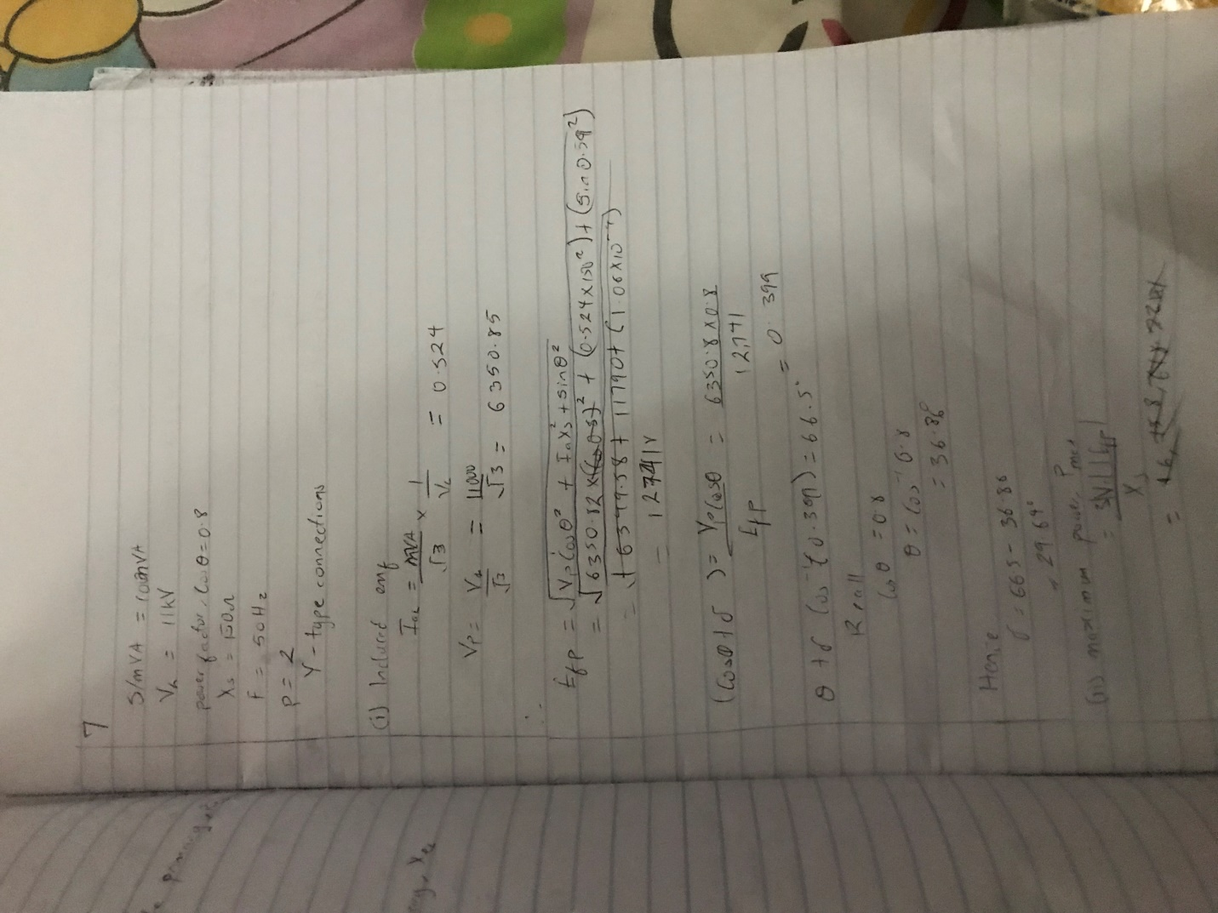
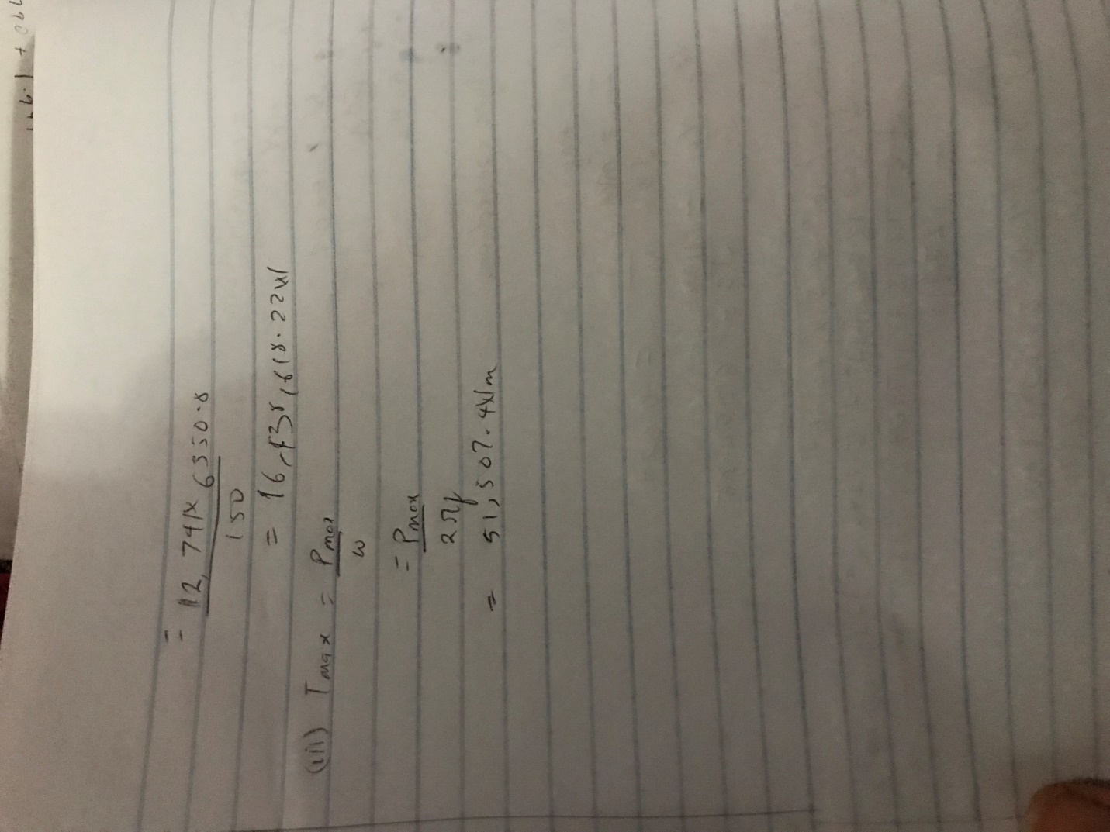
- When two or more generators with same frequency, voltage and phase difference are connected to the bus-bar; such that it increase their overall capacity, ease of maintenance, and active load management. Then they are called to be connected in parallel; and the method used is called paralleling. While the process used in this method to assist is known as synchronizing. It is an effective way to increase the overall power output of a plant; with much better control and ease of maintenance.
Advantages include;
--Continuity of Supply and Maintenance: A parallel connection is more favorable for repair and periodical maintenance work. It is easier for maintenance when smaller individual generating units are used, since we can schedule the maintenance of each unit, one after the other without affecting the continuity of power generation.
If instead it was a single unit, then an entire shutdown would be required for maintenance. This would drastically affect power demand during that duration.
-- Efficiency: According to the efficiency verses load curve, generator efficiency is maximum when the load is 100%, so the generator unit must run on full load. A single large unit would be uneconomical for lower loads, but with smaller individual units we can add up or switch off the generator units as per the load requirements in order to meet the maximum efficiency.
-- Expansion Plans: Suppose the current capacity of a power plant is 500 MW. In order to expand the capacity to 700 MW to fulfill the rising future demand, it would be costlier to replace the entire setup and purchase a bigger unit.
It would be more economical to buy small individual alternator units which can be added in parallel to the bus bar system in order to reduce the initial capital investment.
-- Maximize Power System Reliability: If any one of the generators running in parallel is tripped due to fault, other parallel generators in the system will share the load. So, the electrical system is not interrupted by the tripping of one alternator, only when the shared loads do not make other alternators over loaded

