ROLE OF T- LYMPHOCYTES AND B- LYMPHOCYTES IN THE PATHOGENESIS AND PROGRESSION OF OSTEOARTHRITIS AND OSTEOMYELITIS.

ANA 401
INTRODUCTION TO HISTOPATHOLOGY.

LEDUM SONIA
16/MHS03/017
ANATOMY DEPARTMENT
400 LEVEL.

LECTURER: MR. EDEM E. EDEM

OSTEOARTHRITIS:

Osteoarthritis (OA) is the most common type of arthritis. The prevalence of symptomatic OA is at least 12.1% in both sexes, whereas the prevalence of radiographically defined OA is much higher and increases with age (Lawrence, Helmick, et al., 1998). OA is a heterogeneous disease, and its classification leaves much to be desired (Altman, Asch, et al., 1986). Primary OA, which has no apparent predisposing factor, and secondary OA, in which the patient has a prior trauma or condition related to OA, are the 2 most common subsets. Primary OA is called generalized OA when it affects many joints, nodal OA when it exhibits as nodes over interphalangeal joints, and erosive inflammatory OA when it exhibits as erosions in distal interphalangeal joints. Erosive inflammatory arthritis, which is characterized by flares of inflammation in joints and the presence of inflammation markers in peripheral blood, may represent the far end of the spectrum of generalized OA. Current treatments for OA are purely palliative, and the need for novel therapies is obvious.

Role of T and B- Lymphocytes in the Pathogenesis and Progression of Osteoarthritis:

T- Lymphocytes:

The etiology of primary OA is not known. Unidentified genetic factors have been implicated in the development of OA (Holderbaum, Haggi, et al., 1999), and a genetic component is supported by studies of families and twins (Stecher, Hersh, et al., 1953). Clonal chromosome aberrations, such as the gain of chromosomes 5 and 7, were observed in the synovial membrane of certain patients with OA. Alpha1‐antitrypsin, α1‐antichymotrypsin, gene polymorphisms, and HLA alleles have been associated with generalized OA, whereas type II procollagen gene polymorphisms have been associated with precocious OA with mild chondrodysplasia (Ala‐Kokko, Baldwin et al., 1990).

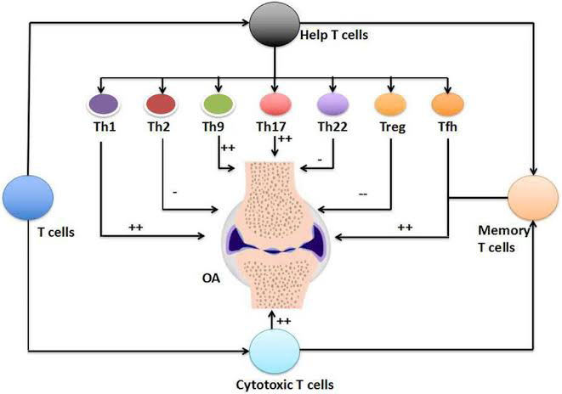

Several lines of evidence support the view that T cells may play an important role in the pathogenesis and progression of OA (Sakkas and Platsoucas, 2002), as follows.

1. CD3+ T cells infiltrate the synovial membrane of patients with OA.

Several groups of investigators, including our own, have reported the presence of mononuclear cell (MNC) infiltrates consisting of T cells and macrophages in the synovial membrane of >50% of patients with OA. MNC infiltrates may be diffuse or perivascular nodular (Lindblad and Hedfors, 1987).

2. T cells infiltrating the synovial membrane of patients with OA express early, intermediate, and late activation antigens.

We previously demonstrated that in the majority of patients with advanced OA, T cells infiltrating the synovial membrane express early activation antigens (CD69), intermediate activation antigens (CD25, CD38), and late activation antigens (CD45RO, HLA class II). These activation antigens were expressed on T cells and other MNCs infiltrating the synovial membrane of both patients with OA and patients with RA, although their proportions were significantly higher in patients with RA than in those with OA. Although it could be argued that CD45RO+ T cells may extravasate from peripheral blood, the expression of CD69, an early activation antigen, suggests that activation occurs in situ, in the synovial membrane. CD38 and the CD43, which are detected in the synovial membrane of patients with OA, mediate adhesion to vascular endothelium and binding to intercellular adhesion molecule 1 (ICAM‐1), respectively. Leukocytes and endothelial adhesion molecules are also expressed in the synovial membrane of patients with OA, although to a lesser degree than in patients with RA. B cells are also activated in patients with OA (Jasin, 1985).

3. HLA association of OA.

Several studies have demonstrated associations of OA with HLA class I and HLA class II alleles. Studies on generalized OA revealed an association with HLA–B8. This association may not be primary, because HLA–B8 is in linkage disequilibrium with DR3. Another study in Japanese patients with generalized OA revealed an association with HLA–Cw4. The frequencies of the HLA–DRB1*0101, *0401, *0405, *1001, and *1402 alleles, which have been reported to be associated with RA, were not significantly different in patients with generalized OA compared with control subjects. Hand OA was found to be associated with the haplotype HLA–A1;B8 and haplotypes HLA–B35;DQ1, HLA–B40;DQ1, and HLA–DR2;DQ1. An association of dysplastic hip OA with HLA–DR4 was observed. An association of the HLA–DRB1*02 allele was found to be a risk factor for the development of distal interphalangeal OA. Similarly, in another study, an association of the HLA–DRB1*02 allele with OA was identified in a cohort of 106 patients, whereas the DR5 allele was negatively associated with the disease. This HLA class II association of OA further supports the concept that OA, at least in certain patients, may be a trimolecular‐complex (T cell receptor [TCR]/antigen/HLA) disease.

Interestingly, the normally HLA–DR–negative chondrocytes become positive in OA, suggesting that they may function as antigen‐presenting cells (APCs). Physical interaction between chondrocytes and T cells is conceivable, because cartilage fragments, which are mechanically shaved from the cartilage surface, are frequently found in the synovial membrane of patients with OA. Proliferative responses in vitro of peripheral blood T cells from patients with OA to autologous chondrocytes were significantly higher compared with those of T cells from normal control subjects. T cells derived from the peripheral blood or synovial fluid of patients with OA responded to membrane preparations of autologous chondrocytes and fibroblasts by proliferation. These T cell responses are monocyte dependent, suggesting an antigen‐specific immune response.

4. T cell cytokines are produced in the synovial membrane of patients with OA.

We have shown interleukin‐2 (IL‐2), interferon‐γ (IFNγ), and IL‐10 transcripts in the synovial membrane of 50% of patients with OA and in the synovial membrane of the majority of patients with RA. IL‐4 or IL‐5 transcripts were not detected by polymerase chain reaction (PCR) amplification in the synovial membrane of patients with OA, suggesting the presence of a Th1 cytokine pattern in the synovial membrane of patients with OA. A predominant Th1 cytokine pattern has also been observed in the synovial membrane of patients with RA. Quantitative PCR analysis using MIMIC demonstrated that IFNγ transcript levels in OA were similar to those in RA, when normalized for T cell equivalents. This means that T cells infiltrating the synovial membrane of patients with OA are as active as those infiltrating the synovial membrane of patients with RA, although they are present in lower numbers in OA. IFNγ protein was detected by immunohistochemistry in the synovial membrane of most patients with OA. Th1‐type cytokine transcripts were also found in MNCs from the synovial fluid of patients with OA. Both IFNγ protein and IL‐4 protein were detected in the synovial fluid of patients with OA.

Because IL‐12 is a major inducer of Th1 cytokines, we examined whether IL‐12 was produced in the synovial membrane of patients with OA and patients with RA. IL‐12 was detected, at both the messenger RNA level (IL‐12 p40) and the protein level (IL‐12 p70) in the synovial membrane of the majority of patients with OA or RA. IL‐12, which is produced by macrophages during phagocytosis, even of inert material, may drive the cytokine pattern in the OA synovial membrane toward the Th1 pattern. In addition to IL‐12, other molecules may participate in the Th1 cell response in OA, including chemokines such as IL‐8 and macrophage inflammatory protein 1α (MIP‐1α). T cells producing Th1 cytokines express CCR5 on the cell surface. CCR5 is a receptor for MIP‐1α, a T cell chemoattractant that is up‐regulated in the synovial fluid of patients with OA. Th1 cells may be driven into the synovial membrane of patients with OA by inciting antigens and/or IL‐12 or chemokines. IL‐10 transcripts have been observed in the synovial membrane of nearly all OA patients examined, often in addition to IFNγ and IL‐2 transcripts. IL‐10 has been classified as an antiinflammatory Th2 cytokine in mice. IL‐10 in humans cooperates with IL‐4 to inhibit the production of proinflammatory cytokines by adherent rheumatoid synovial cells. However, IL‐10 in humans is produced by both monocytes and Th1 cells. In conclusion, proinflammatory Th1 cytokines (such as IFNγ and IL‐2) and IL‐10 are expressed in the synovium of patients with OA.

Peripheral blood mononuclear cells (PBMCs) from patients with OA have been shown to express levels of CCR1, CCR3, CCR5, CCR6, and CCR7 chemokines comparable with the levels expressed by PBMCs from patients with RA. Serum levels of the activation‐induced T cell–derived chemokine‐related cytokine lymphotactin, which is a lymphocyte chemoattractant, were similar in patients with OA and those with RA.

5. Autoantibody responses in OA.

Low numbers of B cells infiltrate the synovial membrane of patients with OA. CXCL13, a potent chemo-attractor of B cells, is expressed in lymphoid aggregates in the OA synovial membrane. Single‐strand conformation polymorphism analysis of immunoglobulin transcripts isolated from the synovial membrane of 6 patients with OA revealed the presence of oligoclonal B cells. Highly mutated immunoglobulin VH genes were observed in OA synovial membrane. Autoantibodies against specific target antigens were detected in patients with OA as early as 20 years ago, although they have attracted little attention. One study demonstrated that anti–cartilage intermediate layer protein, anti–YKL‐39, antiosteopontin, and anti–cyclic citrullinated peptide (anti‐CCP) antibodies were detected in patients with early‐stage knee OA but not in those with late‐stage knee OA. However, according to other investigators, anti‐CCP antibodies are a marker for RA, with a specificity of 98%.

6. T cells infiltrating the synovial membrane of patients with OA contain oligoclonal populations of T lymphocytes.

T cells comprise large numbers of different T cell clones, which are distinguished from each other by expressing different, although highly homologous, TCRs for antigens. Each of these TCRs is a unique fingerprint of the corresponding T cell clone. The size of the T cell repertoire in peripheral blood is estimated to be in the order of 106 different β‐chain TCR transcripts, each one pairing with at least 25 TCR α‐chains. These numbers of T cell clones are still very large and are sufficient to permit recognition of all conceivable antigenic epitopes.

T cells are activated and proliferate either in response to specific antigens (antigen‐driven proliferation) or in a nonspecific manner (antigen‐independent proliferation). Nonspecific activation and proliferation could occur either in response to mitogens or chemokines or in response to superantigens and in both cases will result in a large, heterogeneous, polyclonal population of T cells comprising different T cell clones expressing unique β‐chain TCR transcripts, when compared with each other. T cells activated in response to superantigens will utilize β‐chain TCRs comprising a restricted number of Vβ gene segments and a unique third complementarity‐determining region (CDR3), when compared with each other.

In contrast, specific antigen–driven stimulation of T cells would result in proliferation and clonal expansion of only those T cell clones that recognize the specific antigen. Thus, a specific antigen–driven clonal T cell response is identified by the presence of multiple identical TCR transcripts. Because of the large number of β‐chain TCR transcripts, the probability is negligible that multiple identical copies of a single β‐chain TCR transcript within an independent sample of T cells will be found by chance. Therefore, the presence of multiple identical copies of a β‐chain TCR transcript within an independent sample of T cells, such as those infiltrating the synovial membrane of patients with OA, must be the result of specific antigen–driven proliferation and clonal expansion of a T cell clone(s) in response to a specific antigen, resulting in the presence of substantial proportions of monoclonal or oligoclonal T cells.

To determine whether multiple identical proportions of TCR transcripts are present in a population of T cells, α‐chain and/or β‐chain TCR transcripts were amplified by PCR, followed by cloning and sequencing, or by assessing the length of the CDR3 of the amplified TCR transcripts by CDR3 spectrotyping (β‐chain TCR only). Both approaches require that separate PCR amplifications be carried out for each one of the 32 Vα and 26 Vβ families to which all known human Vα and Vβ segments have been classified. Different 5′‐end amplification primers must be synthesized, and different PCR amplifications must be carried out for each family. Such an approach has several limitations, the most important of which are that quantitation of the results may be limited by different amplification efficiencies and that the approach is laborious.

To address these limitations, we developed a PCR amplification method specifically designed for the amplification of transcripts with variable or unknown 5′ ends, such as the TCRs and immunoglobulins. This method has been designated nonpalindromic adaptor PCR (NPA‐PCR). We have used this approach to study the presence of specific antigen–driven populations of T cells in several diseases, with the overall objective of identifying the antigen(s) recognized by these clonally expanded T cells. NPA‐PCR has certain distinct advantages over classic PCR techniques for the amplification of transcripts with unknown or variable 5′ ends. The major advantage is that only one amplification is needed for the α‐chain, with a second amplification needed for the β‐chain TCR.

7. Putative OA antigens.

Although the antigen or antigens that drive the immune response in OA have not been identified, possible candidates have been postulated, and those antigens should be considered. T cells from the peripheral blood and synovial fluid of patients with OA exhibited strong proliferative responses to preparations of autologous chondrocyte membranes and autologous fibroblast membranes but not to epithelial cell membranes. In RA, however, proliferative responses only to preparations of autologous chondrocyte membranes and not to autologous fibroblast or epithelial cell membranes have been reported.

8. Decreased expression of the CD3 ζ‐chain in T cells infiltrating the synovial membrane of patients with OA.

The CD3 ζ‐chain is one of the CD3 proteins and is part of the T cell signal transduction cascade that is initiated by engagement of the TCR by appropriate antigenic epitopes and culminates in T cell activation and proliferation. The CD3 ζ‐chain is expressed on the cell surface as a disulfide‐linked homodimer and plays a crucial role in the signal transduction pathway. Immunohistochemistry studies revealed that the CD3 ζ‐chain protein was detected in the synovial membrane of 10 of 19 patients with OA, and that staining was of variable intensity. In contrast, the CD3ϵ protein was present in all patients (P = 0.0023). Double immunofluorescence analysis by fluorescence‐activated cell sorting of single‐cell suspensions derived from the synovial membrane of patients with OA, using anti‐CD3ϵ and anti‐CD3ζ monoclonal antibodies, revealed decreased expression of CD3ζ protein. Similarly, analysis by reverse transcription–PCR and semiquantitative PCR (MIMIC) revealed significantly decreased expression of CD3ζ transcripts. Therefore, the expression of CD3ζ transcripts and protein is significantly decreased in T cells infiltrating the synovial membrane of patients with OA, in a manner similar to that observed in T cells in several conditions involving chronic antigenic stimulation of T cells, including RA, human immunodeficiency virus infection, leprosy, and several types of tumors. Decreased expression of the CD3 ζ‐chain is associated with T cell hyporesponsiveness and anergy and defective signal transduction. These results suggest that chronic T cell stimulation is taking place in the synovial membrane of patients with OA, resulting in decreased expression of CD3ζ transcripts and protein in these T cells. These results support the concept of T cell involvement in OA.
Conclusion:

It is now becoming clear that OA encompasses a broad spectrum of changes in the synovial membrane, ranging from minimal inflammation to intense inflammation, and that OA may no longer be considered only a degenerative joint disease. In a microarray analysis using ∼18,000 genes, the expression profile of the synovial membranes from patients with OA was like that observed in the synovial membranes from a group of patients with RA, exhibiting low inflammatory gene expression and high tissue remodeling activity, emphasizing the importance of the synovial membrane in the development of OA. Although OA is a heterogeneous disease in many patients, a T cell immune response is evident and is characterized by the presence of T cell infiltrates (often nodular), expression of T cell activation antigens, production of Th1 cytokines, and the presence of oligoclonal T cells in the synovial membrane.

Evidence supporting the role of T cells in the pathogenesis of osteoarthritis:

1. T cells and monocyte/macrophages infiltrate the synovial membrane of a substantial proportion of patients with osteoarthritis.
2. Mononuclear cells infiltrating the synovial membrane of these patients express early, intermediate, and late activation antigens.
3. T cells in the synovial membrane of patients with advanced osteoarthritis often form perivascular nodules.
4. T cells infiltrating the synovial membrane of patients with osteoarthritis express Th1 cytokine transcripts and proteins.
5. Monoclonal/oligoclonal populations of T cells are present in the synovial membrane of patients with osteoarthritis, suggesting that these cells have undergone specific antigen–driven proliferation and clonal expansion, in response to an unidentified antigen or antigens.
6. T cells exhibit reduced levels of CD3 ζ‐chain transcript and protein, as in other antigen‐driven T cell responses with chronic stimulation.
7. T cells, through direct cell–cell contact or soluble mediators, can activate macrophages to degrade cartilage.
8. T cell–derived cytokines and chemokines are found in the synovial membrane of patients with osteoarthritis, and they can directly degrade cartilage.

B- Lymphocytes:

- Pathogenesis of Osteoarthritis:

Immune cells including T cells, B cells and macrophages infiltrate the joint tissues, cytokines and chemokines are released from different kind of cells present in the joint, complement system is activated, cartilage degrading factors such as matrix metalloproteins (MMPs) and prostaglanding E2 (PGE2) are released, resulting in further damage to the articular cartilage.
Cellular infiltrates in the inflamed OA synovium have been reported to contain activated B cells along with other cell types. A clonal analysis of B cells in OA synovium revealed their oligoclonal nature suggesting an antigen driven activation instead of non-antigenic activation. Moreover, several studies found antibodies against cartilage components highlighting the activation of humoral adaptive immune response in OA. When cartilage cell surface proteins were used as substrate in an ELISA and sera from OA patients were applied, an elevated antibody titer was detected compared to controls. Similarly, autoantibodies were found in OA patients against cartilage derived proteins osteopontin, cartilage intermediate layer protein (CILP), YKL-39, fibulin-4 and collagen. Anti-CCP antibodies were detected in 7 out of 136 OA patients, while another group also detected them in OA patients but at significantly lower levels compared to RA patients. Antibodies against native G1 domain of aggrecan core protein were found in synovial fluid of OA patients. Using proteomic approach, Xiang et al identified triosephosphate isomerase (TPI) as an important antigen with autoantibodies present specifically in OA but not in RA. Other studies have reported autoantibodies in animal models of OA including horses and dogs. The role of the autoantibodies against cartilage components in development of OA has been further highlighted by studies showing their deposition and cytotoxic effects on cartilage, which may be one of the mechanisms playing important role in cartilage degeneration in OA.
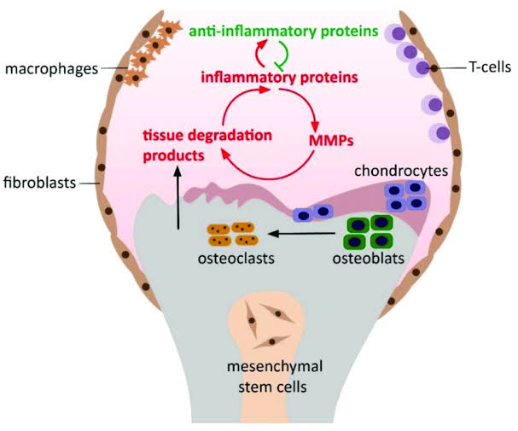
Pathogenesis of osteoarthritis, including the progression of the osteoarthritis (OA) positive feedback loop, including synovial inflammation and tissue degradation. Inflammatory proteins produced mainly by chondrocytes, synovial fibroblasts, and macrophages induce the excess production of tissue-degrading enzymes, such as matrix metalloproteinases. Products of cartilage breakdown are phagocytosed by the synovial cells triggering the release of even more proinflammatory proteins.

- Progression of Osteoarthritis:

Synovial infiltration by B lymphocytes is present in almost half of the knee OA cases. The degree of B lymphocyte infiltration is associated with more pronounced synovial inflammation and with the presence of plasma cells and lymphoid follicles in more severe cases. Autoreactive B cells and Ab specificities have been widely studied in peripheral blood, SF, ST, and bone marrow of RA patients, whereas such data are scarce in other types of chronic arthritis including OA. To gain insights into the possible role of B cells in OA, we analyzed the presence and Ig VH gene usage of B cells in OA synovitis. In this study, we show that B lymphocytes are infiltrating the synovial membrane in clinically inflamed knee OA joints, with the presence of lymphoid follicles and plasma cells in severe cases; B cell clonal and oligoclonal expansions are common in inflamed OA synovium; most of the VH genes are highly mutated in the CDR regions and indicate the presence of Ag-driven, post-GC memory B cells, although some Ag-independent B cell clones may also infiltrate into OA ST; and the expression of intra-clonal offspring mutations in OA synovial B cells indicate an in situ proliferation of these clone(s) under the pressure of local Ag stimulation.

OA is generally considered as a disease of articular cartilage, with a primary failure of chondrocyte and extracellular matrix homeostasis induced by a variety of genetic, metabolic, and biochemical factors. However, increasing evidence points toward inflammation of the synovial membrane in OA, ranging from minimal lining cell layer hyperplasia to severe acute and chronic synovitis. Early OA with active joint effusion can also depict some systemic signs of inflammation such as increased C-reactive protein levels. In the joint, the infiltrating leukocytes and the resident synovial fibroblasts can release inflammatory mediators, in particular matrix metalloproteinases and IL-1, that contribute to the degradation of the extracellular cartilage matrix and the suppression of chondrocyte anabolism. These data indicate that, although probably not the primary mechanisms initiating the disease, inflammation may contribute to the progression and/or perpetuation of OA.

Although this inflammatory component of OA is now well recognized, recently accumulated evidence supports the involvement of autoimmune mechanisms in this process. The synovial infiltration in knee OA is characterized by the presence of both T and B lymphocytes. Cellular autoimmunity against cartilage link protein and proteoglycan aggrecan have been observed in OA patients. Moreover, autoantibodies against cartilage and bone proteins such as collagen type II, the cartilage intermediate layer protein, YKL-39, and osteopontin , which have been demonstrated in the serum of RA patients, have also been detected in OA patients. A recent comprehensive proteomic surveillance has revealed that some Ags are recognized predominantly in OA rather than in RA. In animal models, immunization with cartilage proteins such as collagen type II, human cartilage glycoprotein-39, cartilage link protein, and proteoglycans induce destructive arthritis whereas cartilage intermediate layer protein and YKL-39 cause mild synovitis but no cartilage or bone destruction.
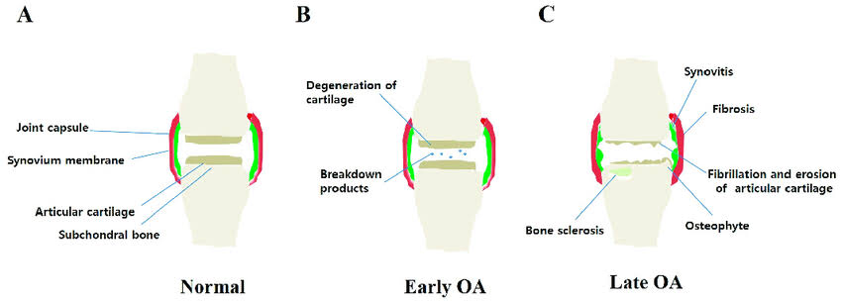

OSTEOMYELITIS:

BI, or osteomyelitis, is an inflammatory process accompanied by bone destruction. While in industrial countries the infecting microorganisms are usually Staphylococcus species, species such as Mycobacterium tuberculosis and Salmonella typhi are more common in other parts of the world. It is noteworthy that bone resorption is associated with infection, regardless of the causative microbiological agent [Potempa, Banbula et al., 2000].

Role of T and B-lymphocytes in the Pathogenesis and Progression of Osteomyelitis:

- Pathogenesis:

Accordingly, it has been demonstrated that activated T cells exert their effect via membrane-bound and secretory receptor activator of nuclear factor kappa B ligand (RANKL). In one in-vitro study it was found that CD4+ T cells can support osteoclastogenesis in the presence of macrophage colony-stimulating factor (M-CSF) alone, and the addition of RANKL led to increased bone resorption. Conversely, CD8+ T cells did not support OC differentiation, but rather inhibited OC differentiation/activation induced by RANKL.

Of note, experimental models used CD3/CD28 stimulation to study lymphocyte–OC interaction. However, co-stimulatory molecules, CD28, CD80, CD86, cytotoxic T-lymphocyte antigen-4 (CTLA-4)/CD152, CD40 and CD40L showed major alterations of expression in bacterial infection, which may be responsible for modulating cellular interactions. Interestingly, analysis of synovium of patients with chronic septic arthritis showed dramatic T cell proliferation. This dramatic proliferation of T cells suggests the occurrence of some major cellular interactions.

Among other key immunological features studied in osteoimmunology is apoptosis of CD4 T cells, for which researchers have suggested an inverse CD4/CD8 ratio observed in patients with aseptic loosening of prosthesis. Apoptosis might be related to regulatory T cells (Tregs), which are specialized to limit the magnitude of T cell effector responses. The pathogenesis of this disease is a double-edged sword whereby not only can staphylococci utilize bone for colonization, bone itself can facilitate infection progression. Moreover, in addition to the ability of staphylococci to adapt to and evade the immune response by using the host's own machinery, they have also acquired resistance mechanisms to survive a plethora of antibiotic treatments available today. This, in conjunction with the need for surgical intervention, has led to new, exciting approaches in the field. For example, there has been a shift toward developing bifunctional bone-regenerative biomaterials whose degradation matches the native bone regeneration rate, combined with local delivery of antibiotics. Controlling the release of antimicrobials, which functions both to minimize systemic toxicity and to reduce the risk of inducing antibiotic resistance by ensuring that the release dose and rate are above minimum bactericidal concentrations enough for total infection clearance, has also become a hot topic in the drug delivery field. This may be achieved through methods such as microparticle incorporation or surface adsorption, with an on-demand release responsive to infection development (pH change, presence of bacterial toxins, or raised temperature) possible. Although nonantibiotic antimicrobials may be second to antibiotics at infection clearance, they do have the added advantage of overcoming some of the resistance mechanisms developed by bacteria. These nonantibiotic antimicrobial-loaded materials may be used for infection prophylaxis, perhaps after orthopedic procedures, which may be lengthy, post-implant removal, or following bone debridement if there is an infection risk.

Another exciting research avenue is the development of new methods to target infection by using a more tailored approach. One such area is the use of clustered regularly interspaced palindromic repeats (CRISPR). CRISPR technology has gained much attention for its gene editing abilities, mainly in mammalian cells. However, there has been considerable research into the use of CRISPR for the treatment of infectious diseases. Seminal research by Bikard et al. demonstrated the potential to use CRISPR/Cas9 in targeting staphylococcal infection by targeting the methicillin resistance gene in S. aureus, making a MRSA isolate susceptible to methicillin once again. Moreover, when the technology was delivered in vivo, there was a moderate, albeit significant reduction in infection in mouse models of S. aureus infection. This research demonstrates the potential use of CRISPR/Cas9 in vivo, advancing the field toward a more targeted and selective approach to treat infections.

Currently, most biological processes understood today are conducted in a two-dimensional (2D) setting. However, there is an increasing need for more physiologically relevant models. Studies using three-dimensional (3D) models over the past 2 decades have bridged the gap between 2D cell culture and in vivo culture. The development of collagen-based scaffolds for tissue regeneration has presented a new focus for studying bone infection. Research from our group has demonstrated that staphylococcus-induced bone infection results in hyper-mineralization of the osteoblasts, correlating with increased metabolic activity, when the bacteria are cultured in a 3D bone matrix (N. Kavanagh, F. J. O'Brien, and S. W. Kerrigan, submitted for publication). This has not been demonstrated previously, therefore highlighting the importance of using more physiologically representative models to study infection. Using such 3D models will help us to elucidate and understand disease progression and thus inform our decisions for translating into in vivo models.

- Progression of osteomyelitis:
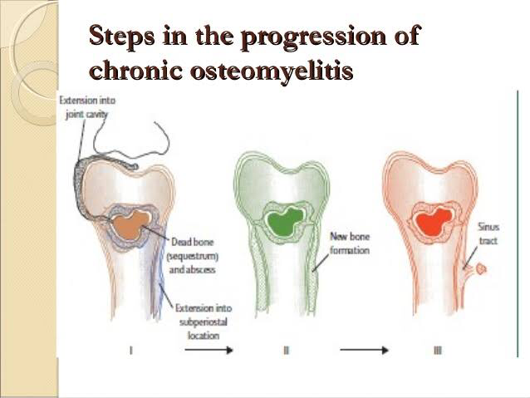

https://images.app.goo.gl/s6Z4MyHX1j8LWBih6

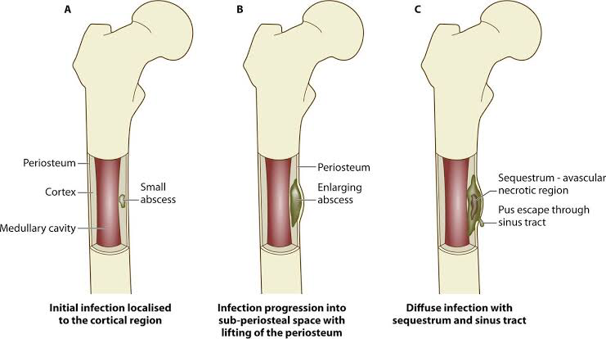

References:

Lawrence RC, Helmick CG, Arnett FC, Deyo RA, Felson DT, Giannini EH, et al. Estimates of the prevalence of arthritis and selected musculoskeletal disorders in the United States. Arthritis Rheum 1998; 41: 778– 99.

Altman R, Asch E, Bloch D, Bole G, Borenstein D, Brandt K, et al, for the Diagnostic and Therapeutic Criteria Committee of the American Rheumatism Association. Development of criteria for the classification and reporting of osteoarthritis: classification of osteoarthritis of the knee. Arthritis Rheum 1986; 29: 1039– 49.

Altman R, Alarcon G, Appelrouth D, Bloch D, Borenstein D, Brandt K, et al. The American College of Rheumatology criteria for the classification and reporting of osteoarthritis of the hand. Arthritis Rheum 1990; 33: 1601– 10.

Altman R, Alarcon G, Appelrouth D, Bloch D, Borenstein D, Brandt K, et al. The American College of Rheumatology criteria for classification and reporting of osteoarthritis of the hip. Arthritis Rheum 1991; 34: 505– 14.
Holderbaum D, Haggi TM, Moskowitz RW. Genetics and osteoarthritis: exposing the iceberg. Arthritis Rheum 1999; 42: 397– 405.

MacGregor AJ, Antoniades L, Matson M, Andrew T, Spector TD. The genetic contribution to radiographic hip osteoarthritis in women: results of a classic twin study. Arthritis Rheum 2000; 43: 2410– 6.

Stecher RM, Hersh AH, Solomon WM, Wolpaw R. The genetics of rheumatoid arthritis: analysis of 224 families. Am J Hum Genet 1953; 5: 118– 38.
CAS PubMed Web of Science®Google Scholar

Broberg K, Limon J, Palsson E, Lindstrand A, Toksvig‐Larsen S, Mandahl N, et al. Clonal chromosome aberrations are present in vivo in synovia and osteophytes from patients with osteoarthritis. Hum Genet 1997; 101: 295– 8.

Ala‐Kokko L, Baldwin CT, Moskowitz RW, Prockop DJ. Single base mutation in the type II procollagen gene (COL2A1) as a cause of primary osteoarthritis associated with a mild chondrodysplasia. Proc Natl Acad Sci U S A 1990; 87: 6565– 8.

Sakkas LI, Platsoucas CD. Role of T cells in the pathogenesis of osteoarthritis [letter]. Arthritis Rheum 2002; 46: 3112– 3.

Lindblad S, Hedfors E. Arthroscopic and immunohistologic characterization of knee joint synovitis in osteoarthritis. Arthritis Rheum 1987; 30: 1081– 8.

Jasin HE. Autoantibody specificities of immune complexes sequestered in articular cartilage in patients with rheumatoid arthritis and osteoarthritis. Arthritis Rheum 1985; 28: 241– 8.

Potempa J, Banbula A, Travis J. Role of bacterial proteinases in matrix destruction and modulation of host responses. Periodontology. 2000; 24:153–192.

Graves DT, Cochran D. The contribution of interleukin-1 and tumor necrosis factor to periodontal tissue destruction. J Periodontol. 2003; 74:391–401.

Horwood NJ, Kartsogiannis V, Quinn JM, Romas E, Martin TJ, Gillespie MT. Activated T lymphocytes support osteoclast formation in vitro. Biochem Biophys Res Commun. 1999;265: 144–150.

Li H, Hong S, Qian J, Zheng Y, Yang J, Yi Q. Cross talk between the bone and immune systems: osteoclasts function as antigen-presenting cells and activate CD4+ and CD8+ T cells. Blood. 2010; 116:210–217.

Wyzga N, Varghese S, Wikel S, Canalis E, Sylvester FA. Effects of activated T cells on osteoclastogenesis depend on how they are activated. Bone. 2004; 35:614–620.

Kong YY, Feige U, Sarosi I, et al. Activated T-cells regulate bone loss and joint destruction in adjuvant arthritis through osteoprotegerin ligand. Nature. 1999; 402:304–309.

Buchwald ZS, Kiesel JR, DiPaolo R, Pagadala MS, Aurora R. Osteoclast activated FoxP3+ CD8+ T-cells suppress bone resorption in vitro. PLOS ONE. 2012; 7:38199.

Cacere CR, Mendes-Giannini MJS, Fontes CJ, Kono A, Duarte AJS, Benard G. Altered expression of the costimulatory molecules CD80, CD86, CD152, PD-1 and ICOS on T-cells from paracoccidioidomycosis patients: lack of correlation with T-cell hyporesponsiveness. Clin Immunol. 2008; 129:341–349.

Pessler F, Dai L, Diaz-Torne C, et al. Increased angiogenesis and cellular proliferation as hallmarks of the synovium in chronic septic arthritis. Arthritis Rheum. 2008; 59:1137–1146.

Landgraeber S, von Knoch M, Löer F, et al. Association between apoptosis and CD4+/CD8+ T-lymphocyte ratio in aseptic loosening after total hip replacement. Int J Biol Sci. 2009; 5:182–191.

Singh N, Yamamoto M, Takami M, et al. CD4+CD25+ regulatory T cells resist a novel form of CD28− and fas-dependent p53-induced T cell apoptosis. J Immunol. 2010; 184:94–104.

Revell PA, Mayston V, Lalor P, Mapp P. The synovial membrane in osteoarthritis: a histological study including the characterisation of the cellular infiltrate present in inflammatory osteoarthritis using monoclonal antibodies. Ann Rheum Dis. 1988; 47:300–307.
Sakkas LI, Scanzello C, Johanson N, et al. T cells and T-cell cytokine transcripts in the synovial membrane in patients with osteoarthritis. Clin Diagn Lab Immunol. 1998; 5:430–437.

Nakamura H, Yoshino S, Kato T, et al. T-cell mediated inflammatory pathway in osteoarthritis. Osteoarthritis Cartilage. 1999; 7:401–402.

Wang Q, Rozelle AL, Lepus CM, et al. Identification of a central role for complement in osteoarthritis. Nat Med. 2011; 17:1674–1679.

