ASIRA DARRELL
18/MHS01/088
ANATOMY
BCH 204(MEDICAL BIOCHEMISTRY)

BETA OXIDATION
Beta-oxidation is the catabolic process by which fatty acid molecules are broken down[1] in the cytosol in prokaryotes and in the mitochondria in eukaryotes to generate acetyl-CoA, which enters the citric acid cycle, and NADH and FADH2, which are co-enzymes used in the ELECTRON TRANSFER CHAIN.
STAGES OF BETA OXIDATION
Beta oxidation takes place in four steps: dehydrogenation, hydration, oxidation and thyolisis. Each step is catalyzed by a distinct enzyme. Briefly, each cycle of this process begins with an acyl-CoA chain and ends with one acetyl-CoA, one FADH2, one NADH and water, and the acyl-CoA chain becomes two carbons shorter. The total energy yield per cycle is 17 ATP molecules. This cycle is repeated until two acetyl-CoA molecules are formed as opposed to one acyl-CoA and one acetyl-CoA. The four steps of beta oxidation are:
- Dehydrogenation
In the first step, acyl-CoA is oxidized by the enzyme acyl CoA dehydrogenase. A double bond is formed between the second and third carbons (C2 and C3) of the acyl-CoA chain entering the beta oxidation cycle; the end product of this reaction is trans-Δ2-enoyl-CoA (trans-delta 2-enoyl CoA). This step uses FAD and produces FADH2, which will enter the citric acid cycle and form ATP to be used as energy. (Notice in the following figure that the carbon count starts on the right side: the rightmost carbon below the oxygen atom is C1, then C2 on the left forming a double bond with C3, and so on.)
- Hydration
In the second step, the double bond between C2 and C3 of trans-Δ2-enoyl-CoA is hydrated, forming the end product L-β-hydroxyacyl CoA, which has a hydroxyl group (OH) in C2, in place of the double bond. This reaction is catalyzed by another enzyme: enoyl CoA hydratase. This step requires water.

- Oxidation
In the third step, the hydroxyl group in C2 of L-β-hydroxyacyl CoA is oxidized by NAD+ in a reaction that is catalyzed by 3-hydroxyacyl-CoA dehydrogenase. The end products are β-ketoacyl CoA and NADH + H. NADH will enter the citric acid cycle and produce
- Thiolysis
Finally, in the fourth step, β-ketoacyl CoA is cleaved by a thiol group (SH) of another CoA molecule (CoA-SH). The enzyme that catalyzes this reaction is β-ketothiolase. The cleavage takes place between C2 and C3; therefore, the end products are an acetyl-CoA molecule with the original two first carbons (C1 and C2), and an acyl-CoA chain two carbons shorter than the original acyl-CoA chain that entered the beta oxidation cycle.

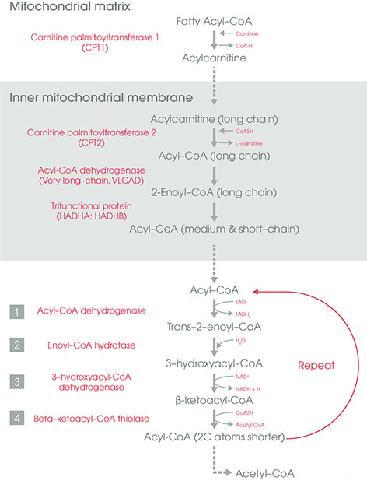
Pathways for beta oxidation of fatty acid

