NAME; Ikaki steven
MATRIC NO; 15/eng06/040
COURSE CODE; MEE586
ASSIGNMENT
- What is an integrated CAD/CAM?
An integrated CAD/CAM system provides one model supporting both design and manufacturing functions instead of having various file formats, numerous data translations/conversions, and different CAD and CAM models. ... Working with the same data is analogous to speaking the same language.

- Draw a product cycle to describe the scope of CAD/CAM in the operation of manufacturing firm.
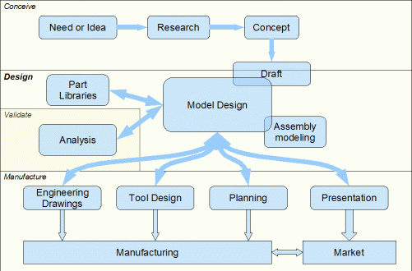

- Explain seven characteristics of a good CAD software.

A) Efficiency: - An Efficient software is that which can use less resources such as CPU in terms of time and usage to give a better output.

B) Simplicity: - A software must be simple to use and easy to understand and must be user friendly.

C) Flexibility: - The software must be able to incorporate the design modification without much of difficulty.

D) Readability: - This provides the capability within the software to help the user as and when required.

E) Portability: - The software must have the capacity to get transferred from one system to other.

F) Reliability: - To avoid causality the software must be able to avoid unwanted operation.

G) Recover ability: - A Good software must be able to give warnings before getting crashed and must be able to recover.

- Explain three division of software components.

There are three major components of a computer system:
- hardware
- software
- human ware
While hardware and software components co-exist to make up the actual computer, the human ware component adds in the human face to bring the complete computer into a functional and productive existence. When installed separately, each may be useful to an extent but incapable of achieving complete computing potential. Hardware and software need the human factor in order to make input and connectivity possible.
1. Computer Hardware
These are computer system components that can be touched by the human hand. Examples include:
- Display monitor.
- Keyboard.
- Mouse.
- Motherboard.
- Memory modules.
- Disk drive.
These parts are housed within the laptop or the desktop system-unit. For the desktop, however, the keyboard and mouse are attached and used externally.
2. Computer Software
The software component refers to the instructions, programs, data, and protocols which run on top of hardware. It is also retained temporarily and persistently in primary and secondary hardware media. The random access memory chip is an example of primary hardware while the hard disk drive is an example of secondary hardware.
3. Human ware
The human ware component refers to the person that uses the computer. More specifically, it is about the individual that makes hardware and software components productive.
Typically, a great deal of testing is done on software packages and hardware parts to ensure they enhance the end-user experience to aid in creating documents, musical and video recordings, and all forms of raw and finished data.

