ADENIJI ABDUL LATEEF
15/ENG06/002
MECHANICAL ENGINEERING
MEE 586 ASSIGNMENT
LECTURER: ENGR. AZEEZ
- What is an integrated CAD/CAM
Integrated CAD/CAM-systems are employed to achieve computer-aided integration in all production functions, from design and planning up to manufacturing and the assurance of quality standards. So far, however, overall integration of this kind has hardly been put into practice. This applies particularly to the medium and small batch production of the machine-building industry ^{*)}. At present various concepts of CAD/CAM integration which complement or overlap each other, often to the extent of operating concurrently in the case of implementation, can be discerned. On the one hand, concepts are concerned with the integration of design functions with planning, controlling and programming functions (CAD/CAP). On the other hand, they are concerned with the integration of manufacturing functions with planning, controlling and programming functions (DNC). Overall computer-aided integration, from design through to manufacturing, has only been conceived for a small number of product elements and limited manufacturing processes so far.
- Draw a product life cycle to describe the scope of CAD/CAM in the operation of manufacturing firm
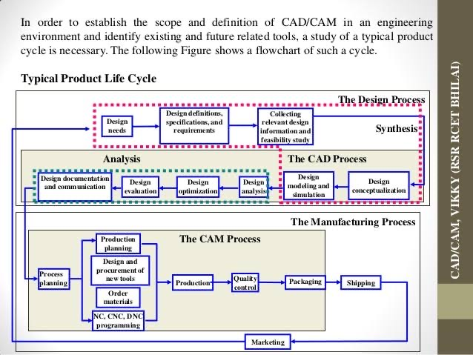
- Explain seven characteristics of a good CAD software
- Efficiency:- An Efficient software is that which can use less resources such as CPU in terms of time and usage to give a better output.

- Simplicity:- A software must be simple to use and easy to understand and must be be user friendly.

- Flexibility: - The software must be able to incorporate the design modification with out much of difficulty.

- Readability:- This provides the capability within the software to help the user as and when required.

- Portability: - The software must have the capacity to get transferred from one system to other.

- Reliability: - To avoid causality the software must be able to avoid unwanted operation.

- Recover ability: - A Good software must be able to give warnings before getting crashed and must be able to recover.
- Explain three divisions of software components
- Application software
which is software that uses the computer system to perform special functions or provide entertainment functions beyond the basic operation of the computer itself. There are many different types of application software, because the range of tasks that can be performed with a modern computer is so large—see list of software.
- System software
which is software for managing computer hardware behaviour, as to provide basic functionalities that are required by users, or for other software to run properly, if at all. System software is also designed for providing a platform for running application software
- Malicious software
which is software that is developed to harm and disrupt computers. As such, malware is undesirable. Malware is closely associated with computer-related crimes, though some malicious programs may have been designed as practical jokes.

