NAME: AKINOLA OLUMAYOWA DAVID
MATRIC NO: 15/ENG06/008
1]
Integrated CAD/CAM-systems are employed to achieve computer-aided integration in all production functions, from design and planning up to manufacturing and the assurance of quality standards. So far, however, overall integration of this kind has hardly been put into practice. This applies particularly to the medium and small batch production of the machine-building industry ^{*)}. At present various concepts of CAD/CAM integration which complement or overlap each other, often to the extent of operating concurrently in the case of implementation, can be discerned. On the one hand, concepts are concerned with the integration of design functions with planning, controlling and programming functions (CAD/CAP). On the other hand, they are concerned with the integration of manufacturing functions with planning, controlling and programming functions (DNC). Overall computer-aided integration, from design through to manufacturing, has only been conceived for a small number of product elements and limited manufacturing processes so far.
2]
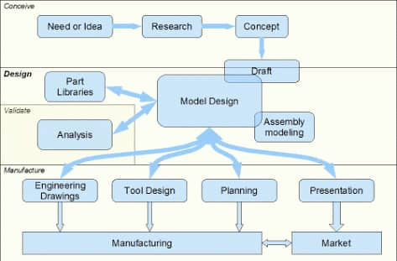

3]
- EFFICIENCY: An Efficient software is that which can use less resources such as CPU in terms of time and usage to give a better output.
- SIMPLICITY:- A software must be simple to use and easy to understand and must be be user friendly
- FLEXIBILITY: - The software must be able to incorporate the design modification with out much of difficulty.
- READABILITY:- This provides the capability within the software to help the user as and when required.
- PORTABILITY: - The software must have the capacity to get transferred from one system to other
- RELIABILITY: - To avoid causality the software must be able to avoid unwanted operation.
- RECOVER ABILITY: - A Good software must be able to give warnings before getting crashed and must be able to recover.

4] The three divisions of software components are application software, system software, and web applications
Application Software: Application Software refer to programs on a client machine which are written to perform specific tasks. Nowadays, there is a wide range of software applications being developed including word processing programs, database management tools, photo editing software, etc. But during the last decade the web has become the new deployment environment for software applications. Software applications that were previously built for specific operating systems and devices are now being designed specifically for the web (web-enabled)
System Software: System software refers to the set of computer programs which are required to support the execution of application programs and maintain system hardware. Operating systems, utilities, drivers and compilers are among the major components of system software. Such components are the enablers and service providers to software applications. Among these components, the operating system is the most popular and important one. The operating system market for client PCs has evolved along the lines predicted by theories of increasing returns and network externalities (Shapiro and Varian 1999).
Web Application: The remarkable reach of web applications into all areas of the Internet makes this field among the largest and most important parts of the software industry. As of today, the Internet consists of hundreds of thousands of small and large-scale web applications ranging from e-Commerce applications to social networking sites to online gaming. This popularity has attracted large user base which made web applications lucrative targets for attackers to exploit vulnerabilities.

