ADEDIPE EMMANUEL SEGUN
15/ENG06/001
MEE586: MACHINE DESIGN III

- What is integrated CAD/CAM?
Integrated CAD/CAM-systems are employed to achieve computer-aided integration in all production functions, from design and planning up to manufacturing and the assurance of quality standards. So far, however, overall integration of this kind has hardly been put into practice. This applies particularly to the medium and small batch production of the machine-building industry. At present various concepts of CAD/CAM integration which complement or overlap each other, often to the extent of operating concurrently in the case of implementation, can be discerned. On the one hand, concepts are concerned with the integration of design functions with planning, controlling and programming functions (CAD/CAP). On the other hand, they are concerned with the integration of manufacturing functions with planning, controlling and programming functions (DNC).

- Draw a product cycle to describe the scope of CAD/CAM in the operation of manufacturing firm.
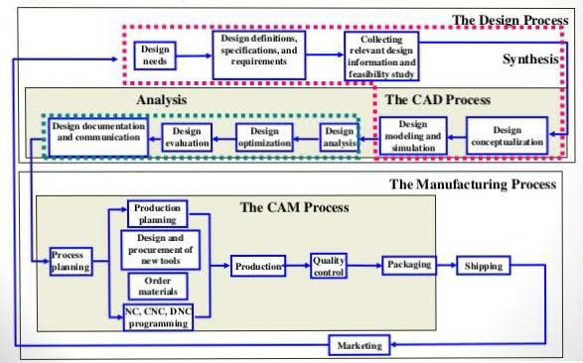
A typical production cycle to of a manufacturing firm.

3. List seven Characteristics of a good CAD software
- Efficiency: An Efficient software is that which can use less resources such as CPU in terms of time and usage to give a better output.
- Simplicity: A software must be simple to use and easy to understand and must be user friendly.
- Flexibility: The software must be able to incorporate the design modification with out much of difficulty.
- Readability: This provides the capability within the software to help the user as and when required.
- Portability: The software must have the capacity to get transferred from one system to other.
- Reliability: To avoid causality the software must be able to avoid unwanted operation.
- Recoverability: A Good software must be able to give warnings before getting crashed and must be able to recover.

4. Explain 3 divisions of software components.
- System Software: System software or operating system is the software used by the computer to translate inputs from various sources into a language which a machine can understand. Basically, the OS coordinates the different hardware components of a computer. There are many OS in the market. The most popular Os are from the stable of Microsoft. We have all heard, used and wondered at the Windows software, which is an OS. Starting with Windows, Microsoft has migrated to windows 10. It may come as a surprise to some that there are other operating systems used by others. Among these UNIX is used for large office setups with extensive networking.

- Application software: A normal user rarely gets to see the operating system or to work with it. But all of us are familiar with application software which we must use to interact with a computer. Popular examples of application software are the Microsoft office suite which includes Word, Excel and PowerPoint. We have used these applications extensively. Internet explorer, Mozilla Firefox is two applications used to access the internet. E-mail software like Outlook express is used to manage Emails. It is obvious that all software utilized for working on a computer is classified as application software. In fact, all user interfaces are an application. The anti-virus is an application and so is the Media player.

- Programming languages: Now this is a kind of computer software which is used exclusively by computer programmers. Unless we are also programmers, we are unlikely to come across programming languages. A simple way to understand programming languages is to think of them as bricks which can be used to create applications and operating system. C++, Java and Simlab are some popular programming languages. Generally, Java is used for internet applications. C++ is a language of professional developers and used extensively in developing operating systems. PHP is another language used for internet applications. There is a new class of languages which are being utilized for the mobiles. These are light weight, modular languages which are used to design mobile applications.

