MACHINE DESIGN III (mee 586) ASSIGNMENT

SUBMITTED BY ALABO UGWUSHICHIKA (15/ENG06/009)

COURSE LECTURER: ENGR. AZEEZ

DATE: 27TH APRIL, 2020.

- Integrated CAD/CAM:
An Integrated CAD/CAM system is a one that combines CAD, CAM, electrode design and CMM programming capabilities in one system in order to save you time and effort. This system provides one model supporting both design and manufacturing functions instead of having various file formats, numerous data translations/conversions, and different CAD and CAM models. With integrated CAD/CAM solutions and tools, all documentation in CAD designing and CAM programming are in the same platform.
Examples of integrated tools include Autodesk’s HSMWorks, a CAM tool for SolidWorks, or Inventor HSM, for Autodesk Inventor, makes file importing and exporting a thing of the past. SolidWorks or Inventor 2D and 3D CAD designs easily translate knowledge of these designs to the CAM side of manufacturing, resulting in faster production time and parts that match up more precisely with the designs. Note that CAD and CAM integration can be of two types:
- Data Integration which involves the ability to share part models (common data files or a common database). For example, a Parasolid file and;
- Application Integration which involves different modules working together for a single user. For example, technology like OLE.
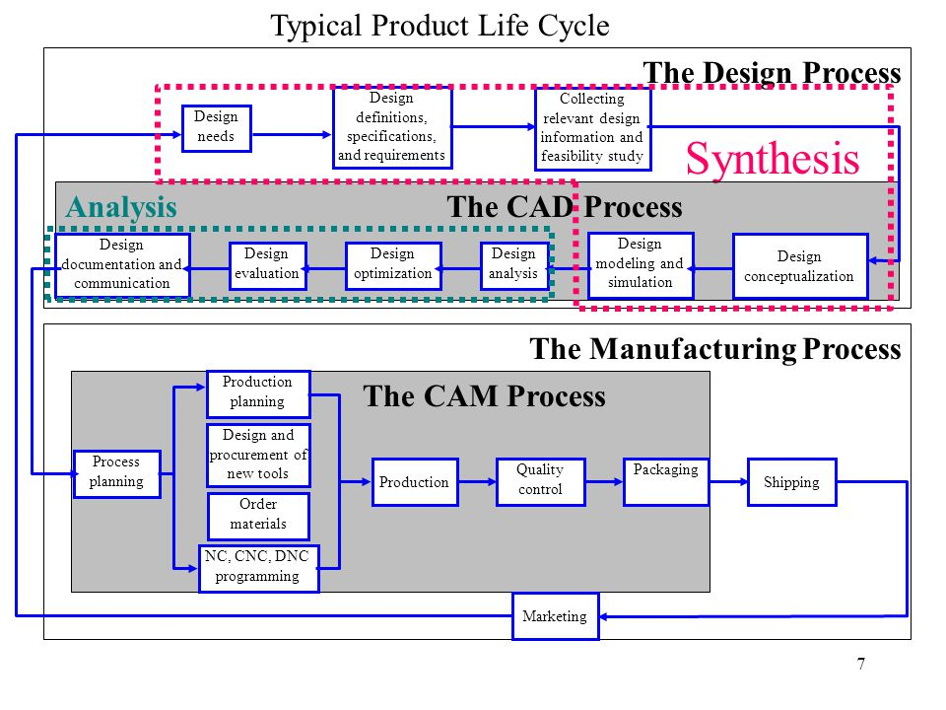
Figure 1: Product Cycle Of CAD/CAM Scope in The Operation of a Manufacturing Firm
- Seven Characteristics of A Good CAD Software:
- Efficiency: An Efficient CAD software is that which can use less resources in terms of time and usage to give a better output.
- Simplicity: A CAD software must be simple to use and easy to understand and must be user friendly.
- Flexibility: A CAD software must be able to incorporate the design modification without much of difficulty.
- Readability: This provides the capability within the software to help the user as and when required.
- Portability: A CAD software must have the capacity to get transferred from one system to other.
- Reliability: To avoid causality the software must be able to avoid unwanted operation.
- Recoverability: - A Good CAD software must be able to give warnings before getting crashed and must be able to recover.
- The Three Divisions of Software Components:
- System Software:
System software or operating system is the software used by the computer to translate inputs from various sources into a language which a machine can understand. Basically, the OS coordinates the different hardware components of a computer. There are many OS in the market. The most popular OS are from the stable of Microsoft. We have all heard, used and wondered at the Windows software, which is an OS. Starting with Windows, Microsoft has migrated to Vista, its latest offering in the market. It may come as a surprise to some that there are other operating systems used by others. Among these UNIX is used for large office setups with extensive networking. XENIX is software which has now become redundant. HP -UX and AIX are some operating systems used by HP computers. Apache OS is quite popular with web servers. IBM still uses proprietary operating systems for its main frames. Proprietary systems are generally built with the help of a variant of UNIX operating system.
- Application software:
A normal user rarely gets to see the operating system or to work with it. But all of us are familiar with application software which we must use to interact with a computer. Popular examples of application software are the Microsoft office suite which includes Word, Excel and PowerPoint. We have used these applications extensively. Internet explorer, Mozilla Firefox is two applications used to access the internet. E-mail software like Outlook express is used to manage Emails. It is obvious that all software utilized for working on a computer is classified as application software. In fact, all user interfaces are an application. The anti-virus is an application and so is the Media player.
- Programming languages:
Now this is a kind of computer software which is used exclusively by computer programmers. Unless we are also programmers, we are unlikely to come across programming languages. A simple way to understand programming languages is to think of them as bricks which can be used to create applications and operating system. C++, Java and Simlab are some popular programming languages. Generally, Java is used for internet applications. C++ is a language of professional developers and used extensively in developing operating systems. PHP is another language used for internet applications. There is a new class of languages which are being utilized for the mobiles. These are light weight, modular languages which are used to design mobile applications.
Reference:
http://mvscad.blogspot.com/2012/08/characteristics-of-good-cad-software.html
http://www.manufacturinglounge.com/the-benefits-of-integrated-cad-cam-solutions/
https://slideplayer.com/slide/4817737/
https://www.3dsystems.com/cadcam-integration-whats-right-choice-you
https://www.inc.com/encyclopedia/computer-aided-design-cad-and-computer-aided-cam.html
https://www.moldmakingtechnology.com/articles/five-benefits-of-integrated-cadcam
https://www.solidworks.com/sw/docs/SW_WP__CAD_CAM.pdf
https://www.streetdirectory.com/etoday/different-types-of-computer-software-jjwap.html

