NAME:Ewim Prosper Ifechukwu

DEPT: HUMAN ANATOMY MAT NO.:19/MHS03/004

COURSE CODE: PHY1O2
1a. Charging by Induction:
Electric charges can be obtained on an object without touching it, by a process called electrostatic induction.
Consider a positively charged rubber rod brought near a neutral (uncharged) conducting sphere that is insulated so that there is no conducting path to ground as shown below. The repulsive force between the protons in the rod and those in the sphere causes a redistribution of charges on the sphere so that some protonsmovetothesideofthespherefarthestawayfromtherod(fig.1.3a).Theregionofthespherenearest the positively charged rod has an excess of negative charge because of the migration of protons away from this location. If a grounded conducting wire is then connected to the sphere, as in (fig. 1.3b), some of the protons leave the sphere and travel to the earth. If the wire to ground is then removed (fig 1.3c), the conducting sphere is left with an excess of induced negativecharge.
Finally, when the rubber rod is removed from the vicinity of the sphere (fig. 1.3d), the induced negatively charge remains on the ungrounded sphere and becomes uniformly distributed over the surface of the sphere.
Diagram:

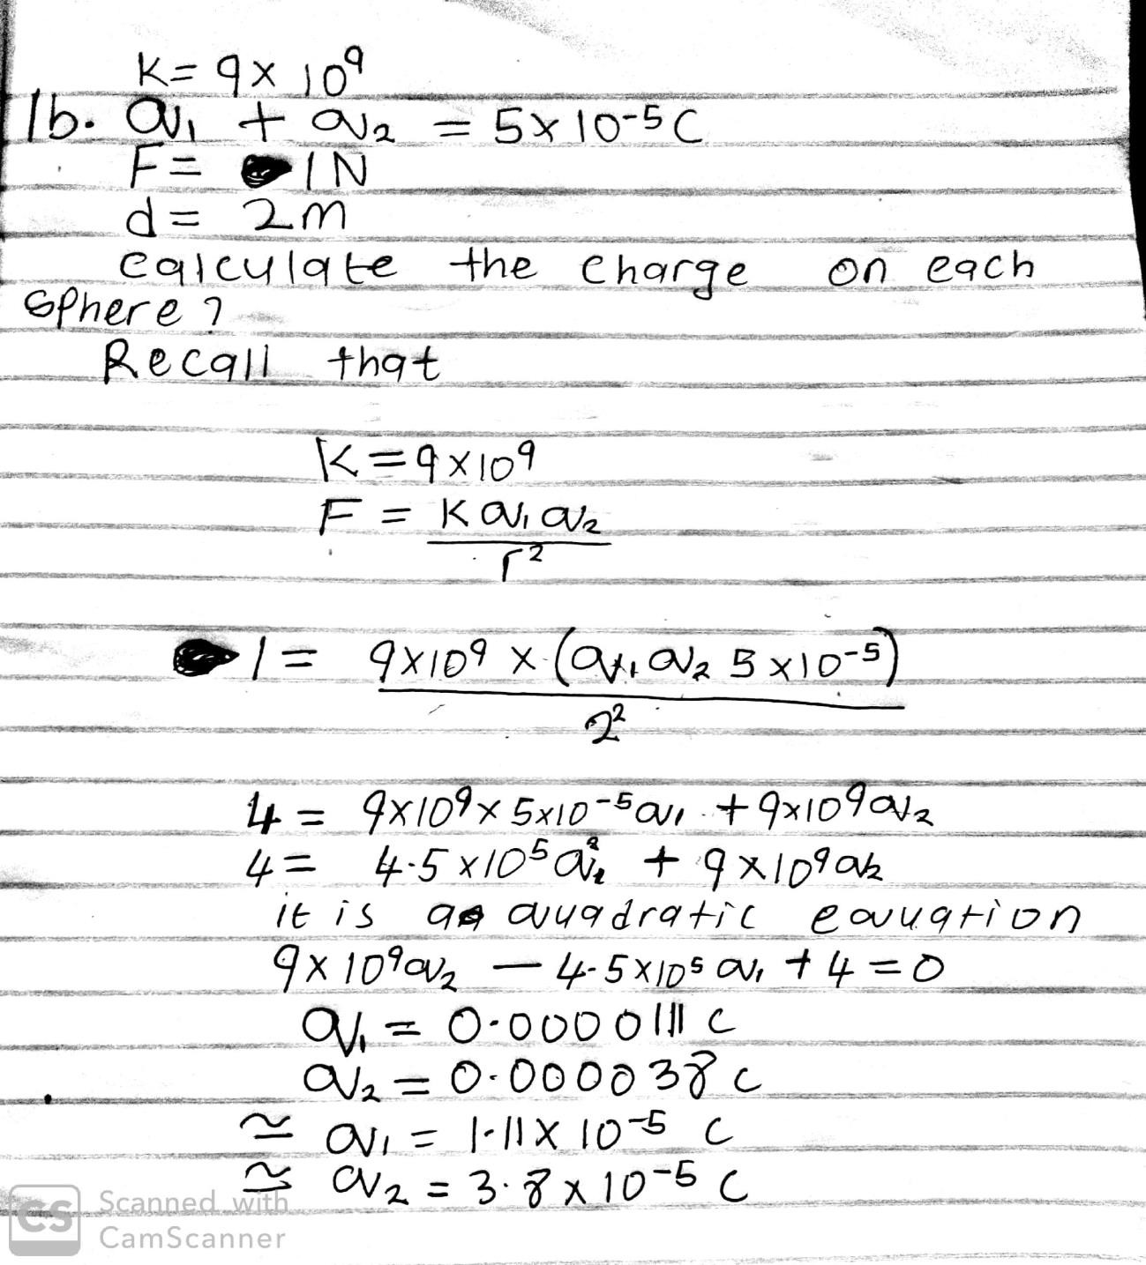

1C
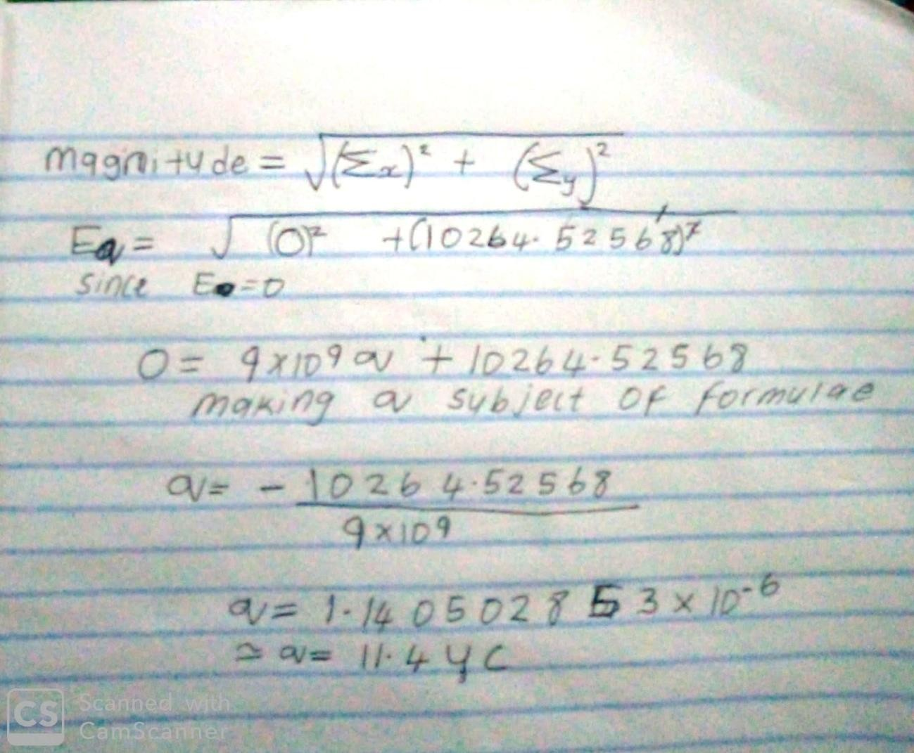

2a). Electric field is a region around a charged particle or object within which a force would be exerted on other charged particles. While. Electric field intensity is the measure of intensity or strength of elsectrical force per unit charge at a given point in the electric field. Denoted by the letter “E” and its unit is Newton per Coulomb (N/C)

3a.

- Volume charge density,𝝆 =

- Surface charge density,𝝈 =
𝒅𝑸

𝒅𝑽
𝒅𝑸

𝒅𝑨
→ 𝒅𝑸 =𝝆𝒅𝑽

→ 𝒅𝑸 =𝝈𝒅𝑨

- Linear charge density, 𝝀=
𝒅𝑸

𝒅𝑳
→ 𝒅𝑸 = 𝝀𝒅𝑳

3b. ELECTRIC POTENTIAL DIFFERENCE
The electric potential difference between two points in an electric field can be defined as the work done per unit charge against electrical forces when a charge is transported from one point to the other. It is measured in Volt (𝒗) or Joules per Coulomb (𝑱/𝑪). Electric potential difference is a scalar quantity.
q0E
Consider the diagram above, suppose a test charge 𝒒𝒐 is moved from point 𝑨 to point 𝑩 alonganarbitrarypathinsideanelectricfield𝑬.Theelectricfield𝑬exertsaforce𝑭=𝒒𝒐𝑬 onthechargeasshowninfig3.1.Tomovethetestchargefrom𝑨to𝑩atconstantvelocity, anexternalforceof𝑭=−𝒒𝒐𝑬mustactonthecharge.Therefore,theelementalworkdone
𝒅𝑾 is given as:

But
𝒅𝑾 =𝑭.𝒅𝑳 … (𝟏)

𝑭=−𝒒𝟎𝑬 … (𝟐)

Substituting equation (𝟐) in (𝟏) yields
𝒅𝑾=−𝒒𝟎𝑬𝒅𝑳 … (𝟑)
Thentotalworkdoneinmovingthetestchargefrom𝑨to𝑩is:
𝑩

𝑾(𝑨 → 𝑩)𝑨𝒈 = −𝒒𝟎 ∫ 𝑬𝒅𝑳
𝑨
… (𝟒)

From the definition of electric potential difference, it follows that:

𝑽𝑩
− 𝑽𝑨
=𝑾(𝑨→𝑩)𝑨𝒈
𝒒𝟎

… (𝟓) Putting equation (𝟒) in (𝟓)yields

𝑩

𝑽𝑩 − 𝑽𝑨 = − ∫ 𝑬𝒅𝑳
𝑨
… (𝟔)

4a. Magnetic flux is defined as the strength of the magnetic field which can be represented by line of forces. It is represented by the symbol Φ.mathematically given as Φ=B. d A
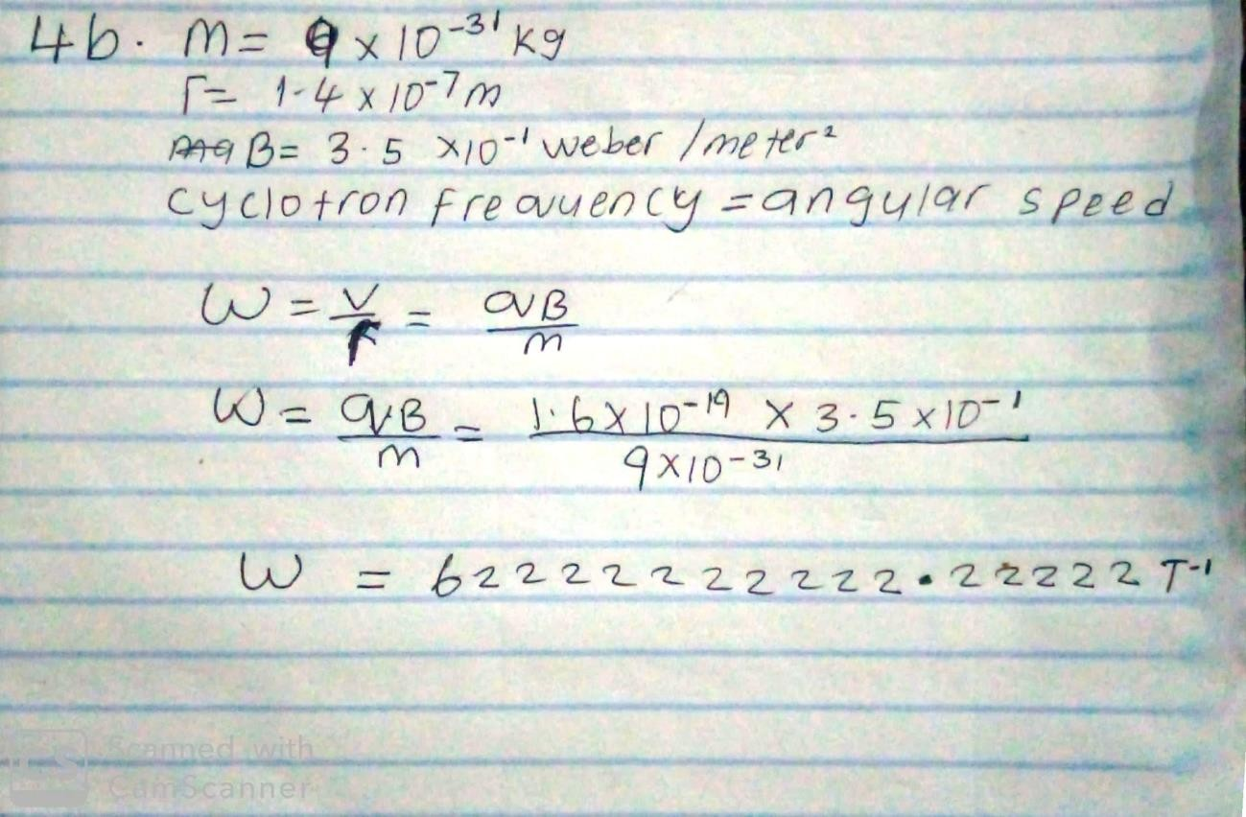
4c. In the question we were given paramiters such as i.mass of the electron =9.11x10⁻³¹kg
- A radius of1.4x10⁻⁷m
- magnetic field of 3.5x10⁻¹weber\metersquare
and you are asked to find the cyclotron frequency which is equal or the same thing as angular speed.it is called cyclotron frequency because it is a frequency of an accelerator called cyclotron.

Recall that angular speed is given asω=
𝒗 𝒒𝑩

=
𝒓 𝒎

Substituting we haveω=
𝒗 𝒒𝑩

= =1.6x10⌃-10x3.5x10⌃-10
𝒓 𝒎

9.11x10⌃-31

𝒒𝑩=𝟏.𝟔×𝟏𝟎−𝟏𝟗𝒙𝟑.𝟓𝒙𝟏𝟎⌃−𝟏 -1

𝒎 𝟗.𝟏𝟏𝒙𝟏𝟎⌃−𝟑𝟏
=62222222222.22222T

SO since cyclotron frequency is equal to angular speed the cyclotron frequency is equal to =62222222222.22222^{T-1}, having a unit as 1\T which is equal to the unit of frequency dimensionally.

5b.Biot-savart law states that the magnetic field is directly proportional to the product permeability of free space(µ),the current(I),the change in length, the radius and inversely proportional to square of radius (r²). It can be represented mathematically by
𝒅⃗𝑩⃗=𝝁𝒐𝑰𝒅𝒍×𝒓̂

𝟒𝝅
𝒓𝟐

where 𝝁𝒐 is a constant called Permeability of free space.

𝝁𝒐
= 𝟒𝝅 × 𝟏𝟎^{−𝟕}𝑻.𝒎
𝑨

Theunitof⃗𝑩⃗isweber\metresquare

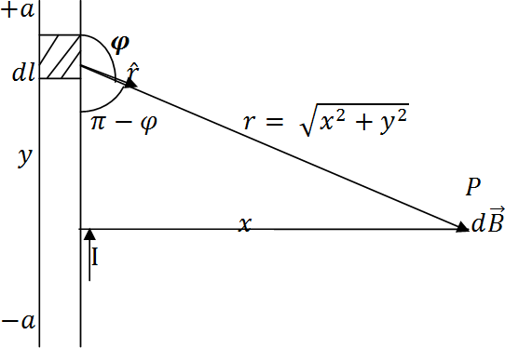
5b. Magnetic Field of a Straight Current Carrying Conductor

Fig 1: A section of a Straight Current Carrying Conductor ApplyingtheBiot-Savartlaw,wefindthemagnitudeofthefield𝒅⃗𝑩⃗

𝑩 =
𝝁𝒐𝑰∫
𝟒𝝅
^{𝒂}𝒅𝒍 𝐬𝐢𝐧 𝝋

𝒓𝟐

−𝒂
𝒔𝒊𝒏(𝝅 – 𝝋) = 𝒔𝒊𝒏𝜽
𝝁𝒐𝑰 ^{𝒂}𝒅𝒍𝒔𝒊𝒏(𝝅 −𝝋)

∴ 𝑩 =
∫
𝟒𝝅 −𝒂

𝒓𝟐

From diagram, 𝒓^{𝟐}= 𝒙^{𝟐}+ 𝒚^{𝟐}(𝑷𝒚𝒕𝒉𝒂𝒈𝒐𝒓𝒂𝒔 𝒕𝒉𝒆𝒐𝒓𝒆𝒎)
𝝁𝒐𝑰 ^{𝒂}𝒅𝒍𝒔𝒊𝒏(𝝅 –𝝋)

𝑩 =
∫
𝟒𝝅 −𝒂
𝒙^{𝟐}+ 𝒚^{𝟐}
𝒙
… (∗)

𝒙

𝑩𝒖𝒕 𝒔𝒊𝒏(𝝅 − 𝝋) =

Substituting(∗∗)into(∗),wehave
√𝒙𝟐 + 𝒚𝟐 = (𝒙𝟐 + 𝒚𝟐)𝟏⁄𝟐
… (∗∗)

𝝁𝒐𝑰 ^{𝒂} 𝒙
−𝒂

Recall 𝒅𝒍 = 𝒅𝒚
𝑩 =
𝟒𝝅 ∫ 𝒅𝒍 (𝒙^{𝟐}+ 𝒚^{𝟐})(𝒙^{𝟐}+ 𝒚^{𝟐})^{𝟏/𝟐}

𝝁𝒐𝑰 ^{𝒂} 𝒙

𝑩 =

𝝁𝒐𝑰𝒙
∫
𝟒𝝅 −𝒂
𝒂
(𝒙𝟐 + 𝒚𝟐 )𝟑⁄𝟐 𝒅𝒚
𝟏

Using specialintegrals:
𝑩 =
∫
𝟒𝝅 −𝒂
(𝒙𝟐 + 𝒚𝟐 )𝟑/𝟐 𝒅𝒚
… (∗∗∗)

𝒅𝒚 𝟏 𝒚
∫ (𝒙𝟐 + 𝒚𝟐)𝟑/𝟐 = 𝒙𝟐 (𝒙𝟐 + 𝒚𝟐)𝟏/𝟐
Equation (∗∗∗) therefore becomes

𝝁𝒐𝑰𝒙
𝒚 𝒂

𝑩 =
𝟒𝝅 [𝒙^{𝟐}(𝒙^{𝟐}+ 𝒚^{𝟐})^{𝟏⁄𝟐}]

−𝒂

𝑩 =𝝁𝒐𝑰𝒙( 𝟐𝒂 )

𝟒𝝅
𝒙𝟐(𝒙𝟐 + 𝒂𝟐)𝟏⁄𝟐

𝑩 = 𝝁𝒐𝑰( 𝟐𝒂 )

𝟒𝝅𝒙
(𝒙𝟐 + 𝒂𝟐)𝟏⁄𝟐

Whenthelength𝟐𝒂oftheconductorisverygreatincomparisontoitsdistance𝒙from pointP,weconsideritinfinitelylong.Thatis,when𝒂ismuchlargerthan𝒙,
(𝒙^{𝟐}+ 𝒂^{𝟐})^{𝟏/𝟐}≅ 𝒂, 𝒂𝒔 𝒂 → ∞

∴
𝝁𝒐𝑰
𝑩 =
𝟐𝝅𝒙

Inaphysicalsituation,wehaveaxialsymmetryaboutthey-axis.Thus,atallpointsina circleofradius𝒓,aroundtheconductor,themagnitudeofBis
𝝁𝒐𝑰

𝑩 =

𝟐𝝅𝒓
… (#)

Equation(#)definesthemagnitudeofthemagneticfieldoffluxdensityBnearalong, straight current carryingconductor.

6a.It’sabasicruleofphysics(Faraday’slaw)thatachangingthatachangingmagneticfield produces electricity only for as the magnetic field is changing- in other words, for only as longasthemetalstringismoving.Oncethestringstopsvibrating,thesoundstops.

