LAWAL ATINUKE HEPHZIBAH
18/ENG01/013
ENG 282
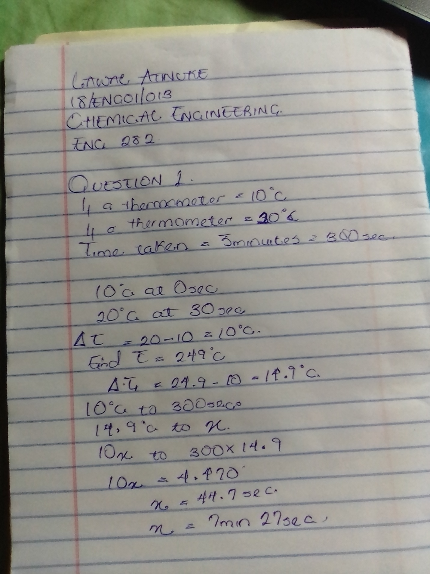
ENGINEERING MATHS
