DABOH INIOLUWA OLUWATOFUNMI
18/ENG01/007
CHEMICAL ENGINEERING
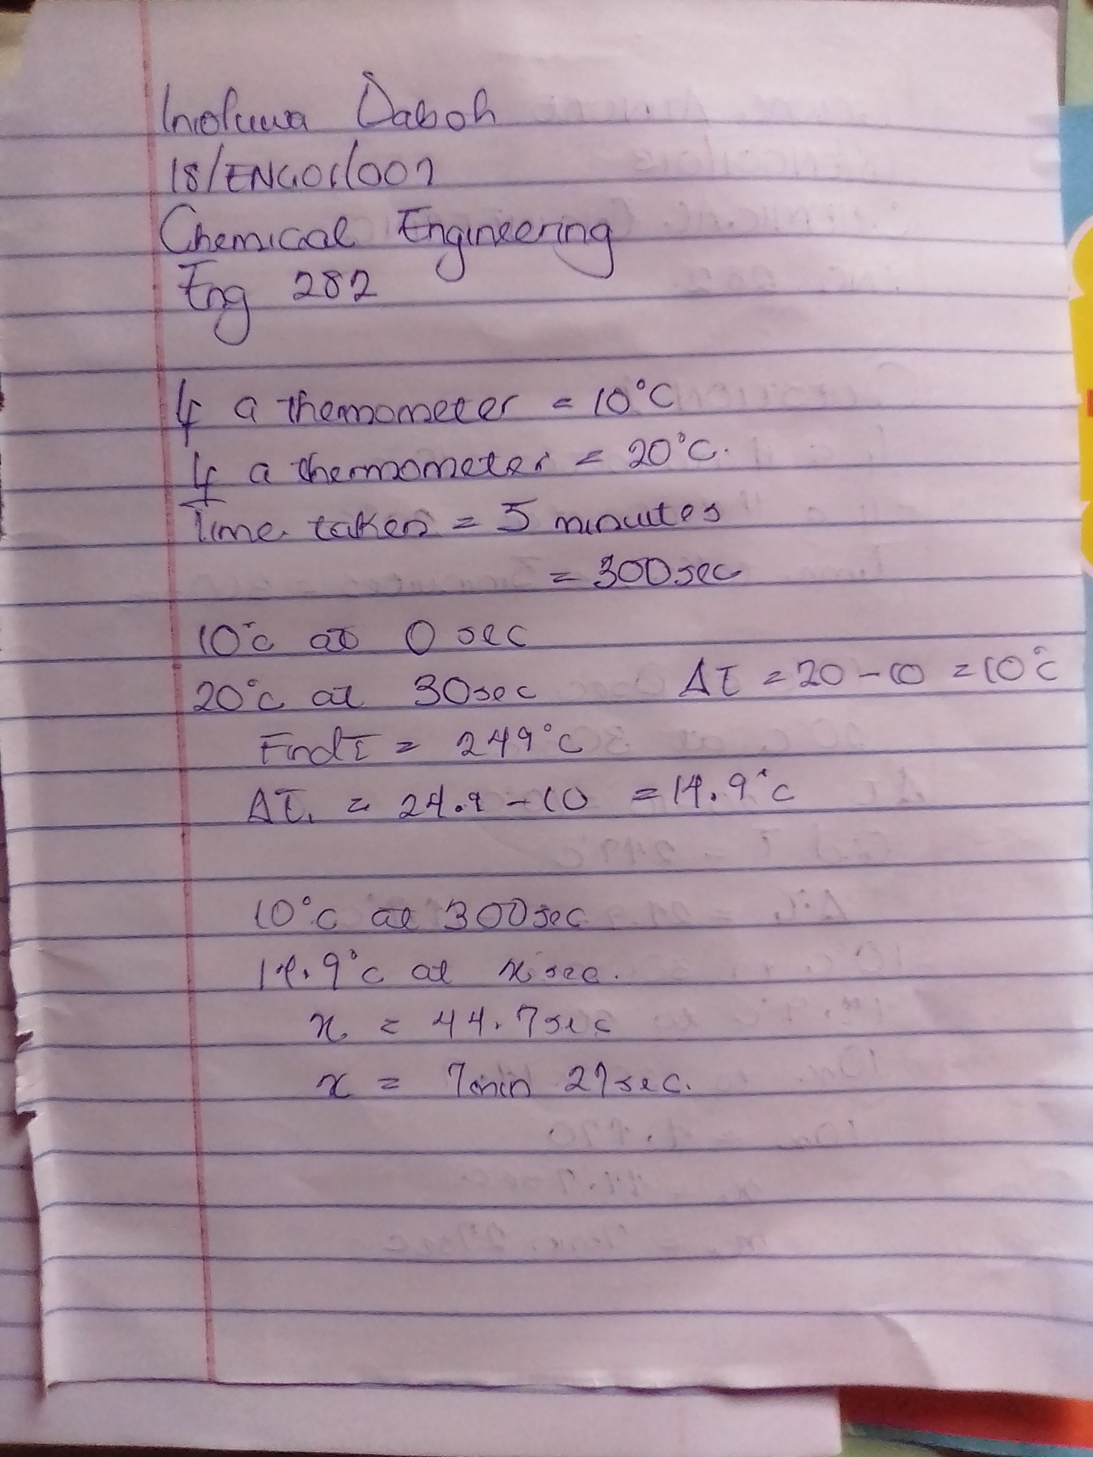
ENGINEERING MATHS QUIZ
