NAME: OKONTE RICHARD-KOKO
MATRIC NO: 15/ENG01/015
COURSE CODE: CHE 512
COURSE TITLE: LOSS PREVENTION AND INDUSTRIAL LAW

ASSIGNMENT
1. Briefly discuss hazard operability technique.
A hazard and operability (HAZOP) study is a structured and systematic technique for the examination and the risk assessment of a planned or existing process in order to identify and evaluate the problems may present risks to personnel, equipment or prevent efficient operation.
It is a qualitative technique and aims to stimulate the imagination of participants to identify potential hazards in a system and operability problems likely to occur. This technique is based on breaking the overall complex design of the process into a number of simpler sections called 'nodes' which are then individually reviewed. A node represents a section of the process where a significant process change takes place. It is carried out by a suitably experienced multi-disciplinary team (HAZOP) during a series of meetings. [1]
HAZOP is based on a theory that assumes risk events are caused by deviations from design or operating intentions. For each node in turn the HAZOP team uses a list of standardized guide-words and process parameters to identify potential Deviations from the design intent. Identification of such deviations is facilitated by using sets of “guide words” as a systematic list of deviation perspectives. Some of which include: More, less, early, late, As well as, before, part of, after[2]. For each deviation, the team identifies feasible Causes and likely Consequences then decides (with confirmation by subsequent risk analysis where necessary) whether the existing safeguards are sufficient, or whether an Action to install an additional safeguard is necessary to reduce the risks to an acceptable level.

2. State the significance of HAZOP technique.
- It allows safety professionals to identify and then either control or eliminate hazards.
- It utilizes operational experience.
- It covers safety as well as operational aspects.
- It covers human errors through systematic examination and assessment of each process.
- An efficient, knowledgeable HAZOP team can save the company more money than the expense of the conducting the study
- HAZOP studies identify hazards and can thus save lives and decrease employee injuries.
- HAZOP teams provide a multi-disciplinary look at various processes.
- The results obtained from the study are recorded and implied.[3] [4]

3. With the aid of a block diagram, list the components of hazard operability.
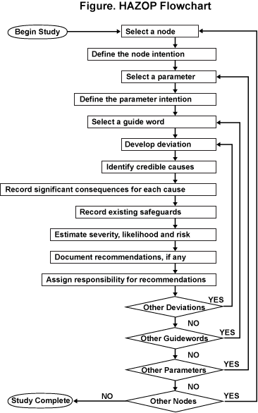
Figure 1: Diagram showing the components of hazards operability[5]
REFERENCES
[1] Wikipedia, “Hazard and operability study,” 2020. [Online]. Available: https://en.wikipedia.org/wiki/Hazard_and_operability_study.
[2] R. Management and T. Guides, “Hazard & Operability Analysis ( HAZOP ),” pp. 1–9.
[3] M. Rausand, “Slides related to the book,” pp. 1–46, 2011.
[4] Safeopedia, “Hazard and Operability Study (HAZOP): Why It’s Important for Safety Professionals,” 2019. [Online]. Available: https://www.safeopedia.com/2/3254/hazards/hazard-and-operability-study-hazop-why-its-important-for-safety-professionals.
[5] Primatech, “HAZOP,” 2020. [Online]. Available: https://www.primatech.com/images/hazop_flowchart_8_18_bw1.png.

