Name: Ikuomola Damilola Chidiebere Stephen
Matric Number: 16/ENG06/082
Department: Mechanical Engineering
Course Code: MEE 514
Course Title: Introduction to Bio-Engineering

- Soft Tissue in Human Body: Soft tissues are found throughout the body. There are many types of soft tissue, including fat, muscle, fibrous tissue, blood vessels, lymph vessels and nerves. Soft tissues surround, support and connect organs and other tissues in the body. These Soft Tissues perform different functions such as:
- Surround, support and connect organs and other body parts.
- Give shape and structure to the body.
- Protect organs.
- Move fluids, such as blood, from one part of the body to another.
- Store energy.

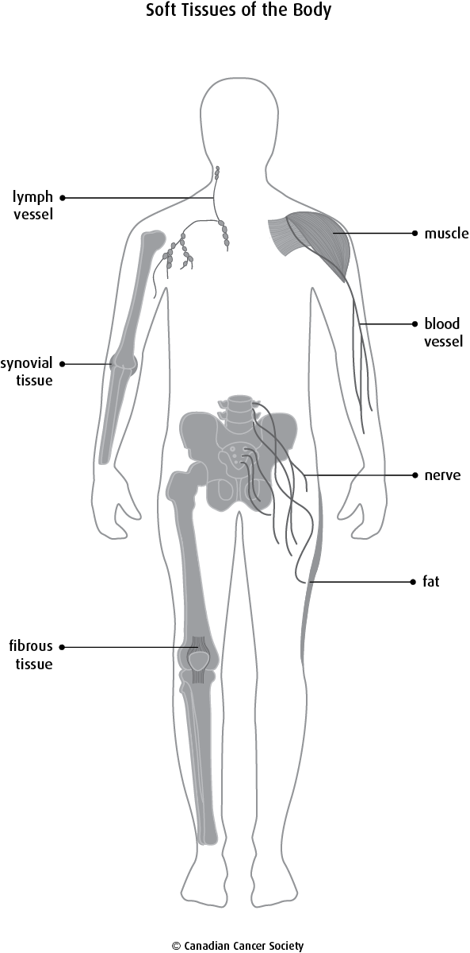
- Collagen as a Fibrous Protein and Basic Structural Elements of STM
Collagen is the most abundant protein in animals. This fibrous, structural protein comprises a right-handed bundle of three parallel, left-handed polyproline II-type helices. Much progress has been made in elucidating the structure of collagen triple helices and the physicochemical basis for their stability. New evidence demonstrates that stereoelectronic effects and preorganization play a key role in that stability. The fibrillar structure of type I collagen–the prototypical collagen fibril–has been revealed in detail. Artificial collagen fibrils that display some properties of natural collagen fibrils are now accessible using chemical synthesis and self-assembly. A rapidly emerging understanding of the mechanical and structural properties of native collagen fibrils will guide further development of artificial collagenous materials for biomedicine and nanotechnology.

- Stress-Strain Relationship in Collagen Bio-Materials

The stress-strain relationship of the skin is associated with collagen orientation. (a) The collagen fibrils are randomly aligned and readily orient with the application of small amounts of stress (low elastic modulus); (b) The collagen fibrils begin to straighten and gradually align in the direction of the applied stress. At the end, almost all collagen fibrils are aligned in the direction of loading; (c) Damage begins to accumulate due to sliding of fibrils past one other, among many other mechanisms.

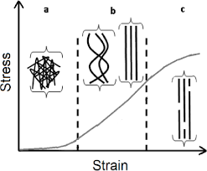
4. Cartillage and its application to joints such as Hip, Knee, Ankle and Shoulder
Cartilage function is more than structural, and has different functions in the life cycle. In the embryo, it provides support and is a precursor to bone. Embryonic cartilage either remains as cartilage or provides a substructure for endochondral ossification, meaning it also functions as a template for the rapid growth and development of the musculoskeletal system. Cartilage is a supple tissue which allows for facial movement as well as providing a lightweight supportive structure in the external ear, and the tip and septum of the nose. In other regions it acts as a shock absorber, cushioning areas where bone meets bone and preventing abrasion and damage. A joint would also not be able to bend without the flexibility of cartilage. A combination of roles is seen in the airways, where cartilage rings around the trachea prevent collapse and damage, and cartilage at the ends of the ribs allows the ribcage to swing upwards and outwards during inspiration. Cartilage also plays a role in bone repair where, as in the embryo, it provides a template for ossification, this time to broken sections of bone.
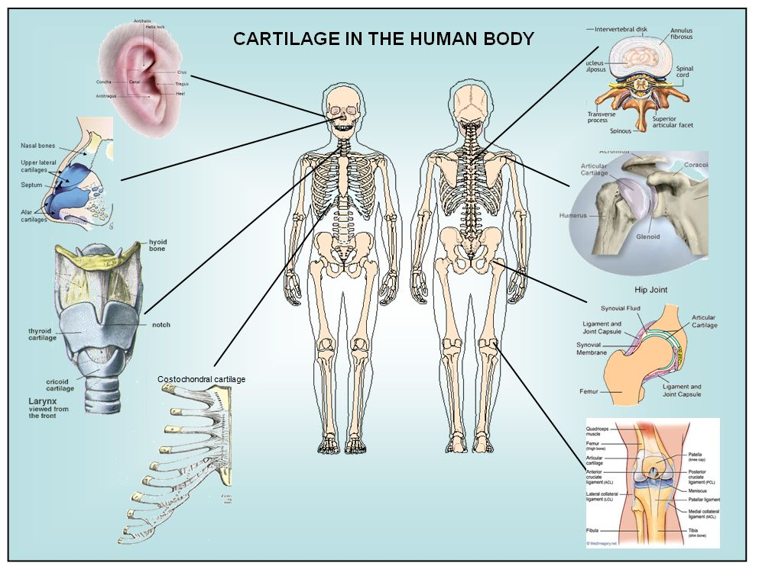
  - Mechanical Testing procedures for soft tissues
This protocol follows the ethical guidelines of our institution's human research ethical committee guidelines on the use, storage, and disposal of human tissue. Human tissue samples can be excised from cadaveric bodies that have been consented for research purposes with relevant ethical approvals. Samples can also be discarded tissue from consented patients undergoing surgical procedures, with relevant ethical approval.

1. Preparation of Skin
- Prepare specimens by manually dissecting off the adipose tissue and the thin layer of deep dermis using a scalpel blade and forceps. This step is important to ensure consistency between samples¹⁴.
- Cut the resulting sheet of split-thickness skin into a standardized sample size (e.g., 1 cm × 5 cm samples). Determine the specimen size based on the dimensions of the testing apparatus. If a tissue-engineered construct is also being tested, the specimen size should be appropriate for the material of interest¹⁴. Dispose of scalpel blades in the appropriate sharps bins.
- To enable completion of the mechanical calculations, measure the thickness of the skin being tested using electronic calipers before and after mechanical testing.

2. Tensile Testing
NOTE: All materials testing machines should be calibrated according to the manufacturer's guidelines prior to testing.
- Test skin samples in uniaxial tension using a materials testing machine at room temperature (22 °C)
- Orientate the skin samples in the same direction for all samples (e.g., perpendicular or in-line with Langer Lines (topological lines drawn on a map of the human body and referring to the natural orientation of collagen fibers in the dermis).
- Immobilize the sample between two clamps (a commercial jig), one affixed to a 98.07 N load cell and the other to an immovable base plate. The resulting area between the clamps tested in uniaxial tension should be 1 cm x 4 cm.
- Cover the sample area (after placement in the apparatus) on both sides with petroleum jelly to prevent specimen desiccation.
- Program the tensile loading and relaxation testing regime into the software as a list of actions, as follows: Zero Load | Zero Position | Find Contact (Tensile loading) | Wait (Relaxation).
- Start the test with the software program. Load the sample under tension to 29.42 N at 1 mm/s. Use a rate and load that does not cause failure of the skin (e.g., 29.42 N at 1 mm/s).
- After the 29.42 N-load is reached, allow the tissue to relax for 1.5 h, a time-point at which there is minimal change in relaxation behavior, controlled by the computer software¹⁴. Note: The displacement is held constant during the relaxation phase, not the load.
- Calculate elastic and viscoelastic properties as per the analysis section guidelines. The mechanical properties investigated will represent the average properties of the split-thickness skin constituents (epidermis and dermis)¹⁴. Note: There is no defined tare load, as it is clear from the raw data when deformation is occurring and thus, only these data points are included.

3. Preparation of Cartilage
- Remove the skin and fascia from the cartilage specimen using a scalpel blade and forceps.
- Divide the cartilage specimens into a standardized sample size (e.g., 1.5-cm blocks) using a scalpel blade and forceps. For all samples, use a semicircular-shaped indenter that has a diameter and thickness at least 8 times greater than the size of the cartilage sample. This ratio ensures that the indenter is not affected by any edge effects from specimen preparation¹⁵. Dispose of scalpel blades in the appropriate sharps bins.
- To enable completion of the mechanical calculations, measure the thickness of the cartilage to be loaded using electronic calipers before and after mechanical testing.

4. Compressive Indentation Testing
- Compress the cartilage samples using a materials testing machine in a hydrated environment at room temperature. Cover the cartilage sample with phosphate-buffered saline (PBS) prior to and during compression testing to ensure that the sample is hydrated. NOTE: PBS does not exactly match the physiological environment, but it allows both the materials and the tissues to be compared equally.
- Orientate the cartilage sample so the surface is perpendicular to the indenter. This allows the compression to be uniaxial and limits any shear loading.
- Program the compressive loading and relaxation testing regime into the software as a list of actions, as follows: Zero Load | Zero Position | Find Contact (Compressive loading) | Wait (Relaxation).
- Start the test using the software program. Load the sample under compression to 2.94 N at 1 mm/s. NOTE: This was determined to be a non-destructive load that is sensitive enough to identify both elastic and viscoelastic properties of cartilage¹⁵.
- After the 2.94-N limit is reached, allow the cartilage to relax for 15 min, a time-point at which there is minimal change in relaxation behavior, using the computer software^{15,16}. The same protocols can then be applied to synthetic biomaterials to match the biomechanical properties to the native tissue being analyzed.

5. Calculation of Young's Elastic Modulus for Indentation and Tensile Testing
- Collect the raw data including time (s), displacement (mm), and load (N) from the materials testing device¹⁴⁻¹⁶.
- Calculate the stress (MPa) and strain (%) using the formulas. NOTE: If a hemispherical indenter was used during compression testing, dividing the force by the cross-sectional area gives the nominal (average) stress, but not the peak stress.
- Use a linear scatter plot to plot the stress MPa (y-axis) against the strain (x-axis). Determine the linear curve fit. The linear curve fit is equal to y = mx + b with a respective R value. NOTE: All data points are included to achieve a minimum R value >0.98. The m value is the slope, which corresponds to the modulus of stress over strain, indicating compressive resistance or resistance to tension in MPa (i.e., Young's Modulus). If the R value is not >0.98, then the assumption of characterizing linear viscoelastic behavior is invalid.
- To identify the viscoelastic properties in which fluid flow from exposure to deformation has reached equilibrium, the ratio of stress over time over the last 200 s of mechanical testing and the final stress level at the end of the experiment are calculated. NOTE: With increasing time, the stress level will decrease (relax) as fluid flow reaches equilibrium. A fast stress-relaxation response indicates that it is difficult to maintain high stresses within the sample.

6. Relaxation Properties
- Plot stress in MPa (y-axis) against time in s (x-axis) on a linear scatter plot.
- Determine a linear curve fit to calculate the rate of relaxation. The linear curve fit is equal to y = mx + b with a respective value of the last 200 s. The m value is the rate of relaxation.
- Include all data points to obtain a minimum R value >0.98. The final stress (MPa) at 1.5 h for skin and 15 min for cartilage is the final absolute relaxation value.

References
- American Cancer Society. (2014, December 29). About Soft Tissue Sarcoma. Retrieved from: https://www.cancer.org/cancer/soft-tissue-sarcoma/about.html.
- Brinckmann J. Collagens at a glance. Top. Curr. Chem. 2005;247:1–-6
- Collagen Fibrils in Skin Orient in the Direction of Applied Uniaxial Load in Proportion to Stress while Exhibiting Differential Strains around Hair Follicles - Scientific Figure on ResearchGate. Available from: https://www.researchgate.net/figure/The-stress-strain-relationship-of-the-skin-is-associated-with-collagen-orientation.
- Chan BP, Leong KW. Scaffolding in tissue engineering: general approaches and tissue-specific considerations. Eur Spine J. 2008;17:467–479.

