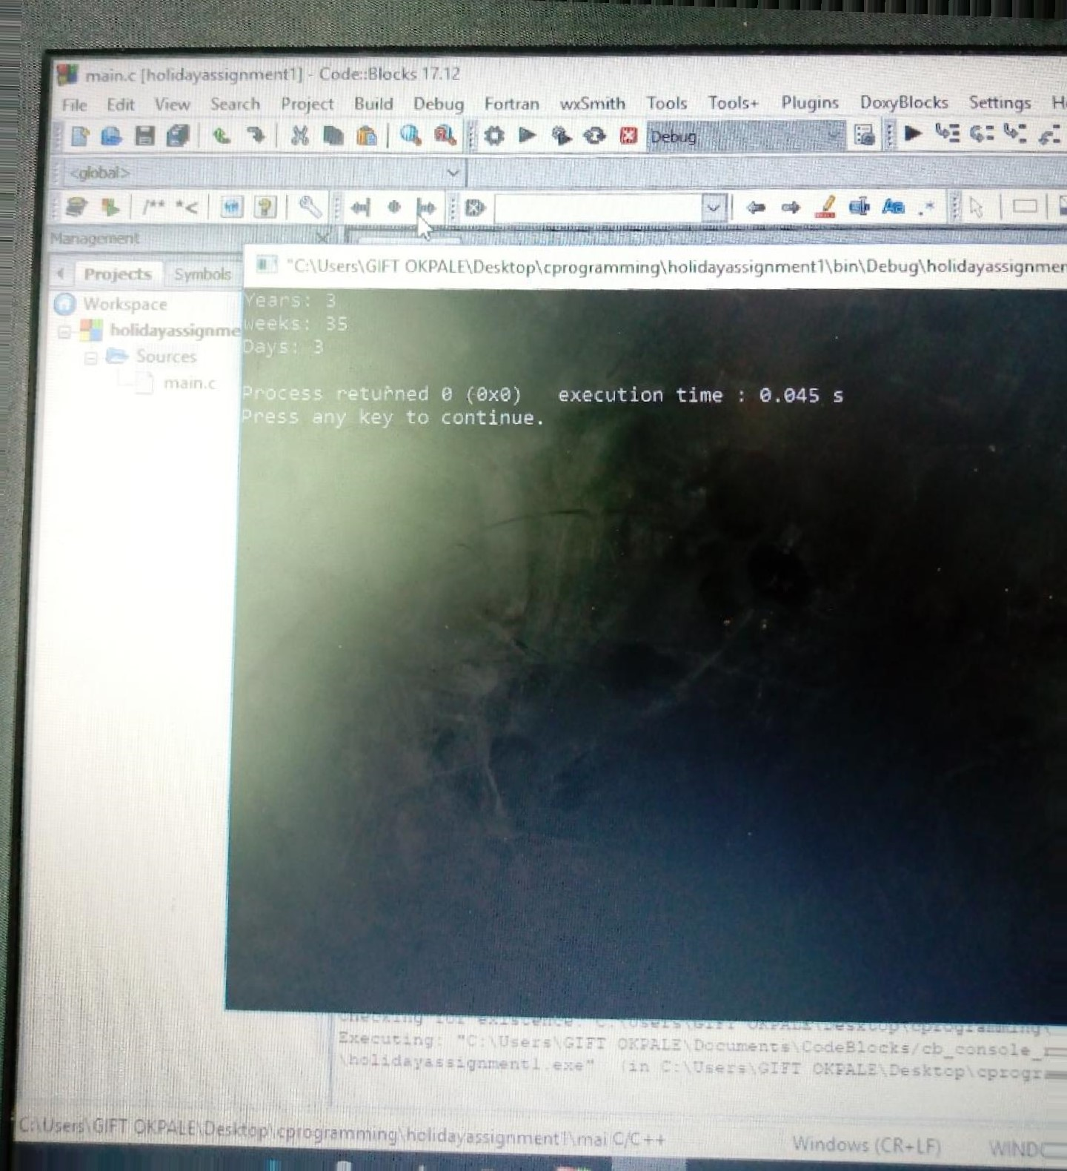

• Code: Blocks
Blocks] Settings Help_
: Enc 1
ayassiqnrnent 1
main
int days v years J weeks days
years :claÿs/üõE; weeks J(daŸ3 V/" '
days days— ( years4ýiEEÓ;

printf ( ;
riet.urn ' .' i
Buþ'ies»ges,
Wi'.•tb 23 second {S p
Line 2. Co

t?) - 171.12
OCbug -tortran liliTOols
t include .
mainÁ y
float x Y, y I, '12, gdistance;
scanf
,pryntf
( .0:; igcii3tance_j
Select i n?
i Oldi

élugins DoxyBlocks Settings Help
,uildm Debug ;ÅdF'Gtian wxSmith AoolSI
main-C X inv I l
t)ti'nvf •
14

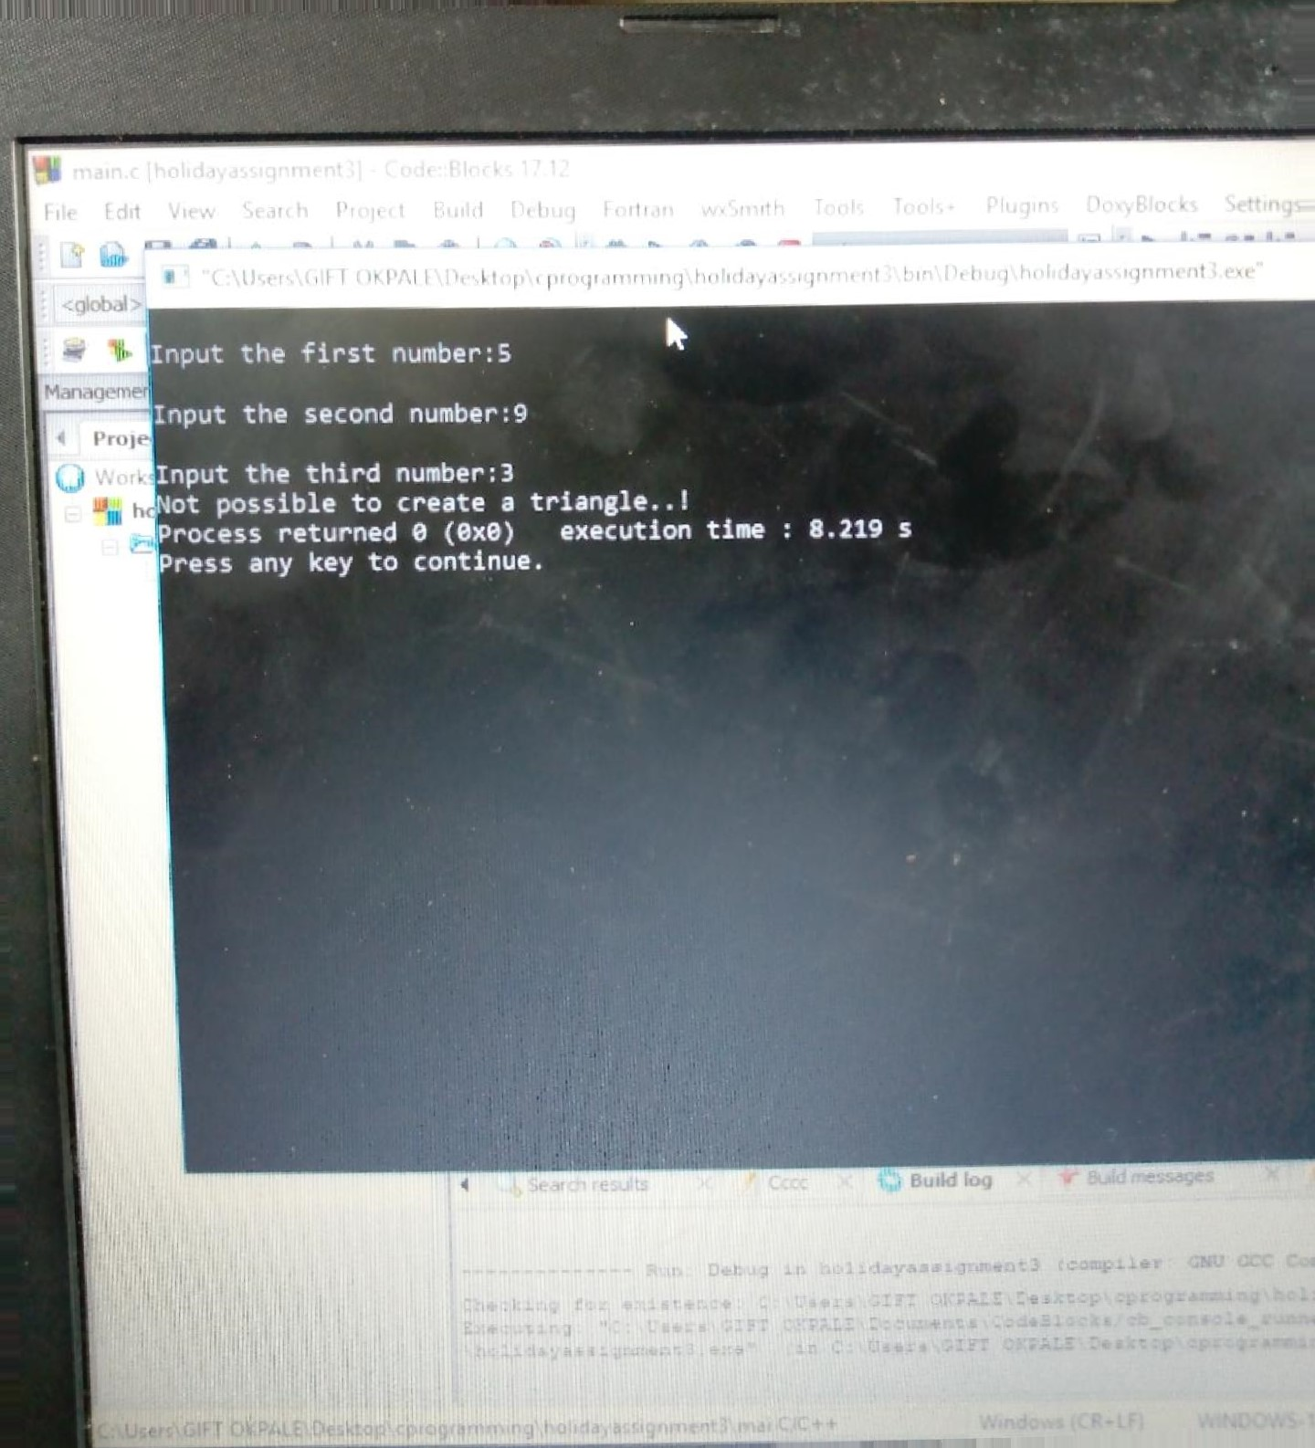

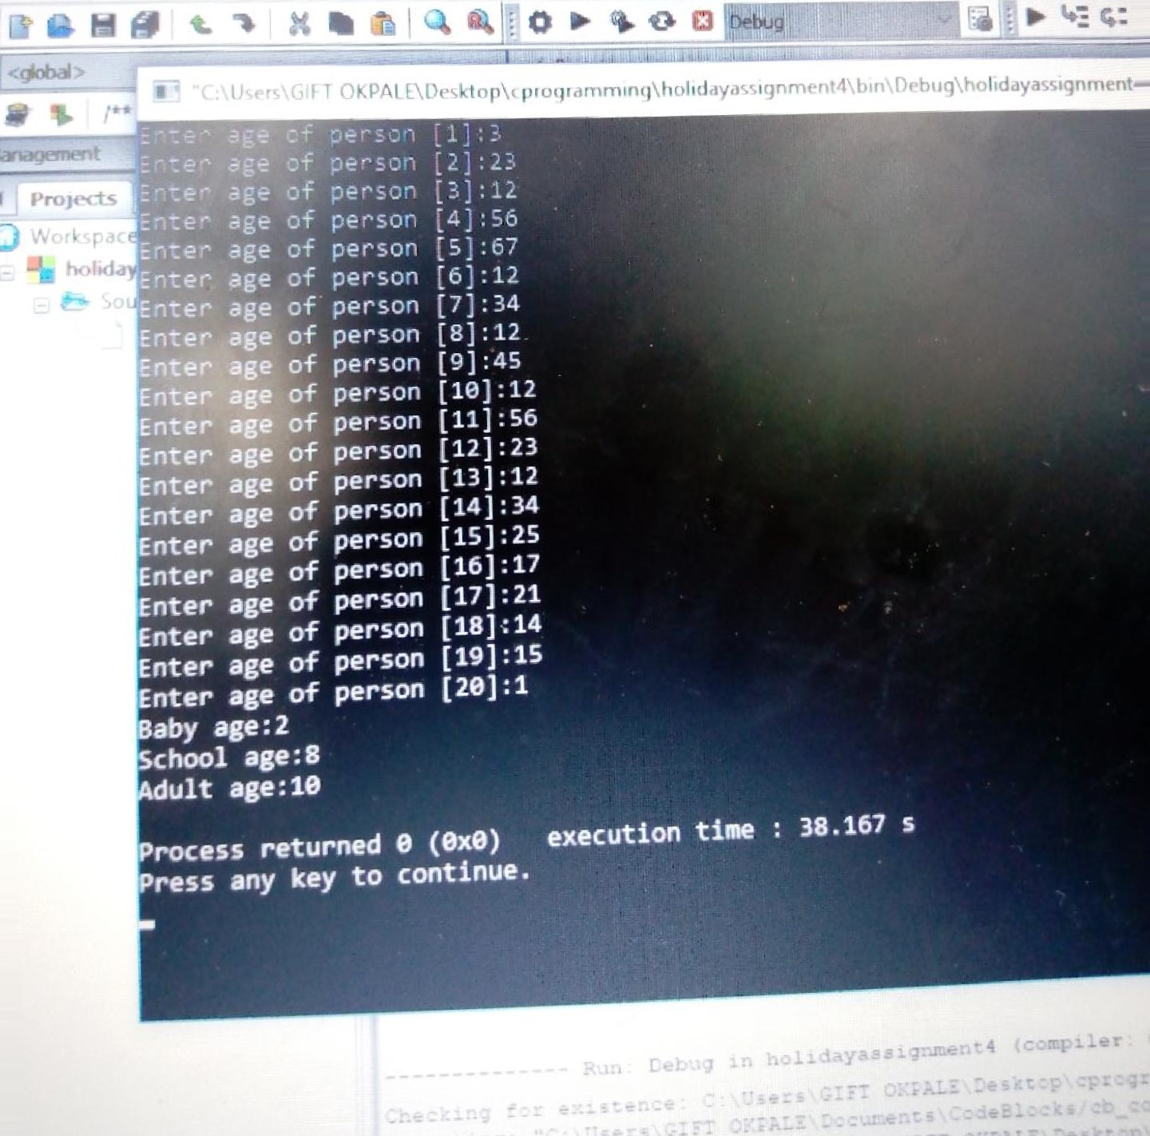
ile Edit View Search Proyect Build Debug Fortran wxSrmth Tools Toolsv Plugms Doxy810cks Sett
17.12
(holidayassrgnment41
main.c

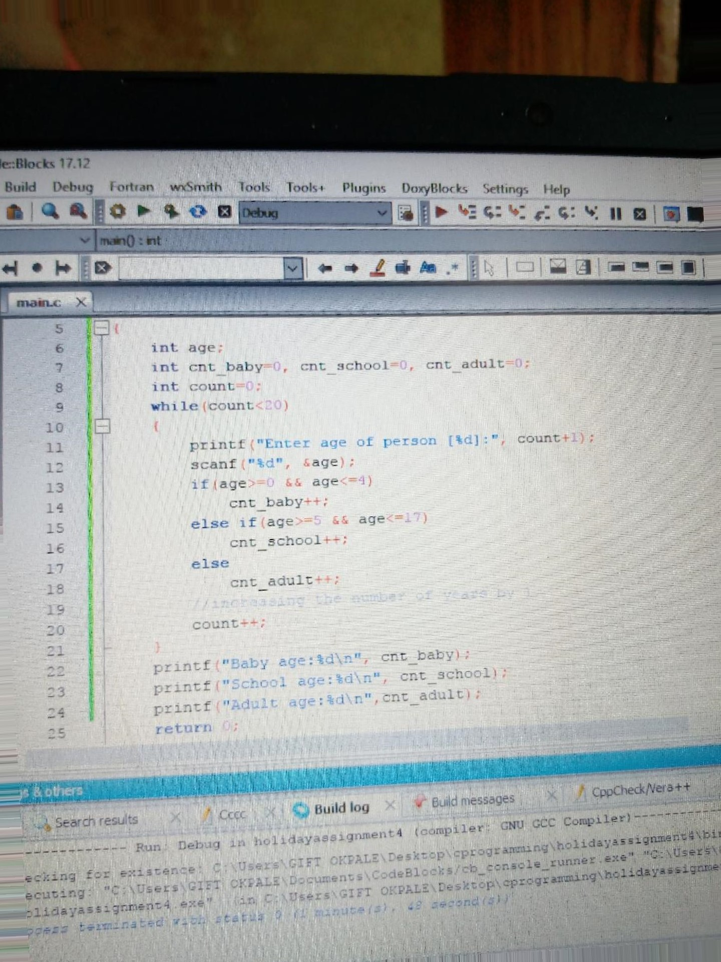

Help
Guess a number from(e to 10) enerated number is greater than entered number, try your luck again...
uess a number from(e to lØØ):2 nerated number is greater than entered number, try your luck again...
Guess a number from(Ø to lee) erated number is greater than entered number, try your luck again...
ss a number from(ø to 169) rated number is greater than entered try your luck again...
s a nu•er from(ø to ated number is greater than, filtered' number, try your luck again..
ss a number from(Ø t
try your luck again...
uqbetþ'try your luck again..
n .487 s
t-tu$h]

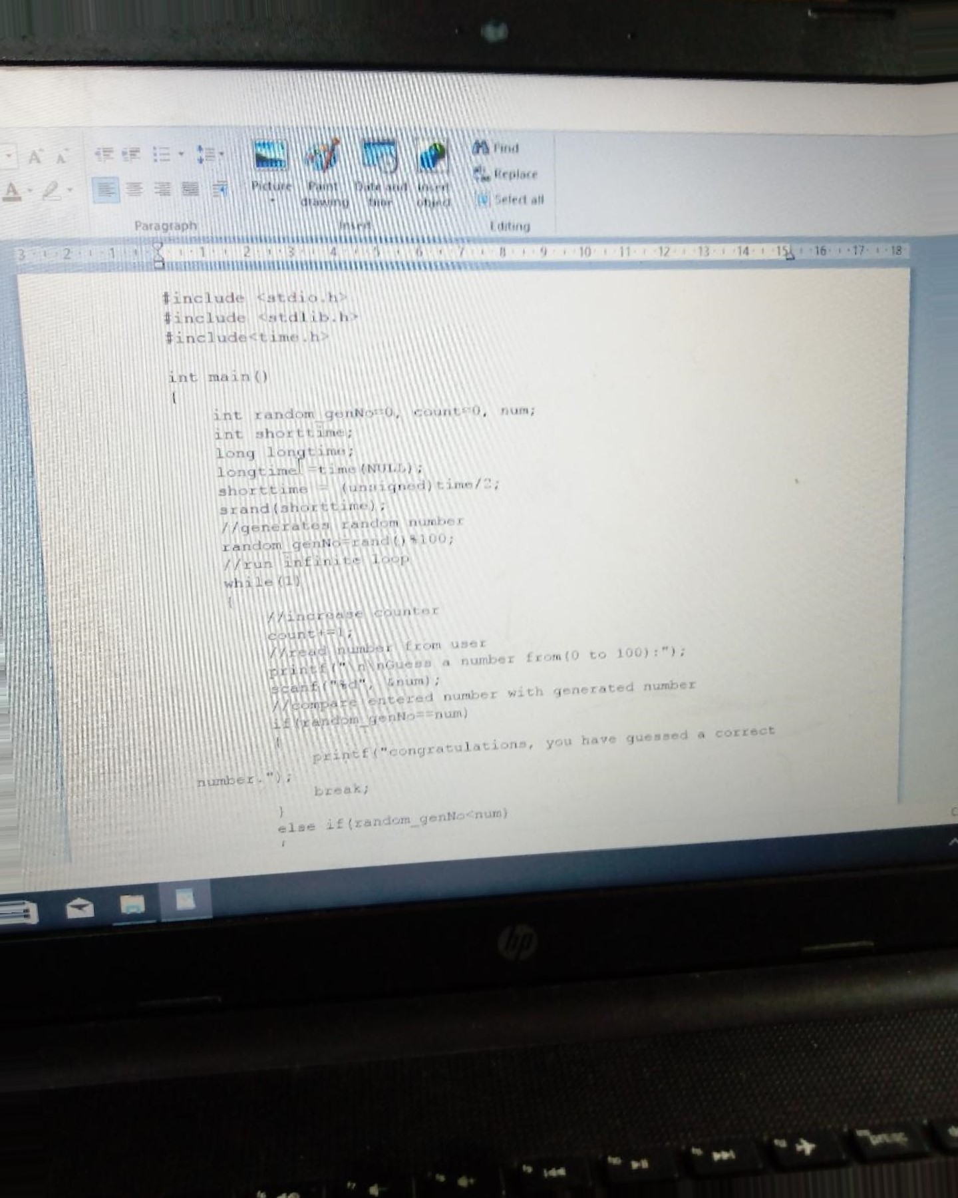

find
Picture Paint Date and Insert Replace drawing time object Select all
Paragraph Insert
Editing
/ / read number from user print f number from (C) to 100) : ") scanf Gnurn) ;
/ / entered number with generated number

i f ( random
( have guessed a „correct
nurni:£r ;

