DOMINIC TIMOTHY DOMINIC
15/ENG06/021
MECHANICAL ENGINEERING
MEE 586

- What is an integrated CAD/CAM
Ans. Integrated CAD/CAM systems are employed to achieve computer aided integration in all production functions, from design and planning up to manufacturing and the assurance of quality standards. These provides one model supporting both design and manufacturing functions instead of having various file formats, numerous data translation/conversions, and different CAD and CAM models. To the CAM system, the CAD model becomes the sole geometry on play.

- Draw a product cycle to describe the scope of CAD/CAM in the operation of manufacturing firm.
Ans.
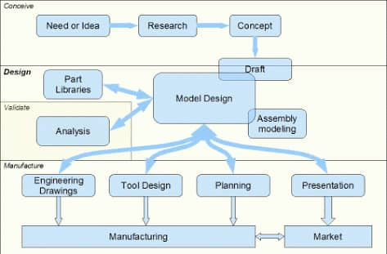
- Explain seven (7) characteristics of good CAD software.
Ans. A) EFFICIENCY: Efficient software is that which can use fewer resources such as CPU in terms of time and usage to give a better output.
B) SIMPLICITY: A software must be simple to use and easy to understand and must be user friendly.
C) FLEXIBILITY: The software must be able to incorporate the design modification without much of difficulty.
D) PORTABILITY: the software must have the capability to get transferred from one system to other
E) READABILITY: This provides the capability within the software to help the user as and when required.
F) RECOVER ABILITY: Good software must be able to give warnings before getting crashed and must be able to recover.
G) RELIABILITY: To avoid causality the software must be able to avoid unwanted operation.

- Explain three (3) divisions of software components.
Ans. Application software: are often called productivity programs or end user programs because they enable their user to complete tasks, such as creating documents, spreadsheets, databases and publications, doing online research, sending emails, designing graphics, running businesses, and even playing games. Application software is specific to the task it is designed for and be as simple as a calculator application or as complex as a word processing application.

B) System software: includes the programs that are dedicated to managing the computer itself, such as the operating system, file management utilities, and disk operating system. The operating system manages the computer hardware resources in addition to application and data. Without systems software installed in our computers we would have to type the instructions for everything we wanted the computer to do.
C) Web application: is a computer program that utilizes web browsers and web technology to perform tasks over the internet. Millions of businesses use the internet as a cost effective communications channel. Its lets them exchange information with their target market and make fast, secure transactions. However, effective engagement is only possible when the business is able to capture and store all the necessary data, and have a means of processing this information and presenting the results to the user.

