15/ENG04/042
EEE512-DIGITAL COMMUNICATION
ELECT/ELECT ENGR.

ASSIGNMENT

3G
3G is the third generation of wireless technologies. It comes with enhancements over earlier wireless technologies, such as high-speed transmission, advanced multimedia access, and global roaming.3G is mostly used with mobile phones and handsets as a means to connect the phone to the internet or other IP networks in order to make voice and video calls, to download and upload data, and to surf the Web.

3G UMTS Core Network
The 3G UMTS core network architecture is a migration of that used for GSM with further elements overlaid to enable the additional functionality demanded by UMTS.
In view of the different ways in which data may be carried, the UMTS core network may be split into two different areas:
Circuit switched elements: These elements are primarily based on the GSM network entities and carry data in a circuit switched manner, i.e. a permanent channel for the duration of the call.
Packet switched elements: These network entities are designed to carry packet data. This enables much higher network usage as the capacity can be shared and data is carried as packets which are routed according to their destination.

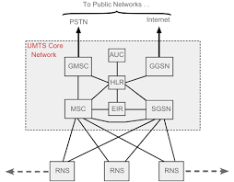

Circuit switched elements
The circuit switched elements of the UMTS core network architecture include the following network entities:
Mobile switching centre (MSC): This is essentially the same as that within GSM, and it manages the circuit switched calls under way.

Gate way msc (Gmsc): this is effectively the gateway of the external network.Serving GPRS Support Node (SGSN): this entity was first developed when GPRS was introduced, and its use has been carried over into the UMTS network architecture. The SGSN provides a number of functions within the UMTS network architecture.
Mobility management When a UE attaches to the Packet Switched domain of the UMTS Core Network, the SGSN generates MM information based on the mobile's current location.
Session management: The SGSN manages the data sessions providing the required quality of service and also managing what are termed the PDP (Packet data Protocol) contexts, i.e. the pipes over which the data is sent.
Interaction with other areas of the network: The SGSN is able to manage its elements within the network only by communicating with other areas of the network, e.g. MSC and other circuit switched areas.
Billing: The SGSN is also responsible billing. It achieves this by monitoring the flow of user data across the GPRS network. CDRs (Call Detail Records) are generated by the SGSN before being transferred to the charging entities (Charging Gateway Function, CGF).
Gateway GPRS Support Node (GGSN): Like the SGSN, this entity was also first introduced into the GPRS network. The Gateway GPRS Support Node (GGSN) is the central element within the UMTS packet switched network. It handles inter-working between the UMTS packet switched network and external packet switched networks, and can be considered as a very sophisticated router. In operation, when the GGSN receives data addressed to a specific user, it checks if the user is active and then forwards the data to the SGSN serving the particular

Shared elements
the shared elements of the 3G UMTS core network architecture include the following network entities:
Home location register (HLR): This database contains all the administrative information about each subscriber along with their last known location. In this way, the UMTS network is able to route calls to the relevant RNC / Node B. When a user switches on their UE, it registers with the network and from this it is possible to determine which Node B it communicates with so that incoming calls can be routed appropriately. Even when the UE is not active (but switched on) it re-registers periodically to ensure that the network (HLR) is aware of its latest position with their current or last known location on the network.Equipment identity register (EIR): The EIR is the entity that decides whether a given UE equipment may be allowed onto the network. Each UE equipment has a number known as the International Mobile Equipment Identity. This number, as mentioned above, is installed in the equipment and is checked by the network during registration.
Authentication centre (AuC): The AuC is a protected database that contains the secret key also contained in the user's USIM card.

ADVATAGES OF 3G NETWORK
- More bandwidth, security and reliability
- Asymmetric data rates
- New radio spectrum to relieve overcrowding in existing systems.
- Interoperability between service providers.
Fixed and variable data rates.

DISADVANTAGES
- requires 3g compatible handsets.
- The cost of upgrading to 3g device is expensive.
- Power consumption is high.
- 3g requires closer base stations which is expensive.

4G NETWORK

To put it simply, 4G is defined as the fourth generation of mobile technology which follows the 2G and 3G networks that came before it. It is also sometimes referred to as 4G LTE, but this is not technically correct as LTE is only a single type of 4G. It is currently the most advanced technology that’s adopted by the majority of mobile network service providers.

The User Equipment (UE)
The internal architecture of the user equipment for LTE is identical to the one used by UMTS and GSM which is actually a Mobile Equipment (ME). The mobile equipment comprised of the following important modules:
Mobile Termination (MT): This handles all the communication functions.
Terminal Equipment (TE): This terminates the data streams.
Universal Integrated Circuit Card (UICC) : This is also known as the SIM card for LTE equipment. It runs an application known as the Universal Subscriber Identity Module (USIM).
A USIM stores user-specific data very similar to 3G SIM card. This keeps information about the user's phone number, home network identity and security keys etc.
The E-UTRAN (The access network)
The architecture of evolved UMTS Terrestrial Radio Access Network (E-UTRAN) has been illustrated below.

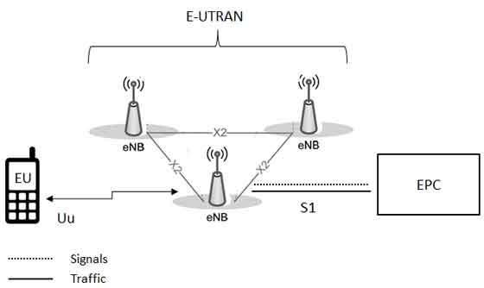
The E-UTRAN handles the radio communications between the mobile and the evolved packet core and just has one component, the evolved base stations, called eNodeB or eNB. Each eNB is a base station that controls the mobiles in one or more cells. The base station that is communicating with a mobile is known as its serving eNB.
LTE Mobile communicates with just one base station and one cell at a time and there are following two main functions supported by eNB:
The eBN sends and receives radio transmissions to all the mobiles using the analogue and digital signal processing functions of the LTE air interface.
The eNB controls the low-level operation of all its mobiles, by sending them signalling messages such as handover commands.
Each eBN connects with the EPC by means of the S1 interface and it can also be connected to nearby base stations by the X2 interface, which is mainly used for signalling and packet forwarding during handover.
A home eNB (HeNB) is a base station that has been purchased by a user to provide femtocell coverage within the home. A home eNB belongs to a closed subscriber group (CSG) and can only be accessed by mobiles with a USIM that also belongs to the closed subscriber group.
ADVANTAGES
- Quickly download files over a wireless network.
- Extremely high voice quality.
- Easily access Internet, IM, social networks, streaming media, video calling.
- Higher bandwidth.
- 4G is 10 times faster than 3G.

DISADVANTAGES
- New frequencies means new components in cell towers.
- Higher data prices for consumers.
- Consumer is forced to buy a new device to support the 4G.
- It is impossible to make your current equipment compatible with the 4G network.

5G NETWORK
5G is the 5th generation mobile network. It is a new global wireless standard after 1G, 2G, 3G, and 4G networks. 5G enables a new kind of network that is designed to connect virtually everyone and everything together including machines, objects, and devices.5G wireless technology is meant to deliver higher multi-Gbps peak data speeds, ultra low latency, more reliability, massive network capacity, increased availability, and a more uniform user experience to more users. Higher performance and improved efficiency empower new user experiences and connects new industries.
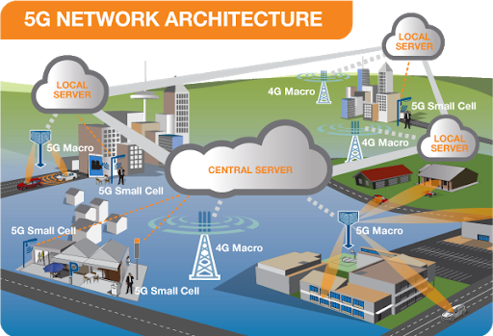

5G network architecture illustrating 5g and 4g working together, with central and local servers providing faster content to users and low latency applications.A mobile network network has two components, the radio access network and the core network.
The radio access network: consists of various types of facilities including small cells, towers, masts and dedicated in building and home systems that connect mobile users and wireless devices to main core network.
Small cells will be a major feature 5g networks particularly at new millimeter wave frequencies where the connection range is very short. To provide a continuous connection, small cells will be distributed in clusters depending on where users require connection which will complement the macro network that provides wide area coverage.5g macro cells will use MIMO ( multiple input, multiple output|) antennas that have multiple elements or connections to send and receive more data simultaneously connect to the network and maintain high throughputThe core network: is the mobile exchange and data network that manages all the mobile voice, data and internet connection. For 5g , the core network is being redesigned to better integrate with the internet and cloud based services and also includes distributed servers across the network improving response times ( reducing latency)

ADVANTAGES
- High resolution and bi-directional large bandwidth shaping.
- Technology to gather all networks on one platform.
- More effective and efficient.
- Technology to facilitate subscriber supervision tools for the quick action.

DISADVANTAGES
- Technology is still under process and research on its viability is going on.
- The speed, this technology is claiming seems difficult to achieve (in future, it might be) because of the incompetent technological support in most parts of the world.
- Developing infrastructure needs high cost.
- Security and privacy issue yet to be solved.

2.) Differences between 3g,4g, and 5g networks

features | 3G | 4G | 5G
Start/development | 1990-2002 | 2000/2010 | 2010/2015
technology | WCDMA | LTE, wiMax | MIMO, mm Waves
frequency | 1.6-2GHZ | 2-8GHz | 3-30GHz
bandwidth | 2mbps | 2000 mbps to 1 gbps | 1 Gbps and higher
Access system | CDMA | CDMA | OFDM/BDMA
Core system | Packet network | internet | internet

3i) is there correlation between between the 5g and coronavirus?
No, there is not.

3ii) in not more than 500bwords justify your answer
Your immune system can be dipped by all sorts of thing by being tired one day, or not having a good diet. Those fluctuations aren't huge but can make you more susceptible to catching viruses, While very strong radio waves can cause heating, 5G is nowhere near strong enough to heat people up enough to have any meaningful effect.
"Radio waves can disrupt your physiology as they heat you up, meaning your immune system can't function. But [the energy levels from] 5G radio waves are tiny and they are nowhere near strong enough to affect the immune system. There have been lots of studies on this, The radio waves involved in 5G and other mobile phone technology sit on the low frequency end of the electromagnetic spectrum. Less powerful than visible light, they are not strong enough to damage cells - unlike radiation at the higher frequency end of the spectrum which includes the sun's rays and medical x-rays.It would also be impossible for 5G to transmit the virus.
The present epidemic is caused by a virus that is passed from one infected person to another. We know this is true. We even have the virus growing in our lab, obtained from a person with the illness. Viruses and electromagnetic waves that make mobile phones and internet connections work are different things.
To understand why 5G and the virus aren’t linked, you have to understand why 5G radio waves aren’t powerful enough to damage the cells in your body alone or transmit a virus. Much like 4G or 3G before it, the radio waves used in 5G are low frequency and non-ionizing radiation. These are on the opposite end of the electromagnetic spectrum to ionizing radiation sources like X-rays, gamma rays, and ultraviolet rays, These 5G radio waves simply aren’t strong enough to heat your body and weaken your immune system..
Likewise, radio waves and viruses aren’t transmitted in the same way. The coronavirus spreads from one person to another, typically through tiny droplets of saliva produced when a sick person coughs, sneezes, or breathes. The only types of viruses you can transmit by radio waves are ones that affect computers, not humans.
The difference between 5G and previous generations of mobile services (4G, 3G) is that the latter use lower radio frequencies (in the 6 gigahertz range), whereas 5G [also] uses frequencies in the 30–300 ghz range. In the 30-300 gigahertz range, there's not enough energy to break chemical bonds or remove electrons when in contact with human tissue. Thus, this range is referred to as "non-ionizing" electromagnetic radiation
Radiation can come into contact with the skin, for example, when we put a 5G mobile to our ear to make a call. This is when we're most exposed to non-ionizing radiation But this exposure is well below the recommended safety level.
5G radiation can't penetrate skin, or allow a virus to penetrate skin, so there is no evidence 5G radio frequencies cause or exacerbate the spread of the coronavirus.

