NAME: ONOH IKECHUKWU CHINEDU
MATRIC NUMBER: 16/ENG06/087
COURSE: MEE 586 (ASSIGNMENT)

- An integrated CAD/CAM system provides one model supporting both design and manufacturing functions instead of having various file formats, numerous data translations/conversions, and different CAD and CAM models. ... Working with the same data is analogous to speaking the same language.

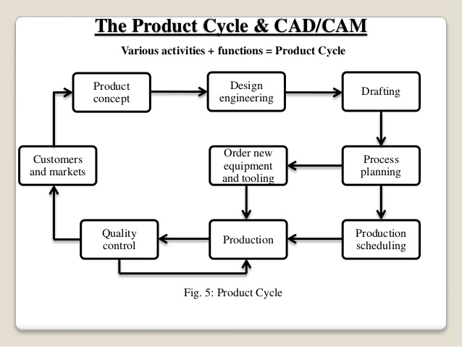
3)
A) Efficiency:- An Efficient software is that which can use less resources such as CPU in terms of time and usage to give a better output.

B) Simplicity:- A software must be simple to use and easy to understand and must be be user friendly.

C) Flexibility: - The software must be able to incorporate the design modification with out much of difficulty.

D) Readability:- This provides the capability within the software to help the user as and when required.

E) Portability: - The software must have the capacity to get transferred from one system to other.

F) Reliability: - To avoid causality the software must be able to avoid unwanted operation.

G) Recover ability: - A Good software must be able to give warnings before getting crashed and must be able to recover.
4)

System Software
The system manages other software and devices inside the computer. The foremost example of system software is the operating system (OS).
In a typical setup, the operating system is like the motherboard for software. It is the first thing that is installed, followed by applications and other software. Three popular operating systems for traditional computers include Windows, Mac OS X, and Linux.
Popular mobile operating systems include Android OS, iPhone OS, Windows Phone OS, and Firefox OS.

Application Software
This is designed for end users to perform a specialized assignment in order to output useful information.
An example would be a word processing application used to compose letters or brochures, such as Microsoft Word.
Other popular examples include Adobe Photoshop, Corel Draw, and AutoCAD.
A collection of application software is bundled in a package that is commonly known as a software suite. A typical suite includes software for word processing, presentation, graphic design, and spreadsheet.
Examples include Microsoft Office, Open Office, and iWork.

Programming Software
These are tools used by developers to create all kinds of software like Windows OS and Word processing. Also called languages, they are used to write source codes, debug errors, maintain and create new software for computers and write malicious scripts like viruses and trojans.
Popular examples of high-level languages are Java, Javascript, BASIC, PHP, Visual Basic, Visual C++, Visual Basic, Python, Ruby, Perl, Java.

