NAME: ONOH IKECHUKWU CHINEDU
MATRIC NUMBER: 16/ENG06/087
COURSE: MEE 514 (ASSIGNMENT)
TERM PAPER ON SOFT TISSUE MECHANICS (STM)
- SOFT TISSUE IN THE BODY
Soft tissues are found throughout the body. There are many types of soft tissue, including fat, muscle, fibrous tissue, blood vessels, lymph vessels and nerves. Soft tissues surround, support and connect organs and other tissues in the body.
What the soft tissues do
Soft tissues:
- surround, support and connect organs and other body parts
- give shape and structure to the body
- protect organs
- move fluids, such as blood, from one part of the body to another
- store energy
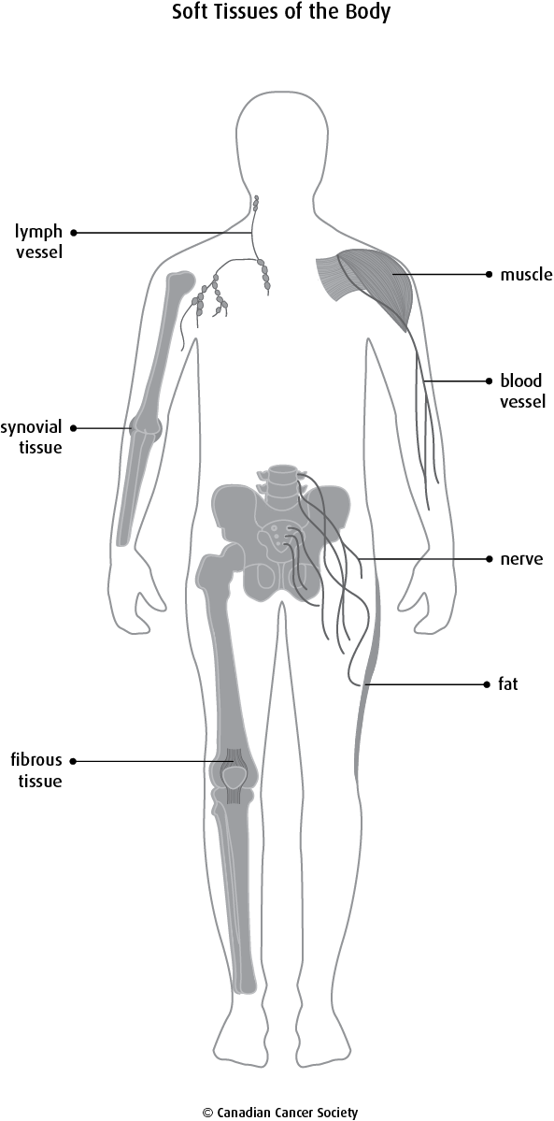
Types of soft tissue
There are different types of soft tissue found in the body.

Fat
Fat is a soft tissue made up of fat cells (adipocytes) that are packed tightly together. It may also be called fat tissue or adipose tissue.
Fibrous tissue
Fibrous tissue is connective tissue made up of rope-like parts called fibres. These fibres help move body parts and keep them strong and stable. Tendons (which attach muscle to bone) and ligaments (which attach bone to another bone) are made up of fibrous tissue.
Muscle
There are 3 types of muscle – smooth muscle, skeletal muscle and cardiac (heart) muscle.
Smooth muscle works automatically without you thinking about it (involuntary muscle).
Skeletal muscle is a type of muscle that you control to move your body (voluntary muscle).
Cardiac muscle forms the walls of the heart and allows the heart to pump blood. Cardiac muscle works automatically without you controlling it.
Synovial tissue
Synovial tissue is thin and loose connective tissue that lines joints, such as elbows and knees. It is also found around tendons and fluid-filled sacs between bones and tendons (bursa). Synovial tissue makes synovial fluid, which is a thick liquid that allows areas to move easily.
Blood vessels
Blood vessels are long, elastic hollow tubes that are found throughout the body. Arteries, veins and capillaries are types of blood vessels. Blood travels through blood vessels and carries oxygen, nutrients, hormones, waste and other products around the body.
Lymph vessels
Lymph vessels are small tubes like blood vessels that run throughout the body. They contain lymph fluid to collect and carry waste products, germs and damaged cells away from the body’s tissues.
Nerves
Nerves are soft tissues that control all of the body’s functions and movements. Nerve tissue is made of 2 main types of cells – nerve cells (neurons) and glial cells (neuroglia cells). Nerve cells send messages (as electrical impulses) from one part of the body to another. Glial cells support the nerve cells. Most of the body’s nerve tissue is found in the brain and spinal cord, which is known as the central nervous system (CNS). Some nerve tissue is outside of the brain and spinal cord and called the peripheral nervous system. Nerve tissue is also called nervous tissue or neural tissue.(Pahwa et al., 2011)
- COLLAGEN AS A FIBROUS PROTEIN AND BASIC STRUCTURAL ELEMENTS OF STM
Collagen is the main structural and load-bearing element of various connective tissues, where it forms the extracellular matrix that supports cells. It has long been known that collagenous tissues exhibit a highly nonlinear stress–strain relationship, although the origins of this nonlinearity remain unknown. Here, we show that the nonlinear stiffening of reconstituted type I collagen networks is controlled by the applied stress and that the network stiffness becomes surprisingly insensitive to network concentration.(Cummings et al., 2004)
- STRESS-STRAIN RELATIONSHIP IN COLLAGEN BIOMATERIALS
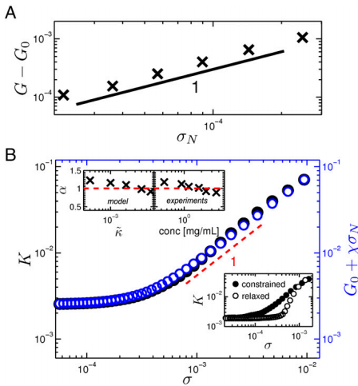
Form the figure above, Stiffening induced by normal stresses. (A) The change in the linear shear modulus grows in direct proportion to an external normal stress σN applied on the shear boundaries. (B) Comparison of K (black) with G0 +χσN (blue) vs. shear stress in the linear and stiffening regimes. The local slope α=1 (red dashed line) in the stiffening region is shown as a visual guide. The Upper Insets show the variation of α as a function of bending rigidity/protein concentration. The Lower Inset shows the reduction in network stiffness when the normal stress is removed.(James et al., 2015)

- CARTILAGE AND ITS APPLICATIONS IN ARTICULATING JOINTS SUCH AS HIP, KNEE ANKLE AND SHOULDER
Joints, such as the hip and knee, are crucial for support and locomotion in animals, and are the frequent sites of serious human diseases such as arthritis. The Growth and differentiation factor 5 (Gdf5) gene is required for normal joint formation, and has been linked to risk of common arthritis in Eurasians. Here, we surveyed the mouse gene for the regulatory information that controls Gdf5's expression pattern in stripes at sites of joint formation. The gene does not have a single regulatory sequence that drives expression in all joints. Instead, Gdf5 has multiple different control sequences that show striking specificity for joints in the head, vertebral column, shoulder, elbow, wrist, hip, knee, and digits. Rescue experiments show that multiple control sequences are required to restore normal joint formation in Gdf5 mutants. The joint control sequences originally found in mice are also present in humans, where they are marked as active regions during fetal development and post-natal life, and map to a large region associated with arthritis risk in human populations. Regulatory variants in the human GDF5 control sequences can now be studied for their potential role in altering joint development or disease risk at particular locations in the skeleton.(Miller, 2005)

5) MECHANICAL TESTING PROCEDURES FOR SOFT TISSUES
Mechanical properties of very soft tissues, such as brain, liver, kidney and prostate have recently joined the mainstream research topics in biomechanics. This has happened in spite of the fact that these tissues do not bear mechanical loads. The interest in the biomechanics of very soft tissues has been motivated by the developments in computer-integrated and robot-aided surgery--in particular, the emergence of automatic surgical tools and robots-as well as advances in virtual reality techniques. Mechanical testing of very soft tissues provides a formidable challenge for an experimenter. Very soft tissues are usually tested in compression using an unconfined compression set-up, which requires ascertaining that friction between sample faces and stress-strain machine platens is close to zero. In this paper a more reliable method of testing is proposed. In the proposed method top and bottom faces of a cylindrical specimen with low aspect ratio are rigidly attached to the platens of the stress-strain machine (e.g. using surgical glue). This arrangement allows using a no-slip boundary condition in the analysis of the results. Even though the state of deformation in the sample cannot be treated as orthogonal the relationships between total change of height (measured) and strain are obtained. Two important results are derived: (i) deformed shape of a cylindrical sample subjected to uniaxial compression is independent on the form of constitutive law, (ii) vertical extension in the plane of symmetry lambda(z) is proportional to the total change of height for strains as large as 30%. The importance and relevance of these results to testing procedures in biomechanics are highlighted.(Miller, 2005)

REFERENCE
Makin HJ. Structure and functions of the joint In Arthritis and Allied Conditions: A Textbook of Rheumatology. London: Williams and Wilkins Press; 1997.
Lawrence RC, Felson DT, Helmick CG, Arnold LM, Choi H, Deyo RA, et al. Estimates of the prevalence of arthritis and other rheumatic conditions in the United States. Part II. Arthritis Rheum. 2008;58(1):26–35. Epub 2008/01/01. 10.1002/art.23176.
Cummings, C. L., Gawlitta, D., Nerem, R. M., & Stegemann, J. P. (2004). Properties of engineered vascular constructs made from collagen, fibrin, and collagen-fibrin mixtures. Biomaterials. https://doi.org/10.1016/j.biomaterials.2003.10.073
James, A., Münster, S., Sharma, A., Sheinman, M., Jawerth, L. M., & Fabry, B. (2015). Stress controls the mechanics of collagen networks. 112(31). https://doi.org/10.1073/pnas.1504258112
Miller, K. (2005). Method of testing very soft biological tissues in compression. Journal of Biomechanics. https://doi.org/10.1016/j.jbiomech.2004.03.004
Pahwa, P., Karunanayake, C. P., Dosman, J. A., Spinelli, J. J., & McLaughlin, J. R. (2011). Soft-tissue sarcoma and pesticides exposure in men: Results of a canadian case-control study. Journal of Occupational and Environmental Medicine. https://doi.org/10.1097/JOM.0b013e3182307845
Cummings, C. L., Gawlitta, D., Nerem, R. M., & Stegemann, J. P. (2004). Properties of engineered vascular constructs made from collagen, fibrin, and collagen-fibrin mixtures. Biomaterials. https://doi.org/10.1016/j.biomaterials.2003.10.073
James, A., Münster, S., Sharma, A., Sheinman, M., Jawerth, L. M., & Fabry, B. (2015). Stress controls the mechanics of collagen networks. 112(31). https://doi.org/10.1073/pnas.1504258112
Miller, K. (2005). Method of testing very soft biological tissues in compression. Journal of Biomechanics. https://doi.org/10.1016/j.jbiomech.2004.03.004
Pahwa, P., Karunanayake, C. P., Dosman, J. A., Spinelli, J. J., & McLaughlin, J. R. (2011). Soft-tissue sarcoma and pesticides exposure in men: Results of a canadian case-control study. Journal of Occupational and Environmental Medicine. https://doi.org/10.1097/JOM.0b013e3182307845

