NAME: SHIGABA ANNA NAMA
MATRIC NUMBER: 17/MHS03/030
COURSE CODE: STAT 312
DEPARTMENT: ANATOMY
LEVEL: 300L

ASSIGNMENT
1. WHAT DO YOU UNDERSTAND BY HYPOTHESIS TESTING?
A Hypothesis may be defined simply as a statement about one or more population set up for the purpose of being discredited or approved.
It is the theory, methods, and practice of testing a hypothesis by comparing it with the bull hypothesis. The null is only rejected if it's probability falls below a predetermined significance level, in which case the hypothesis being tested is said to have that level of significance.
Hypothesis testing was introduced by Ronald Fisher, Jerzy Neyman, Karl Pearson and Pearson’s son, Egon Pearson. Hypothesis testing is a statistical method that is used in making statistical decisions using experimental data. Hypothesis Testing is basically an assumption that we make about the population parameter.

2. DIFFERENTIATE BETWEEN THE CLASSICAL AND P-VALUE APPROACH FOR HYPOTHESIS TESTING?
S/N | Classical Approach | P Value Approach
1. | The first approach of hypothesis testing is a classical test statistic approach, which computes a test statistic from the empirical data and then makes a comparison with the critical value. | For the p-value approach, the likelihood (p-value) of the numerical value of the test statistic is compared to the specified significance level (αα) of the hypothesis test.
2. | The classical approach also has three different decision rules, depending on whether it is a left tail, right tail or two tail test. | The p-value corresponds to the probability of observing sample data at least as extreme as the actually obtained test statistic
3. | If the test statistic in this classical approach is larger than the critical value, then the null hypothesis is rejected. Otherwise, it is accepted. | If the p-value is less than alpha, you would reject the null hypothesis.
4. | The classical approach is based on standard deviations. This method compares the test statistic (Z-score) to a critical value (Z-score) from the standard normal table. | This method compares the area associated with the test statistic to alpha (α), the level of significance (which is also area under the normal curve).

The steps in the classical approach:
1. Define or state the null and alternative hypotheses.
2. Select a test statistic.
3. Select a significance level, or a specific probability level, which if exceeded, signals that the test statistic is large enough to consider significant.
4. Delineate the "rejection region" under the pdf of the appropriate distribution for the test statistic, (i.e. determine the specific value of the test statistic that if exceeded would be grounds to consider it significant.
5. Compute the test statistic.
6. Depending on the particular value of the test statistics either a) reject the null hypothesis (Ho) and accept the alternative hypothesis (Ha), or b) fail to reject the null hypothesis.
The steps in the "p-value" approach are:
1. Define or state the null and alternative hypotheses.
2. Select and compute the test statistic.
3. Refer the test statistic to its appropriate reference distribution.
4. Calculate the probability that a value of the test statistic as large as that observed would occur by chance if the null hypothesis were true (this probability, or p-value, is called the significance level).
5. If the significance level is small, the tested hypothesis (Ho) is discredited, and we assert that a "significant result" or "significant difference" has been observed.
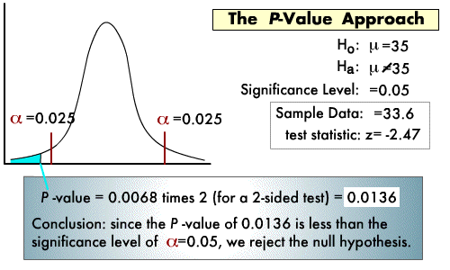
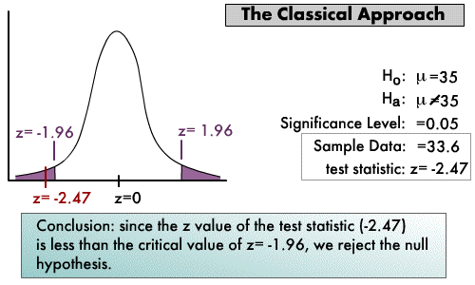
3. WHAT IS THE IMPORTANCE OF HYPOTHESIS TESTING IN RESEARCH?
IMPORTANCE OF HYPOTHESIS
Hypothesis as the Investigator’s ‘Eyes’: By guiding the investigator in further investigation it serves as the investigator’s ‘Eyes’ in seeking answers to tentatively adopted generalization.
1. It Focuses Research: Without it, research is unfocussed research and remains like a random empirical wandering. It serves as necessary link between theory and the investigation.
2. It Places Clear and Specific Goals: A well thought out set of hypothesis is that they place clear and specific goals before the research worker and provide researcher with a basis for selecting sample and research procedure to meet these goals.
3. It Links Together: It serves the important function of linking together related facts and information and organizing them into wholes.
4. It Prevents Blind Research: The use of hypothesis prevents a blind search and indiscriminate gathering of masses of data which may later prove irrelevant to the problem under study.
5. As a Sort of Guiding Light: A hypothesis serves as a powerful beacon that lights the way for the research work.
George J. Mouley thinks that Hypotheses serve the following purposes – They:
6. Provide direction to research and prevent the review of irrelevant literature and the collection of useful or excess data.
7. Sensitize the investigator certain aspects of situation which are irrelevant from the standpoint of the problem at hand.
8. Enable the investigator to understand with greater clarity his/her problem and its ramification
9. Serve as a framework for the conclusive - in short a good hypothesis: (a) Gives help in deciding the direction in which he has to proceed. (b) It helps in selecting pertinent fact. (c) It helps in drawing conclusions.

