Name: Okechukwu Uchendu
Matric No: 15/ENG06/050
Mechanical Engineering
MEE 586

- An integrated CAD/CAM system provides one model supporting both design and manufacturing functions instead of having various file formats, numerous data translations/conversions and different CAD and CAM models.
- 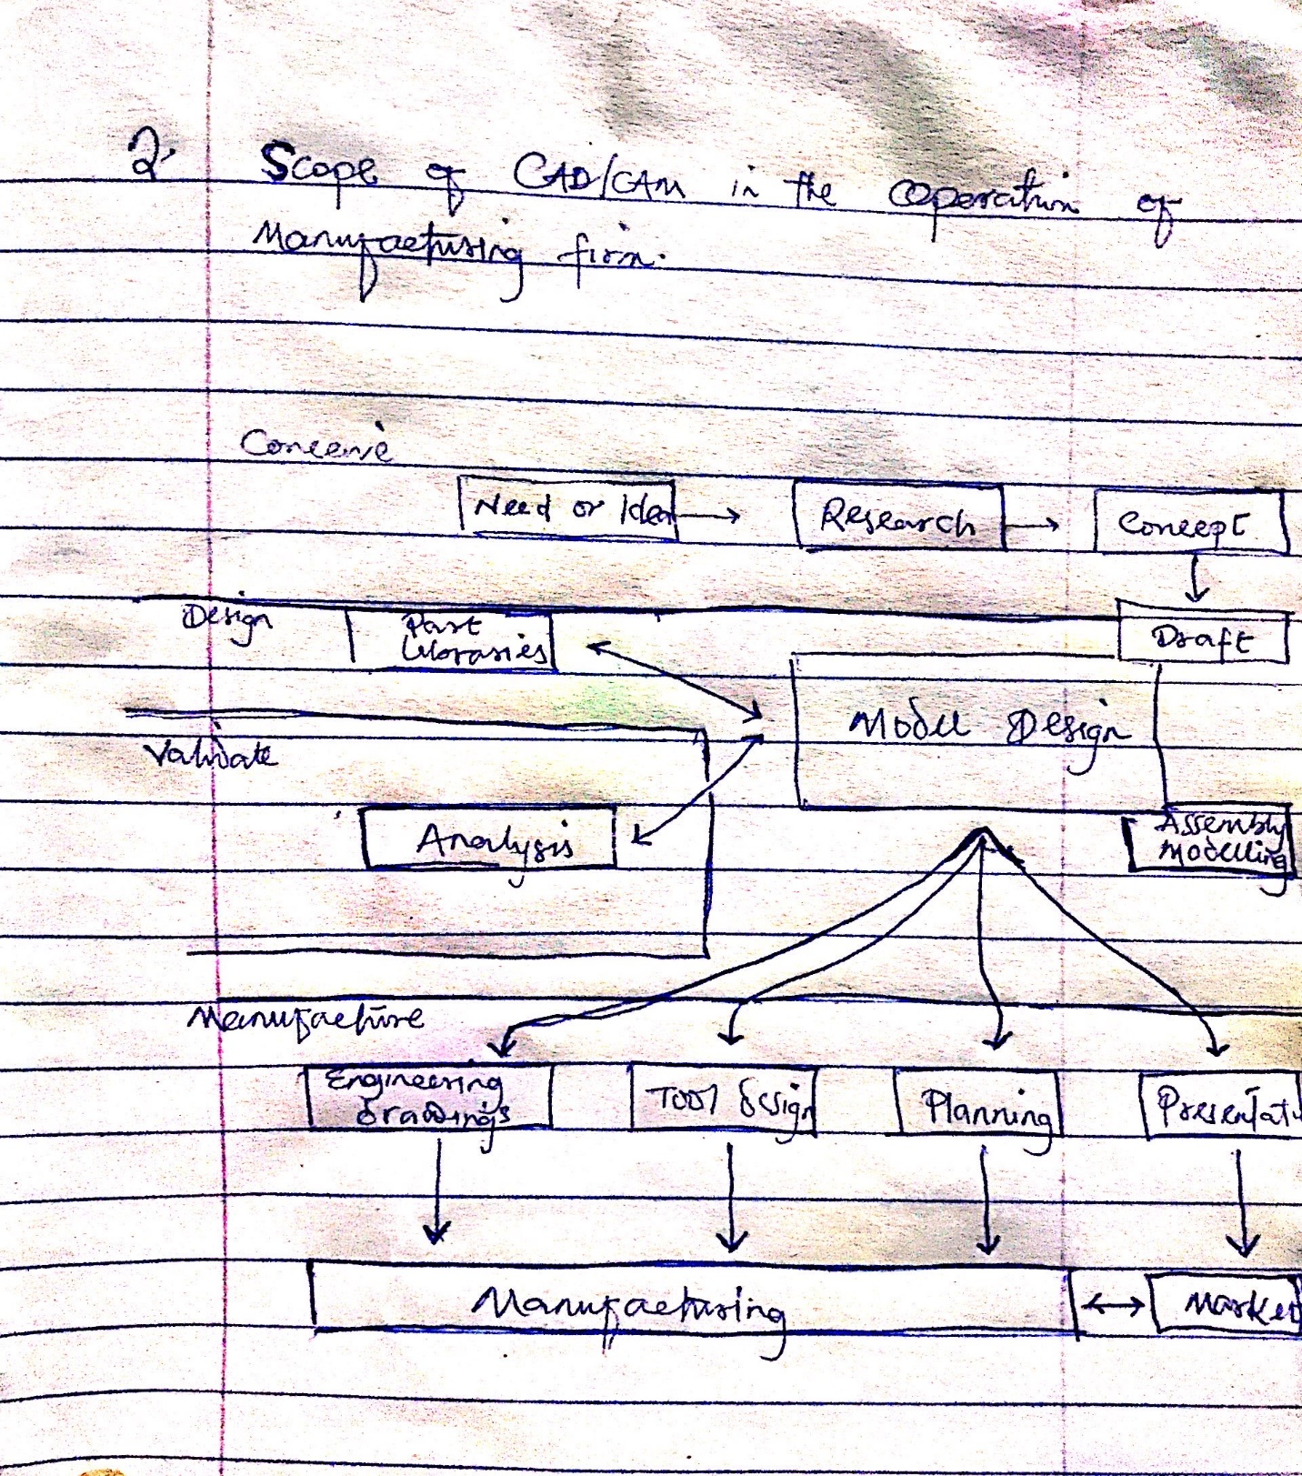

- 7 characteristics of a good CAD software

- Simplicity: A software must be simple to use and easy to understand and must be user friendly

- Portability: The software must have the capacity to be transferred from one system to another

- Recoverability: A good software must be able to give warnings before being crashed and must be able to recover

- Reliability: To avoid casualty the software must be able to avoid unwanted operation

- Efficiency: An efficient software is that which can use less resource such as CPU in terms of time and usage to give a better output

- Flexibility: The software must be able to incorporate the design modification without much difficulty

- Readability: This provides the capability within the software to help the user as and when required

- The division of software component

- System software: It includes the programs that are dedicated to managing the computer itself, such as the operating system, file management utilities and disk operating system. The operating system manages the computer hardware resources in addition to application and data. Without systems software installed in our computers we would have to type the instructions for everything we wanted the computer to do

- Application software: Application software or simply application are often productivity or end-user programs because they enable the user to complete tasks, such as creating documents, spreadsheets, databases and publications, doing online research, sending email, designing graphics, running businesses, and even playing games. Application software is specific to the task it is designed for and can be as simple as a calculator application or as complex as a word processing application.

