HAASTRUP OLUWADOYINSOLA MERCY
15/ENG06/032
MECHANICAL ENGINEERING
MEE 514
ASSIGNMENT

SOFT TISSUE IN THE HUMAN BODY
INTRODUCTION
Soft tissues in the human body refer to the tissues that connect, support, or surround other structures and organs of the body; not being hard tissue such as bone. Soft tissue includes tendons, ligaments, fascia, skin, fibrous tissues, fat, and synovial membranes(which are connective tissue), and muscles, nerves and blood vessels (which are not connective tissue). [1]
USES
The uses of the soft tissues are as follows:
- To store energy
- They give shape and structure to the body
- They move fluids, such as blood, from one part of the body to another
- They protect organs
- They surround, support and connect organs and other body parts

TYPES OF SOFT TISSUE
There are different types of soft tissue found in the body. They are:

Fat
Fat is a soft tissue made up of fat cells (adipocytes) that are packed tightly together. It may also be called fat tissue or adipose tissue. Fat is commonly found under the skin of the buttocks, hips, waist and abdomen. It also surrounds organs, such as the kidneys. Fat cushions the body, provides padding between organs and helps keep the body warm. The body also stores fat and uses it for energy when you need it.

Fibrous tissue
Fibrous tissue is connective tissue made up of rope-like parts called fibres. These fibres help move body parts and keep them strong and stable. Tendons (which attach muscle to bone) and ligaments (which attach bone to another bone) are made up of fibrous tissue. Fibrous tissue is also found in the walls of blood vessels and surrounds many organs.

Muscle
There are 3 types of muscle namely; smooth muscle, skeletal muscle and cardiac (heart) muscle.
Smooth muscle works automatically without you thinking about it (involuntary muscle). It is found in the walls of the body’s hollow organs, such as the stomach, intestines, bladder, uterus and blood vessels. Smooth muscle allows organs to relax and get bigger (expand) or tighten and get smaller (contract).
Skeletal muscle is a type of muscle that you control to move your body (voluntary muscle). It is found mainly in muscles that attach to bones. Some skeletal muscles in the face attach to the skin. Skeletal muscle keeps the skeleton together and helps you stand upright. It also allows you to move different parts of your body, such as your arms and legs.
Cardiac muscle forms the walls of the heart and allows the heart to pump blood. Cardiac muscle works automatically without you controlling it.

Synovial tissue
Synovial tissue is thin and loose connective tissue that lines joints, such as elbows and knees. It is also found around tendons and fluid-filled sacs between bones and tendons (bursa). Synovial tissue makes synovial fluid, which is a thick liquid that allows areas to move easily.

Blood vessels
Blood vessels are long, elastic hollow tubes that are found throughout the body. Arteries, veins and capillaries are types of blood vessels. Blood travels through blood vessels and carries oxygen, nutrients, hormones, waste and other products around the body.

Lymph vessels
Lymph vessels are small tubes like blood vessels that run throughout the body. They contain lymph fluid to collect and carry waste products, germs and damaged cells away from the body’s tissues.

Nerves
Nerves are soft tissues that control all of the body’s functions and movements. Nerve tissue is made of 2 main types of cells – nerve cells (neurons) and glial cells (neuroglial cells). Nerve cells send messages (as electrical impulses) from one part of the body to another. Glial cells support the nerve cells. Most of the body’s nerve tissue is found in the brain and spinal cord, which is known as the central nervous system (CNS). Some nerve tissue is outside of the brain and spinal cord and called the peripheral nervous system. Nerve tissue is also called nervous tissue or neural tissue. [2]
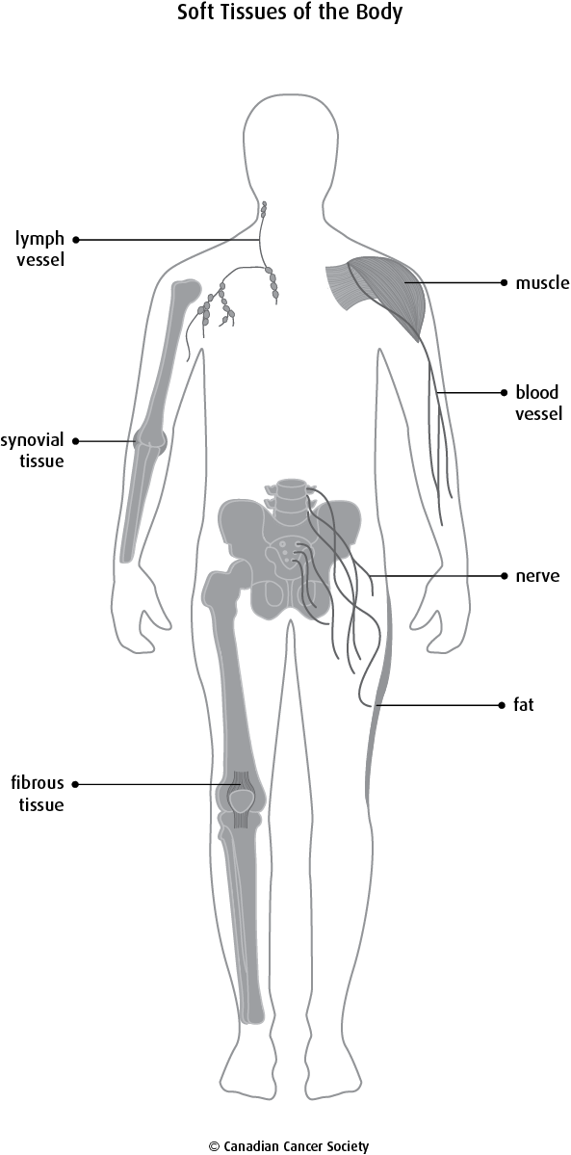
COLLAGEN AS A FIBROUS PROTEIN AND BASIC STRUCTURAL ELEMENTS OF SOFT TISSUE MECHANICS
Collagen is a fibrous protein consisting of three polypeptide chains wound around each other. Each of the three chains is a coil itself. Hydrogen bonds form between these coils, which are around 1000 amino acids in length, which gives the structure strength. It is the primary component of connective tissue, and is the most abundant protein in vertebrates. The collagen present in the human body is responsible for giving strength to bones, teeth, cartilage, tendon and the fibrous matrices of skin, cornea, inter vertebral discs and blood vessels. This is important given collagen’s role, as structural protein. This strength is increased by the fact that collagen molecules form further chains with other collagen molecules and form Covalent Cross Links with each other, which are staggered along the molecules to further increase stability. Collagen molecules wrapped around each other form Collagen Fibrils which themselves form Collagen Fibres.
Collagen has many functions in the body such as;
- It forms the structure of bones
- It makes up cartilage and connective tissue
- Prevents blood that is being pumped at high pressure from bursting the walls of arteries
- It is the main component of tendons, which connect skeletal muscles to bones [3]
STRESS STRAIN RELATIONSHIP IN COLLAGEN BIOMATERIALS
Stress- strain measurements are used in biomaterials to determine other mechanical properties of the materials using mechanical methods
CARTILAGE AND ITS APPLICATIONS IN ARTICULATING JOINTS SUCH AS HIP, KNEE, ANKLE AND SHOULDER
A cartilage is a highly specialized connective tissue of diarthrodial joints with unique viscoelastic properties. Its principal function is to provide a smooth, lubricated surface for low friction articulation and to facilitate the transmission of loads with a low frictional coefficient to the underlying subchondral bone. They are found in joints like the hip, shoulder, knee and ankle. The cartilage for articulating joints is devoid of blood vessels, lymph vessels, and nerves and is subject to a harsh biomechanical environment. It is important to note that the cartilage used in articulation has a limited capacity for intrinsic healing and repair. Hence, the preservation and health of cartilage used in articulation are paramount to joint health.[4]
MECHANICAL TESTING OF SOFT TISSUES
Mechanical testing can be used to establish the compressive, tensile, bending, or shear properties of a tissue. The mechanical properties of such materials should mimic the human tissues they are aiming to replace; to provide the required anatomical shape, the materials must be able to sustain the mechanical forces they will experience when implanted at the defect site. Several compressive and tensile protocols are reported for evaluating materials. Whilst an understanding of tissue failure is important, it is also important to have knowledge of the elastic and viscoelastic properties under more physiological loading conditions.
To understand the mechanical properties of a tissue, the Young modulus of elasticity is typically calculated by analyzing the linear portion of the stress strain curve, indicating the elastic resistance to tension or compression. Several testing regimes have been devised to test the mechanical properties of soft tissues
References
[1] Definition at National Cancer Institute
[2] Martini FH, Timmons MJ, Tallitsch RB. (2012). Human Anatomy. (7th Edition). San Francisco: Pearson Benjamin Cummings.
[3] Retrieved from https://alevelnotes.com/notes/biology/biological-molecules/biological-molecules/protein-structure
[4] The Basic Science of Articular Cartilage: Structure, Composition, and Function
Alice J. Sophia Fox, Asheesh Bedi, Scott A. Rodeo
Sports Health. 2009 Nov; 1(6): 461–468.

