NAME: OGUNNIKE IYANUOLUWA. O
MATRIC NO: 18/MHS05/011
COURSE: AFE 202
DEPARTMENT: PHYSIOLOGY
COLLEGE: MHS

QUESTION
Prepare a business plan on a chosen agricultural enterprise following the guideline in the note.
Overview on chosen agricultural enterprise
Chosen agricultural crop: Cocoa
The Cocoa bean is also known as Cacao. It is the dried and fully fermented seed of Theobroma cacao, from which Cocoa solids and cocoa butter can be extracted. Cocoa beans are raw materials used in the production of chocolates. The Cacao tree is native to the Amazon Basin. It grows in the foothills of the Andes in the Amazon and Orinoco basins of South America, in Colombia and Venezuela where wild cacao still grow till date.
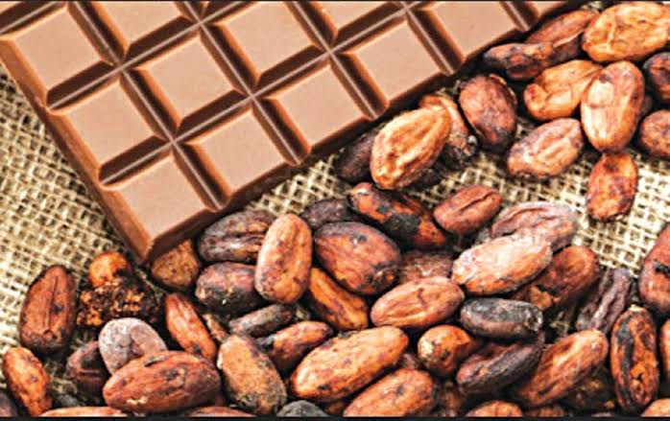

Project cycle
- Project identification/ Selection
- Objectives
1.Plantation of Cocoa is to regenerate interest in the Cocoa subsector by providing incentives and subsidies to Cocoa growers.
2.To increase productivity per acre thus increasing farm returns. 3.And also to rehabilitate most of the existing Cocoa acreages.
Selection based on;
- Suitable soil and climatic factors
Cocoa plant does well on a deep, well-drained and well aerated soil with a PH of between 5 and 8. It responds well to a high temperature with a maximum annual average of 30-32⁰C and a minimum average of 18-21⁰C. High organic matter content in the topsoil is essential for good growth and productivity.
- Access to raw materials
- Proximity to export market
- Availability of large domestic market.

- Preparation and Analysis
Cocoa farming is one of the most promising business opportunities for a potential investor. It provides a generous harvest without demanding too much effort or expensive equipments.
Here are things to do to start cocoa farming and do it well;
- Pick the right location for your plantation
Pick a land that has regular rainfall, water source and where the temperature ranges from twenty-one to thirty-two degrees Celsius throughout the entire year.
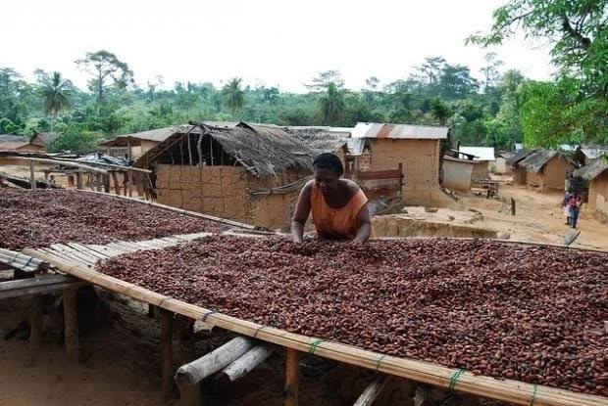

- Prepare the soil for planting
A deep, relatively damp soil is required to grow the crop the way nature intended. This layer of soil should be at least one and a half meters deep and be rich with coarse elements.
- Decide which type of tree you are going to grow
As it stands right now, there are three main varieties of cocoa tree that one can choose from, The Criollo, the Forastero and the Trinitario. Though each type of plants has its own set of benefits and drawbacks. The Criollo is commonly accepted as the best type of Cocoa. In the olden days, it was mostly consumed by rich people. However, due to the more demanding nature of these trees, growing them has become really tiresome in most countries. The Forastero cocoa is a reliable choice that possesses a pleasantly bitter taste, even though it doesn’t have the same aroma as Criollo. Another benefit is that it yields extremely rich harvests. The Trinitario is a mixture of the Criollo and Forastero, it incorporates the harvesting potential of the Forastero and the aroma of Criollo.
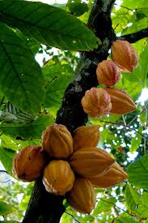

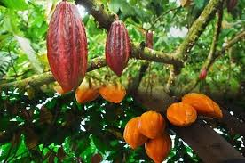

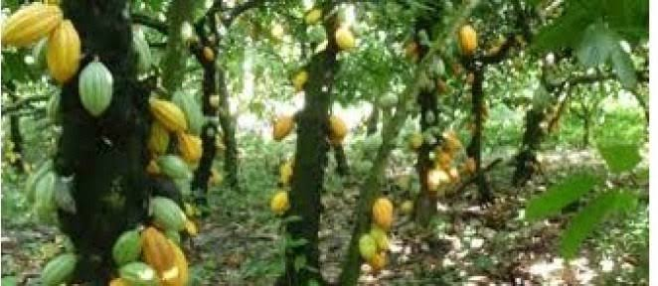
- Start your plantation when the conditions are perfect for it.
The prime time to do your planting is between October and January.
- Watch over the wellbeing of your crops.
You need to protect your farm from infections and various rodents that are lurking about.
How to plant cocoa:
- Seeding
- Budding
- Cutting
- Appraisal
- Implementation/ monitoring
- Evaluation.

