NAME: OKOLIE CHINEDU
MATRIC NO: 15/ENG06/052
COURSE CODE: ENG 586
COURSE NAME: MACHINE DESIGN III
- What is an integrated CAD/CAM?
An integrated CAD/CAM system offers one complete solution for design through manufacturing and are employed to achieve computer-aided integration in all production functions, from design and planning up to manufacturing and the assurance of quality standards. So far, however, overall integration of this kind has hardly been put into practice. This applies particularly to the medium and small batch production of the machine-building industry. At present various concepts of CAD/CAM integration which complement or overlap each other, often to the extent of operating concurrently in the case of implementation, can be discerned. On the one hand, concepts are concerned with the integration of design functions with planning, controlling and programming functions (CAD/CAP). On the other hand, they are concerned with the integration of manufacturing functions with planning, controlling and programming functions (DNC). Overall computer-aided integration, from design through to manufacturing, has only been conceived for a small number of product elements and limited manufacturing processes so far.

- Draw a product cycle to describe the scope of CAD/CAM in the operation of manufacturing firm.
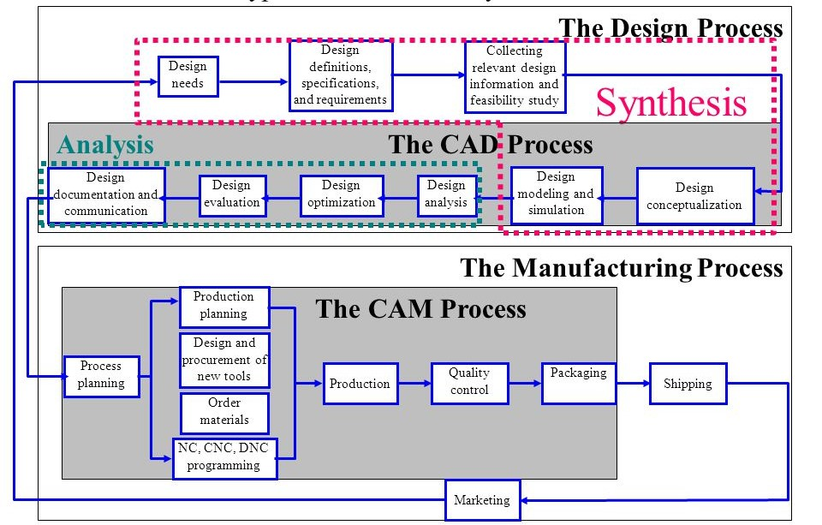

- Explain seven characteristics of a good CAD software.
- Efficiency:- An Efficient software is that which can use less resources such as CPU in terms of time and usage to give a better output.
- Simplicity:- A software must be simple to use and easy to understand and must be user friendly.
- Flexibility: - The software must be able to incorporate the design modification without much of difficulty.
- Readability:- This provides the capability within the software to help the user as and when required.
- Portability: - The software must have the capacity to get transferred from one system to other.
- Reliability: - To avoid causality the software must be able to avoid unwanted operation.
- Recover ability: - A Good software must be able to give warnings before getting crashed and must be able to recover.
- Explain three divisions of software components
Application software
Application software, or simply applications, are often called productivity programs or end-user programs because they enable the user to complete tasks, such as creating documents, spreadsheets, databases and publications, doing online research, sending email, designing graphics, running businesses, and even playing games! Application software is specific to the task it is designed for and can be as simple as a calculator application or as complex as a word processing application. When you begin creating a document, the word processing software has already set the margins, font style and size, and the line spacing for you. But you can change these settings, and you have many more formatting options available. For example, the word processor application makes it easy to add color, headings, and pictures or delete, copy, move, and change the document's appearance to suit your needs.
System software
Systems software includes the programs that are dedicated to managing the computer itself, such as the operating system, file management utilities, and disk operating system (or DOS). The operating system manages the computer hardware resources in addition to applications and data. Without systems software installed in our computers we would have to type the instructions for everything we wanted the computer to do.
Programming languages
Now this is a kind of computer software which is used exclusively by computer programmers. Unless we are also programmers, we are unlikely to come across programming languages. A simple way to understand programming languages is to think of them as bricks which can be used to create applications and operating system. C++, java and Simlab are some popular programming languages. Generally, java is used for internet applications. C++ is a language of professional developers and used exclusively in developing operating systems. PHP is another language used for internet applications. There is a new class of languages which are being utilized for the mobiles. These are light weight, modular languages which are used to design mobile applications

