OLAMIDE OLOTU | [Course Title] | April 24, 2020

BUSINES PLAN FOR
  - OLAMS FARMS

EXECUTIVE SUMMARY
Olams Farms is an agricultural startup which is dedicated to sustainable, profitable and unique agricultural products. Our mission is to produce and grow quality, livestock, vegetables and fruits to supply local restaurants and consumers in the South western region of Nigeria.
Olams Farms is owned and operated by Olamide Olotu, and seven other agricultural extension workers who are employed by the federal government under the National Social Investment Office (N-Power).
Through market research it is evident that consumers are interested in high end specialty products, and our advantage is the specialty aspect.

MISSION
The mission of our farm it to provide unique and wholesome produce that is enjoyable and sustainable. We work harmoniously with nature and the land to grow quality, livestock, vegetables and fruit to supply local restaurants and consumers south western region of Nigeria.

GOALS
* Grow high quality livestock, vegetables and fruits for wholesale and retail markets.
* Production methods are economically feasible as well as utilizing sustainable agriculture and best management practices.
* Increase production of fruits and vegetables in order to benefit from economies of scale.
* Penetrate the food market by fixing our product prices a little below market price.
* Break even at the end of year 2, and make 20% -28% profit at the end of year 3.
* The operational and management team will attend courses on production and management to increase profitability.

BACKGROUND INFORMATION
- Business Name And Address:olotuolamide24@gmail.om
- Business Email;olotuolamide24@gmail.com
- Web: Olamzfarmz.com
- Telephone:07010510662
- Type of Ownership: Partnership – Olamide Olotu, NSIO, ABUAD Cooperative.
The NSIO owns a partnership share of 15% by providing seven seasoned agricultural extension workers.
ABUAD cooperative owns a partnership share of 35% by providing 10 acres of land and a 10 horsepower tractor.
Olamide Olotu owns 50% partnership share by coordinating and orchestrating all the business procedures as stated in the partnership deed.
- Business Advisors
  - Bank:
  - Accountant: Solz resources, 1018 nairobi st, Ado Ekiti.
  - Insurance Agent:
- Staff And Team:
  - A
  - B
  - C
  - D
  - E
  - F
  - G
  - H

OPERATIONAL LAYOUT:
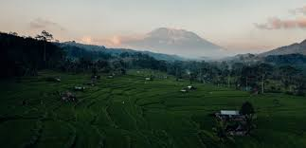
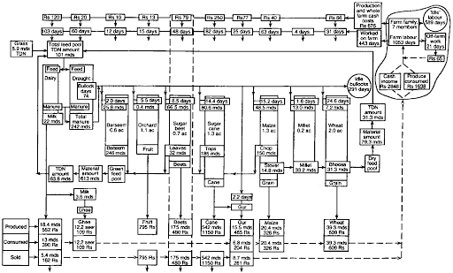

MARKET RESEARCH OUTPUT:
* There are approximately 185,000 people in a 50 mile radius of the farm. With a growing population.
* The Nigerian Homegrown School Feeding Program is interested in sourcing food only from local farmers.
* More families are health conscious and seeking healthy foods.
* Asun has become a very popular menu item.

BUSINESS PROPERTIES AND FACILITIES:
Land: The farm includes 10 acres, 1 acre includes the high tunnels, 3 acres in crop production, 2 acres are in conservation, 1 acre is the residence and 3 are in pastures. The soil types are very good for agricultural production.
Livestock: We have recently purchased 50 goats and 8 cows. Meat and milk are the primary products from our livestock.
Equipment: We have a 10 horsepower tractor that is used for mowing, tilling and work around the farm. Attachments to the tractor include a mower, tiller, spray equipment and loader. As the farm expands we would like to purchase a delivery van, walk in refrigerator box and a packing line for the greens.
Facilities: We have a small livestock run in shed, and a pole building for storage and packing.
Transportation: We currently have a 2004 pick-up that is used for farm work, deliveries and farmers markets. We hope to purchase a delivery van in the next 2 years.
Expertise: Olamide Olotu is proficient in the farm operation and have been following new research. He also has expertise in business management skills and organization. The agricultural extension workers have expertise in farm operations, marketing, pricing, selling to consumers and web development.

ESTIMATED BUSINESS COST:
- PERSONNEL COST PER ANNUM:
  - Monthly stipends of N30,000 each for 8 agricultural extension workers = N240,000
  - Monthly stipend of N45,000 to the tractor operator = N45,000
Total Personnel cost per month = N285, 000
Total personnel cost per year = N3, 420,000

- OVERHEAD& VARIABLE COST PER ANNUM:
S/N | DESCRIPTION OF ITEMS | COST (N)
1 | Fertilizers | 500,000
2 | Herbicides/ fungicides | 95,000
3 | Seeds/plant | 290,000
4 | Feed | 400,000
5 | Fuel/diesel | 420,000
6 | Soil test | 100,000
7 | Veterinary doctors services | 600,000
8 | Electricity | 120,000
9 | Insurance | 60,000
10 | Accounting | 100,000
 | TOTAL | N2,685,000

- CAPITAL& FIXED COST:
S/N | DESCRIPTION | COST(N)
1 | Land | 14,000,000
2 | Residence building | 3,750,000
3 | Tractor and all extensions | 12,250,000
4 | Truck | 3,480,000
5 | Livestock | 1,390,000
6 | Power Generator | 540,000
7 | Irrigation system/ borehole | 890,000
8 | Delivery van | 5,000,000
 | TOTAL | N41,300,000

ESTIMATED BUSINESS REVENUE:
INCOME
Sale of crop products | 50,000
Sale of livestock products | 25,000
Government payments | 10,000
Total Income | 85,000
Expenses
Seed | 10,000
Fertilizer | 15,000
Feed | 15,000
Processing | 15,000
Marketing | 5,000
Interest | 5,000
Depriciation | 2,000
Total expenses | 67,000
Net Income | 13,000

FUNDING SOURCES:
- Local banks; in this case I as an investing farmer can obtain loans from banks to help aid my farming business.
- Private contracts; Also I can look for individuals who offer private contracts to aid fund the business enterprise. This could go a long way in ensuring that the business enterprise is properly funded for a number of years.
- Farm Credit Services
- Aggie Bond programs

CONCLUSION:
With the above stated business plan I have been able to sketch the range of costs and expenses and also the income. This means that within a given time and resources efforts being made could do a great deal of large scale agricultural work.

