AKOMOLAFE David Olusegun
15/ENG01/003
CHE 512 ASSIGNMENT
- Briefly discuss HAZOP Techniques
A hazard and operability study (HAZOP) is a structured and systematic examination of a complex planned or existing process or operation in order to identify and evaluate problems that may represent risks to personnel or equipment. The intention of performing a HAZOP is to review the design to pick up design and engineering issues that may otherwise not have been found. The technique is based on breaking the overall complex design of the process into a number of simpler sections called 'nodes' which are then individually reviewed. It is carried out by a suitably experienced multi-disciplinary team (HAZOP) during a series of meetings. The HAZOP technique is qualitative, and aims to stimulate the imagination of participants to identify potential hazards and operability problems. Structure and direction are given to the review process by applying standardized guide-word prompts to the review of each node. The relevant international standard calls for team members to display 'intuition and good judgement' and for the meetings to be held in 'a climate of positive thinking and frank discussion'.
The flowsheet below describes some steps taken in HAZOP techniques.
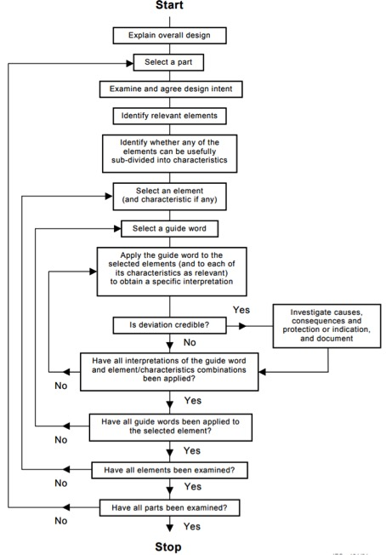
- Significance of HAZOP
HAZard and OPerability (HAZOP) is a well-known and well documented study. HAZOP is used as part of a Quantitative Risk Assessment (QRA) or as a standalone analysis. HAZOP is a more detailed review technique than HAZID.
The purpose of the HAZOP is to investigate how the system or plant deviate from the design intent and create risk for personnel and equipment and operability problems.
HAZOP studies have been used with great success within chemical and the petroleum industry to obtain safer, more efficient and more reliable plants. HAZOP has become a standard method in the design of process system in the North Sea.

- With the aid of a block diagram, list the components of HAZOP
B.
WHAT IF
D.
CONSEQUENCE
C.
CAUSE
A.
DEVIATION
1.
PROCESS
2
RISK
3
SCENERIO
4
RISK MANAGEMENT
5
SAFEGUARD
REFERENCES

- https://www.academia.edu/9989571/Saudi_Aramco_HAZOP_Guidelines_LOSS_PREVENTION_DEPARTMENT_SAUDI_ARAMCO
- https://www.slideshare.net/gauravkrsrajput/hazard-and-operability-study-hazop-gaurav-singh-rajput
- https://www.safeopedia.com/2/3254/hazards/hazard-and-operability-study-hazop-why-its-important-for-safety-professionals
- https://www.thesafetymaster.com/hazop-study-a-great-tool-for-hazardous-industry-to-identify-process-hazard/
- https://en.wikipedia.org/wiki/Hazard_and_operability_study

