Assignment Title: First Assignment (20 marks)
Course Title: Digital Communications
Course Code: EEE 512
digital comumication
ASSIGNMENT
Azeez Fiyinfoluwa Andrew
15/ENG04/012

Table of Contents
QUESTION 1(i) 1
3G ARCHITECTURE 1
3G UMTS network constituents 2
User Equipment (UE): 2
Radio Network Subsystem (RNS): 2
Core Network: 2
4G NETWORK ARCHITECTURE 3
4G (LTE) 3
LTE Basic Parameters 3
LTE Network Architecture 4
The User Equipment (UE) 5
• Mobile Termination (MT) : 5
• Terminal Equipment (TE) : 5
• Universal Integrated Circuit Card (UICC) 5
• The Home Subscriber Server (HSS 6
• The Packet Data Network (PDN) Gateway (P-GW 6
• The serving gateway (S-GW) acts 6
• The mobility management entity (MME) 7
• The Policy Control and Charging Rules Function (PCRF) 7
5G ARCHITECTURE 8
QUESTION 1(ii) 10
Advantages of 3G: 10
Disadvantages of 3G: 10
Advantages of 4G: 10
Disadvantages of 4G: 10
Advantages of 5G 11
Disadvantages of 5G 11
QUESTION 2 12
QUESTION 3 14
JUSTIFICATION 14

QUESTION 1(i)
With the aid of a well labelled architectural diagram, provide detailed explain on the working principle of 3G, 4G and 5G networks

3G ARCHITECTURE
3G actually stands for “third generation”, as it is the third type of access technology that has been made widely commercially available for connecting mobile phones.
The first generation of mobile phones was launched in the 1980s, and transmitted across an analogue signal; these phones were large, brick-like devices that were often kept in a vehicle as they were impractical and inconvenient to carry around.
They were supplanted by the second generation in the 1990s, which now used a more reliable digital signal, and enabled the use of text messaging, or SMS (Short Message Service). However, the technology was still not robust or fast enough to deal with the thousands, and then millions, of consumers who wanted to use mobile phones; the signal could not carry enough data simultaneously, and there were many areas the signal did not cover. There was also a rapidly growing demand for transmitting data – using email and accessing the internet – across mobiles, which 2G was just not fast or reliable enough to manage. An intermediate technology – sometimes called EDGE or 2.5G – came next, but the technology rapidly moved on towards proper 3G.
In the UK, 3G services were launched commercially in 2003 through Hutchinson 3G, now known as Three. Now, all of the mobile network operators in the UK offer 3G services, and all major mobile phone manufacturers offer 3G phones that can access these services; many can be found in the 3 store online. In fact, just about every smartphone and most feature phones support 3G.
3G data technology uses a network of phone towers to pass signals, ensuring a stable and relatively fast connection over long distances. The tower nearest to the user’s mobile phone passes data to it. While it may not sound complex, 3G technology was revolutionary at the time it was released.
Third generation (3G) mobile networks define three components of the overall path from mobile station to IP network: the radio frequencies used, the air interface options used between the mobile device and base station, and the entire network architecture, including interfaces between components.
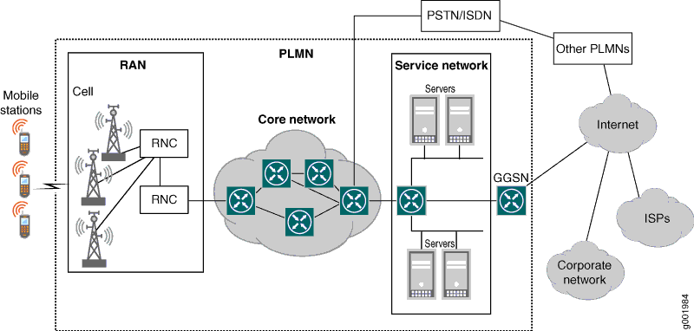
Figure 1 shows the overall architecture of a 3G network.

3G UMTS network constituents
The UMTS network architecture can be divided into three main elements:
User Equipment (UE): -A service network reached through the core network. The User Equipment or UE is the name given to what was previous termed the mobile, or cell phone. The new name was chosen because the considerably greater functionality that the UE could have. It could also be anything between a mobile phone used for talking to a data terminal attached to a computer with no voice capability. Some of the services reached (the servers in Figure 1) are specific to the service provider, such as accounting information (current balance), short message service (SMS) texting, paging, and voice mail. Other services are reached through the GGSN (which is not properly part of the 3G service network), such as the Internet, other Internet service providers (ISPs), or corporate network virtual private networks (VPNs). The MobileNext Broadband Gateway can be configured as a GGSN.
Radio Network Subsystem (RNS): The RNS also known as the UMTS Radio Access Network, UTRAN, is the equivalent of the previous Base Station Subsystem or BSS in GSM. It provides and manages the air interface fort he overall network.
Core Network: The core network provides all the central processing and management for the system. It is the equivalent of the GSM Network Switching Subsystem or NSS.
The core network is then the overall entity that interfaces to external networks including the public phone network and other cellular telecommunications networks.

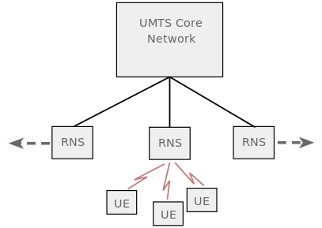
The main UMTS network blocks

4G NETWORK ARCHITECTURE

4G (LTE)
LTE stands for Long Term Evolution and it was started as a project in 2004 by telecommunication body known as the Third Generation Partnership Project (3GPP). SAE (System Architecture Evolution) is the corresponding evolution of the GPRS/3G packet core network evolution. The term LTE is typically used to represent both LTE and SAE.
LTE evolved from an earlier 3GPP system known as the Universal Mobile Telecommunication System (UMTS), which in turn evolved from the Global System for Mobile Communications (GSM). Even related specifications were formally known as the evolved UMTS terrestrial radio access (E-UTRA) and evolved UMTS terrestrial radio access network (E-UTRAN). First version of LTE was documented in Release 8 of the 3GPP specifications.
A rapid increase of mobile data usage and emergence of new applications such as MMOG (Multimedia Online Gaming), mobile TV, Web 2.0, streaming contents have motivated the 3rd Generation Partnership Project (3GPP) to work on the Long-Term Evolution (LTE) on the way towards fourth-generation mobile.
The main goal of LTE is to provide a high data rate, low latency and packet optimized radioaccess technology supporting flexible bandwidth deployments. Same time its network architecture has been designed with the goal to support packet-switched traffic with seamless mobility and great quality of service.

LTE Basic Parameters
This section will summarize the Basic parameters of the LTE:
Parameters | Description
Frequency range | UMTS FDD bands and TDD bands defined in 36.101(v860) Table 5.5.1, given below
Duplexing | FDD, TDD, half-duplex FDD
Channel coding | Turbo code
Mobility | 350 km/h
Channel Bandwidth (MHz) | - 1.4  - 3  - 5  - 10  - 15  - 20
Transmission Bandwidth Configuration NRB : (1 resource block = 180kHz in 1ms TTI ) | - 6  - 15  - 25  - 50  - 75  - 100
Modulation Schemes | UL: QPSK, 16QAM, 64QAM(optional)  DL: QPSK, 16QAM, 64QAM
Multiple Access Schemes | UL: SC-FDMA (Single Carrier Frequency Division Multiple Access) supports 50Mbps+ (20MHz spectrum)  DL: OFDM (Orthogonal Frequency Division Multiple Access) supports 100Mbps+ (20MHz spectrum)
Multi-Antenna Technology | UL: Multi-user collaborative MIMO  DL: TxAA, spatial multiplexing, CDD ,max 4x4 array
Peak data rate in LTE | UL: 75Mbps(20MHz bandwidth)  DL: 150Mbps(UE Category 4, 2x2 MIMO, 20MHz bandwidth)  DL: 300Mbps(UE category 5, 4x4 MIMO, 20MHz bandwidth)
MIMO  (Multiple Input Multiple Output) | UL: 1 x 2, 1 x 4  DL: 2 x 2, 4 x 2, 4 x 4
Coverage | 5 - 100km with slight degradation after 30km
QoS | E2E QOS allowing prioritization of different class of service
Latency | End-user latency < 10mS

LTE Network Architecture

The high-level network architecture of LTE is comprised of following three main components:
- The User Equipment (UE).
- The Evolved UMTS Terrestrial Radio Access Network (E-UTRAN).
- The Evolved Packet Core (EPC).
The evolved packet core communicates with packet data networks in the outside world such as the internet, private corporate networks or the IP multimedia subsystem. The interfaces between the different parts of the system are denoted Uu, S1 and SGi as shown below:
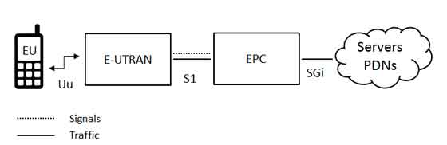

The User Equipment (UE)
The internal architecture of the user equipment for LTE is identical to the one used by UMTS and GSM which is actually a Mobile Equipment (ME). The mobile equipment comprised of the following important modules:
- Mobile Termination (MT) : This handles all the communication functions.
- Terminal Equipment (TE) : This terminates the data streams.
- Universal Integrated Circuit Card (UICC) : This is also known as the SIM card for LTE equipments. It runs an application known as the Universal Subscriber Identity Module (USIM).
A USIM stores user-specific data very similar to 3G SIM card. This keeps information about the user's phone number, home network identity and security keys etc.
The E-UTRAN (The access network)
The architecture of evolved UMTS Terrestrial Radio Access Network (E-UTRAN) has been illustrated below.
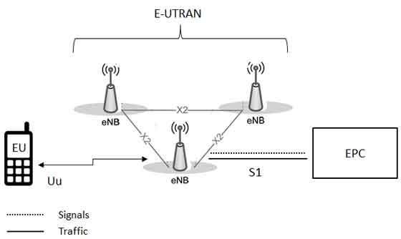
The E-UTRAN handles the radio communications between the mobile and the evolved packet core and just has one component, the evolved base stations, called eNodeB or eNB. Each eNB is a base station that controls the mobiles in one or more cells. The base station that is communicating with a mobile is known as its serving eNB.
LTE Mobile communicates with just one base station and one cell at a time and there are following two main functions supported by eNB:
- The eBN sends and receives radio transmissions to all the mobiles using the analogue and digital signal processing functions of the LTE air interface.
- The eNB controls the low-level operation of all its mobiles, by sending them signalling messages such as handover commands.
Each eBN connects with the EPC by means of the S1 interface and it can also be connected to nearby base stations by the X2 interface, which is mainly used for signalling and packet forwarding during handover.
A home eNB (HeNB) is a base station that has been purchased by a user to provide femtocell coverage within the home. A home eNB belongs to a closed subscriber group (CSG) and can only be accessed by mobiles with a USIM that also belongs to the closed subscriber group.
The Evolved Packet Core (EPC) (The core network)
The architecture of Evolved Packet Core (EPC) has been illustrated below. There are few more components which have not been shown in the diagram to keep it simple. These components are like the Earthquake and Tsunami Warning System (ETWS), the Equipment Identity Register (EIR) and Policy Control and Charging Rules Function (PCRF).
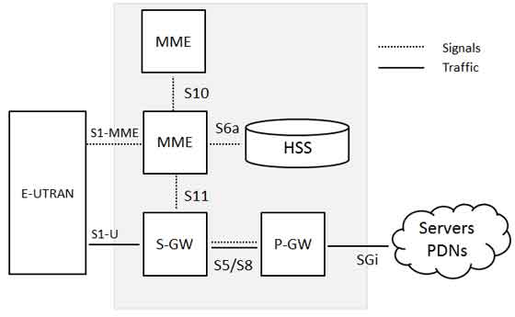
Below is a brief description of each of the components shown in the above architecture:
- The Home Subscriber Server (HSS) component has been carried forward from UMTS and GSM and is a central database that contains information about all the network operator's subscribers.
- The Packet Data Network (PDN) Gateway (P-GW) communicates with the outside world ie. packet data networks PDN, using SGi interface. Each packet data network is identified by an access point name (APN). The PDN gateway has the same role as the GPRS support node (GGSN) and the serving GPRS support node (SGSN) with UMTS and GSM.
- The serving gateway (S-GW) acts as a router, and forwards data between the base station and the PDN gateway.
- The mobility management entity (MME) controls the high-level operation of the mobile by means of signalling messages and Home Subscriber Server (HSS).
- The Policy Control and Charging Rules Function (PCRF) is a component which is not shown in the above diagram but it is responsible for policy control decision-making, as well as for controlling the flow-based charging functionalities in the Policy Control Enforcement Function (PCEF), which resides in the P-GW.
The interface between the serving and PDN gateways is known as S5/S8. This has two slightly different implementations, namely S5 if the two devices are in the same network, and S8 if they are in different networks.
Functional split between the E-UTRAN and the EPC
Following diagram shows the functional split between the E-UTRAN and the EPC for an LTE network:
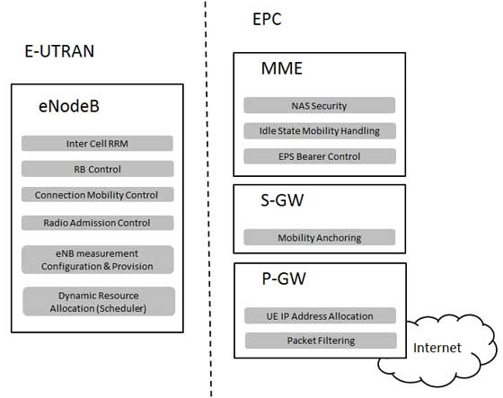

5G ARCHITECTURE

Architecture of 5G is highly advanced, its network elements and various terminals are characteristically upgraded to afford a new situation. Likewise, service providers can implement the advance technology to adopt the value-added services easily.
However, upgradeability is based upon cognitive radio technology that includes various significant features such as ability of devices to identify their geographical location as well as weather, temperature, etc. Cognitive radio technology acts as a transceiver (beam) that perceptively can catch and respond radio signals in its operating environment. Further, it promptly distinguishes the changes in its environment and hence respond accordingly to provide uninterrupted quality service.
Architecture of 5G
As shown in the following image, the system model of 5G is entirely IP based model designed for the wireless and mobile networks.
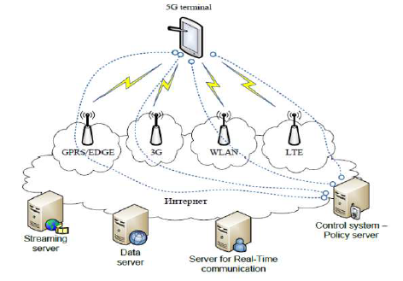
The system comprising of a main user terminal and then a number of independent and autonomous radio access technologies. Each of the radio technologies is considered as the IP link for the outside internet world. The IP technology is designed exclusively to ensure sufficient control data for appropriate routing of IP packets related to a certain application connections i.e. sessions between client applications and servers somewhere on the Internet. Moreover, to make accessible routing of packets should be fixed in accordance with the given policies of the user (as shown in the image given below).
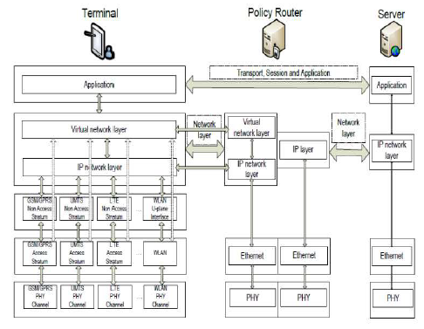
The Master Core Technology
As shown in the Figure 5, the 5G MasterCore is convergence point for the other technologies, which have their own impact on existing wireless network. Interestingly, its design facilitates MasterCore to get operated into parallel multimode including all IP network mode and 5G network mode. In this mode (as shown in the image given below), it controls all network technologies of RAN and Different Access Networks (DAT). Since, the technology is compatible and manages all the new deployments (based on 5G), it is more efficient, less complicated, and more powerful.
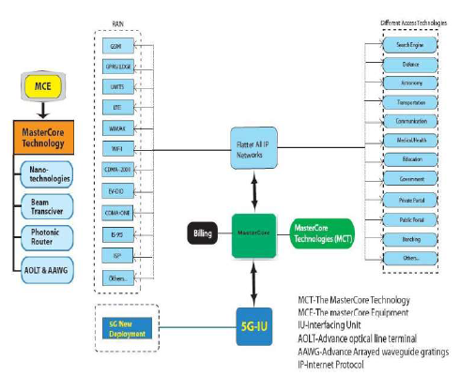
Surprisingly, any service mode can be opened under 5G New Deployment Mode as World Combination Service Mode (WCSM). WCSM is a wonderful feature of this technology; for example, if a professor writes on the white board in a country – it can be displayed on another white board in any other part of the world besides conversation and video. Further, a new services can be easily added through parallel multimode service.

QUESTION 1(ii)
Outline the advantage and disadvantages of 3G, 4G and 5G

Advantages of 3G:
- Overcrowding is relieved in existing systems with radio spectrum
- Bandwidth, security and reliability are more
- Provides interoperability among service providers
- Availability of fixed and variable rates.
- Support to devices with backward compatibility with existing networks
- Always online devices – 3G uses IP connectivity which is packet based
- Rich multi media services are available

Disadvantages of 3G:
- The cost of cellular infrastructure , upgrading base stations is very high
- Needs different more expensive mobile device.
- Roaming and data/voice work together has not yet been implemented
- Power consumption is high
- Requires closer base stations and are expensive
- Spectrum-license costs, network deployment costs and handset subsidies subscribers are tremendous.

Advantages of 4G:
- Quickly download files over a wireless network
- Extremely high voice quality
- Easily access Internet, IM, social networks, streaming media, video calling
- 4G mobile network offers amazing speed and higher bandwidth
- 4G is 10 times faster than 3G

Disadvantages of 4G:
- Higher battery consumption
- Limited 4G network towers
- New frequencies means new components in cell towers.
- Higher data consumption and prices
- Consumer is forced to buy a new device to support the 4G
- It is impossible to make your current equipment compatible with the 4G network

Advantages of 5G
There are several advantages of 5G technology, some of the advantages have been shown in the above Ericsson image, and many others are described below −
- High resolution and bi-directional large bandwidth shaping.
- Technology to gather all networks on one platform.
- More effective and efficient.
- Technology to facilitate subscriber supervision tools for the quick action.
- Most likely, will provide a huge broadcasting data (in Gigabit), which will support more than 60,000 connections.
- Easily manageable with the previous generations.
- Technological sound to support heterogeneous services (including private network).
- Possible to provide uniform, uninterrupted, and consistent connectivity across the world.

Disadvantages of 5G
Though, 5G technology is researched and conceptualized to solve all radio signal problems and hardship of mobile world, but because of some security reason and lack of technological advancement in most of the geographic regions, it has following shortcomings −
- Technology is still under process and research on its viability is going on.
- The speed, this technology is claiming seems difficult to achieve (in future, it might be) because of the incompetent technological support in most parts of the world.
- Many of the old devices would not be competent to 5G, hence, all of them need to be replaced with new one — expensive deal.
- Developing infrastructure needs high cost.
- Security and privacy issue yet to be solved.

QUESTION 2

In tabular form, establish adequate differences between 2G, 3G, 4G and 5G

Difference Between 2G And 3G Technologies In Tabular Form

BASIS OF COMPARISON | 2G | 3G
Main Function | The main function of 2G technology is the transmission of information via voice signals. | The main function of 3G technology is data transfer via video conferencing, MMS etc.
Additional Features | Features like mobile TV, video transfers and GPS system are not available with 1G and 2G technologies. | Features like mobile TV, video transfers and GPS systems are the additional features of 3G technology that are not available with 1G and 2G technologies.
Downloading And Uploading Speeds | The downloading and uploading speeds available in 2G technologies are up to 236kbps. | The downloading and uploading speeds are up to 21 Mbps and 5.7 Mbps respectively.
Security | 2G technology offers a low level of security as compared to 3G technology because 3G networks permit validation measures when communicating with other devices. | 3G technology offers a high level of security as compared to 2G technology because 3G networks permit validation measures when communicating with other devices.
Turbo Codes | There is no turbo codes which are used for error correction in 2G technology. | There is turbo codes which are used for error correction in 3G technology.
Switching Type | The switching type used in 2G is circuit switching and packet switching. | 3G uses packet switching for data transmission.
Downloading & Uploading Speeds | The downloading and uploading speeds available in 2G technologies are up to 236kbps. | The downloading and uploading speeds are up to 21 Mbps and 5.7 Mbps respectively.
Transmission Speed | The Speed Of Transmission is very low when compared to 3G. | The speed of transmission is very fast when compared to 2G.
Drawback | The disadvantage of 2G is the slow rate of data transmission and low network ranges. | The drawback of 3G is that it is simply not available in certain regions.

Difference Between 3G And 4G Technologies In Tabular Form

BASIS OF COMPARISON | 3G | 4G
Uploading Speed | The maximum uploading speeds are up to 5.7 Mbps. | The maximum upload rate of 4G technology is 500 Mbps.
Channelization Protocol |  | For accessing, OFDMA (Orthogonal Frequency Division Multiple Access) and FDE (Frequency-Domain Equalization are the main channelization protocol in 4G.
Download Rate | The downloading speeds of 3G are up to 21 Mbps. | The maximum download rate of 4G technology is 1Gbps.
Error Correction | There is turbo codes which are used for error correction in 3G technology. | 4G technology uses concatenated codes for error correction.
Frequency Range | The frequency range of 3G technology is from 1.8GHz to 2.5 GHz. | The frequency range of 4G technology is from 2GHz to 8GHz.
Handoff Management | Handoff management is done vertically in 3G. | Handoff management is done both vertically and horizontally.
Data Transmission | 3G uses packet switching for data transmission. | When it comes to data transmission, 4G uses packet switching technique as well as message switching technique.
Data Bandwidth | 3G offers 500Mbps maximum data bandwidth. | When it comes to data bandwidth 4G offers 1Gbps maximum data bandwidth.
Speed Of Transmission | The speed of transmission is very low when compared to 4G. | The speed of transmission is very fast when compared to 3G.

Difference Between 4G And 5G Technology In Tabular Form

BASIS OF COMPARISON | 4G | 5G
Connection Density | Supports less devices per unit area when compared to 5G. | 5G is expected to support many more connected devices than 4G. The standard states that 5G network map should be able to support 1 million connected devices per square kilometer.
Speed | Has low speed when compared to 5G. | Greater speed, enough to download a full-length HD movie in few seconds.
Application | Application Is still limited to internet access. | 5G technology is anticipated to be utilized widely for applications such as smart logistics, driverless cars and other such smart applications which demand high-speed internet.
Coverage | 4G has a limited coverage area. | 5G is expected to have a better coverage area and high data rate at the edge of the cell.
Multiple Data Transfer Rate | No multiple data transfer rate. | Availability of multiple data transfer rate.

QUESTION 3
Recently in Nigerian there has been a widespread of opinion that the advent of 5G
evolution will aid the spread of the corona virus which has become a pandemic all over the world.
(i)Is there any correlation between 5G and Corona virus
(ii)Do you support the state, if yes or No, in not more than 500 words Justify your answer to (i) and (ii)

    - No there is no correlation between 5g an corona virus

    - No I don’t support the state

JUSTIFICATION

“Nothing has been scientifically demonstrated that links electromagnetic radiation and virus proliferation,”
5G, or fifth-generation wireless technology, is a new global wireless standard being deployed around the world now. While previous mobile network generations relied on lower frequency wavelengths being transmitted across wider areas, the standard 5G spectrum is about a factor of 10 — an order of magnitude — higher than the previous four generations of cell networks. That increased information flow, coupled with more accurate antenna connectivity and decreased latency, makes a range of new real-time operations possible over the network.
"The frequencies of 5G waves are so much lower in power and still four orders of magnitude, or 10,000 times less, than ionizing waves, which are known to possibly be carcinogenic in large doses," Ted Rappaport, an electrical engineer, and professor at New York University’s Tandon School of Engineering and School of Medicine said in an interview with USTODAY News
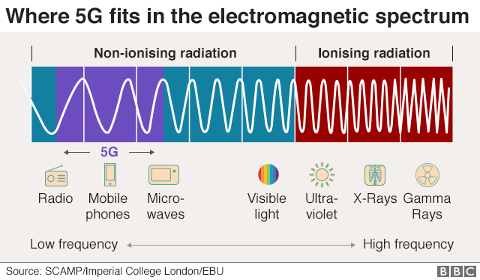
The radio waves involved in 5G and other mobile phone technology sit on the low frequency end of the electromagnetic spectrum. Less powerful than visible light, they are not strong enough to damage cells - unlike radiation at the higher frequency end of the spectrum which includes the sun's rays and medical x-rays.
It would also be impossible for 5G to transmit the COVID19 virus

The World Health Organization issued a similar statement dispelling myths that 5G is caused by the coronavirus. “Viruses cannot travel on radio waves/mobile networks. COVID-19 is spreading in many countries that do not have 5G mobile networks,” the WHO said on its website.
“COVID-19 is spread through respiratory droplets when an infected person coughs, sneezes or speaks. People can also be infected by touching a contaminated surface and then their eyes, mouth or nose.”
Standard 5G frequencies were also ruled safe by the International Commission on Non‐Ionizing Radiation Protection, an organization of scientists that reviews the health risks posed by lower frequency electromagnetic waves.

