#include <stdio.h>
#include <stdlib.h>
#include <time.h>

int main()
{

float x1, y1, x2, y2, dis;
printf("Input x1: ");
scanf("%f" , &x1);

printf("Input x2: ");
scanf("%f" , &x2);

printf("Input y1: ");
scanf("%f" , &y1);

printf("Input y2: ");
scanf("%f" , &y2);

dis = ((x2 - x1) * (x2 - x1)) + ((y2 - y1) * (y2 - y1));

printf("Distance between the said points = %.4f", sqrt(dis));
printf("\n");
return 0;

}

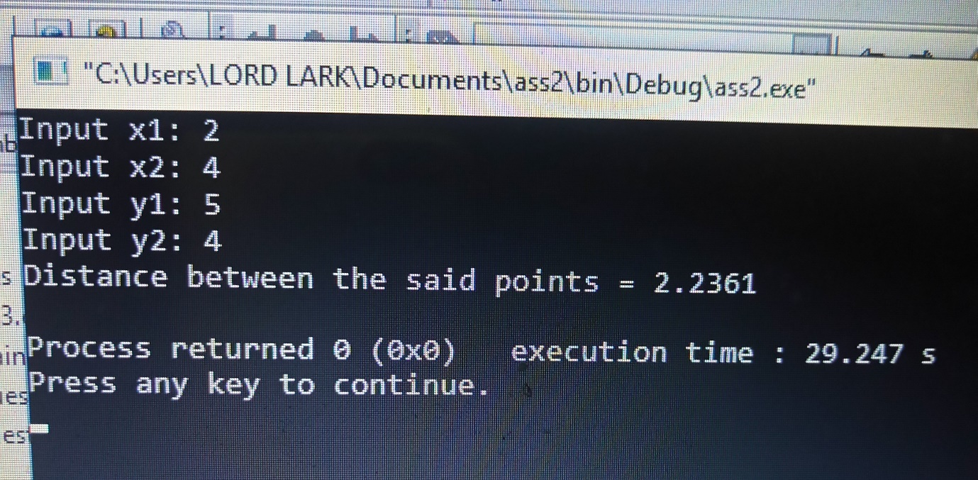

#include <stdio.h>
#include <stdlib.h>
#include <time.h>

int bj()
{
float x, y, z, P, A;

printf("Input x: ");
scanf("%f" , &x);

printf("Input y: ");
scanf("%f" , &y);

printf("Input z: ");
scanf("%f" , &z);

if(x < (y+z) && y < (x+z) && z < (y+x))
{
P = x+y+z;
printf("\nPerimeter = %.1f\n", P);
}
else
{
printf("Not possible to create a triangle");
}
}

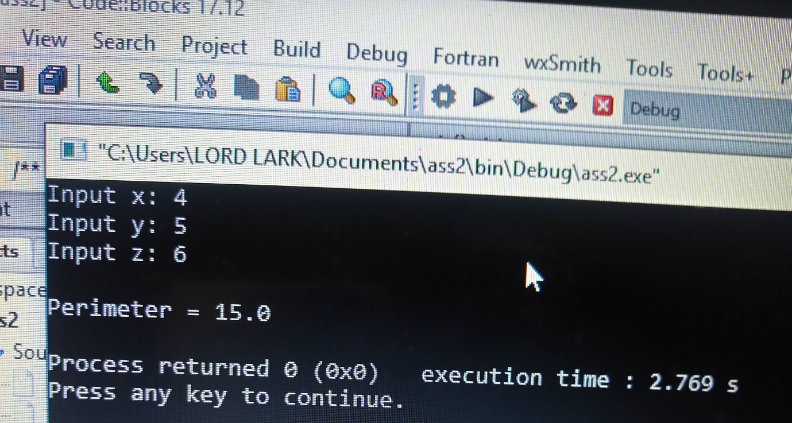

#include <stdio.h>
#include <stdlib.h>
#include <time.h>

int nj()
{
int age;
int cnt_baby = 0, cnt_school = 0, cnt_adult = 0;
int count = 0;
while (count<20)
{
printf("Enter age of person [%d]: ", count+1);
scanf("%d", &age);
if(age>= 0 && age<=5)
cnt_baby++;
else if(age>=6 && age<=17)
cnt_school++;
else if(age>17)
cnt_adult++;

count++;
}
printf("Baby age: %d\n",cnt_baby);
printf("School age: %d\n",cnt_school);
printf("Adult age: %d\n",cnt_adult);

return 0;
}
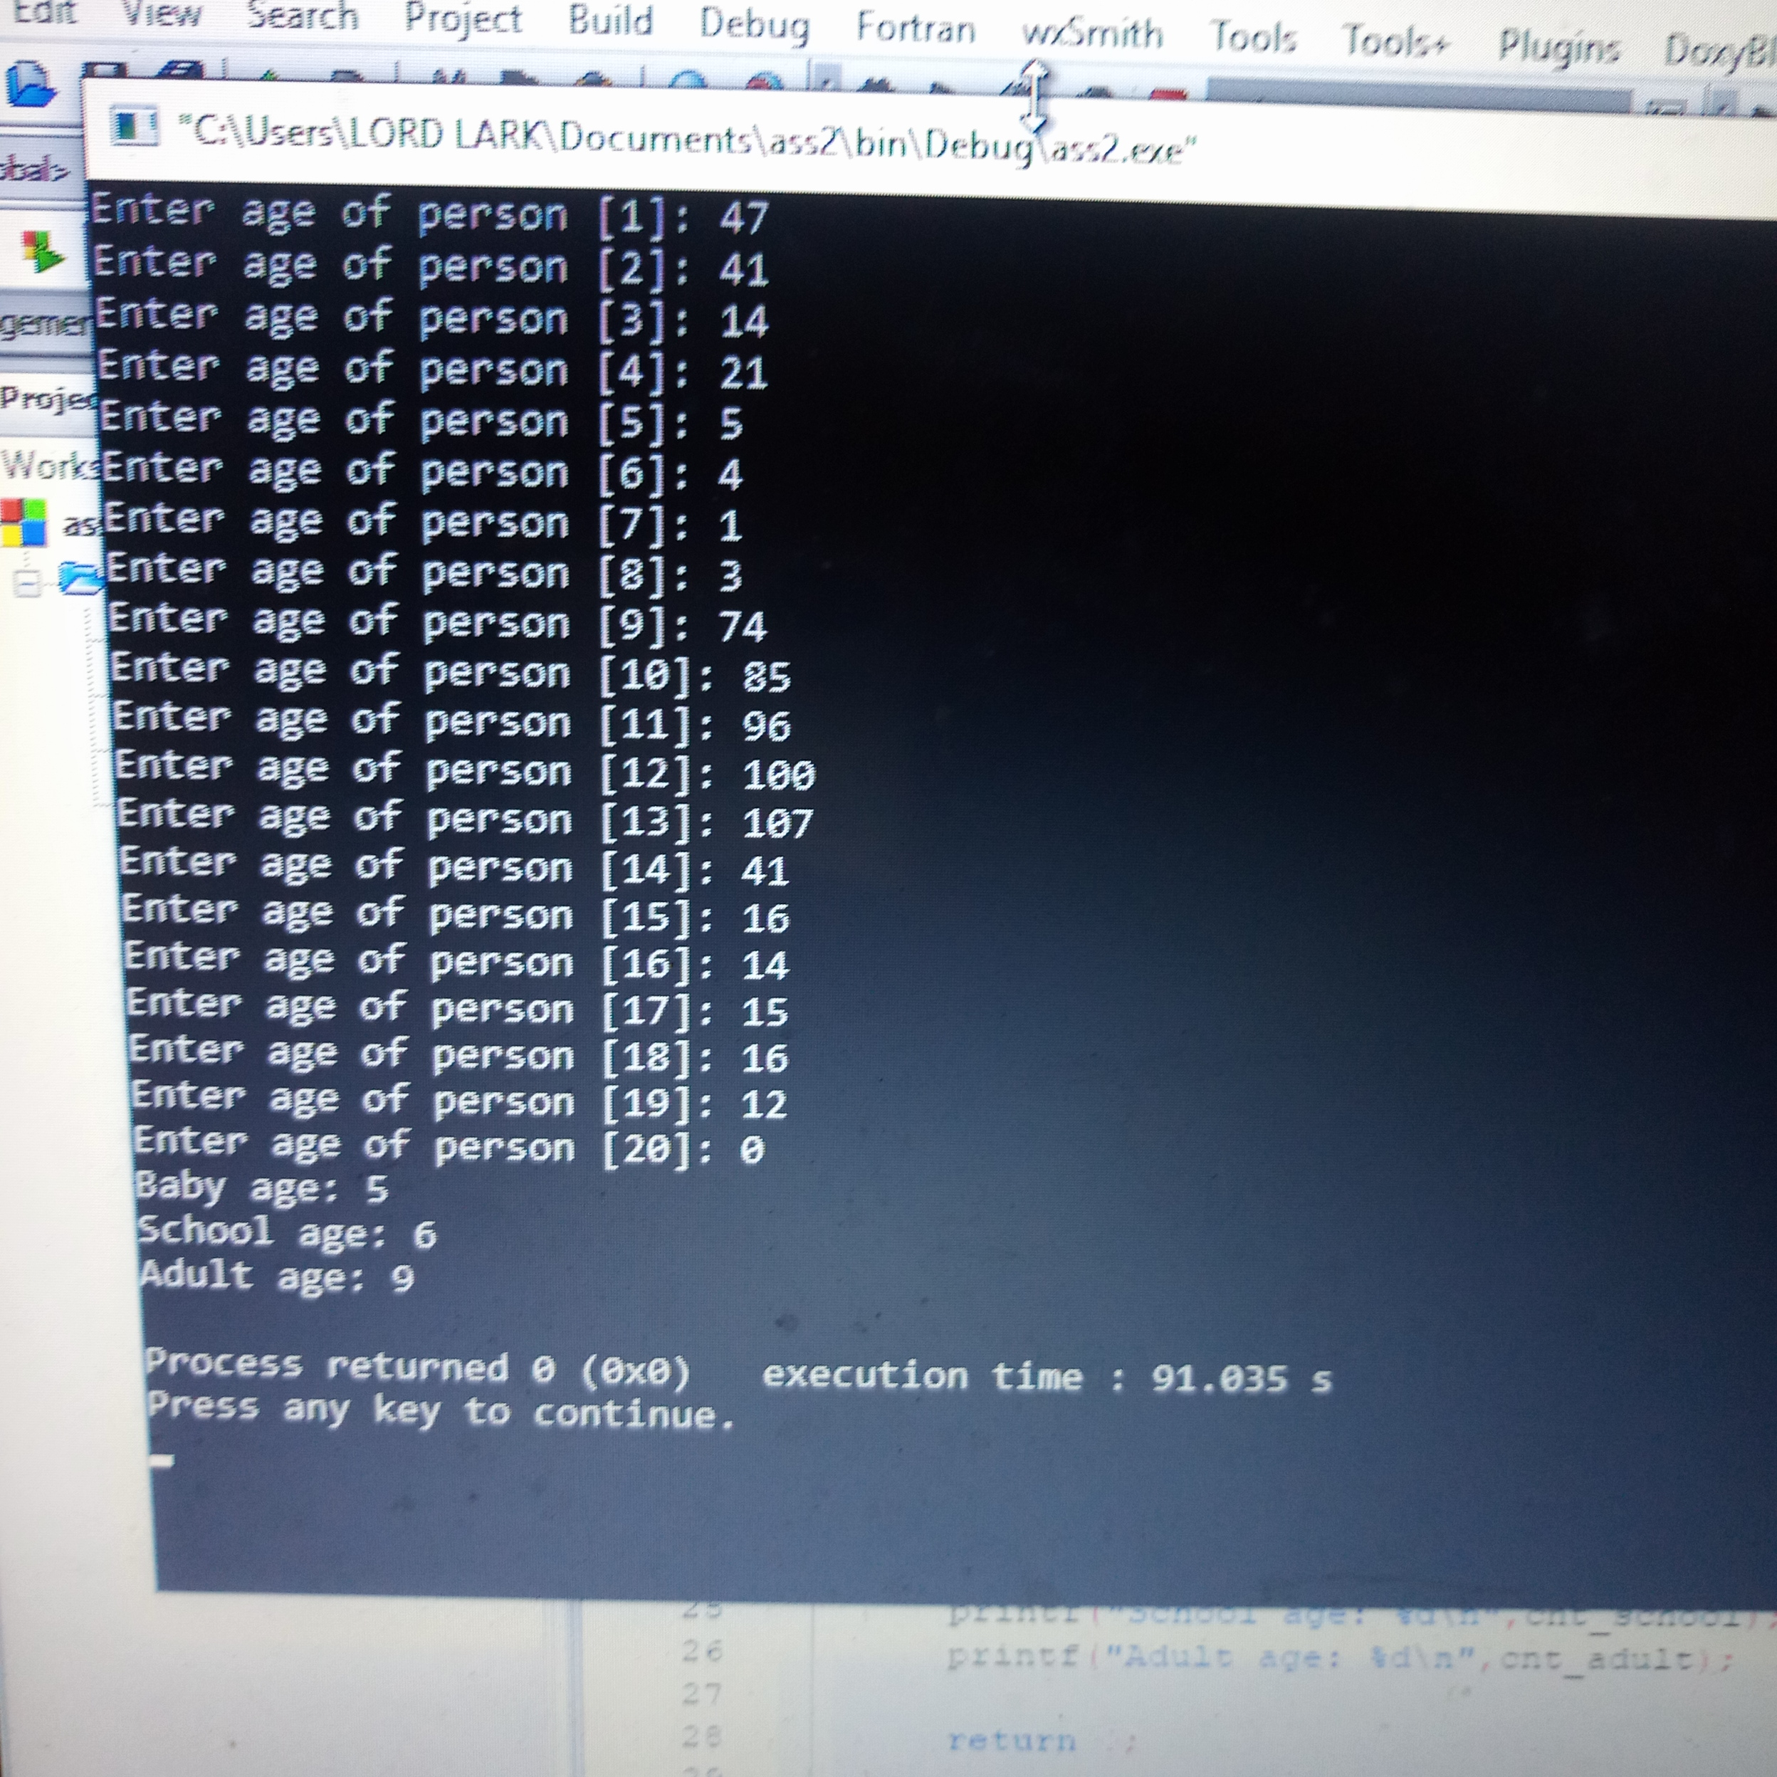
#include <time.h>

#include <stdio.h>
#include <stdlib.h>
#include <time.h>

int main()
{
int randomnom = 0, count = 0, num;
int stime;
long ltime;
ltime = time(NULL);
stime = (unsigned) ltime/2;
srand(stime);
randomnom = rand()%1000;
while(1)
{
count+=1;
printf("\n\nGuess a number from (0 to 1000): ");
scanf("%d", &num);
if (randomnom == num)
{
printf("You have guessed a correct number.");
break;
}
else if(randomnom < num)
{
printf("Generated number is less than entered number, try again");
}else if(randomnom > num)
{
printf("Generated number is greater than entered number, try again");
}

if(count==7)
{
printf("\n\n### Maximum number of attempts reached");
break;
}
}
return 0;
}
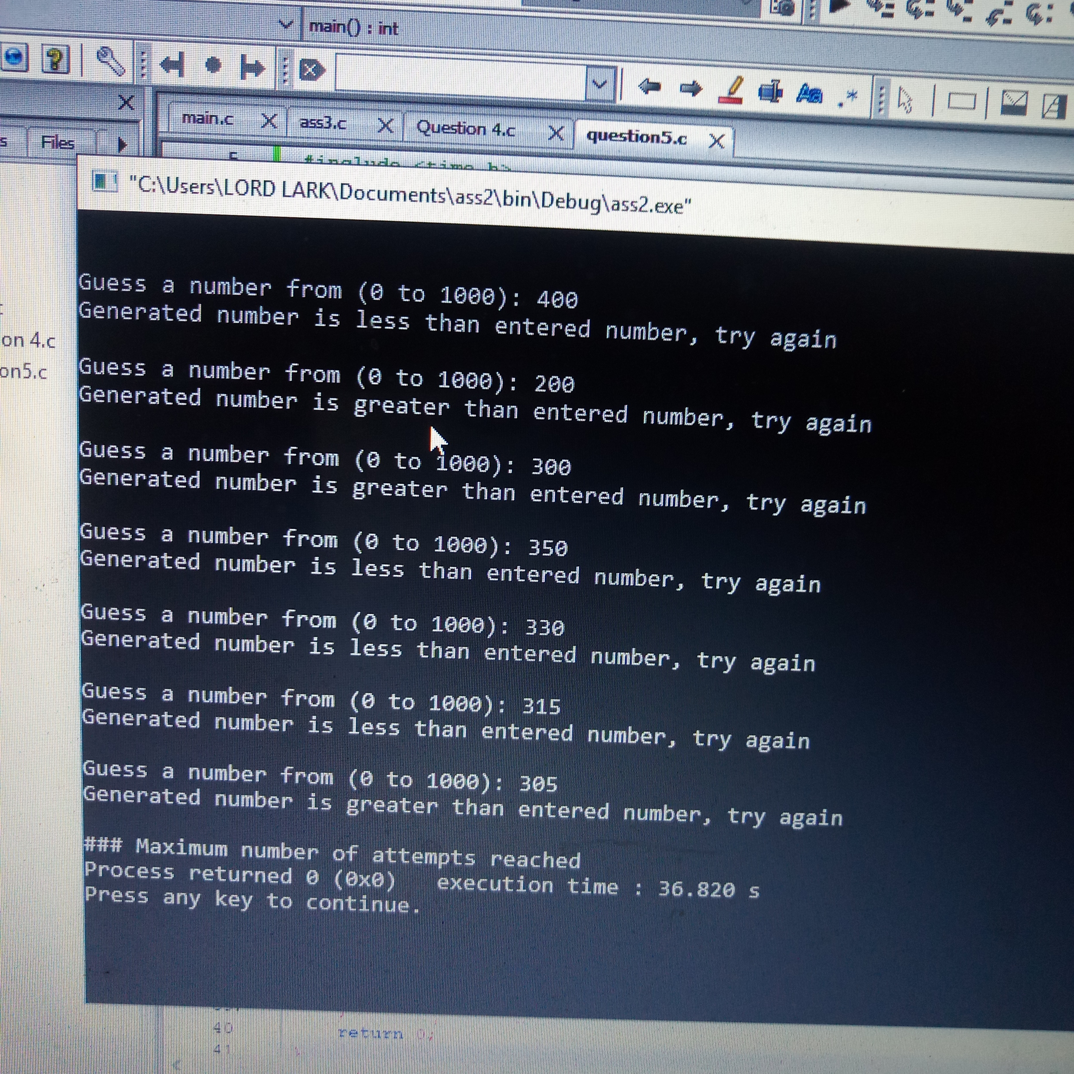
#include <stdio.h>
#include <stdlib.h>

int main()
{
int days, years, weeks;
days = 1329;

years = days/365;

weeks = (days % 365)/7;

days = days - (days%365)%7;

printf("Years = %d\n", years);
printf("Weeks = %d\n", weeks);
printf("Days = %d\n", days);

return 0;
}
