NAME: UWAGBOE ESEOSA ADAUGO
MATRIC NO:18/LAW01/213
COLLEGE: LAW
DEPARTMENT: LAW
COURSE TITLE: FOOD PRODUCTION AND HEALTH AWARENESS
COURSE CODE: AFE 202
LECTURERS: MR. SALAMI ABDULRASHEED, MR. OLUWASUSI JOHN TOYIN
ASSIGNMENT: Prepare a business plan on a chosen agricultural enterprise following the guideline in the note.
Before picking a business plan, what can we say a business plan is? A business plan may be defined as a formal written document containing business goals, the methods on how these goals can be attained, the time frame within which these goals need to be achieved. It is simply a written description of a business future.
Here the entrepreneur will be focusing on a business plan situated in the agricultural sector. Before venturing into that let’s discuss agriculture a bit. What is agriculture? Agriculture is the science or practice of farming, including cultivating of crops and the rearing of animals to provide food, wool and other products. In Nigeria the agriculture sector provides more than 41 percent of the country’s Gross Domestic Product. The reason why the agricultural sector is very important is that it is the sector which provides essentials for people. A person could start up an agricultural sector with little amount of money. The government encourages the agricultural sector by providing local agricultural products and implements for local farmers.
Every business plan has a particular format it will follow and what it should contain that is its contents, an agricultural business plan is not any different. A business plan contains the following in this order:
Chapter 1: Executive Summary and Brief Description of the project
Chapter 2: Introduction, Sponsorship, Management and Technical partners
Chapter 3: Market and Sales
Chapter 4: Technical Feasibility, Project engineering, Resources and Environment
Chapter 5: Government Support and Regulatory Policies
Chapter 6: Project Implementation Timelines
Chapter 7: Financial Evaluation- project cost and revenue estimates
Chapter 8: Funding mechanisms
Chapter 9: Conclusions
Here the agriculturist will be concentrating on starting up a maize plantation and this will be its business plan/ feasibility report.

A FEASIBILITY REPORT/ BUSINESS PLAN FOR THE DEVELOPMENT OF A 200 HECTARES MAIZE PLANTATION AT SUNNYVILLA ESTATE, LAGOS STATE, NIGERIA BY DANSOYE AGRO VENTURES AND CONSULTANCY CONFIDENTIALITY AGREEMENT.
Chapter 1: Executive summary / Project Description
Here, when talking about the business plan. It will explain the feasibility and outcome of the establishment of the 200 hectares maize plantation at Sunny Villa Estate. The estate will be the best place to establish such large plantation since it is secluded and there is no water issue so the plants will not be choked up and will be able to grow well. Lately the demand for maize is alarming which is about 7 million people in Nigeria alone. With such a project the agriculturist can do a lot in solving the food issues we have in Nigeria. In our country a lot of people don’t have food but this project could help a bit. Maize production in Nigeria is a lot, it was 11,000 tonnes in 2019 and it keeps growing at an annual rate of 6.89%. The proposed project will complement the number of maize producers.
- Objectives;
- The project will help to solve the problem of unavailability of food we have in our nation.
- The project will help create job opportunities especially for local farmers
- It will add as a source of revenue to the government
- It will create market access
Chapter 2: Introduction, Sponsorship, Management and Technical Partners
Introduction;
When talking about this agricultural project it involves large production of maize to be able to increase food availability and accessibility. The production will take place over the space of about 60 to 100 that is 2 to 3 months before harvesting. Maize is a crop by the binomial name- Zea mays. Maize is a staple food consumed by many people in different parts of the world. Maize although consumed directly by humans is also used for corn ethanol, animal feed, corn starch and corn syrup and other maize products. Maize is the most widely grown grain crop in the world. By the end of this project the corn will be harvested and will be divided to be used for the different purposes mentioned above. Per hectare of land about 52,000 cobs of maize can be harvested and the project will be covering 200 hectares of land which means the harvest of maize by the end of production will be vast.

Sponsorship:
Looking at the final evaluations in chapter 7, it is not a new thing that the amount of capital needed to be invested into this business will be a lot therefore the agriculturist cannot sponsor it on his own so he will need a sponsor and a capable one at that .
The project will be sponsored by Olusegun Obasanjo. He has been known to be one richly interested in helping the agricultural sector. He owns Ota Farm which formally opened on October 8, 1979. The farm is known as Obasanjo Farms Limited. He makes about N34 million dollars per day. Clearly from the above, he is not a novice farmer having been in the business for a long time. Seeing the amount of money he makes from his farm, he will be able to sponsor the project efficiently. He is willing to sponsor growing and aspiring agriculturists like this one. He has pledged to contribute 80% of whatever capital will be needed to grow the business and ensure the objectives and goals of this project are achieved.

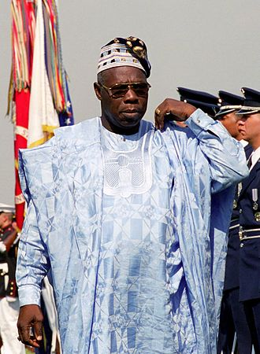
Olusegun Obasanjo: sponsor of the 200 Hectares maize plantation project

Management
The farm will be managed by a board of directors since although it is in the line of a sole proprietorship, it is seen as a corporation. A large part of the company that is about 70% will be held by the sole owner that is Miss Eseosa Uwagboe, the remaining 30% will be shared between the board of directors.
The basic businesses categories of sale, marketing, administration and production are the main categories for medium scale businesses like the above project. The board of directors will be made up of shareholders, owners of cooperative agro businesses, agro consultants, etc. The Managing director will be responsible for coordinating everything that goes on daily from carrying business risks and focusing on wealth creation.

Chapter 3: Market and Sales
Every business or product has the market it targets. This describes how you plan generating profit and creating exposure to best sell your product. There are certain things that the sole owner will consider which are:
- Unique value proposition
The market need to be met by the project is to ensure no gaps are left in the demand for maize throughout Nigeria. As mentioned before the demand for maize is high so Dansoye Agro ventures has it as its aim to meet this demand in the west, north, east and south.
- Pricing strategy
The price of a product depends on the demand for it, in order for the venture to deliver it will make its prices to be at the middle, it will not be too high nor will it be shallowly low. Its prices will be affordable to customers. One thing is that the business will ensure that its price will be one that will make it different and ideal compared to its competitors.
- Sale/Distribution plan
The firm plans to distribute its products to customers versatilely meaning that its products will be available in shops, online, through mail orders, through other companies and any other distribution plan possible. Although it will focus mainly on retail outlets before expanding to the others.
- Marketing Plan
The business will use different strategies to get customers to patronize it. It will have a lot of advertisements. The branding will be interacting from its colours to texts of the business letterhead, the business cards will give an overall welcoming image.

Chapter 4: Technical Feasibility , Project engineering, Resources and environment
When we talk about technical feasibility, it means the feasibility concerned with specifying equipment and software to be used. The project is technically feasible seeing as all the technical equipment for carrying out the project are available. Our project as mentioned before involves setting up a 200 hectares maize plantation. Since it is a big project and one that cannot be done manually or even if done manually would slow down the work and not yield good result.
There are certain technical equipment that will be needed which will be addressed below as well as their uses.
- Planter
This is an agricultural equipment which we will use to perform the task of properly inserting or putting seeds in the ground so they can grow well although a human being can do this….Dansoye will prefer using this equipment so the farming will be profitable and productive.
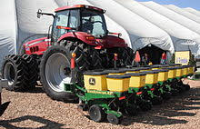
- Sheller( Maize sheller)
It is used for removing the outer covering( skin, bark or husk) of harvested crops. It performs the first processing work on harvested crops making them suitable for human consumption and the production will involve using this equipment.
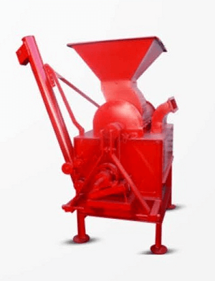
- Cutter
The project will involve using a cutting equipment for removing or levelling grass, weed and it will be used to clear the land. A lawn mower will be used in this case.
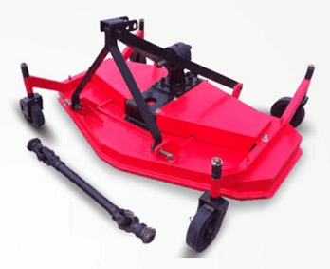
- Plough
A plough will be used for digging and turning over the soil before seeds are planted. Since the project plans on surpassing its competitors….it needs to use this equipment to ensure the nutrients can come from the soil.
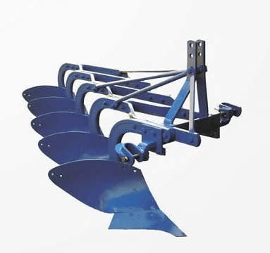
- Harvester
A harvester will be among the instruments that will be used in the production and it will be used for cutting off ripe crops or plants and for gathering them. Since harvesting is a very tedious work and we want utmost result we’ll use a harvester.
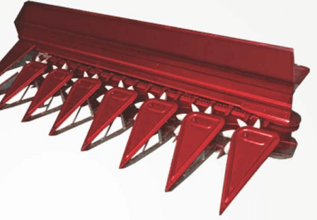
- Fertilizer Broadcaster
This will be used for spreading fertilizer( nitrogen fertilizer will be used being the most efficient on maize) evenly across the farm in an effective and efficient manner.
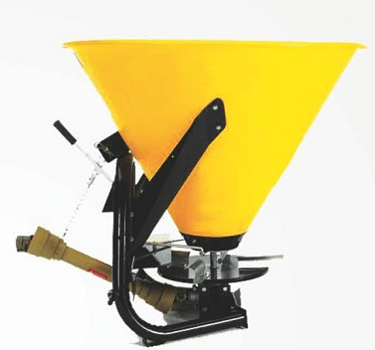

- Boom spray
It will be used doing production to spray pesticides and herbicides. We cannot have insects and pests eating up out production. Herbicides will be used to kill weeds because weed infestation can reduce maize production by 30%.
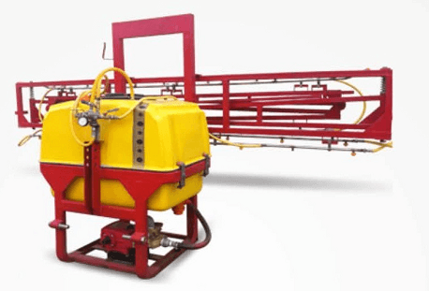
These technical equipment mentioned although expensive is just what we need for effective and profitable production.
Apart from technical equipment we need to look at some other things like:
- The Location
The farm will be located at Sunny villa estate in the Ajah area of Lagos State. Most people are of the opinion that Lagos State will not have enough land to take such mass production of Maize however the site that has been picked is not a developed area so there are no threats to the plants to be grown. About half of the estate has been purchased for this production. The location is suitable for efficient production, processing and marketing.

- The Raw Materials
Since the production is not one that involves going through rigorous means to get raw materials so much money need not be put into it. The maize seedlings will be bought in large quantity to be planted. These seeds will be local ones so they are not corrupted with westernized mechanisms.
- Labour
On the production, specialists in mechanization, irrigation, crop production, agric extension, marketing, etc will be employed when talking about skilled labour. One of the aims of the project is to create job opportunities so some unskilled labourers will also be employed. The two types of labour will work hand in hand to ensure manifold and efficient production.
A business is said to be technically and operationally feasible if it has the necessary expertise, infrastructure and capital to develop, install, maintain and operate the business and looking at all the above the project meets all criteria mentioned therefore it is technically feasible.

Chapter 5: Government Support and Regulation
The government especially the present administration is interested in the agricultural aspect of the economy and does what it can to support farmers at different levels. Since the project supports plans of the government towards reduction of importation, provision of employment opportunities, reliance on agriculture, food security etc the government will be ready to support it. The Federal Ministry of Agriculture and Rural Development is the office responsible for agricultural development and it seeks to help and contribute to agricultural projects like this one.
The government brings up certain measures to aid agriculture which will be followed in the development of this project:
- New Fiscal incentives to encourage domestic import substitution
- Removal of restrictions on areas of investment and maximum equity ownership in investment by foreign investors
- Currency exchange controls- free transfer of capital, profits, dividend, etc
- Constitutional guarantees against expropriation of investments.
- Zero percent duty on agricultural machinery and equipment imports
All the measures that have been put in by the government will be used during the carrying out of this project and as a result the project will benefit from the government.

Chapter 6: Project Timeline
When we say project timeline, we mean how long the project will take. The initiating of the project will begin in November 2020 and end at about February 2021 since it is the dry season which the perfect time for clearing the land and getting it ready for planting. Maize is usually planted at around March/April and that is when the planting of maize will begin on our project. Maize takes about 60 to 90 days to grow that is about 3 months from March/April and since it is the raining season the maize will grow fast and the maize will be harvested by June/July of 2021. The cycle may keep going that way until the project ceases to exist.

Chapter 7: Financial Evaluation- project costs and revenue estimates
Fixed Cost
- Land Clearing
Activity | QTY | ₦ | K
Land Clearing | 1Hectare | 110,000 | 00
Cross cutting | 1Hectare | 11,000 | 00
Rome ploughing | 1Hectare | 30,000 | 00
Sub total | 1Hectare | 151,000 | 00
Total | 200 Hectare | 30,200,000 | 00
(B) Equipment
Name | QTY | MODEL | USD | ₦ | K
Tractor | 1 | AC 190 X-T | 18,500 | 6,752,500 | 00
Planter | 1 | IH- M 56 | 3,100 | 1,131,500 | 00
Lawn mower | 2 | ZT HD 48 9911 | 2,000 | 730,000 | 00
Maize Sheller | 1 | 5XZC-3A | 3,100 | 1,131,500 | 00
Plough | 2 | ZEYI-17 | 600 | 219,000 | 00
Harvester | 2 | HT-178-23 | 33 | 12,000 | 00
Boom sprayer | 1 | DS-35 | 3,500 | 1,277,500 | 00
Fertilizer broad caster | 2 | CDR-260 | 240 | 87,600 | 00
Sub total |  |  | 31,072 | 11,341,600 | 00
(C) Vehicle
Type Model QTY ₦ K
Pick up Truck | HILUX | 1 | 15,000,000 : 00
4 Runner | Toyota | 1 | 9,700,000 : 00
- Irrigation
Type QTY Model USD ₦ K
Hose Reel | 2 | 70-AD-J | 12 | 8,760 : 00
PVC Pipe | 3 | ¾ QW-R | 8 | 8,760 : 00

Operating Cost
Working Capital
 | ₦ | K
Ploughing/Ha | 17,000 | 00
Harrowing/Ha | 8,000 | 00
Sub total | 25,000 | 00
For 200 Ha | 5,000,000 | 00
Mechanization and storage | 70,000 | 00
For 200Ha | 14,000,000 | 00
Input / Ha | 65,000 | 00
For 200Ha | 13,000,000 | 00
Area yield insurance | 8,000 | 00
Produce aggregation | 2,500 | 00
Geo Spatial Service | 2,000 | 00
Sub total | 12,500 | 00
For 200Ha | 2,500,000 | 00
Interest per hectare | 23,000 | 00
For 200Ha | 4,600,000 | 00
Total cost per hectare | 251,000 | 00
Total cost for 200Ha | 50,200,000 | 00
Loan principal and interest (cost per Hectare) | 270,000 | 00
Total for 200Ha | 54,000,000 | 00
Irrigation cost for 200Ha (excluding fixed cost) | 8,000,000 | 00

Amortization
₦ K
Land clearing amortization (per hectare) | 25,000 : 00
Land clearing amortization (200hectare) | 5,000,000 : 00

REVENUE
Yield per hectare 3tonnes@ ₦150000 per tone
 | ₦ K
Revenue per hectare | 450,000 : 00
For 200Ha | 90,000,000 : 00
Net revenue for 200Ha(without amortization) | 36,000,000 : 00
Net revenue with amortization(400ha clearing) | 31,000,000 : 00
Currency conversion rate:₦365.00 to 1USD

Chapter 8: Funding Mechanisms
Obasanjo farms will provide 200Ha of cleared farmland in Sunny villa estate and lease it to members of the cooperative. Obasanjo farms will also lease storage capacity for storing maize like a lot of bags to store maize. Our sponsors will provide money for equipment, vehicles etc. Obasanjo farms having been there for a while will be able to supply experienced labourers, there will be also be supervisors, agribusiness professionals, etc.
Obasanjo farms will also provide for working capital and other important expenses. Some loans will be taken to cover extremely large budgets too.

Chapter 9: Conclusion
From the feasibility study of the project for 20 hectares of maize plantation it is clear that the project is technically feasible and commercially viable seeing as it has funding from a reliable sponsor- Olusegun Obasanjo. Looking at the project timeline, it will done at the best time and season so it will yield much harvest. The project will also be backed up by government support so there will be no issues with government policies. The business plan has estimated the cost of the project and revenue so not a lot of extra expenses will be incurred. In conclusion the above business plan has shown that this project is viable and feasible in all aspects and can be commenced.

References:
https://articles.bplans.com
https://investopedia.com
https://knoema .com
https;//agriacademy.com
https://www.tandfonline.com
https://alibaba.com/showroom/agriculture
www.inc.com

