NAME: OYEBOADE Rukayah Kiitan
MATRIC NO: 17/ENG08/004
DEPARTMENT: Biomedical Engineering
COURSE CODE: BME 322
COURSE TITLE: Systems Bioengineering I

ASSIGNMENT

Cardiac pressure-volume loop analysis is the “gold-standard” in the assessment of load-dependent and load-independent measures of ventricular systolic and diastolic function. Cardiac pressure volume loop analysis provides detailed information of cardiac function and are the gold standard for functional assessment. While imaging techniques such as echocardiography or cardiac MRI provide functional measures, these measures are highly dependent on loading conditions. . Load-independent measures of cardiac contractility and relaxation require dynamic measurements of the ventricular pressure and volume relation over a range of preload and afterload.

Afterload is the mean tension produced by a chamber of the heart in order to contract. It can also be considered as the ‘load’ that the heart must eject blood against. Afterload is, therefore, a consequence of aortic large vessel compliance, wave reflection, and small vessel resistance (LV afterload) or similar pulmonary artery parameters (RV afterload).
Preload is described as the stretching of a single cardiac myocyte immediately prior to contraction and is, therefore, related to the sarcomere length. Since sarcomere length cannot be determined in the intact heart, other indices of preload such as ventricular end-diastolic volume or pressure are used.

Cardiac pressure-volume loop
Real-time left ventricular (LV) pressure–volume loops provide a framework for understanding cardiac mechanics in experimental animals and humans. Such loops can be generated by real-time measurement of pressure and volume within the left ventricle. Several physiologically relevant hemodynamic parameters such as stroke volume, cardiac output, ejection fraction, myocardial contractility, etc. can be determined from these loops.
To generate a PV loop for the left ventricle, the LV pressure is plotted against LV volume at multiple time points during a single cardiac cycle.
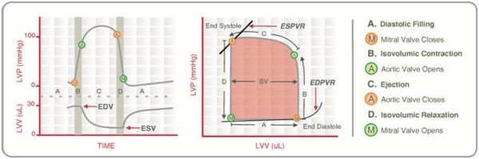
Fig 1- Idealized pressure–volume diagram featuring cardiac cycle components.

PRESSURE VOLUME LOOP ANALYSIS
The PV loop is rectangular or trapezoidal, depicting the four phases of the cardiac cycle
- Isovolumetric contraction,
- Ejection,
- Isovolumetric relaxation, and
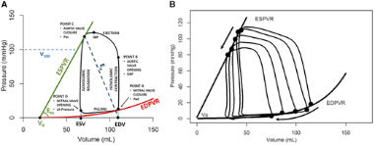
- Passive filling.
Fig 2- phases of PV loop

End-systolic pressure volume relationship
End-systolic pressure volume relationship (ESPVR) describes the maximal pressure that can be developed by the ventricle at any given LV volume. This implies that the PV loop cannot cross over the line defining ESPVR for any given contractile state.
The slope of ESPVR (Ees) represents the end-systolic Ela-stance, which provides an index of myocardial contractility. The ESPVR is relatively insensitive to changes in preload, afterload, and heart rate. This makes it an improved index of systolic function over other hemodynamic parameters like ejection fraction, cardiac output, and stroke volume.
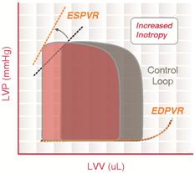
The ESPVR becomes steeper and shifts to the left as inotropy (contractility) increases. The ESPVR becomes flatter and shifts to the right as inotropy decreases.

Fig 3- Pressure-Volume loops showing end-systolic pressure volume relationship

The ESPVR has been shown to be reasonably linear over a wide range of conditions, and can therefore be expressed by a simple equation:
Pes = Ees (V-Vo)
Where:
- Pes is the end-systolic pressure,
- Vo is as defined above,
- V is the volume of interest and
- Ees is the slope of the linear relation.
Ees stands for end systolic Ela-stance. Ela-stance means essentially the same thing as stiffness and is defined as the change in pressure for a given change in volume within a chamber; the higher the Ela-stance, the stiffer the wall of the chamber.

End-diastolic pressure volume relationship
End-diastolic pressure volume relationship (EDPVR) describes the passive filling curve for the ventricle and thus the passive properties of the myocardium. The slope of the EDPVR at any point along this curve is the reciprocal of ventricular compliance (or ventricular stiffness).
For example, if ventricular compliance is decreased (such as in ventricular hypertrophy), the ventricle is stiffer. This results in higher ventricular end-diastolic pressures (EDP) at any given end-diastolic volume (EDV). Alternatively, for a given EDP, a less compliant ventricle would have a smaller EDV due to impaired filling.
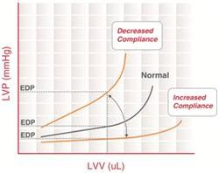
If ventricular compliance increases (such as in dilated cardiomyopathy where the ventricle becomes highly dilated without appreciable thickening of the wall), the EDV may be very high but the EDP may not be greatly elevated.
Fig 4- End-diastolic pressure volume relationship.

Cardiac pressure-volume analysis presents particular advantages over other measures of cardiac function, as they allow for measurement of ventricular function independent of loading conditions and of heart rate. Specific load-independent cardiac indices of contractility include: end-systolic pressure volume relation (ESPVR), dP/dt_{max}–end-diastolic volume relation, maximal Ela-stance (E_{max}) and preload recruitable stroke work (PRSW).

REFERENCES

Dennis, A., & Lan M., (2015, 17 September), Cardiac Pressure-Volume Loop Analysis Using Conductance Catheters in Mice. Journals of visualized experiments. (103): 52942. doi: 10.3791/52942

Marcelo, B.B, Daniel B., Jiri, M., Joost, D., Corstiaan, A, Koen, A., Mattie, L., Felix, M., Felix, Z., Jan, J.S., Nicolas, M., & Van, M., (2020, 21 March). Invasive left ventricle pressure–volume analysis: overview and practical clinical implications. European Heart Journal. Vol 41, Issue 12, pg 1286–1297
- Wikipedia

