OBERHIRHI FAVOUR OGHENENYORE
17/ENG01/019
CHEMICAL ENGINEERING
MATHS ASSIGNMENT V

Simulation File
commandwindow
clearvars
clc
format short g
syms t kp td tp
v = kp*(1-exp(-((t-td)/tp)));
mdata = xlsread(' 1587203818odevbesdata', 'data1');
t1 = mdata(:,1);
v = mdata(:,2);
V1 = round(mdata(900,2),1)
t0 = ones(length(v),1)
t = [t0 t1]
[mcoeff, mcoeffint, mresid, mresidint, manova] = regress(v,t);
% mcoeff
% rsquaredvalue=mcoeff(1)
plot(t,v);
xlabel('Time (min)')
ylabel('Volume (m^3)')
grid on

Or

commandwindow
clearvars
clc
format short g
syms t kp td tp
v = kp*(1-exp(-((t-td)/tp)));
mdata = xlsread('1587203818odevbesdata', 'data1');
t1 = mfig(:,1);
mfig(:,2);
V1 = round(mfig(900,2),1)
t0 = ones(length(v),1)
t = [t0 t1]
[mcoeff, mcoeffint, mresid, mresidint, mania] = regress (v,t);
%mcoeff
%rsquaredvalue = mcoeff(1);
mcoeff
manova
kp = V1
td = -mcoeff(1)
tp = mcoeff(2)
plot(t,v(:,1));
grid on
grid minor

Beta = nlinfit(V,t,vf,beta0)
Beta0 = [t0 t1 ]
Plot(t,Beta)

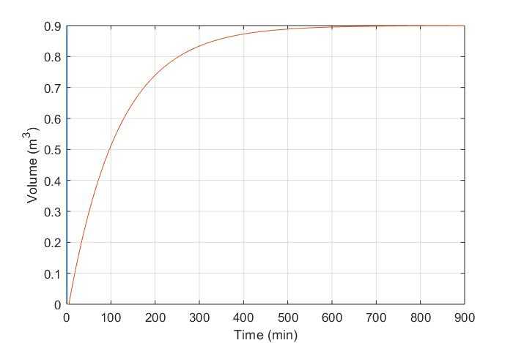

G

commandwindow
clearvars
clc
format short g
syms t kp td tp
v = kp*(1-exp(-((t-td)/tp)));
mdata = xlsread(' 1587203818odevbesdata', 'data1');
t1 = mdata(:,1);
v = mdata(:,2);
V1 = round(mdata(900,2),1)
t0 = ones(length(v),1)
t = [t0 t1]
[mcoeff, mcoeffint, mresid, mresidint, manova] = regress(v,t);
% mcoeff
% rsquaredvalue=mcoeff(1)
plot(t,v(:,1), 'g-0', 'Marketindices',([1:40::length(t)]);
xlabel('Time (min)')
ylabel('Volume (m^3)')
grid on

GRAPH WAS GOTTEN WITH THE AID OF THE CODE ABOVE .....................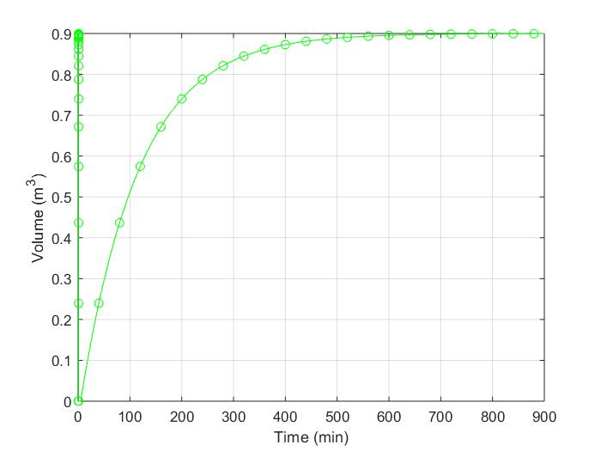
GRAPH OF VOLUME(m3) AGAINST TIME(min)

