- Hypothesis testing is an act in statistics where an analyst test an assumption regarding a population parameter. Hypothesis testing is used to assess the plausibility of hypothesis by using sample date such as population.

- .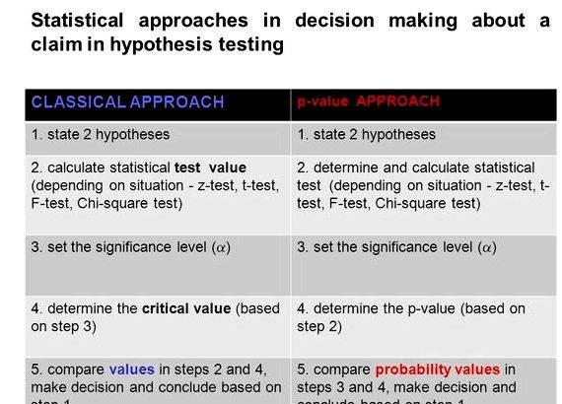

3.The importance’s of hypothesis testing is to assist clinicians, administrators and researchers in making wise decisions which generally depends on the statistical decision.

