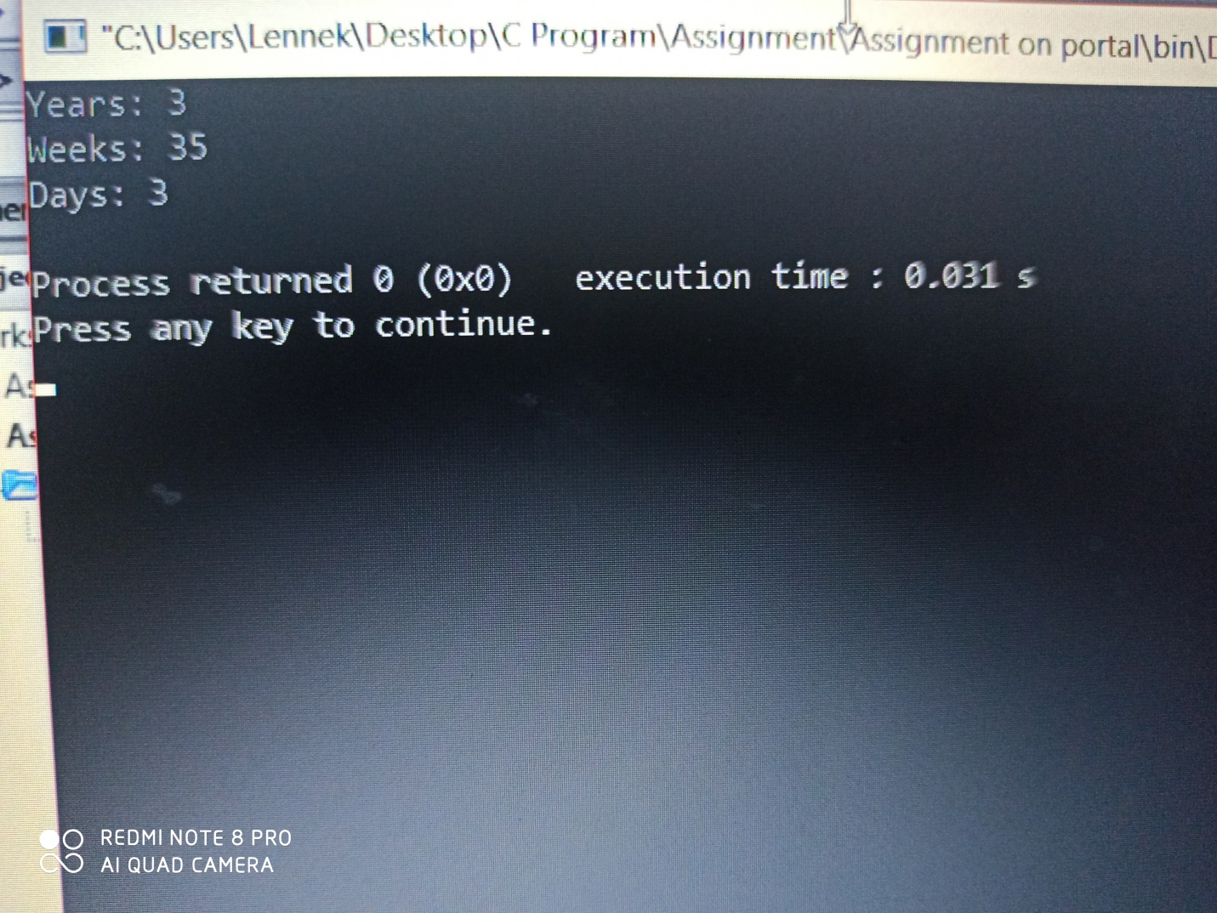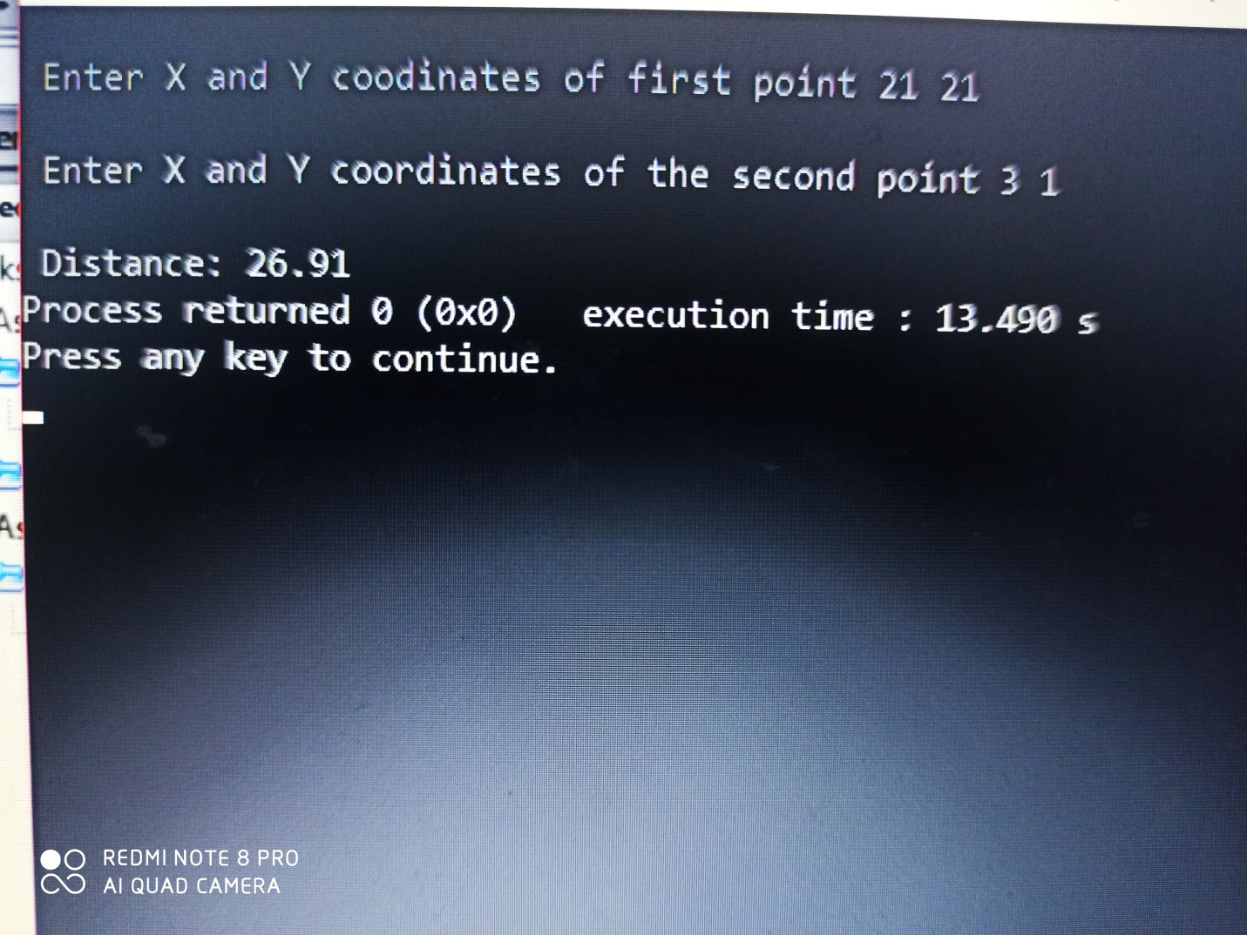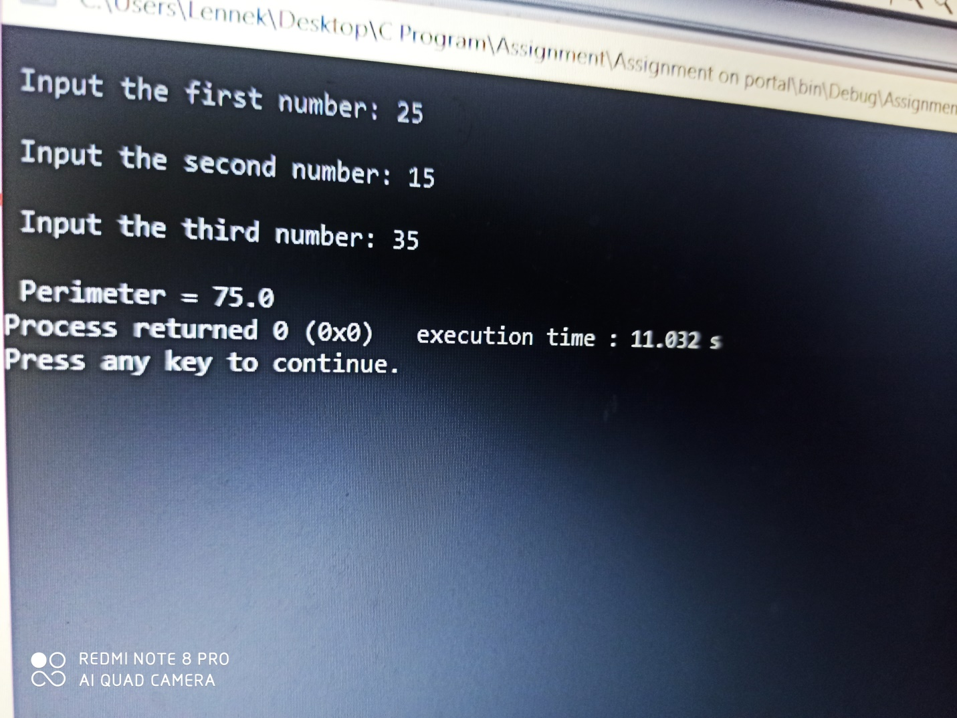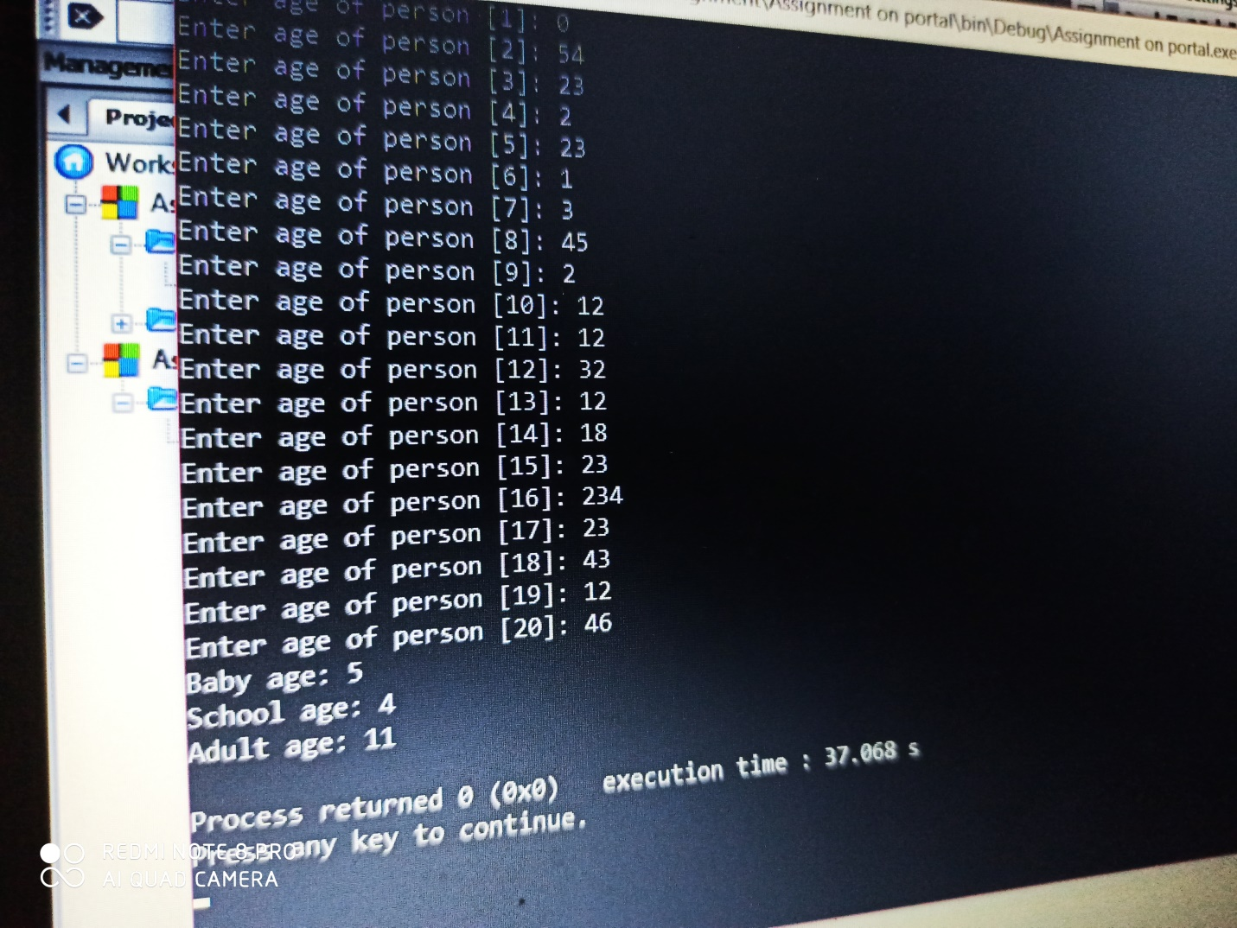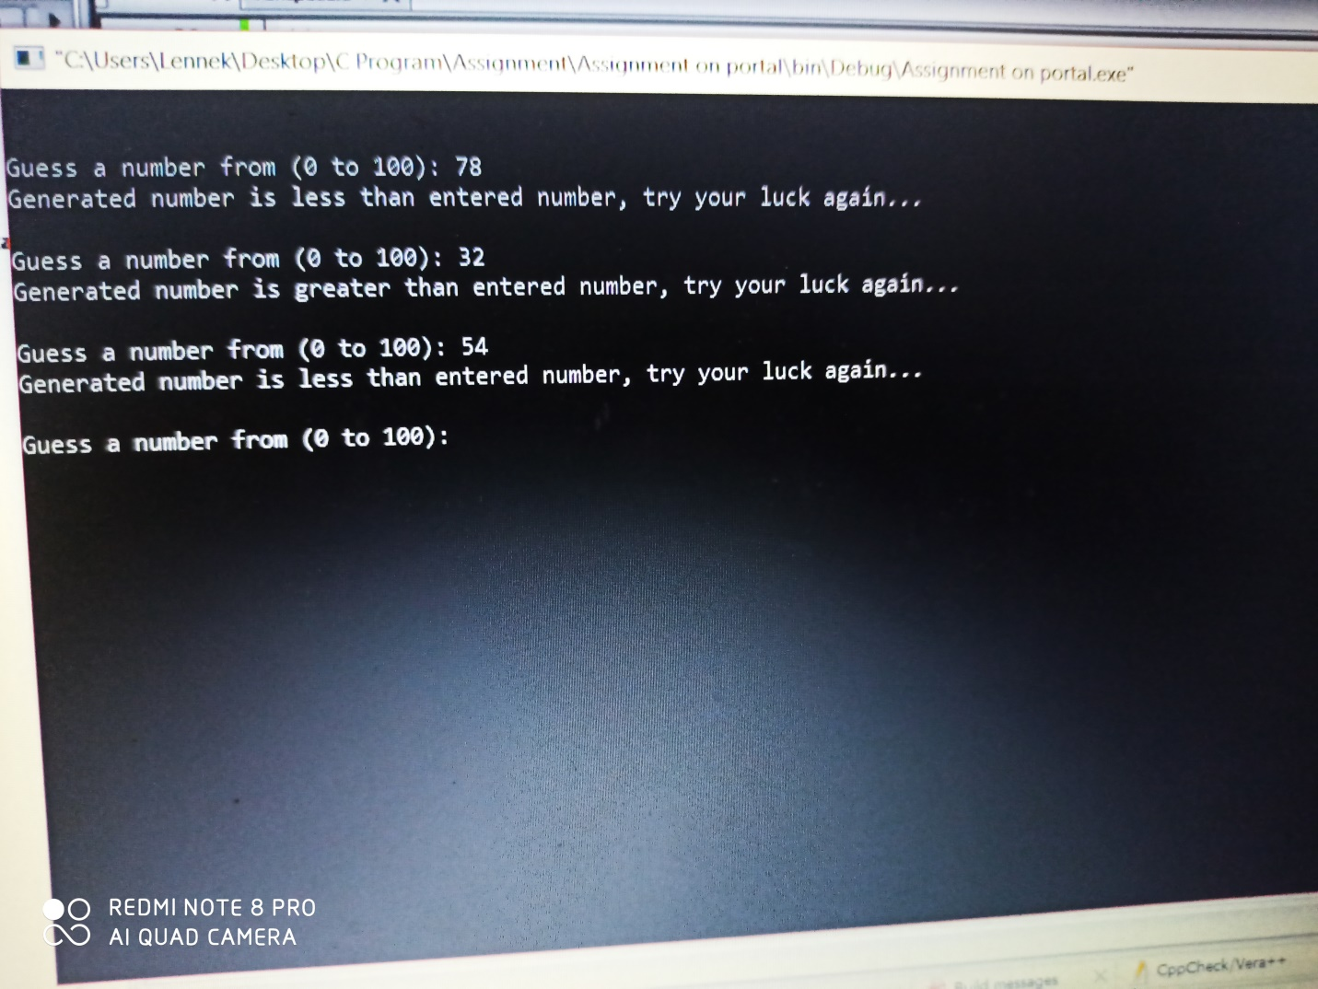NUMBER 1
#include <stdio.h>
int main()
{
int days, years, weeks;
days=1343;
years=days/365;
weeks=(days%365)/7;
days=days-((years*365)+(weeks*7));
printf("Years: %d\n", years);
printf("Weeks: %d\n", weeks);
printf("Days: %d\n", days);
return 0;
}
NUMBER 2
#include <stdio.h>
#include <math.h>
int main()
{
int x1, x2, y1, y2;
int x, y;
float distance;
printf("\n Enter X and Y coodinates of first point ");
scanf("%d %d", &x1, &y1);
printf("\n Enter X and Y coordinates of the second point ");
scanf("%d %d", &x2, &y2);
x=x2-x1;
y=y2-y1;
distance=sqrt((x*x)+(y*y));
printf("\n Distance: %.2f",distance);
return 0;
}
NUMBER 3
#include<stdio.h>
int main()
{
float x, y, z, P, A;
printf("\n Input the first number: ");
scanf("%f", &x);
printf("\n Input the second number: ");
scanf("%f", &y);
printf("\n Input the third number: ");
scanf("%f", &z);
if(x<(y+z) && y<(x+z) && z<(y+x))
{
P=x+y+z;
printf("\n Perimeter = %.1f", P);
}
else
{
printf("Not possible to create a triangle...");
}
}
NUMBER 4
#include<stdio.h>
int main()
{
int age;
int cnt_baby=0, cnt_school=0, cnt_adult=0;
int count=0;
while(count<20)
{
printf("Enter age of person [%d]: ",count+1);
scanf("%d", &age);
if(age>=0 && age<=4)
cnt_baby++;
else if(age>=5 && age<=17)
cnt_school++;
else
cnt_adult++;
count++;
}
printf("Baby age: %d\n", cnt_baby);
printf("School age: %d\n", cnt_school);
printf("Adult age: %d\n", cnt_adult);
return 0;
}

NUMBER 5
#include <stdio.h>
#include <stdlib.h>
#include <time.h>
int main()
{
int random_No=0,count=0,num;
int stime;
long ltime;

//initialise srand with current time, to get random number on every run
ltime = time(NULL);
stime = (unsigned) ltime/2;
srand(stime);

//generate random number
random_No=rand()%100;

//run infinite loop
while(1)
{
//increase counter
count+=1;

//read number from user
printf("\n\nGuess a number from (0 to 100): ");
scanf("%d",&num);

//compare entered number with generated number

if(random_No==num){
printf("Congratulations, you have guessed a correct number.");
break;
}
else if(random_No<num){
printf("Generated number is less than entered number, try your luck again...");
}
else if(random_No>num){
printf("Generated number is greater than entered number, try your luck again...");
}

if(count==7){
printf("\n\n### Maximum limit of atttempt finished, BAD LUCK !!!\n");
break;
}
}

return 0;
}

NAME: Sajinyan Olanrewaju
MATRIC: 18/ENG05/055
DEPARTMENT: Mechatronics.

