OMOJOLA TEMILOLUWA
17/ENG04/058
ELECTRICAL/ELECTRONICS ENGINEERING

commandwindow
clearvars
clc
format short g

syms t kp td tp
v = kp*(1-exp(-((t-td)/tp)))
mdata = xlsread('1587203818odevbesdata', 'data1');
t1 = mdata(:,1);
v = mdata(:,2);
V1 = round(mdata(900,2),1)
t0 = ones(length(v),1)
t = [t0 t1]
[mcoeff, mcoeffint, mresid, mresidint, manova] = regress (v,t);
%mcoeff
%rsquaredvalue = mcoeff(1)
mcoeff
manova
kp = V1
td = -mcoeff(1)
tp = mcoeff(2)
plot(t,v(:,1));
grid on
grid minor

Beta = nlinfit(V,t,vf,beta0)
Beta0 = [t0 t1 ]
Plot(t,Beta)
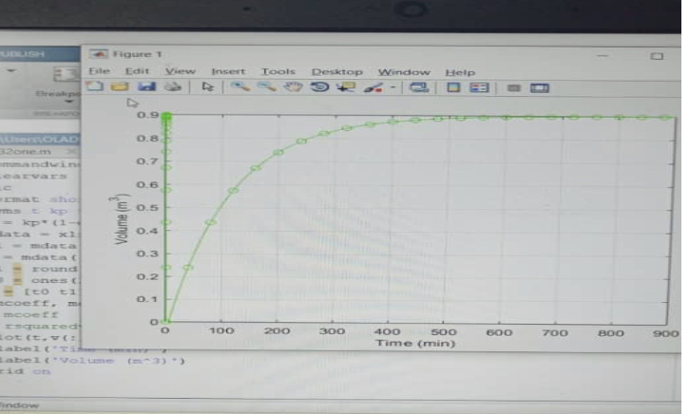
Command window
Clear
Clc
Format store g
Syms t kp td tp
Mdata =xls read(‘1587203818odevbe sdata’, ‘data1’);
T1=mdata(:,1);
V=mdata(:,2);
To=ones(length(v), 1)
T=(To T1)
Y=@(kp,td,tp)(-((exp(T1)-exp(td))/exp(tp)));
Initials=(0.1,0.1,0.1)
%(mcoeff, mcoeffint, mresid, mresidint, manova)=nlinfit (v,t,y,initials)
%mcoeff
Plot(t,v)
Grid on
Grid minor

